Summer Term
Learning Project
Week 1
Emus
Year 5

Home Learning Project WEEK 1 - My Family
Upper Key Stage 2 - Class: Emus
Maths Tasks |  | Writing Tasks
As a school, we will be following the White Rose Home Learning sequence.  Your teacher will explain which lesson to complete in a daily Marvellous Me message. Here is the overview of what the week will look like:  Monday: Decimals up to 2 dp  Tuesday: Decimals as fractions (1)  Wednesday: Decimals as fractions (2)  Thursday: Understand Thousandth  Friday: Thousandths as decimals  Below is extra maths links you might find useful:  - Play on Hit the Button - focus on halves, doubles and times tables.  - Complete Multiplication 2Dos on Purple Mash.  - Play Whack a Mole and practise your multiples. |  | Your teacher will send specific writing tasks to be completed on a daily Marvellous Me message. Here is the overview of what the week will look like:  Monday: Read through the WAGOLL (What A Good One Looks Like) of a character description and identify the key features outlined to you.  Tuesday: Answer comprehension questions based on the WAGOLL text.  Wednesday: Complete grammar task.  Thursday: Apply grammar focus independently.  Friday: Have a go at writing your own character description based on a member of your family.
Spelling Tasks |  | Reading Tasks
Below is a selection of spelling tasks to choose from throughout the week:  - Practise the Year 5/6 list for Common Exception words.  - Complete weekly spelling 2Dos on Purple Mash. Make sure you use your personal logins.  - Practise your spelling on Spelling Frame  - Practise your spellings by playing a game on Topmarks.  - Choose 5 Common Exception words. Write them, as a synonym, antonym, a definition and an example of how to use the word in a sentence.  - Create and add to topic word bank which includes any new words you come across this week.  - Proof read work and use a dictionary to check spellings that they are unsure of. |  | Below is a selection of reading tasks to choose from throughout the week:  - Share a story together. This could be a chapter book where you read and discuss a chapter a day.  - Ask children to summarise what they have read. Can they represent it, in a comic strip, bullet point it or represent their work in a creative way.  - Encourage children, to write down any unfamiliar words and to use a dictionary to explore the meanings of them.  - Watch Newsround and discuss what is happening in the wider world.  - Sign in to epic! using your class login and get reading!  Emus:Srb1488  - Bake a new recipe and let your child read the instructions to you.  - Read the First News newspaper and The Week Jr magazine together.
Wider Curriculum Menu
As well as completing a daily maths, English, spelling and reading task, we have put together a selection of different wider curriculum activities for you to complete at your leisure. We realise this is a busy time and so most of these do not require written work but instead are discussion and interaction based. You can complete as many as you like in any order you want!
Spend time looking through old photos, discussing the people in your family and their history. | Play a board game with members of your family. Can you create your own game, together? |  | Help the adults in your home to make a healthy lunch/ dinner. Create an advert to promote it.
Create a poster which displays why differences between families should be celebrated. Make it positive and include power phrases. | With the help of adults in your family, create a family tree which shows the growth of your family. Display in a creative way. |  | Listen to different pieces of music together with your family from the different generations. Are there any from different cultures? Explore the history of these.
Create a portrait of your family. It could be drawn, painted, sculpted or collaged. Get creative! | FaceTime or Skype a member of your family you have not seen this week for a catch up. |  | Locate on a map where different people in your family originate from. Explore the different languages spoken.
Enjoy a family picnic in the garden or even in the living room if the weather isn’t very warm. | Have a family workout alongside Joe Wicks at 9am.  Or learn some new dance moves, with Diversity |  | Encourage an adult to share a story from their childhood. Illustrate the story, so that you can retell it to your peers.
Additional learning resources you may wish to engage with
There are plenty of events happening online to take advantage of while at home:
- Maths with Carol Vorderman www.themathsfactor.com
- Cooking with Jamie Oliver https://www.jamieoliver.com/features/category/get-kids-cooking/
- Music with Myleene Klass https://www.youtube.com/channel/UCQh2wgJ5tOrixYBn6jFXsXQ
- Science with Professor Brian Cox, Robin Ince & Guests https://cosmicshambles.com/stayathome/upcoming-schedule
- Daily drawing lessons with Author Mo Willems https://www.youtube/Mjacom/watch?v=RmzjCPQv3y8
- Virtual museum tours https://www.familydaystriedandtested.com/free-virtual-tours-of-world-museums-educational-sites-galleries-for-children/
- San Diego Zoo live cam https://zoo.sandiegozoo.org/live-cams

Maths 20.4.20
Today we would like you to focus on Lesson 1 of the home learning which can be found here: https://whiterosemaths.com/homelearning/year-5/ (please make sure, you click on week 1 tab, for today’s session. It is lesson 1)
Today’s lesson is, Decimals up to 2dp.
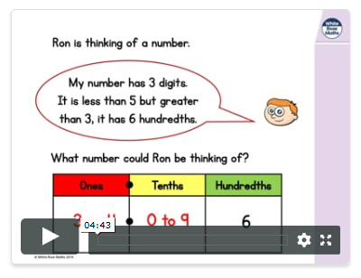
Watch the lesson video (which looks like the screen above) and then answer the attached worksheet. If you find this lesson comfortable and would like to stretch yourselves, have a go at the go deeper questions which are also attached at the end of this document.

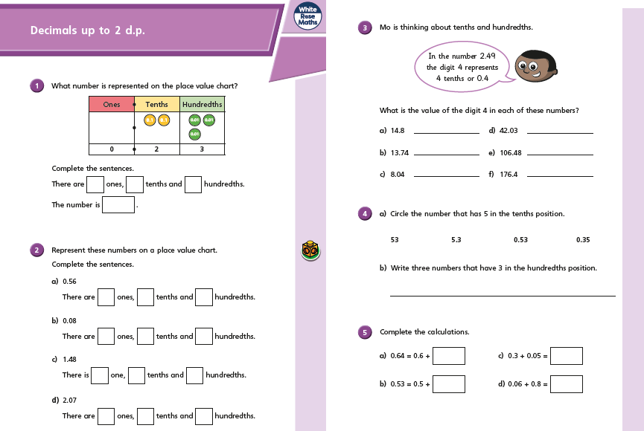

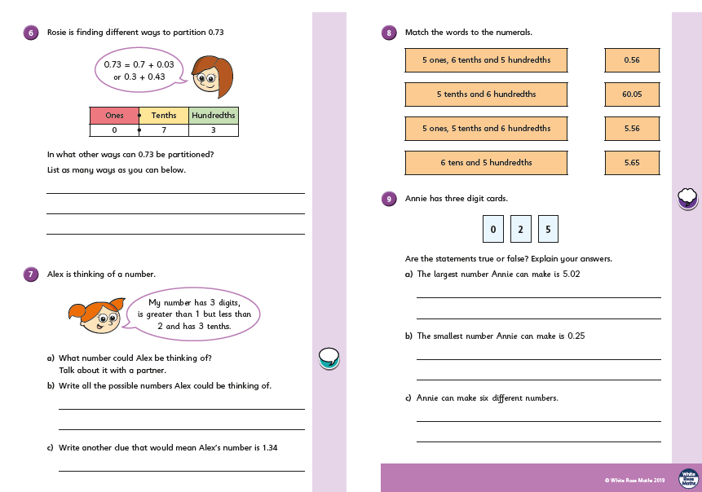

Go Deep:
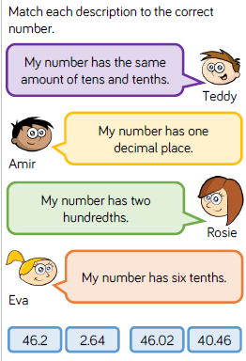
Go Deeper:
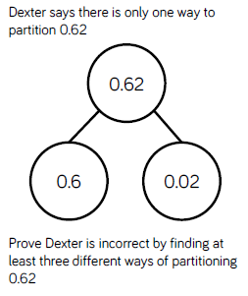

English 20.4.20 Character Descriptions.
This week we are going to be building up to writing our own character descriptions of a family member. Today I would like you to read through the WAGOLL (What A Good One Looks Like), of Harry Potter and identify the key features. You can underline, highlight or circle the features within the texts. I have included a little reminder of what each key feature is, just in case you need some help in retrieving the information.

Key features to find | Key
Subordinating clauses | Blue line
Embedded clauses | Red line
Powerful descriptive language, to engage the reader | Orange line

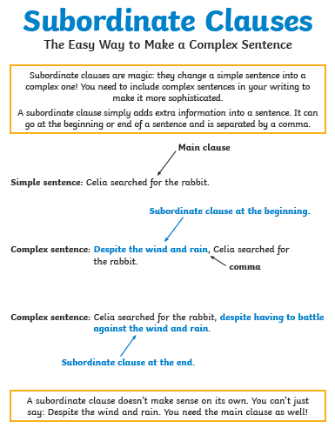

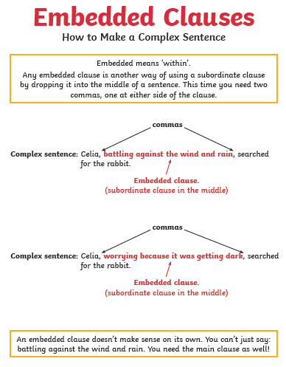

Descriptive language, that engages the reader.
Deep down inside the mountain, by the dark water, lived old shmog- a petite, slimy creature, whose body had become weak and muted after years in the darkness. Where did he come from? Nobody knows nor do they know who he was before he became Shmog. Clearly, something had changed the creature. Something had worked away at his mind, leaving him wild and feral. He was as dark as darkness except for his two big, round, pale eyes, which protruded from his bony, gaunt face. His hair had fallen out leaving a few greasy, thin strands behind, which stuck to his slimy head

Character Description of Harry Potter (WAGOLL)

Clever Harry Potter never liked to be defeated; he always rose to the non-stop magical or deadly challenges that were thrown his way. Due to his flexibility, quick thinking and bravery, he was a talented quidditch player and his hiding skills weren’t too bad either. After a lot of practise, he became the king of magic spells and could use this to his advantage, in many life-threatening situations. He was underestimated! Because he was so loving and gentle, he was often naïve to the evilness at Hogwarts, but he never let his bad luck spoil his good nature. He was recognised by everybody. You couldn’t miss the glaring lightning bolt stamped on his young forehead or his distinguishable stare. Round glasses hung in front of his glossy blue eyes which glowed with a mixture of determination, sorrow and confusion. His once quivering hands turned to steel over time and it was rare to see him without his pointed, life-saving wand or a jet-black cape. Although he had a relatively ordinary appearance, he was far from ordinary, Harry Potter was the kind of wizard that you could meet once but never forget!

21.4.20
Today I would like you to focus on the Week 1 Lesson 2 of the home learning which can be found here: https://whiterosemaths.com/homelearning/year-5/ (please make sure, you click on the first week 1 tab, for today’s session. It is lesson 2)
Today’s lesson is, Decimals as fractions.
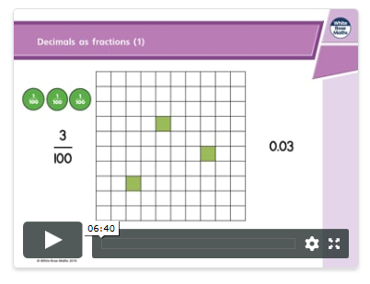

Watch the lesson video (which looks like the screen above) and then answer the attached worksheet. If you find this lesson comfortable and would like to stretch yourselves, have a go at the go deeper questions which are also attached at the end of this document.

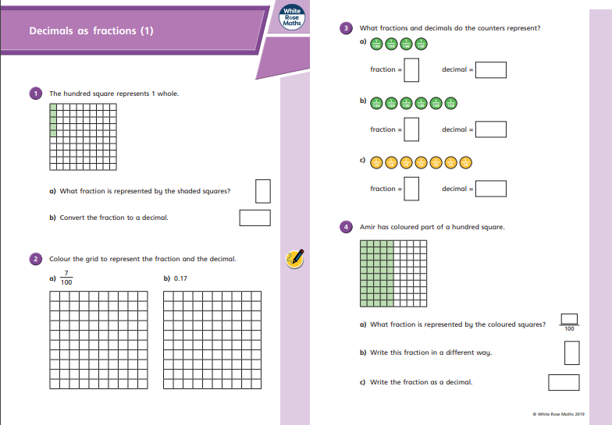

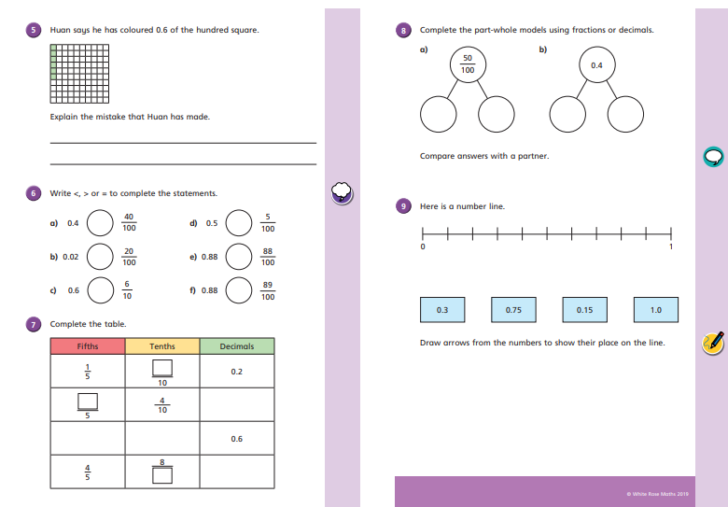

Go Deep:
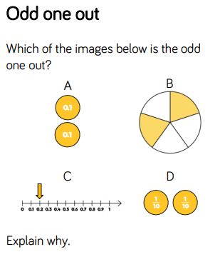
Go Deeper:
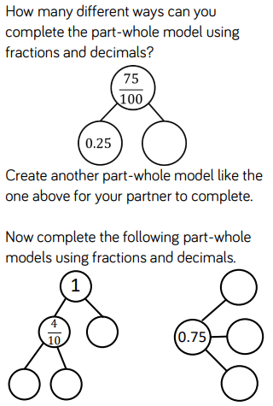

English 21.4.20 Character Descriptions.
This week we are going to be building up to writing our own character descriptions of a family member. Today I would like you to use the WAGOLL (What A Good One Looks Like), of Harry Potter and answer the following questions.

- The text says ‘he always rose to the challenge’. What does this mean and why did he do this?
- Identify two qualities that made him a talented quidditch player.
- He was ‘King of Magic Spells’ How did this help him?
- What evidence can you find to suggest why Harry was underestimated?
- In the text it says ‘Everybody recognised him’. Find the evidence to support this.
- It states that Harry had a ‘distinguishable’ stare. What does ‘distinguishable’ mean?
- What is meant by ‘His once quivering hands turned to steel over time’
- Use evidence in the text to explain why Harry, was a wizard you would never forget.
Character Description of Harry Potter (WAGOLL)

Clever Harry Potter never liked to be defeated; he always rose to the non-stop magical or deadly challenges that were thrown his way. Due to his flexibility, quick thinking and bravery, he was a talented quidditch player and his hiding skills weren’t too bad either. After a lot of practise, he became the king of magic spells and could use this to his advantage, in many life-threatening situations. He was underestimated! Because he was so loving and gentle, he was often naïve to the evilness at Hogwarts, but he never let his bad luck spoil his good nature. He was recognised by everybody. You couldn’t miss the glaring lightning bolt stamped on his young forehead or his distinguishable stare. Round glasses hung in front of his glossy blue eyes which glowed with a mixture of determination, sorrow and confusion. His once quivering hands turned to steel over time and it was rare to see him without his pointed, life-saving wand or a jet-black cape. Although he had a relatively ordinary appearance, he was far from ordinary, Harry Potter was the kind of wizard that you could meet once but never forget!

Maths 23.4.20
Today I would like you to focus on the Week 1 Lesson 2 of the home learning which can be found here: https://whiterosemaths.com/homelearning/year-5/ (please make sure, you click on the first week 1 tab, for today’s session. It is lesson 2)
Today’s lesson is, Decimals as fractions.
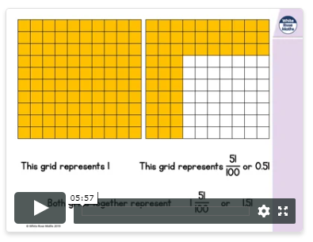

Watch the lesson video (which looks like the screen above) and then answer the attached worksheet. If you find this lesson comfortable and would like to stretch yourselves, have a go at the go deeper questions which are also attached at the end of this document.

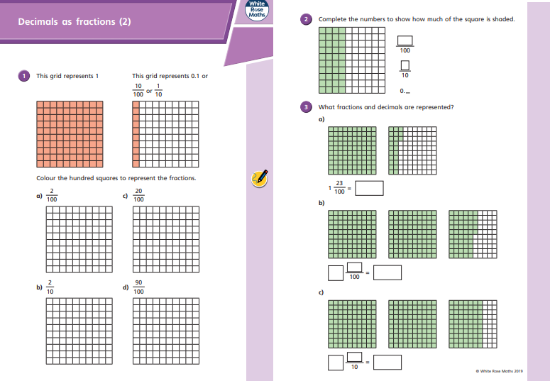

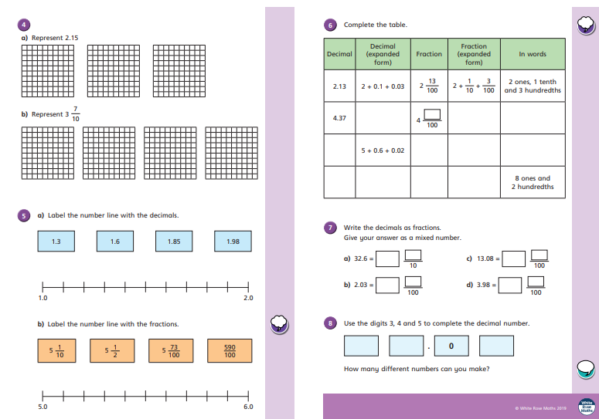

Go Deep:
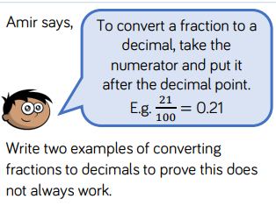
Go Deeper:
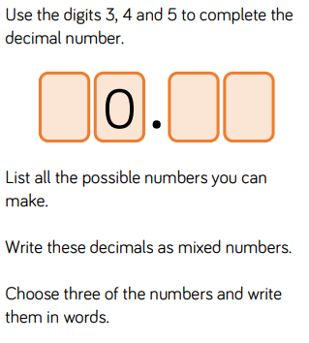

English 23.4.20 Character Descriptions.
This week we are going to be building up to writing our own character descriptions of a family member. Today I would like you to revisit your work on expanded noun phrases. Remember this is adding detail, through description.

During Harry’s time at Hogwarts, he had to face many mythical creatures. Today you are going to write some detailed descriptive expanded noun phrases about one of them. Today, you are going to write some expanded noun phrases about dragons!
I have included some picture for you, for inspiration (you have seen these before), which give you a hint of the detail I am expecting and a prompt sheet, to help you with descriptive words and phrases about dragons.
I have included an example below.

Remember to start you sentence in an interesting way!

Terrifyingly, the ferocious, thick legged creature, soared downwards, surveying the cattle filled field.

Angered, crazed and frustrated, the merciless beast spread its huge, bat like wings, as it glided through, the rosy red sunset sky.

If you really want to impress me and dig deep, add a simile
Dragon

Character
fierce, brutal, savage, violent, vicious, menacing, merciless, malicious, ferocious, malevolent, frightening, terrifying, petrifying
Covering
spikes, studs, scales
spikes along its back
body armour with spikes along its back
tough, armour-plated skin with pointed, bony plates
hairless, leathery, scaly, wrinkled
hard, leathery skin
glistened like wet leather
as wrinkled as a prune
scaly body
covered in heavy scales
scaly, clammy skin
dry, scaly skin
slippery, wet, moist, clammy, slimy
sharp, stiff, bony, pointed
vicious spirit in the shape of a dragon
ran from its head to the tip of its tail

Head, Face and Eyes
horns, nostrils, tongue, slime
hooked, curved, forked, knobbly, rubbery
dripping, snarling, slavering, grotesque
scissor-like jaws
monstrous, slobbering mouth
savage, needle teeth like spikes on a trap
dripping slime
pupils, sockets, slits, beady, cold, evil, piercing
glared, flickered, bulged
blazing, bloodshot eyes
glowing red eyes, malicious staring eyes
burned like furnaces

Wings and Tail
large, thick, heavy, broad, flat
scaly, bony, barbed, spiked, whip-like
large, winged creature
long, scaly wings sprouted from its shoulder
huge, black, bat-like wings
long tail with a spear on the end
used its tail to fly through the trees
thrashed the air, searching for its target
its thick, heavy tail dragged along behind it

Legs and Feet
terrifying, four-legged monster
tree-trunk legs
razor talons, eagle talons on its fingers were long and deadly
fingernails made of brass
long, agile legs and four-toed feet
powerful legs and feet, which were tipped with vicious talons

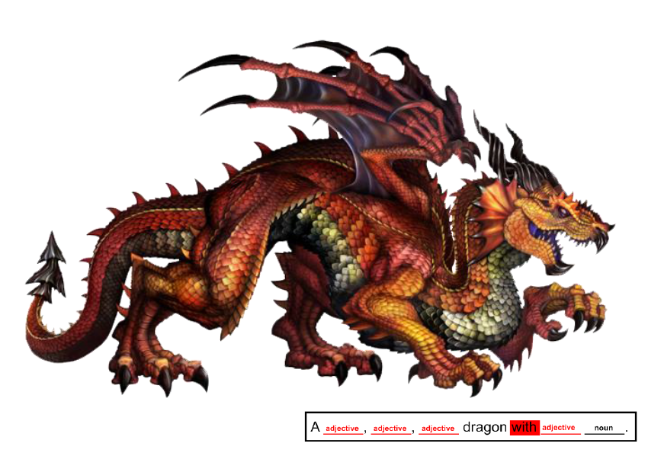
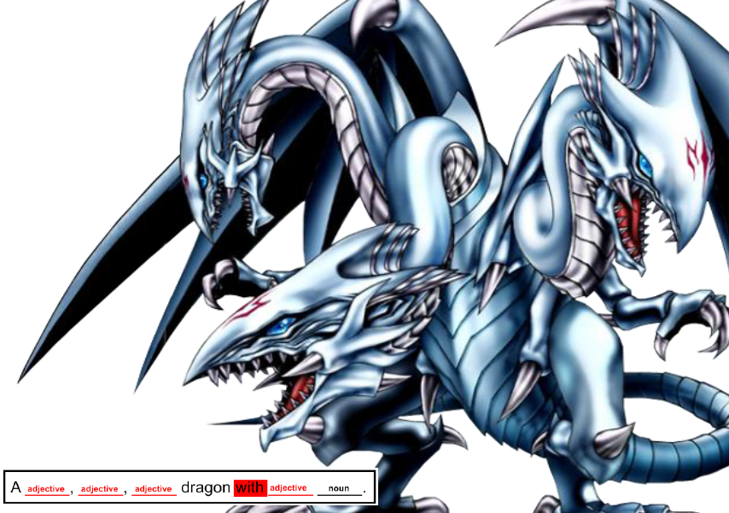

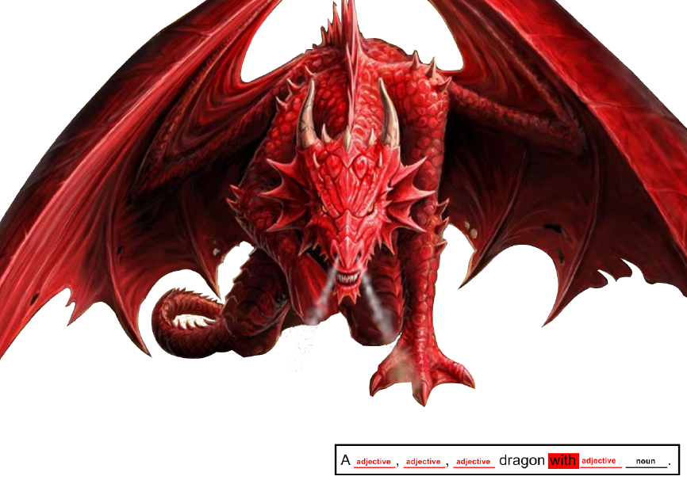

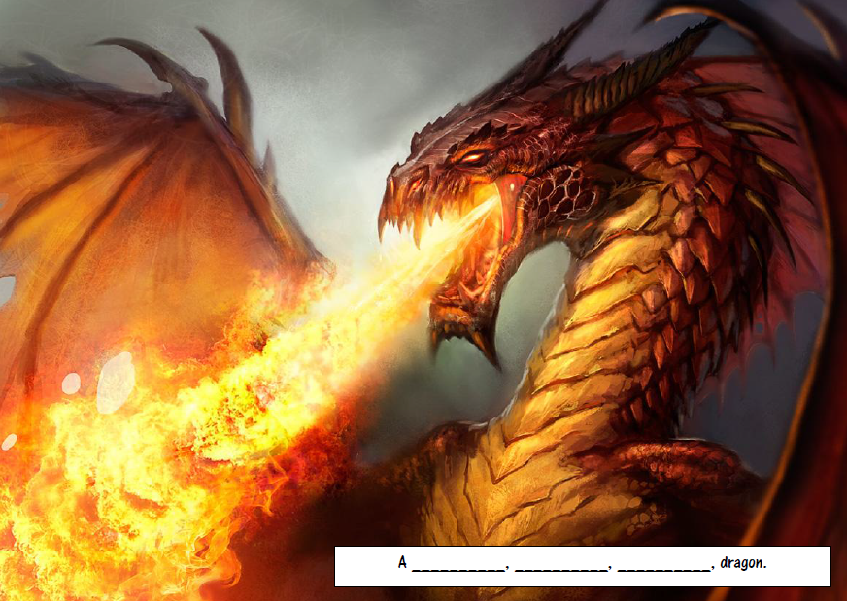

Maths 24.4.20
Today I would like you to focus on the Week 1 Lesson 4 of the home learning which can be found here: https://whiterosemaths.com/homelearning/year-5/ (please make sure, you click on the first week 1 tab, for today’s session. It is lesson 4)
Today’s lesson is, Understand thousandths.
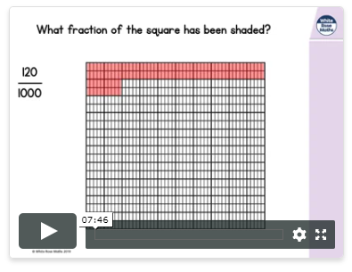

Watch the lesson video (which looks like the screen above) and then answer the attached worksheet. If you find this lesson comfortable and would like to stretch yourselves, have a go at the go deeper questions which are also attached at the end of this document.

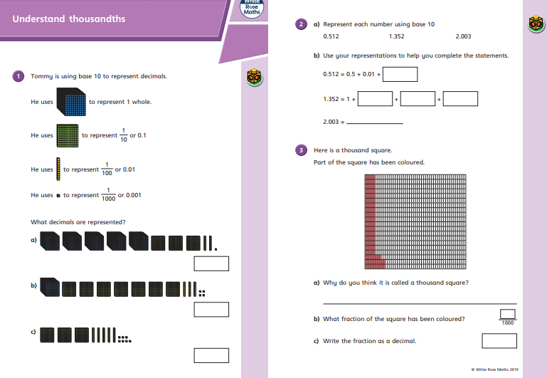

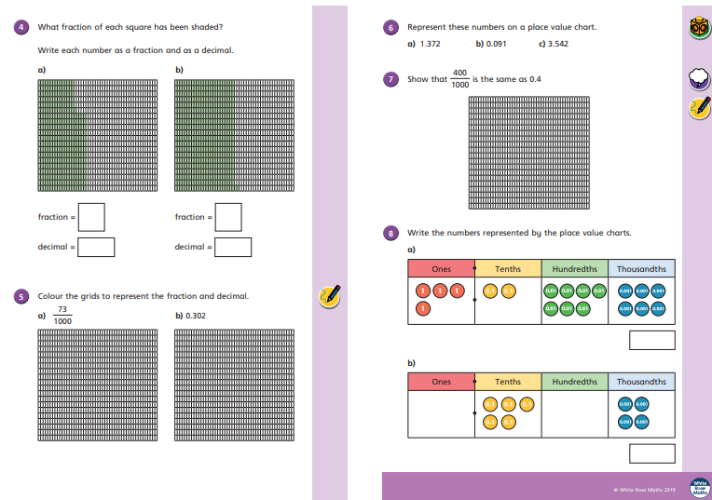

Go Deep:
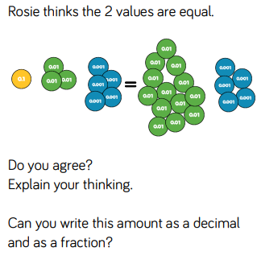
Go Deeper:
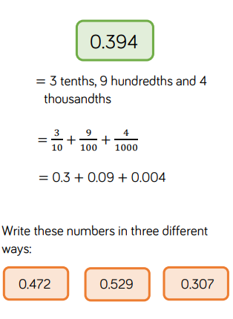

English 24.4.20 Character Descriptions.
Today I would like you to revisit your work on subordinating clauses, including relative clauses and start to vary them within a sentence
Today, you will be using your work from yesterday, to expand them and uplevel the sentences, by including a subordinate or relative clause.
I have included prompt sheets, to help you to retrieve your knowledge of subordinating conjunctions and relative pronouns.
Have some fun, creating some wonderful sentences.
I have included an example below.
Remember to start you sentence in an interesting way!
1.Terrifyingly, the ferocious, thick legged creature, soared downwards, surveying the cattle filled field.
add a clause

1a. Due to incredible hunger, the ferocious, thick legged creature, soared towards the cattle filled field, seeking its next meal
2. Angered, crazed and frustrated, the merciless beast spread its huge, bat like wings, as it glided through, the rosy red sunset sky.
add a clause

2a. Even though the merciless beast was angered at not catching a meal, it gracefully glided through the beautiful sunset sky, spreading out its bat like wings.

If you really want to impress me and dig deep, vary the position of your clause.

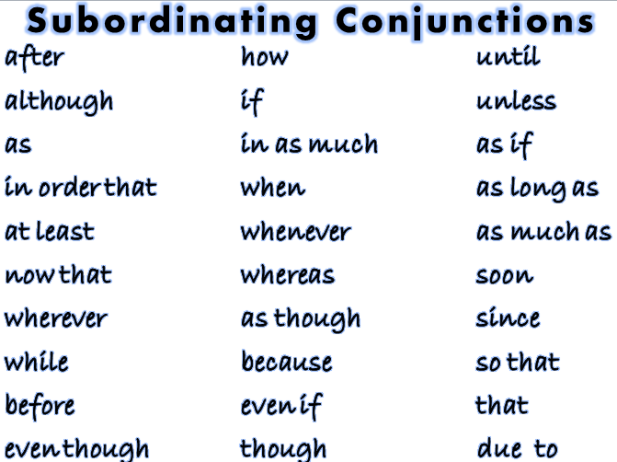

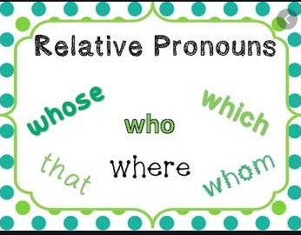

Maths 24.4.20
Today I would like you to focus on the Week 1 Lesson 5 of the home learning which can be found here: https://whiterosemaths.com/homelearning/year-5/ (please make sure, you click on the first week 1 tab, for today’s session. It is lesson 5)

Today’s lesson is, Thousandths as decimals
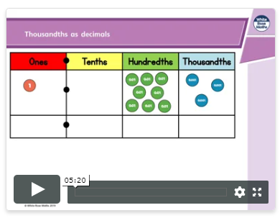

Watch the lesson video (which looks like the screen above) and then answer the attached worksheet. If you find this lesson comfortable and would like to stretch yourselves, have a go at the go deeper questions which are also attached at the end of this document.

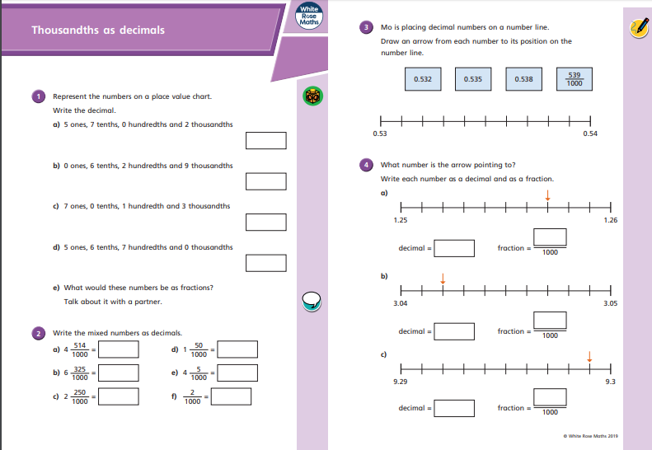
o

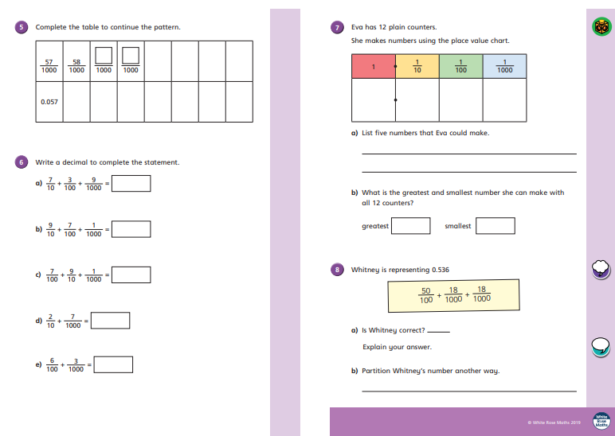

Go Deep:
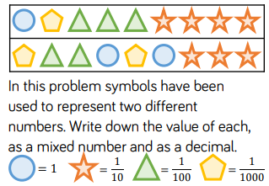
Go Deeper:
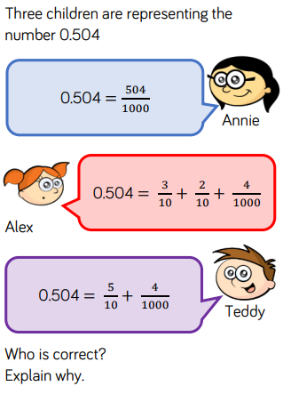

English 24.4.20 Character Descriptions.

Today I would like you to write a character description of a member of your family.
Re read the WAGOLL and familiarise yourself with how it is written.
Remember, to add lots of descriptive language, using expanded noun phrases.
Also add a clause to make it really exciting.

Vary the sentences and make sure you re-read your work and edit it twice.
- Edit to make it look better. (punctuation and grammar}
- Edi to make it sound better. (word choice, sentence structure}

Good Luck writing your description. If you publish your writing, I would love to read it. Please send it to me.

Character Description of Harry Potter (WAGOLL)

Clever Harry Potter never liked to be defeated; he always rose to the non-stop magical or deadly challenges that were thrown his way. Due to his flexibility, quick thinking and bravery, he was a talented quidditch player and his hiding skills weren’t too bad either. After a lot of practise, he became the king of magic spells and could use this to his advantage, in many life-threatening situations. He was underestimated! Because he was so loving and gentle, he was often naïve to the evilness at Hogwarts, but he never let his bad luck spoil his good nature. He was recognised by everybody. You couldn’t miss the glaring lightning bolt stamped on his young forehead or his distinguishable stare. Round glasses hung in front of his glossy blue eyes which glowed with a mixture of determination, sorrow and confusion. His once quivering hands turned to steel over time and it was rare to see him without his pointed, life-saving wand or a jet-black cape. Although he had a relatively ordinary appearance, he was far from ordinary. Harry Potter was the kind of wizard that you could meet once but never forget!

