Summer Term
Learning Project
Week 2
Emus
Year 5

Learning Project WEEK 2 – The Area You Live In
Upper Key Stage 2 - Classes: Emus
Maths Tasks |  | Writing Tasks
As a school, we will be following the White Rose Home Learning sequence.  Your teacher will explain which lesson to complete in a daily Marvellous Me message. Here is the overview of what the week will look like:  Monday: Rounding decimals  Tuesday: Order and compare decimals  Wednesday: Understand percentages  Thursday: Percentages as fractions and decimals  Friday: Equivalent fractions, decimals and percentages  Below is extra maths links you might find useful:  - Play on Hit the Button - focus on halves, doubles and times tables.  - Complete Multiplication 2Dos on Purple Mash.  - Play Whack a Mole and practise your multiples. |  | Your teacher will send specific writing tasks to be completed on a daily Marvellous Me message. Here is the overview of what the week will look like:  Monday: Read through the WAGOLL (What A Good One Looks Like) of a diary entry and identify the key features outlined to you.  Tuesday: Answer comprehension questions based on the WAGOLL text.  Wednesday: Complete grammar task.  Thursday: Apply grammar focus independently.  Friday: Have a go at writing your own diary entry, summarising the events of the past week in your house.
Spelling Tasks |  | Reading Tasks
Below is a selection of spelling tasks to choose from throughout the week:  - Practise the Year 5/6 list for Common Exception words.  - Complete weekly spelling 2Dos on Purple Mash. Make sure you use your personal logins.  - Practise your spelling on Spelling Frame  - Practise your spellings by playing a game on Topmarks.  - Choose 5 Common Exception words. Write them, as a synonym, antonym, a definition and an example of how to use the word in a sentence.  - Create a vocabulary bank about the area they live in. They may want to use this for their writing tasks this week |  | Below is a selection of reading tasks to choose from throughout the week:  - Share a story together. This could be a chapter book where you read and discuss a chapter a day.  - Ask children to summarise what they have read. Can they represent it, in a comic strip, bullet point it or represent their work in a creative way.  - Discuss what your child like or dislikes about the book they are reading and encourage them to justify their answers.  - Encourage children, to write down any unfamiliar words and to use a dictionary to explore the meanings of them.  - Watch Newsround and discuss what is happening in the wider world.  - Sign in to epic! using your class login and get reading!  Emus:Srb1488  Read the First News newspaper and The Week Jr magazine together.
Wider Curriculum Menu
As well as completing a daily maths, English, spelling and reading task, we have put together a selection of different wider curriculum activities for you to complete at your leisure. We realise this is a busy time and so most of these do not require written work but instead are discussion and interaction based. You can complete as many as you like in any order you want!
Look through old photos of Nottingham (try here) and make a presentation of the differences between modern-day and historic Nottingham. | Create an urban landscape drawing or sketch of the view from your window – watch this video for tips. |  | Draw a map from memory of your street, your suburb or your city. Which landmarks, natural and/or physical features will you include?
There are lots of historical places of worship in Nottingham. Research them and put them on a time line. Why are some older than others? What impact has society had on this? | Design and make a model/structure that represents our school. It must inspire people. Make it out of materials around the house. Evaluate your structure. |  | Research what our city is famous for (it might be a person or an invention -start here) and present your findings.
A visitor from abroad is coming to Nottingham. Your job, is to show them how amazing it is. What famous landmarks would you visit, local cuisines would you taste? etc. Write down an itinerary of your tour. | Write a nice letter to a local nursing home to be read out to residents who may be alone during this time. |  | Locate on a map where your house is compared to school. Plan three different routes (on foot, public transport and by car).
Reflect: Think about what would improve the local area. What is the area missing? What spoils your local area? What could be done to improve it? | Conduct a survey of the local wildlife you can see from your window or in your garden. Present your findings in a pictograph, bar chart and line graph. |  | Research Nottingham Castle and the history around it. How is it related to the legend of Robin Hood? Present your findings in a creative way.
Additional learning resources you may wish to engage with
There are plenty of events happening online to take advantage of while at home:
- Maths with Carol Vorderman www.themathsfactor.com
- Cooking with Jamie Oliver https://www.jamieoliver.com/featues/category/get-kids-cooking/
- Music with Myleene Klass https://www.youtube.com/channel/UCQh2wgJ5tOrixYBn6jFXsXQ
- Daily drawing lessons with Author Mo Willems https://www.youtube/Mjacom/watch?v=RmzjCPQv3y8
- Virtual museum tours https://www.familydaystriedandtested.com/free-virtual-tours-of-world-museums-educational-sites-galleries-for-children/
- San Diego Zoo live cam https://zoo.sandiegozoo.org/live-cams

Maths 27.4.20
Today we would like you to focus on Week 2 Lesson 1 of the home learning which can be found here: https://whiterosemaths.com/homelearning/year-5/ (please make sure, you click on week 2 tab, for today’s session. It is lesson 1)
Today’s lesson is, Rounding decimals
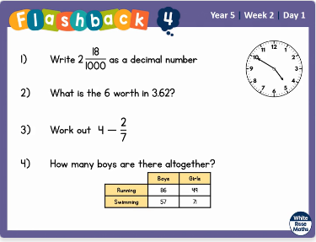

Watch the lesson video (which looks like the screen above) and then answer the attached worksheet. If you find this lesson comfortable and would like to stretch yourselves, have a go at the go deeper questions which are also attached at the end of this document.

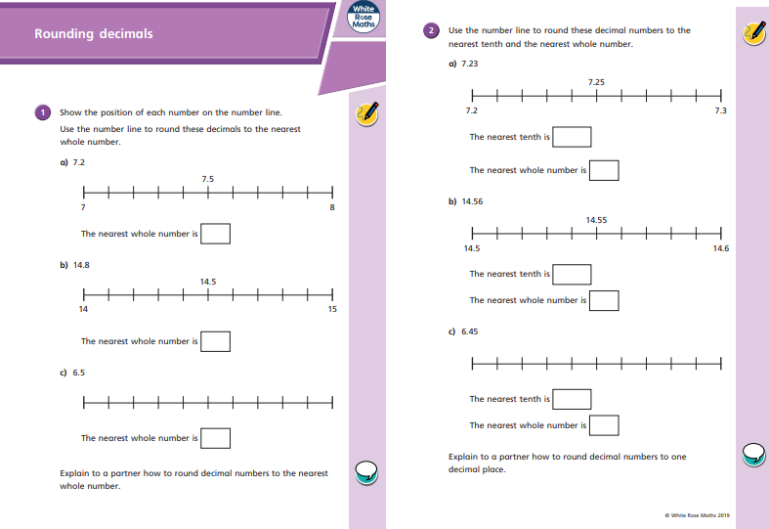

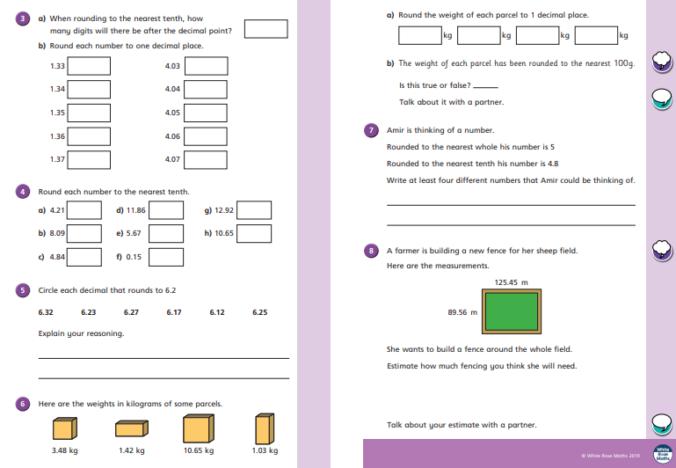

Go Deep:
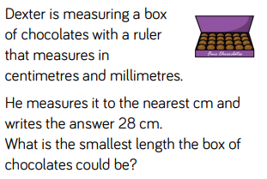
Go Deeper:
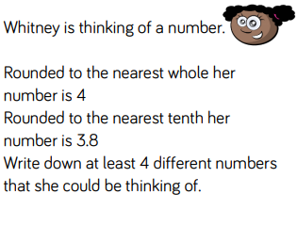

English 27.04.20. WAGOLL – Diary Entry.
Dear Diary,
Today was a beautiful, bright and sunny day so I decided to build a boat! I needed to get some long, hard wood so I travelled to the forest to collect a huge pile. After I had gathered some wood, I began to nail the pieces together using my flint hammer and dinosaur teeth for nails. It took 2 hours to build, but once it was finished I was very proud of myself. Was it going to float?
After some time, I began to get hungry so I decided to go fishing on my brand new log boat. Heaving the boat, I pushed it down towards the lake and into the water. Fortunately, the boat floated and so I jumped in! Slowly, I rowed out into the middle of the lake and then threw my fishing rod (made from a stick) into the deep, fresh water. Suddenly, my rod pulled me forward so I began to lift the fish into the boat. It was really tricky to catch the fish because it was so wriggly and heavy! Eventually, I caught the fish and sailed back to land. The fish was golden and very slippery!
In the afternoon, I decided to have a nap because I was so tired from fishing! At that moment, a huge brown bear came charging through the woods like thunder. Some hunters from my tribe ran away but I stood my ground and began to throw spears at the growling, snarling bear! How was I going to get away! The spears didn’t work so I grabbed my hand made bow and arrow and started shooting at it. Whimpering, the bear tumbled to the ground. YES! We had defeated it!
As the sun set in the sky, my belly began to grumble. What was I going to eat? I skipped back to my family’s hut and asked my Mum for something to eat whilst my baby sister lay on her fur skin mat. She was cooking some raw, mammoth meat on the fire and it smelt delicious. We were running out of wood so I went outside to look for some. Fortunately, I had some left over from my boat! Once the mammoth was cooked, I began to eat it. Unfortunately, it tasted disgusting, however it filled me up!
I wonder what will happen tomorrow…

Monday 27th April 2020.
Today, I would like you to revisit your work on diary entries. Your first task is to read the WAGOLL (What a good one looks like), and identify the key features of a diary. Below I have highlighted the key features that I would like you to focus on. You can highlight the features, or write the examples of them that you have found, in your books. Good Luck!

Features to identify.
Can you spot the following, in the WAGOLL?
- Chronological Order – It should be in time order, using adverbials
- Written in First Person – I/We
- Colloquial Language – Informative language.
- Uses past tense – it has already happened.
- Self-reflection – should include thoughts, feelings, opinions and hopes.
- Detailed Description – Use emotion and 5 senses to make it more imaginable. Similes, can be effective.

Maths 28.4.20
Today we would like you to focus on Week 2 Lesson 2 of the home learning which can be found here: https://whiterosemaths.com/homelearning/year-5/ (please make sure, you click on week 2 tab, for today’s session. It is lesson 2)
Today’s lesson is, Order and compare decimals

Watch the lesson video (which looks like the screen above) and then answer the attached worksheet. If you find this lesson comfortable and would like to stretch yourselves, have a go at the go deeper questions which are also attached at the end of this document
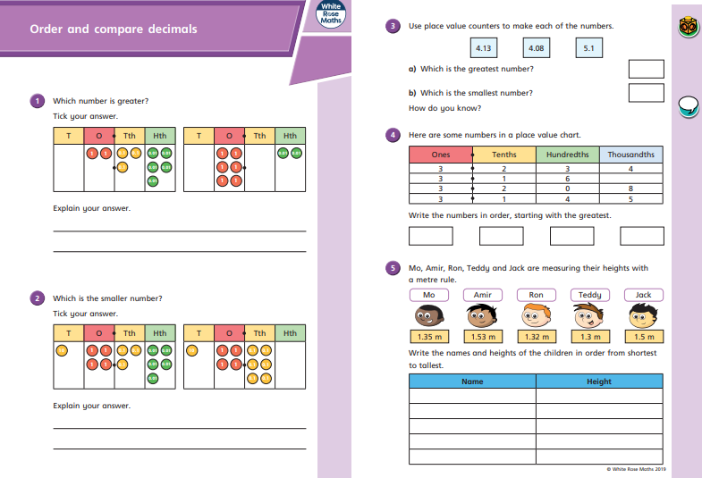

.

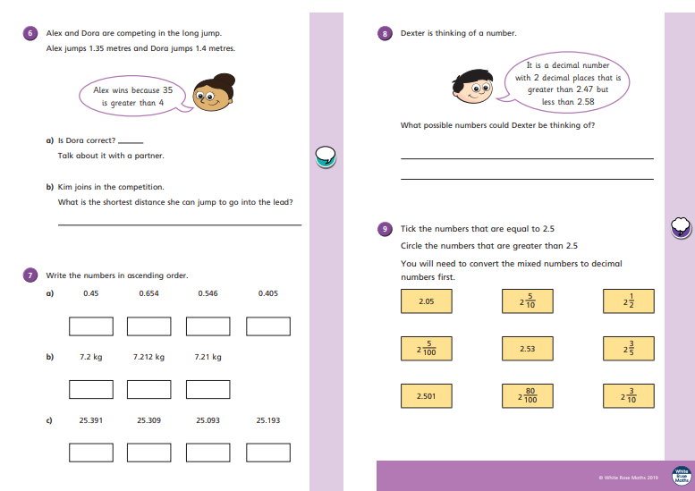
Go Deep:
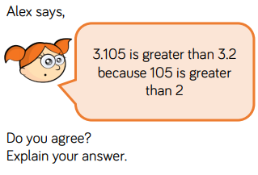
Go Deeper:
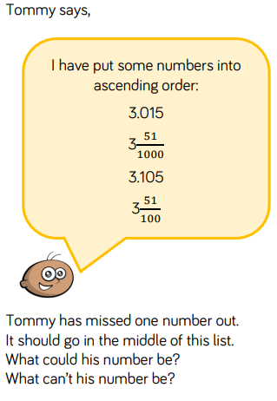

English,Tuesday 28th April 2020.
Today, I would like you to re-read the WAGOLL and then answer some questions. Remember to look really carefully in order to retrieve the right information. You will find the questions below. Please, answer them in your book. Good Luck!

- Why did the boy, so into the forest?
- What tools did he use to build the boat?
- How was the boy feeling, after he built the boy. Find evidence to support your answer.
- In the text, it says ‘Heaving the boat’, what does the word ‘Heaving’ mean.
- Why was it tricky to catch the fish?
- The boy tells us a ‘huge’ brown bear comes into the village’. Can you write some other synonyms for huge.
- The boys says, that the bear came charging through the woods like thunder. What writing feature has he used here? Why has she used this?
- The bear was ‘whimpering’ what does this mean?
- Can you describe the mixture of emotions that the boy went through in paragraph 3.
- What role, does the boy play in the family? Find evidence to support your answer.

Maths 29.4.20
Today we would like you to focus on Week 2 Lesson 3 of the home learning which can be found here: https://whiterosemaths.com/homelearning/year-5/ (please make sure, you click on week 2 tab, for today’s session. It is lesson 3)
Today’s lesson is, Understand percentages

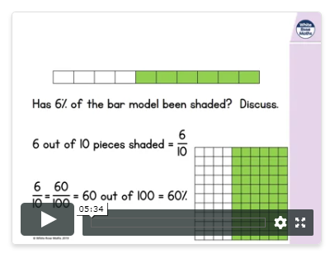

Watch the lesson video (which looks like the screen above) and then answer the attached worksheet. If you find this lesson comfortable and would like to stretch yourselves, have a go at the go deeper questions which are also attached at the end of this document

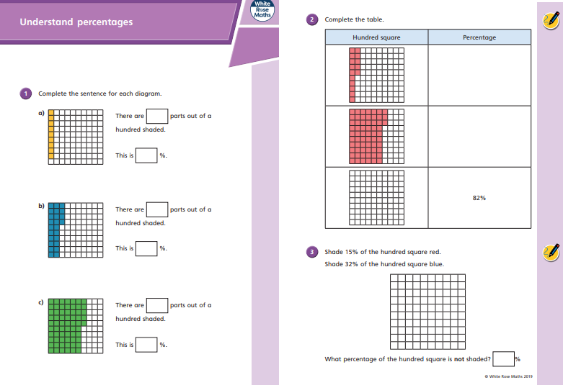

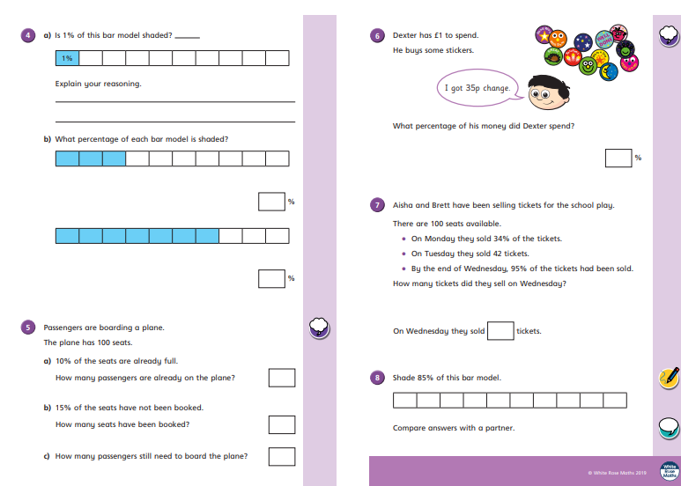

Go Deep:
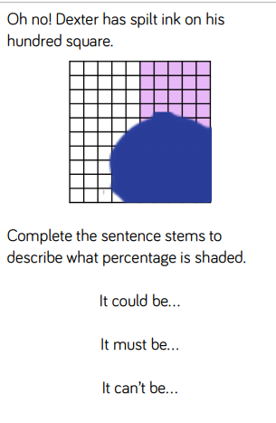
Go Deeper:

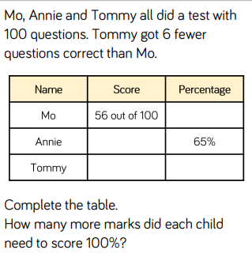
English. Wednesday 29th April 2020.
Today, I would like you to have a go at writing some similes

Just to remind you.
- a SIMILE is a phrase that describes something in comparison to something else using something both objects have in common.
- Examples: She went as white as a sheet.
The horse galloped as fast as the wind.

- Although actually going as white as a sheet is almost impossible, using this SIMILE phrase emphasises to the reader or listener how pale ‘she’ went.
- A horse can’t really gallop as fast as the wind, but this SIMILE phrase emphasises that the horse was very fast.

Below, is a poem that has been composed (made up) entirely of Similes:
AS

As wet as a fish – as dry as a bone;
As bright as a parrot – as dull as a stone;
As plump as a partridge – as poor as a rat;
As strong as a horse – as weak as a cat;
As hard as flint – as soft as a mole;
As white as a lily – as black as coal;
As plain as a pike –staff - as rough as a bear;
As heavy as lead – as light as a feather;
As steady as time – uncertain as weather.

TASK
I would like you to, create your own simile poem by filling in the gaps below. Make your ideas as unusual as you can. Your poem doesn’t have to rhyme. Good Luck!

As wet as ___________________________ as dry as ____________________________;
As bright as ___________________________ as dull as ___________________________;
As plump as ________________________ as poor as ___________________________;
As strong as ________________________ as weak as __________________________;
As hard as _________________________ as soft as ____________________________;
As white as ________________________ as black as __________________________;
As plain as ________________________ as rough as __________________________;
As heavy as _______________________ as light as ___________________________;
As steady as _______________________uncertain as __________________________.
When you are happy with your poems, publish it and email me a copy! I would love to read them! Hmmmm, I wonder how many of these, I will feature in! LOL!

Maths 30.4.20
Today we would like you to focus on Week 2 Lesson 4 of the home learning which can be found here: https://whiterosemaths.com/homelearning/year-5/ (please make sure, you click on week 2 tab, for today’s session. It is lesson 4)
Today’s lesson is, Percentages and fractions as decimals.
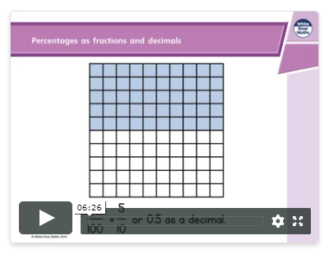

Watch the lesson video (which looks like the screen above) and then answer the attached worksheet. If you find this lesson comfortable and would like to stretch yourselves, have a go at the go deeper questions which are also attached at the end of this document

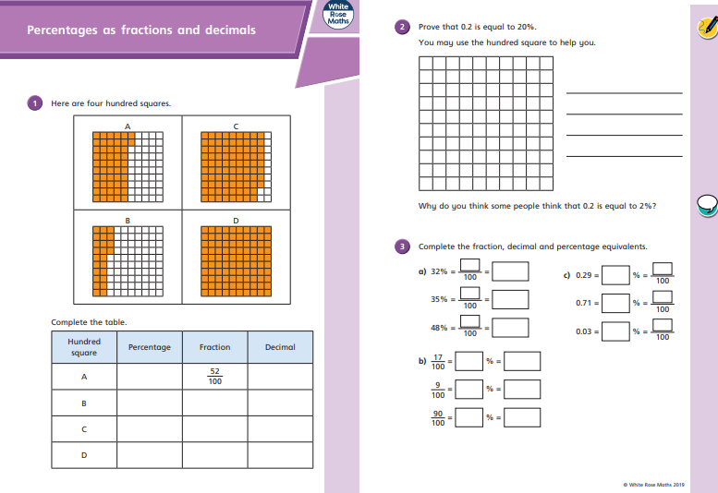

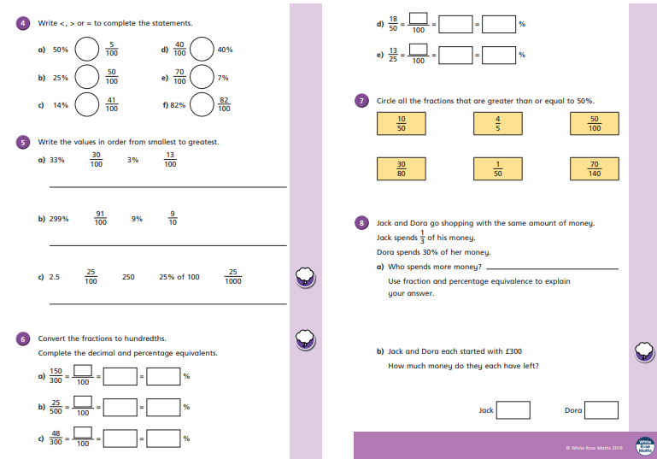

Go Deep:
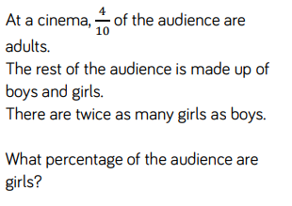
Go Deeper:
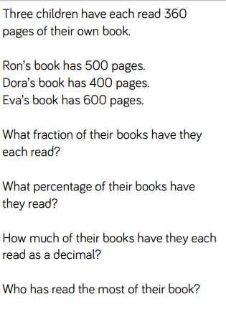

Thursday 30th April 2020.
Today, I would like you to have a go at identifying and using an adverbial phrases.
Tip: Adverbial phrases explain when, where or how something happens, for example:
Early in the morning, the tiger went to hunt.
‘Early in the morning’ is the adverbial phrase here as it explains when the tiger went to hunt.
TASK 1
Identify the adverbial phrases in the sentences below.

- Moments later, a shooting star appeared in the sky.

- Anna completed her difficult homework at the kitchen table.

- With a smile on his face, Arturo held up the trophy.

- Charlotte bought lots of new things at the market.

- In haste, Jamelia completed her chores because she wanted to go out to play.

- Every Saturday, Peter ate porridge for his breakfast.

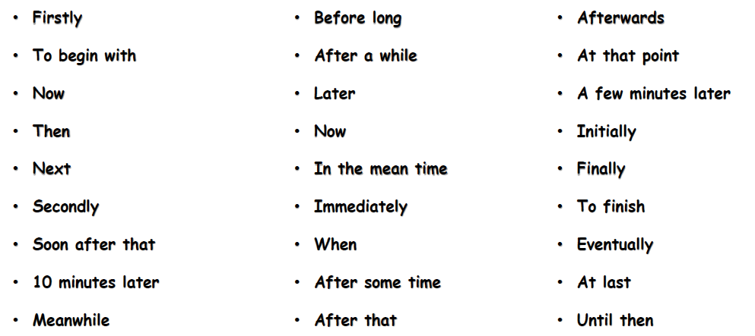
TASK 2 – Use these adverbials, to write your own descriptive sentences. Try and write in First Person. (I, We)

Maths 01.5.20
Today we would like you to focus on Week 2 Lesson 5 of the home learning which can be found here: https://whiterosemaths.com/homelearning/year-5/ (please make sure, you click on week 2 tab, for today’s session. It is lesson 5)
Today’s lesson is Eequivalent FDP
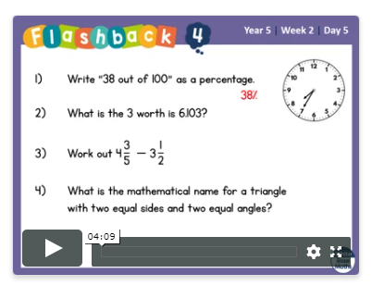

Watch the lesson video (which looks like the screen above) and then answer the attached worksheet. If you find this lesson comfortable and would like to stretch yourselves, have a go at the go deeper questions which are also attached at the end of this document

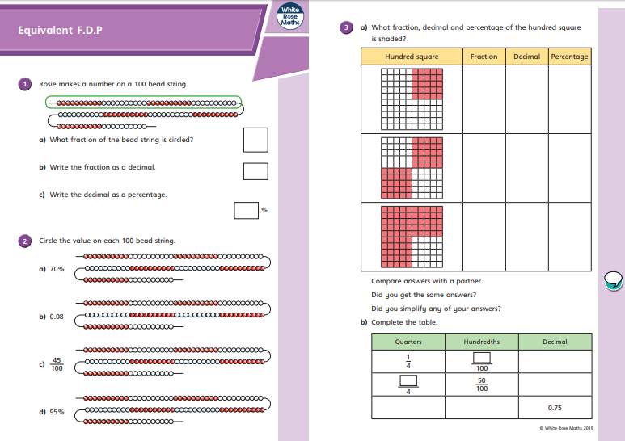

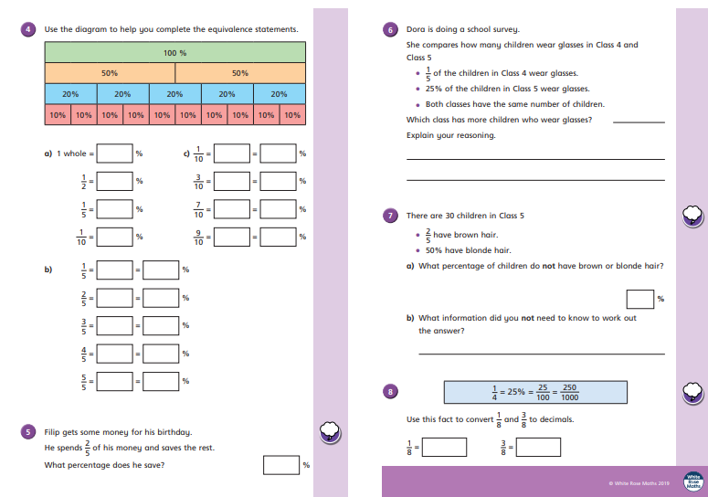

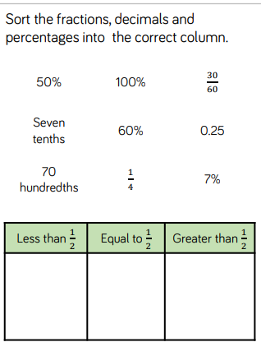
Go Deep:

Go Deeper:
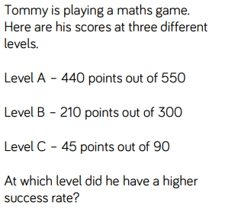
Go Deeper Still

Friday 1st May.
Today, I would like you to write a diary entry of your own. Use one of the days this week, for your writing. When writing, think about the features we discussed on Monday.
Features of a diary.
- Chronological Order – It should be in time order, using adverbials
- Written in First Person – I/We
- Colloquial Language – Informative language.
- Uses past tense – it has already happened.
- Self-reflection – should include thoughts, feelings, opinions and hopes.
- Detailed Description – Use emotion and 5 senses to make it more imaginable. Similes, can be effective.
TIPS
Make sure you use your simile and adverbial knowledge, from this week.
Re read your work and edit it twice.
- To make it look better. (grammar, punctuation, spelling)
- To make it sound better. (word choice, sentence structure)

If you would like to send me your diary entries, I would be very happy to read them!

Good Luck!

