Learning Project WEEK 1- My Family
Age Range: EYFS – Ducklings, Peacocks and Flamingos
Maths Tasks |  | Reading Tasks
As a school, we will be following the White Rose Home Learning sequence found at https://whiterosemaths.com/homelearning/.  Your child’s class teacher will explain which lesson to complete via Marvellous Me. The lessons are based upon videos that teach your child the subject knowledge needed to then complete the linked activity sheet and answer sheet attached to the video.  Feel free to try some of the links and ideas below if you want to continue practising your arithmetic.  - Watch a Numberblocks clip each day at: BBC or CBeebies. Use this guide here to give you ideas on what to do with your children whilst watching an episode. Some episodes teach different concepts.  FS1: Your aim is to learn numbers 1 to 5 and count to 10 independently.  FS2: Your challenge is to be able to count and order numbers up to 20. Solve addition, subtraction, doubling, sharing and halving problems using manipulatives  - Working on Numbots - your child will have an individual login to access this. Follow this link: https://play.numbots.com/#/intro Here, you can access online maths games.  FS1: Focus on the subtising game.  FS2: Focus on the number bonds  - FS1: Practise counting to 10.  FS2: practise counting up to 20. This can be done through playing hide and seek, singing number songs, chanting, board games etc.  - FS1: Write out the digits 0 - 9.  FS2: Write out the digits 0 - 20.  - Practise recognising amounts up to five or up to ten by playing these games. This can be done by reading a dice when playing board games, playing with cards, identifying how many food items on the plate etc.  - Sing Number songs to practice counting, reciting numbers in order, one more, one less using number songs:  - Five Little Ducks,  https://www.bing.com/videos/search?q=five+little+ducks&docid=608049536288359458&mid=6FF7190F353B74542F6A6FF7190F353B74542F6A&view=detail&FORM=VIRE  - Five Little Men,  https://www.bing.com/videos/search?q=five+little+men+in+a+flyinf+saucer&&view=detail&mid=6EF8780A816F7FC5980A6EF8780A816F7FC5980A&rvsmid=4404A275FC3D907273C64404A275FC3D907273C6&FORM=VDRVRV  - Ten Green Bottles  https://www.bing.com/videos/search?q=ten+grene+bottles&docid=607991116138940309&mid=5A4B12CF3152635EF54C5A4B12CF3152635EF54C&view=detail&FORM=VIRE |  | - Read a variety of books at home. Favourites can be repeated. Hearing the patterns of language in a story will support your child’s language development.  Some of the best stories that have repeated language are Traditional Tales such as:  - The Gingerbread Man (Week 1)  - Goldilocks and the Three Bears (Week 2)  - The Little Red Hen (Week 3)  - Three Little Pigs (Week 4)  - Little Red Riding Hood (Week 5)  - The Enormous Turnip (Week 6)  - Jack and the Beanstalk (Week 7)  We suggest that you follow our guide above and read the same book for the week.  The week, read the story:  - The Gingerbread Man (Week 1)  Challenge: Can you learn it off by heart without using pictures or prompts to help you retell it?  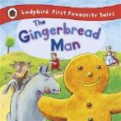  All these books above can be found as eBooks on Epic. Simply login to Epic using your class code:  Ducklings: jex1806  Peacocks: qkt2781  Flamingos: tnh5475  - Children to read to parents daily.  Visit Oxford Owl for free eBooks that link to your child’s book band.  - Go to https://www.oxfordowl.co.uk/for-home  - Click ‘My Class Login’ at the top of the page.  - Enter details:  Username: bluecoatprimary  Password: Reading  Read a new book every day and then complete the linked Play activities for each book. Make sure you select ages 4-5.  - With your child, look in magazines, newspapers and books for the tricky words they are currently learning. They could use a highlighter to highlight in magazines and newspaper.  The Tricky Words are:  I, no, the, to. go, into, a, he, she, we, me, be, you, all, are, her, was, they, my.
Phonics Tasks |  | Writing Tasks
Ducklings:  - Sing Nursery Rhymes and songs together. Add in actions and change the words. Can children think of different rhyming words to add in? Repeat old favourites and learn new rhymes. You can find an A-Z of Nursery Rhymes here.  - Sing the song ‘Daddy Finger’- Can your child change their voice for each person e.g. a deep voice for Daddy finger, a squeaky voice for Baby finger.  - Make Silly Soup with your child. Ask them on each day, to place in a bowl items that start with that sound.  - Monday: s  - Tuesday: t  - Wednesday: m  - Thursday: c  - Friday: g  Peacocks and Flamingos  - Daily phonics – Your children should know all the following phonemes (sounds). Write them out onto a piece of paper, like below. Then, play Fastest Finger First. You say the sound and your child points to the sound.  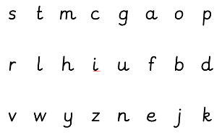  - Practice the sounds your child is working on above. Then, write the following CVC words for your child to read and write. Make sure you do only one set a day.  CVC Words to read  - Set 1: Cat, sat, mat, hat, pat (Day 1 – Monday)  - Set 2: Cog, fog, log. Dog (Dag 2 – Tuesday)  - Set 3: Lip, tip, sip, nip, kip, (Day 3 - Wednesday)  - Set 4: Sap, nap, tap, lap (Day 4 - Thursday)  - Set 5: Cot, pot, hot, dot (Day 5 - Friday)  Ask your child to oral blend the sounds (spoken out loud c-a-t). Please use the sound mat with the actions on to support. Alternatively, find the ‘Sounds’ prerecord on our school website.  Ask your child to segment and write the sounds (you say the word and your child writes it).  - Finally, each day ask your child to read the following simple sentence:  Monday: The cat is on the mat.  Tuesday: The dog ran to the log.  Wednesday: The cat can sip the milk.  Thursday: The cat is on my lap.  Friday: The pot is hot.  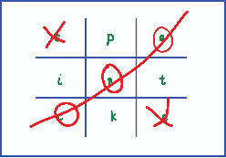  - Play phonics noughts and crosses. Draw out a grid and write the letter above in each part of the grid. Take it in turns to name what is written in the grid. If you say it correctly you can add your nought or cross in that square. |  | End of Week Goal: To write a character description  Day 1:  Practice forming the letters of the alphabet using the sound mat in your learning pack. The sound mat has all the phonics actions on too and how to form the letter. In your Reading Diary, you will find the actions we use to form the letters. This will be sent out via Marvellous Me for you today.  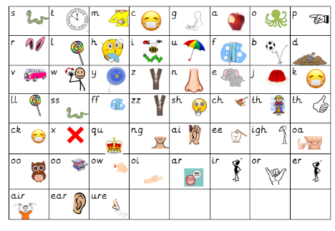  Day 2  Ask your child to write out these tricky words onto separate pieces of paper twice:  I, no, the, to. go, into, a, he, she, we, me, be, you, all, are, her, was, they, my.  Then, turn them over and put them into pairs. Turn it over, say the tricky word and try and match it with the following Tricky word.  Day 3  Practice name writing. Can they write their first name? Middle name? Surname?  Day 4  Can they write the names of their family members? Do they know Mummy and Daddy’s real name? They could copy this or use their phonics knowledge. Can they write this? Using chalks, crayons, paint, felt tips.  Day 5  Now take everything you have been learning over the week and ask your child to draw a picture of the people who live in their house.  FS2: Can they label their family members using their phonics knowledge? Can they write a simple sentence using the tricky words they learnt on day 2? For example, ‘This is my mum’. This is the cat’. Label the different feature of the family member, for example, brown hair, blue eyes or glasses. Here is an example below:  Blue eyes  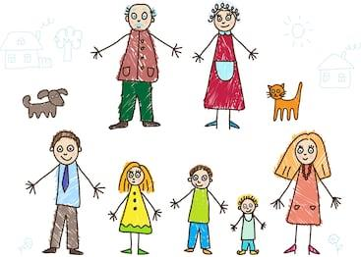  Four legs  Little brother  Curly hair  Brown hair
Wider Curriculum Menu
As well as completing a daily maths, English, phonics and reading task, we have put together a selection of different wider curriculum activities for you to complete at your leisure. We realise this is a busy time and so most of these do not require written work but instead are discussion and interaction based. You can complete as many as you like in any order you want!
The project this week aims to provide opportunities for your child to gain a better understanding of their own family. Learning may focus on what different makeup of families, what traditions your family has, stories linked to your family etc.
Look at a selection of family photographs and discuss the changes over time.  Show your child a photograph of them as a baby, a 1 year old, and a 2 year old. What could they do at that age? What can they do now that they couldn’t do then?  Look at a picture of a family member as a baby (this could be parents, siblings). Discuss how everyone was a baby once.  Are there any black and white photographs? Why are these photographs black and white? Do they show older family members when they were younger? Talk about how life was different then. | Draw a family tree-  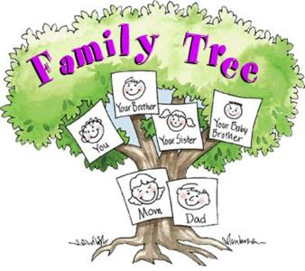  How does your family link together? Can your child draw out their family members and link them together using lines? |  | Lay the table for your family for dinner- How many people are there? How many knives, forks, and cups do you need? Write out name cards for everyone in your family to show them where to sit. Write a menu to let them know what is for dinner that night. Role-play as a waiter/ waitress. What would everyone like in their sandwiches for lunch? What drinks would everyone like to have with their dinner?  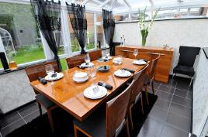
Do a picture survey of the people in your house.  How many family members have blonde/ brown/ black/ red hair? Can you record this with pictures? How many people have blue/ brown/ green eyes?  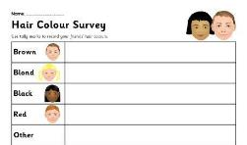 | Have a family picnic.  Lay out a blanket in the living room or garden. Can children make sure everyone has a plate, fork, spoon, and cup? How many do we need all together? Give your child a selection of food and ask them to share it fairly between everyone? If there is one left over what could we do? |  | Put on a show or performance- Perform a story or song to your family. Plan out costumes, props. Children could make a show program.  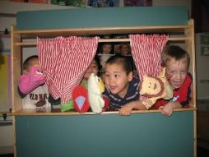
Sort out the clean clothes.  Who do they belong to? Can they deliver them to the right place in the house? Pair up socks. Can they match the patterns/ colours? Can they count in twos to work out how many there are all together? Peg clothes on the airer (this will support children to develop hand strength which will impact on their writing). | Make a birthday card for the next family birthday-  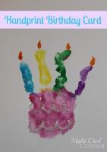  How old are they going to be? Can they write the numerals to show the correct age? Write a message inside for your family member and sign it with your name. |  | What jobs do the people in your family do? Talk to your child about your job and what you do. What would they like to be when they grow up? Can they draw a picture of themselves in the job they would like to do?
Use play dough to make your family members- Use ready-made play dough or make your own using this recipe:  2 cups of plain flour, one cup of salt, a tablespoon of oil, a cup of water (add gradually), a couple of drops of food colouring (optional), a teaspoon of cream of tartar (optional, but will make it last longer) | Play a family board game-  Play a game together. Talk about taking it in turns and playing fairly. Dice games will support your child’s number recognition. You could use a spinner with numerals on to help develop numeral recognition. If you don’t have a spinner you could make one using an old cereal box and a split pin. |  | Find out everyone’s favourite song in your family-  Listen to each person’s favourite song and make up a dance to match. Do you like the same music? What is your favourite song?
Additional learning resources you may wish to engage with
https://www.ictgames.com/mobilePage/literacy.html - a range of phonics games for all phonic phases, modelling of handwriting, spelling activities EYFS/KS1
www.phonicsplay.com – phonics activities and games EYFS/KS1
www.bbc.co.uk/cbeebies/shows/alphablocks - Letters of the alphabet tell stories and make words using phonics. EYFS/KS1
https://www.bbc.co.uk/cbeebies/shows/alphablocks - An interactive show that teachers children the different phonemes and graphemes.
https://www.oxfordowl.co.uk/for-home/find-a-book/library-page/
Over 100 free to read eBooks, developed for children aged 3–11 years old. Just login you’re your class login and password.
https://www.bbc.co.uk/cbeebies/shows/bedtime-stories - A range of famous bedtime stories read by famous celebrities. Fantastic to listen to before bed.
https://www.bbc.co.uk/programmes/b007t9wg - Jackanory Junior. A range of online interactive stories.
https://www.bbc.co.uk/cbbc/shows/blue-peter – Author chats, story challenge with Matt Haig, Cressida Cowell & many more.
http://www.wordsforlife.org.uk/ - Fun stuff for different ages, downloadable activities, recommended reads, tips from authors and supportive tools for parents to support their children with reading.
https://m.facebook.com/story.php?story_fbid=10157244494779370&id=76302436/ - World book online have made their 3000 ebooks available for free! Over 3000 ebooks you can enjoy at home on your tablet or PC.
https://authorfy.com/ - Authorfy brings readers and writers closer together through interactive video masterclasses, fun downloadable activities and exciting after school resources.
https://www.bbc.co.uk/cbeebies/shows/alphablocks - An interactive show that teachers children the different phonemes and graphemes.
https://literacytrust.org.uk/freeresources/?gclid=EAIaIQobChMIvKfVtLSL6AIVibTtCh01fQAgEAAYASABEgLS-_D_BwE Early years activities - CBeebies magazine resource
Writing Friday: Cressida Cowell's top writing tips for primary pupils Children's author and illustrator Cressida Cowell has created some fantastic resources for primary school pupils, packed full of writing tips and inspiring...
A River of Stories - Tales and Poems from Across the Commonwealth Explore intercultural understanding with your class using four beautifully illustrated anthologies of poems and stories from around the world, with comprehensive supporting... Authors inspiring reading classroom posters.
https://www.weareteachers.com/virtual-author-activities/ - These authors are offering read-alouds of their books and books by their favourite authors.
https://www.oliverjeffers.com/books#/abookaday/ - Famous Author, Oliver Jeffers reads his favourite story every day.
https://www.ictgames.com/mobilePage/literacy.html - A range of literacy and mathematic games.
https://www.oxfordowl.co.uk/for-home/find-a-book/library-page/ - Free Oxford Owl eBooks For children
https://www.storylineonline.net/ Online reading/videos - Hundreds of free ebooks.
https://www.topmarks.co.uk/maths-games/3-5-years/counting
Teachers love this site for fun maths games that you can plan on the laptop, tablet or interactive whiteboard. Just choose the area of maths you want to practise.
https://www.ictgames.com/mobilePage/literacy.html- A range of literacy and mathematic games.
https://www.familydaystriedandtested.com/free-virtual-tours-of-world-museums-educational-sites-galleries-for-children/
Free Virtual Tours of World Museums, Educational Sites & Galleries For Children
https://www.nationalgeographic.com/ - This website offers your child a range of texts and video clips all about our natural world.
https://www.researchify.co.uk/ - A safe search website that enables you to ask questions and find information.
http://www.primaryhomeworkhelp.co.uk/ - A range of wider curriculum subjects with interactive activities
https://www.nationaltrust.org.uk/50-things-to-do - Created by the national Trust, here are 50 things to do before you turn 11.

