Home Learning Project Week 1 - My Family
Key Stage 1: Penguins, Puffins, Kingfishers and Hummingbirds
Maths tasks | Writing Tasks
As a school, we will be following the White Rose Home Learning sequence found at https://whiterosemaths.com/homelearning/.  Your teacher will explain which lesson to complete in a daily Marvellous Me message. The lessons are based upon videos and a linked activity sheet. .  Optional maths games:  - Practise counting in 2s, 5s and 10s use the following links to practice this:  https://mathsframe.co.uk/en/resources/resource/504/Super-Maths-Bowling-Multiplication  https://www.topmarks.co.uk/times-tables/coconut-multiples | Your teacher will send you more information about the daily tasks through marvellous me. Here is the overview of what the week will look like:  Monday: Read through the WAGOLL (What A Good One Looks Like) of a character description and identify the key features outlined to you.  Tuesday: Read examples of texts about families- compare similarities and differences between the stories and to your own experiences.  Wednesday- Complete the grammar task.  Thursday- Apply grammar focus independently.  Friday- Have a go at writing your own character description based on a member of your family.
Phonics/Spellings Tasks  Aim to do 1 per day | Reading Tasks  Aim to do 1 per day
Phonics learning will still be sent through on marvellous me, however these are other activities for children to enjoy:  - Daily phonics - your child to practice their sounds and blend words. Interactive games found on link below.  - Phonics play  - Top Marks  - Spelling  - Spell the days of the week: Keep a diary of things you do in the week.  - Spell common exception words  - Spelling City | Below is a selection of reading tasks to choose from throughout the week:  - Reading a variety of books at home. Your child could share a book everyday. This can be reading a book aloud everyday or sharing a book with an adult.  - Listen to a story read, Storytime.  - Watch Newsround and find out what is happening in the world. What did you find out? Is there anything you need help understanding?  - Create a bookmark, perhaps you could choose characters from your favourite stories.  - Complete a book review on one of the books you have read - what did you like about it? Would you recommend it to anyone? You can write this on purple mash if you like: https://www.purplemash.com/#app/pup/blank_book_reviews  - Take a look at a variety of poems with your child. Ask them to pick their favourite poem and write a poem https://www.poetry4kids.com/topic/family/
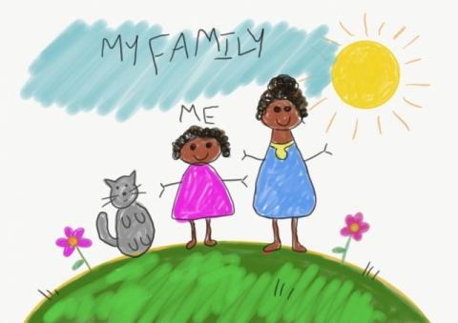
Wider Curriculum Menu

Choose one of these projects on the theme of family to have a go at over the week. The numbered step by step guide by each can help make your chosen project extra special by working on a bit each day, if you want to:

Draw a portrait of a family member
1, Have a go at drawing your own face by looking at it in the mirror. If you can, watch this BBC video on self-portraits. You could use pencil crayons and chalk if you have it.
https://www.bbc.co.uk/teach/class-clips-video/art-and-design-draw-self-portrait/z6ytscw
2, Look at what you have drawn. Decide what you like and what you could make better. Choose a part to practice again, maybe just the nose or the outline of the head. Practice just that bit on another piece of paper.
3. Now watch the video again, if you can. Have a go at drawing your face using something different. If you used pencil crayons before, have a go using felt tip pens now.
4. Either find a photo of someone in your family (it could be on a phone if you don’t have a paper photo) or find yourself a live model in your family to sit while you draw them. Have a go at drawing their face using pens, chalk or pencil crayons depending on what you liked best.
5. Find some coloured paper or even old magazines with pictures on. Cut this into long strips (2 long ways and 2 across) to stick around the outside of your picture as a frame.
or

Create a card:

1. Choose someone to make a card for by asking parents or carers if they can think of someone who would really like to hear from you. It could be wider family who don’t live with you, friends or neighbours.
2. If you have 2 bits of paper and glue you can try a pop up card. Watch this How to Make a Simple Pop Up Card video by JB and have a go, or simply fold a piece of card or paper in half and write your message inside.
https://www.youtube.com/watch?v=hBGLyjraKbs
3. Decide what you would like to draw and practice it on scrap paper. Now draw your picture onto the front of your card using a pencil and rubber.
4. Next add colour using pencil crayons or felt pens.
5. Now to deliver the card. If it is not possible to give or send the card now you can speak to the person on the phone and describe the card and all the effort you put in for them. Explain it is waiting for them and keep it safe for when you see them next. Perhaps you can take a photograph and send that to them using a mobile phone.
or

Be a news reporter by interviewing family members about their favourite things:

1. Make a list of things you could ask family members about, for example their favourite food, colour, book, place, sport, food or anything else you can think of. Pick a top 5 to use for your interviews.

2. Make flash cards by cutting paper up into squares that are about the size of your hand and use a felt tip to write a word from your list onto each card ready for your interviews

3. Now get in touch with as many people as possible to ask your questions to. If you have a phone you can film your interviews, with a little introduction explaining what you are doing first. If not try to remember, or write down, what each person said. Is there anyone in your wider family that you could phone to add to what you’ve learnt?

4. What did you learn? Either film or just explain to someone anything you found out that you didn’t know before. Does anyone like the same thing as someone else? Did anything surprise you?

5. Finally, are there any extra questions that you would want to add in now? Maybe you can find someone to ask them to.

or

Be a data detective and create a tally chart to show something about your family:

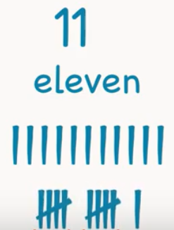
1. Look at the people in your house and choose something you want to investigate about your family. It could be hair colour or eye colour or something else. Think about the answers people could give and list these. For example, eye colour might have blue, green, brown and other and write these down ready for a tally chart.
2. Time to practice how to tally. Watch this clip on Youtube about tally marks from Kids Academy if you can. Write down the numbers 6, 10 and 12 using tally marks, like the bottom marks on the picture here.
https://www.youtube.com/watch?v=-pEA3w8SQws
3, Investigation time. Get your list of answers from 1. and then look at or ask everyone in your home about what you’re investigating (like eye colour). Put a tally mark by the answer they give.
4. Who else could you ask? Think about wider family, neighbours and friends. Can you get more answers from anyone else and add them into your tally chart?
5. Finally, look at your tally chart and explain what you have found out. Tell someone about which answer had the most tally marks by it and what that means.
Additional learning resources you may wish to engage with
- Have a family workout alongside Joe Wicks, live at 9am or catch up later on

- Work on a shopping list for the weekly shop and get children to add up how many items and add up the cost of some items. This game could support work on making amounts of money.

- Practise telling the time. This could be done through this game (scroll down to access the game). Read to the hour and half hour.

- Take a nosey inside Buckingham Palace through a virtual tour

#TheLearningProjects

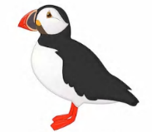
Year 1 Work
Week 3 – Monday

Hello to our fabulous team of Puffins and Penguins! We hope you have all had a lovely Easter break and have had the time to relax, enjoy family time and have made the most of the lovely weather we have been having. We will continue to send you your maths and English work every day and your topic work will come out on a Monday. You can pick what you would like to do and you can do it at your own pace over the week. Parents, you are doing a great job but remember please do not put too much pressure on yourself to complete everything! Do what works best for you and your families and your individual circumstances. We appreciate everything that you have been doing!
The theme of the week this week is family. Enjoy spending some time together!
Miss Horridge and Miss Keith.
Maths Dash:
Subtraction on a number line – use your number lines in your packs to help you with these.
14 - 8 = 12 - 6 = 13 - 5 =

16 - 5 = 17 - 5 = 16 - 7 =

17 - 11 = 15 - 8 = 12 - 8 =

Maths:
Today you will be carrying on with capacity which you started before the half term. Here a the video links from before the holidays if you want to refresh your memory.
https://whiterosemaths.com/homelearning/year-1/ - Week 1 – Lesson 4 and 5.
Begin your lesson by watching the following clip:
https://whiterosemaths.com/homelearning/year-1/ - Week 2 – Lesson 1

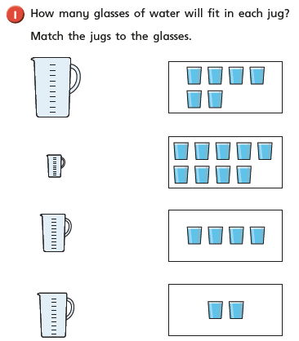

Can you draw on the pictures.
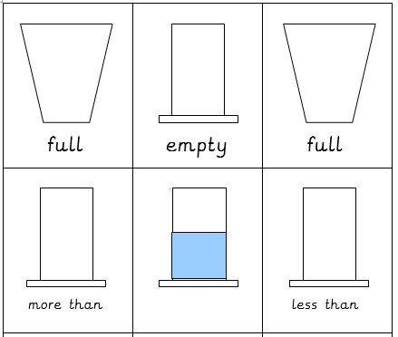

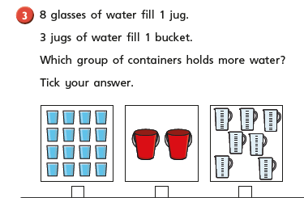

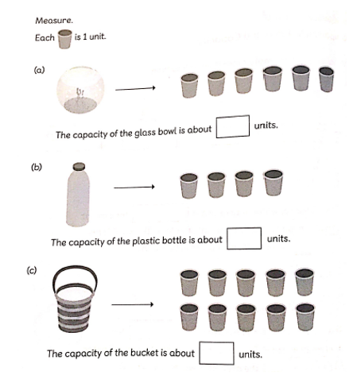

Grammar Dash
Find the words which have the prefix un. Remember the prefix goes at the start of a word and changes the meaning of the word (it makes it do the opposite). If we take off the prefix we will be left with the root word (unwell – the root word is well).

unhappy | unblock | happy | unsafe | untidy | unfit
uncover | well | unpack | unkind | fit | fold
safe | unfriendly | safe | friendly | lock | unlock
unwell | cover | block | unable | unfold | tidy
English
Task : This week you will be looking at and writing your own character description about a member of your family. A character description gives different information that helps describe a character or a person.

Today we would like you to read the WAGOLL (what a good one looks like) below of a character description of someone in my family. Once you have read it go through and underline the different features of the text (features are the things that make it a character description).

My Mum
My mum is called Shelly and she is 56 years old. She has long, black hair and small round eyes. My mum has a beautiful smile and rosy cheeks. My favourite thing about my mum is that she tells me funny jokes and she always makes me laugh. Her chocolate cakes is the best and she even lets me lick the bowl after she has finished making it. In her free time she enjoys cooking delicious food and reading lots of story books. The thing she loves doing the most is watching movies with our family.

Task: go through the character description again and highlight the different features including:
-appearance (what she looks like)
-personality (what is she like as a person)
-hobbies (what she enjoys doing)
-adjectives (an adjective describes the noun – example short, blonde hair. Hair is the noun and short and blonde describe it. Long and blonde are adjectives, they help the reader get a better picture of the nouns in their heads).

Story time:
Here is a link to a great story it is ‘The Smartest Giant in Town’
https://www.youtube.com/watch?v=cfiPrA8E3qE
Enjoy!

Year 1 Work
Week 3 – Tuesday

Good Morning! We hope you are all well and are enjoying the theme of the week so far! In maths today you will be looking at a new skill! You will be counting in 10s. We think you will be amazing at this! Always remember to try you best and don’t worry if you make a juicy mistake! Those juicy mistakes make sure that your brain is being stretched!
Miss Horridge and Miss Keith.
Maths Dash:
Bonds to 10 – Remember these are good to know off by heart!
10 + 0 = | 4 + = 10 | 2 + 8 = | 0 + = 10 | 1 + 9 =
7 + 3 = | 3 + = 10 | 4 + = 10 | 0 + 10 = | 4 + 6 =
9 + = 10 | 9 + 1 = | 5 + = 10 | 10 = 6 + | 3 + 7 =
2 + 8 = | 10 = 4 + | 7 + = 10 | 4 + 6 = | 1 + = 10
2 + = 10 | 5 + 5 = | 10 + = 10 | 5 + = 10 | 8 + = 10

Maths:
Today you will be starting
Begin your lesson by watching the following clip:
https://whiterosemaths.com/homelearning/year-1/ - Week 2 Lesson 2

What does this pattern look like?
10 | 20 | 30 | 40 | 50
1 lot of 10 | 2 lots of 10 | 3 lots of 10 | 4 lots of 10 | 5 lots of 10

60 | 70 | 80 | 90 | 100
6 lots of 10 | 7 lots of 10 | 8 lots of 10 | 9 lots of 10 | 10 lots of 10

When we count in tens we start at 10 and go down the column. Have a minute to think about what do you notice about these numbers? What stays the same and what changes?

Answer: The tens number changes but the ones stay the same.
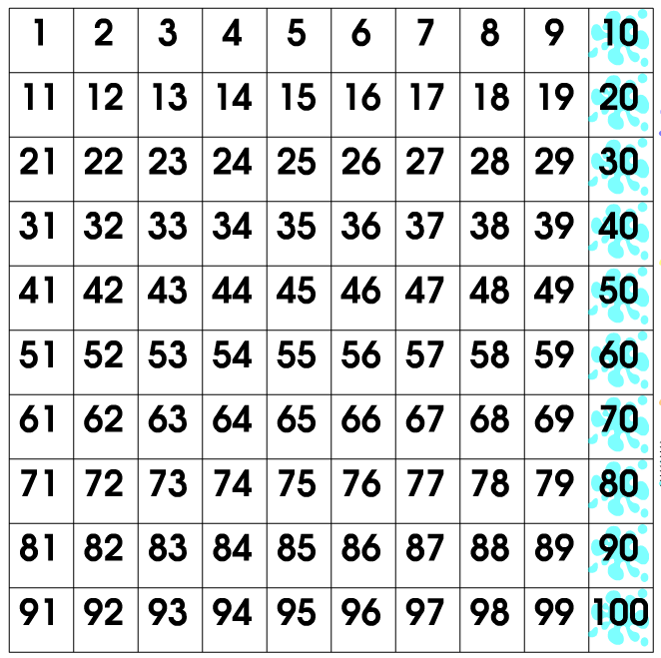

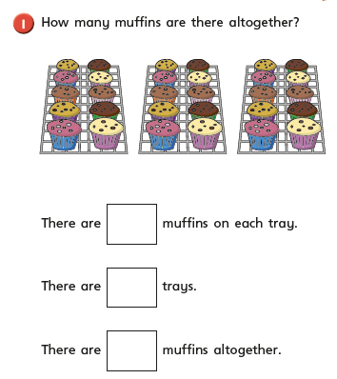

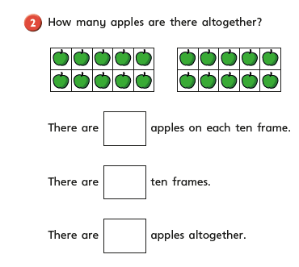

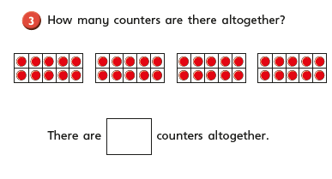

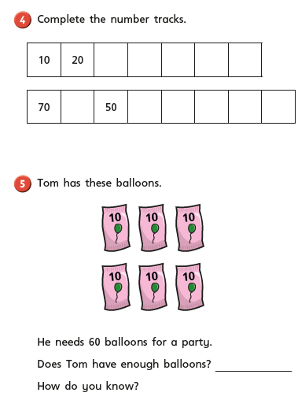

Challenge question:
If I was counting in 10s, would I say the number 37? If not why?

Would I say the number 60? Why? Prove it to me!

Counting in 10s is a key skill to know for Year 2. You can practise counting in 10s by splatting the numbers on the hundred square splat here.
https://www.primarygames.co.uk/pg2/splat/splatsq100.html

You can also use the number frames to count in 10s by filling the 10s frames.
https://apps.mathlearningcenter.org/number-frames/

You can count in tens by using the sticks of 10s.
https://apps.mathlearningcenter.org/number-pieces/

Grammar Dash
Highlight/point to the words that need capital letters. Remember that a proper noun is the name of a person, a place or day of the week or month of the year.
today is wednesday
my friend sam likes cats
it will be march tomorrow
the queen lives at buckingham palace
they are on the bus to nottingham
we are going on an adventure to paris

English
Task: Read these different books about different families. When reading them, think about what is similar and different between their families and your family.

- Who is important to you? Draw a picture of the people that are most important to you? (Family members, friends, neighbours etc). Why are they important to you? (You can do this in your book).

Read some stories on Epic: Sonya’s family, Miguel’s family and My Family. https://www.getepic.com/app/search

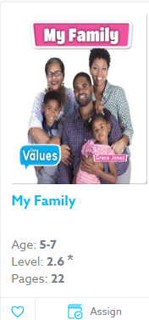
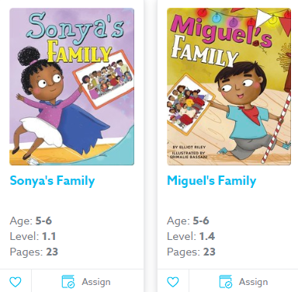

- Write a list of things that are similar or different about these families:

- Are there any similarities between your family and Sonya’s?

- Are there any similarities between your family and Miguel’s?

Story time:
Here is a link to a story that we love in Year 1! It is ‘The Book with No Pictures’. It is being read by the author B. J. Novak.
https://www.youtube.com/watch?v=EZwY5BeYcyo
Enjoy!

Year 1 Work
Week 3 – Wednesday

Hello to our fabulous Year 1s! Here is a video for you today to remind you of why it is good to always try your best and to remember why you should always stretch your brain!
https://www.youtube.com/watch?v=IOaFwwLyTRo
Remember you are all amazing and we are all so proud of you!
Miss Horridge and Miss Keith
Maths Dash:
Doubles to 10 – Practise your doubles to 10 (these are a good thing to know off by heart).
1 + 1 = | 9 + 9 = | 4 + 4 = | 8 + 8 = | 5 + 5 =
6 + 6 = | 3 + 3 = | 7 + 7 = | 2 + 2 = | 10 + 10 =
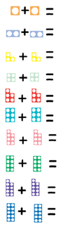

Maths:
Begin your lesson by watching the following clip:
https://whiterosemaths.com/homelearning/year-1/ - Week 2 – Lesson 3

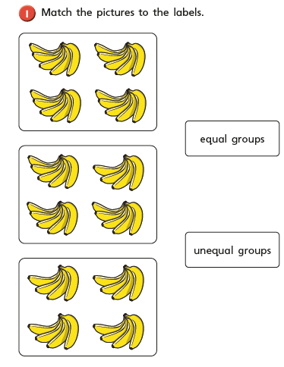

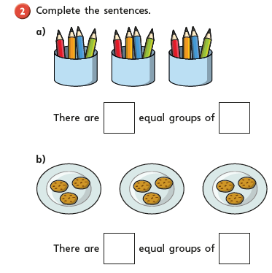

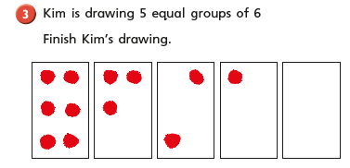

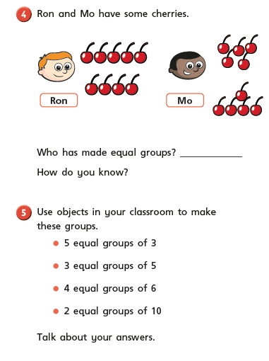

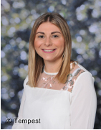
Challenge
Miss Horridge thinks she has made 5 groups of 3. Is she right?

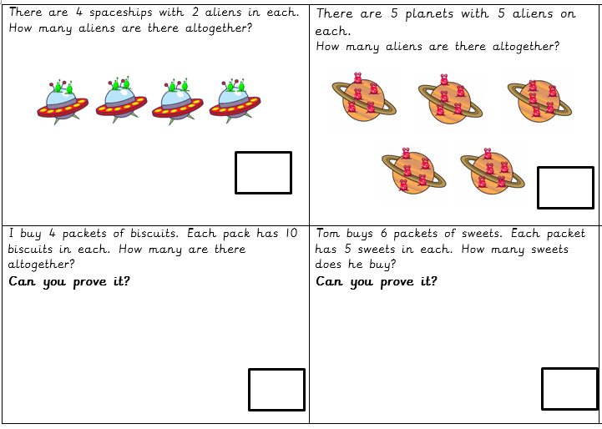
Have a go at working out the word problems below:
If you want to carry on the learning…
You could get creative with this and decorate biscuits. Your biscuit could represent the groups and the toppings could represent how many are in that group! Remember, they all have to be equal.

Grammar Dash
Have a go at spelling the days of the week. See if you can write them out in order lots of times. Remember they are proper nouns so they need capital letters too!
Monday | Tuesday | Wednesday | Thursday | Friday | Saturday | Sunday

English
Task: Complete grammar task about adjectives.

An adjective is a word that describes a noun. It will help the reader visualise a picture in their head when reading a story or a piece of text.
Example: The flames were bright red and orange.
In this sentence the word flames is the noun and bright red and orange are the adjectives as they describe the noun.
Have a look on the website below to help you before you complete the task below.
https://www.bbc.co.uk/bitesize/topics/zrqqtfr/articles/zy2r6yc
- Read the sentences below and underline the adjectives and circle the nouns.
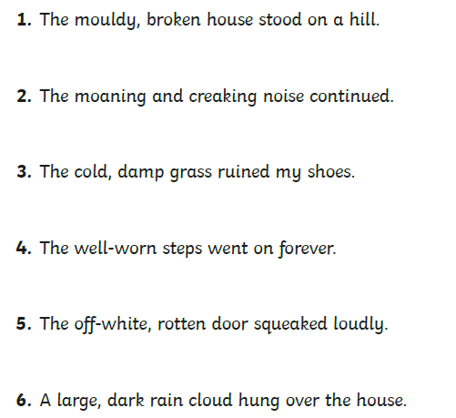

- Circle the adjectives from the list of words to describe the picture:
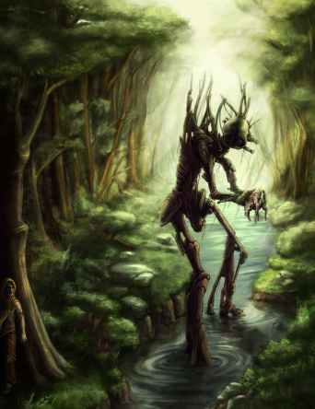

- From the word bank below, select an adjective to describe the noun
huge | old | scary | fluffy
young | tiny | smelly | little
angry | brown | cheerful | big
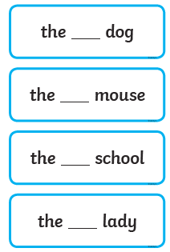
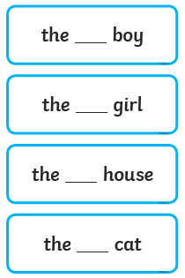

Story time:
Here is a link to a great story ‘The Day the Crayons Quit’
https://www.youtube.com/watch?v=ZttMDho5HMw
Enjoy!

Year 1 Work
Week 3 – Thursday
Good Morning!
A Thursday would usually be our singing assembly! It is one of the highlights of our week! We are really missing hearing all of your wonderful voices! So we have copied some links below of some of our favourite songs that you will be able to share with you families! Sing loud and proud, we will be able to hear you!
https://www.youtube.com/watch?v=Yc6T9iY9SOU – Count on Me
https://www.youtube.com/watch?v=IfGmj_NZ85M – This is Me
https://www.youtube.com/watch?v=jWS9WPC8Ez4 – When Jesus says yes
Miss Horridge and Miss Keith.

Maths Dash:
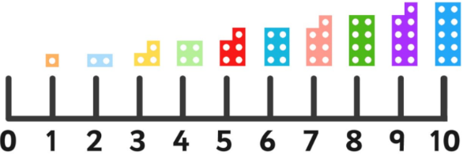
One more – One less

8 + 1 = 4 - 1 = 9 + 1 = 6 + 1 =

3 + 1 = 1 + 1 = 7 + 1 = 5 - 1 = 2 - 1 =

8 - 1 = 4 + 1 = 9 + 1 = 6 + 1 = 3 - 1 =

1 + 1 = 7 + 1 = 5 + 1 = 2 + 1 =
Maths:
Begin your lesson by watching the following clip:
https://whiterosemaths.com/homelearning/year-1/ - Week 2 – Lesson 4

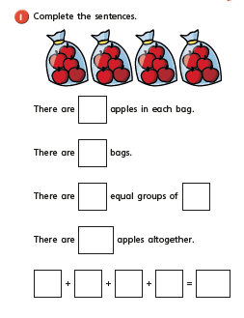
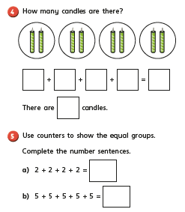
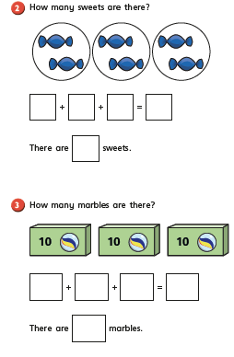

Challenge
Mr Smith thinks he has made equal groups what has he represented? Is he right?

Grammar Dash
Find and highlight the nouns
The cow ran quickly.
The house was starting to fall down.
The ice-cream slipped off the cone.
After a while, Sam woke up.
A flower started to grow on the tree.
Harry had fish and chips for tea.

English
Start by spotting the adjectives in the sentences:
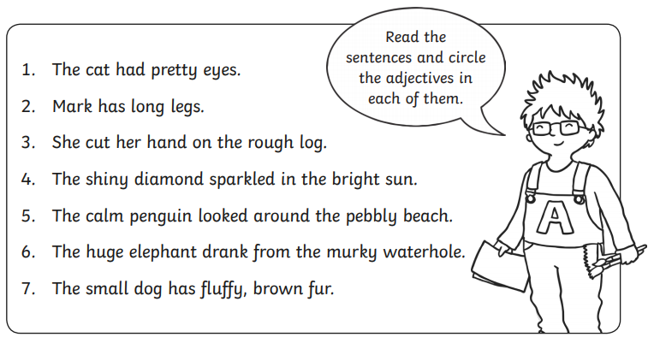

Write some sentences about what members of your family or people do day to day and what they are like. Remember to use adjectives and write this in your book. You can draw pictures in the boxes.

Story time:
Here is a link to a great story ‘The Rainbow Fish’
https://www.youtube.com/watch?v=ifXlc0QI2kY
Enjoy!

Year 1 Work
Week 3 – Friday

Happy Friday! You have completed another fantastic week of home learning! To celebrate have a dance around to one of our favourite songs in Year 1! It will get you moving and will help warm you brains up!
It’s George Ezra – Shotgun!
https://www.youtube.com/watch?v=v_B3qkp4nO4
Work yourselves hard today and then have a restful weekend and always remember, we think you are incredible! Take care!
Miss Horridge and Miss Keith

Maths Dash:
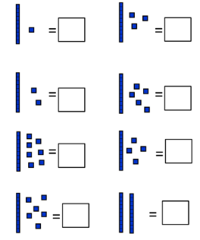
Tens and ones – work out the numbers that have been represented in tens and ones.

Maths:
Begin your lesson by watching the following clip:
https://whiterosemaths.com/homelearning/year-1/ - Week 2 – Lesson 5
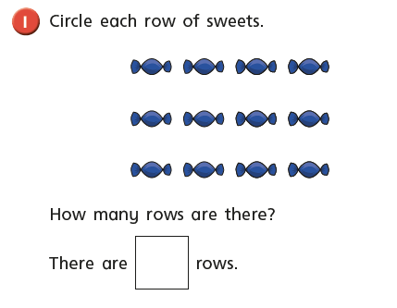

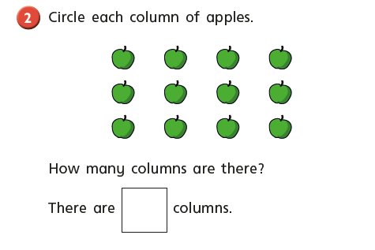

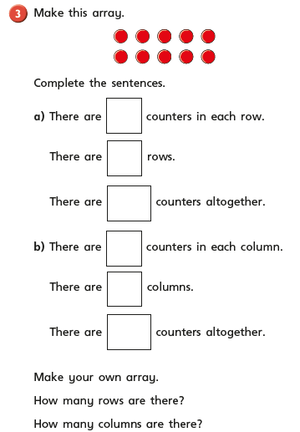

If you want to carry on the learning you can do this with raisons, chocolate buttons, lego etc! See what different arrays you can make here are some suggestions below:

2 rows of 5 =
3 rows of 5 =
4 rows of 2 =
5 rows of 10 =

See what you can make and record them in your book – remember you can represent your arrays in dots (mathematicians do not like to waste time drawing!).

Grammar Dash
Decide if each one is a sentence or question. Put in the correct punctuation to show this. Does it need a full stop or question mark?
What time are you going on the train
Who will you be going with
They went to the park
Where did you put your hat
Harry read his book
Why did you do that

English
Task: Write a character description about a family member.

Have a go at writing your own character description based on a member of your family. You can do this in your book. The diagram below can help you plan out your writing. You can fill in the boxes with your ideas before you write them out in full sentences.
You must use: adjectives, capitals and full stops.
Remember to write about:
- Appearance
- Personality
- What they do
- Favourite thing about them
Appearance | Favourite thing about them
Personality | What they do
 | Draw a picture of the family member

Story time:
Here is a link to a great story it is ‘A Squash and a Squeeze’.
https://www.youtube.com/watch?v=PkdX73Onf04
Enjoy!

