Home Learning Project Week 1 - My Family
Key Stage 1: Penguins, Puffins, Kingfishers and Hummingbirds
Maths tasks | Writing Tasks
As a school, we will be following the White Rose Home Learning sequence found at https://whiterosemaths.com/homelearning/.  Your teacher will explain which lesson to complete in a daily Marvellous Me message. The lessons are based upon videos and a linked activity sheet. .  Optional maths games:  - Practise counting in 2s, 5s and 10s use the following links to practice this:  https://mathsframe.co.uk/en/resources/resource/504/Super-Maths-Bowling-Multiplication  https://www.topmarks.co.uk/times-tables/coconut-multiples | Your teacher will send you more information about the daily tasks through marvellous me. Here is the overview of what the week will look like:  Monday: Read through the WAGOLL (What A Good One Looks Like) of a character description and identify the key features outlined to you.  Tuesday: Read examples of texts about families- compare similarities and differences between the stories and to your own experiences.  Wednesday- Complete the grammar task.  Thursday- Apply grammar focus independently.  Friday- Have a go at writing your own character description based on a member of your family.
Phonics/Spellings Tasks  Aim to do 1 per day | Reading Tasks  Aim to do 1 per day
Phonics learning will still be sent through on marvellous me, however these are other activities for children to enjoy:  - Daily phonics - your child to practice their sounds and blend words. Interactive games found on link below.  - Phonics play  - Top Marks  - Spelling  - Spell the days of the week: Keep a diary of things you do in the week.  - Spell common exception words  - Spelling City | Below is a selection of reading tasks to choose from throughout the week:  - Reading a variety of books at home. Your child could share a book everyday. This can be reading a book aloud everyday or sharing a book with an adult.  - Listen to a story read, Storytime.  - Watch Newsround and find out what is happening in the world. What did you find out? Is there anything you need help understanding?  - Create a bookmark, perhaps you could choose characters from your favourite stories.  - Complete a book review on one of the books you have read - what did you like about it? Would you recommend it to anyone? You can write this on purple mash if you like: https://www.purplemash.com/#app/pup/blank_book_reviews  - Take a look at a variety of poems with your child. Ask them to pick their favourite poem and write a poem https://www.poetry4kids.com/topic/family/
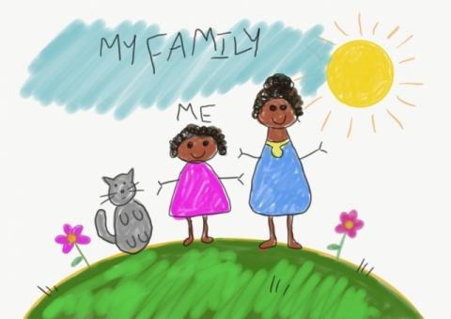
Wider Curriculum Menu

Choose one of these projects on the theme of family to have a go at over the week. The numbered step by step guide by each can help make your chosen project extra special by working on a bit each day, if you want to:

Draw a portrait of a family member
1, Have a go at drawing your own face by looking at it in the mirror. If you can, watch this BBC video on self-portraits. You could use pencil crayons and chalk if you have it.
https://www.bbc.co.uk/teach/class-clips-video/art-and-design-draw-self-portrait/z6ytscw
2, Look at what you have drawn. Decide what you like and what you could make better. Choose a part to practice again, maybe just the nose or the outline of the head. Practice just that bit on another piece of paper.
3. Now watch the video again, if you can. Have a go at drawing your face using something different. If you used pencil crayons before, have a go using felt tip pens now.
4. Either find a photo of someone in your family (it could be on a phone if you don’t have a paper photo) or find yourself a live model in your family to sit while you draw them. Have a go at drawing their face using pens, chalk or pencil crayons depending on what you liked best.
5. Find some coloured paper or even old magazines with pictures on. Cut this into long strips (2 long ways and 2 across) to stick around the outside of your picture as a frame.
or

Create a card:

1. Choose someone to make a card for by asking parents or carers if they can think of someone who would really like to hear from you. It could be wider family who don’t live with you, friends or neighbours.
2. If you have 2 bits of paper and glue you can try a pop up card. Watch this How to Make a Simple Pop Up Card video by JB and have a go, or simply fold a piece of card or paper in half and write your message inside.
https://www.youtube.com/watch?v=hBGLyjraKbs
3. Decide what you would like to draw and practice it on scrap paper. Now draw your picture onto the front of your card using a pencil and rubber.
4. Next add colour using pencil crayons or felt pens.
5. Now to deliver the card. If it is not possible to give or send the card now you can speak to the person on the phone and describe the card and all the effort you put in for them. Explain it is waiting for them and keep it safe for when you see them next. Perhaps you can take a photograph and send that to them using a mobile phone.
or

Be a news reporter by interviewing family members about their favourite things:

1. Make a list of things you could ask family members about, for example their favourite food, colour, book, place, sport, food or anything else you can think of. Pick a top 5 to use for your interviews.

2. Make flash cards by cutting paper up into squares that are about the size of your hand and use a felt tip to write a word from your list onto each card ready for your interviews

3. Now get in touch with as many people as possible to ask your questions to. If you have a phone you can film your interviews, with a little introduction explaining what you are doing first. If not try to remember, or write down, what each person said. Is there anyone in your wider family that you could phone to add to what you’ve learnt?

4. What did you learn? Either film or just explain to someone anything you found out that you didn’t know before. Does anyone like the same thing as someone else? Did anything surprise you?

5. Finally, are there any extra questions that you would want to add in now? Maybe you can find someone to ask them to.

or

Be a data detective and create a tally chart to show something about your family:

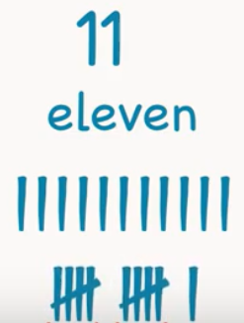
1. Look at the people in your house and choose something you want to investigate about your family. It could be hair colour or eye colour or something else. Think about the answers people could give and list these. For example, eye colour might have blue, green, brown and other and write these down ready for a tally chart.
2. Time to practice how to tally. Watch this clip on Youtube about tally marks from Kids Academy if you can. Write down the numbers 6, 10 and 12 using tally marks, like the bottom marks on the picture here.
https://www.youtube.com/watch?v=-pEA3w8SQws
3, Investigation time. Get your list of answers from 1. and then look at or ask everyone in your home about what you’re investigating (like eye colour). Put a tally mark by the answer they give.
4. Who else could you ask? Think about wider family, neighbours and friends. Can you get more answers from anyone else and add them into your tally chart?
5. Finally, look at your tally chart and explain what you have found out. Tell someone about which answer had the most tally marks by it and what that means.
Additional learning resources you may wish to engage with
- Have a family workout alongside Joe Wicks, live at 9am or catch up later on

- Work on a shopping list for the weekly shop and get children to add up how many items and add up the cost of some items. This game could support work on making amounts of money.

- Practise telling the time. This could be done through this game (scroll down to access the game). Read to the hour and half hour.

- Take a nosey inside Buckingham Palace through a virtual tour

#TheLearningProjects

