Learning Project WEEK 2- The area you live in
Age Range: EYFS – Ducklings, Peacocks and Flamingos
Maths Tasks |  | Reading Tasks
As a school, we will be following the White Rose Home Learning sequence found at https://whiterosemaths.com/homelearning/.  Your child’s class teacher will explain which lesson to complete via Marvellous Me. The lessons are based upon videos that teach your child the subject knowledge needed to then complete the linked activity sheet and answer sheet attached to the video.  Feel free to try some of the links and ideas below if you want to continue practising your arithmetic.  - Watch a Numberblocks clip each day at: BBC or CBeebies. Use this guide here to give you ideas on what to do with your children whilst watching an episode. Some episodes teach different concepts.  FS1: Your aim is to learn numbers 1 to 5 and count to 10 independently.  FS2: Your challenge is to be able to count and order numbers up to 20. Solve addition, subtraction, doubling, sharing and halving problems using manipulatives  - Working on Numbots - your child will have an individual login to access this. Follow this link: https://play.numbots.com/#/intro Here, you can access online maths games.  FS1: Focus on the subtising game.  FS2: Focus on the number bonds and learn them off by heart.  - FS2: Play the Numberblocks adding game.  - FS1: Practise counting back from 10.  FS2: practise counting back from 20.  This can be done through playing hide and seek, singing number songs, chanting, board games etc.  - FS1: Write out the digits 0 - 9.  FS2: Write out the digits 0 – 20.  - Use the ‘Tens Frames’ or ‘Five Frames’ on this game and practise recognising amounts. This can also be done by reading a dice when playing board games, playing with cards, identifying how many food items on the plate etc.  - Look for the numbers on the doors of houses. Do the numbers get bigger or smaller as you go up and down the street? |  | Below is a selection of reading tasks to choose from throughout the week:  - Read a variety of books at home. Favourites can be repeated. Hearing the patterns of language in a story will support your child’s language development.  Some of the best stories that have repeated language are Traditional Tales such as:  - The Gingerbread Man (Week 1)  - Goldilocks and the Three Bears (Week 2)  - The Little Red Hen (Week 3)  - Three Little Pigs (Week 4)  - Little Red Riding Hood (Week 5)  - The Enormous Turnip (Week 6)  - Jack and the Beanstalk (Week 7)  We suggest that you follow our guide above and read the same book for the week.  The week, read the story:  - Goldilocks and the Three Bears (Week 2)  Challenge: Can you learn it off by heart without using pictures or prompts to help you retell it?  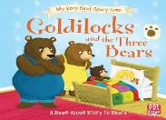  All these books above can be found as ebooks on Epic. Simply login to Epic using your class code:  Ducklings: jex1806  Peacocks: qkt2781  Flamingos: tnh5475  - Answer these questions once you have read Goldilocks and the Three Bears:  - How did the Three Bears feel when they saw Goldilocks in their bed?  - How did baby bear feel when his chair had been broken?  - How did Goldilocks feel when she broke baby bears chair?  - Why did Goldlilocks not like Daddy Bear’s and Mummy Bear’s porridge, beds and chairs?  - What could Goldilocks do to say sorry to the Three Bears?  - Children to read to parents daily.  Visit Oxford Owl for free eBooks that link to your child’s book band.  - Go to https://www.oxfordowl.co.uk/for-home  - Click ‘My Class Login’ at the top of the page.  - Enter details:  Username: bluecoatprimary  Password: Reading  Read a new book every day and then complete the linked Play activities for each book. Make sure you select ages 4-5.  - With your child, look in magazines, newspapers and books for the tricky words they are currently learning. They could use a highlighter to highlight in magazines and newspaper.  The Tricky Words are:  I, no, the, to. go, into, a, he, she, we, me, be, you, all, are, her, was, they, my.
Phonics Tasks |  | Writing Tasks
Ducklings:  - Sing Nursery Rhymes and songs together. Add in actions and change the words. Can children think of different rhyming words to add in? Repeat old favourites and learn new rhymes. You can find an A-Z of Nursery Rhymes here.  - Send your child on a sound hunt around the house or in the garden. Can they find and record all of the items that make sounds? (e.g. hairdryer, TV, fridge, microwave, phone)  - Make Silly Soup with your child. Ask them on each day, to place in a bowl items that start with that sound.  - Monday: a  - Tuesday: o  - Wednesday p:  - Thursday: r  - Friday: 1  Peacocks and Flamingos  - Daily phonics – Your children should know all the following phonemes (sounds). Write them out onto a piece of paper, like below. Then, play Fastest Finger First. You say the sound and your child points to the sound.  - Practice the sounds your child is working on above. Then, write the following CVC words for your child to read and write. Make sure you do only one set a day.  CVC Words to read  - Set 1: Cat, sat, mat, hat, pat (Day 1 – Monday)  - Set 2: Cog, fog, log. Dog (Dag 2 – Tuesday)  - Set 3: Lip, tip, sip, nip, kip, (Day 3 - Wednesday)  - Set 4: Sap, nap, tap, lap (Day 4 - Thursday)  - Set 5: Cot, pot, hot, dot (Day 5 - Friday)  Ask your child to oral blend the sounds (spoken out loud c-a-t). Please use the sound mat with the actions on to support. Alternatively, find the ‘Sounds’ prerecord on our school website.  Ask your child to segment and write the sounds (you say the word and your child writes it).  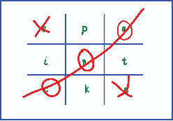  - Play phonics noughts and crosses. Draw out a grid and write the letter above in each part of the grid. Take it in turns to name what is written in the grid. If you say it correctly you can add your nought or cross in that square. |  | End of Week Goal: To write a dairy entry  Day 1:  Practice forming the letters of the alphabet using the sound mat in your learning pack. The sound mat has all the phonics actions on too and how to form the letter. In your Reading Diary, you will find the actions we use to form the letters. This will be sent out via Marvellous Me for you today.  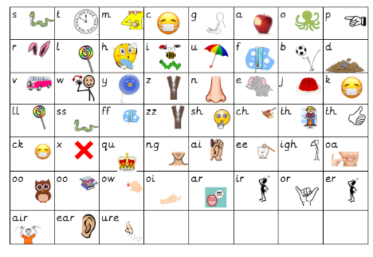  Day 2  Ask your child to write out these tricky words onto separate pieces of paper twice:  I, no, the, to. go, into, a, he, she, we, me, be, you, all, are, her, was, they, my.  Then, turn them over and into a game. Turn it over, say the tricky word and try and match it with the following Tricky word.  Day 3  Watch and recap the days of the week song we sing at school:  https://www.youtube.com/watch?v=spi77By9-iA  Practice writing the days of the week. Monday, Tuesday Wednesday, Thursday, Friday, Saturday, Sunday. Write them lots of times. Can they write this? Using chalks, crayons, paint, felt tips.  Day 4  Today, the children are going to start writing a diary for the days Monday to Wednesday. Explain that a dairy is a book in which one keeps a daily record of events and experiences.  Ask the children to write the days of the week in a long list.  Monday:  Tuesday:  Wednesday:  FS1: Next to the day, ask the children to draw a picture of what they did that day.  FS2: Next to the day, ask the children to write a simple sentence about what they did that day. For example.  Monday: I read a book.  Tuesday: I played with my brother.  Wednesday: I helped my mum cook.  Day 5  Today, the children are going to finish writing a diary for the days Thursday to Friday. Explain that a dairy is a book in which one keeps a daily record of events and experiences.  FS1: Next to the day, ask the children to draw a picture of what they did that day.  FS2: Next to the day, ask the children to write a simple sentence about what they did that day. For example Next to the day, ask the children to write a simple sentence about what they did that day. For example.  Thursday: I went on Epic and read the book …  Friday: I looked at numbers on houses.  By the end of the week, each child should have an A4 diary entry page. Your challenge is to continue writing your diary while school is close each week.
Wider Curriculum Menu
As well as completing a daily maths, English, phonics and reading task, we have put together a selection of different wider curriculum activities for you to complete at your leisure. We realise this is a busy time and so most of these do not require written work but instead are discussion and interaction based. You can complete as many as you like in any order you want!
The project this week aims to provide opportunities for your child to learn more about the area in which they live. Learning may focus on your local area, famous people, key landmarks and links to your city.
The rooms in my house-  Support your child to create a map or cross section of their home. Can they name all of the rooms?  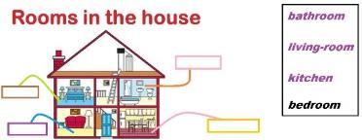  Label each room using phonics knowledge. | Go on a numeral hunt-  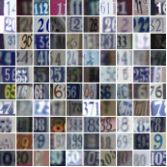  Search for numerals around the house (clocks, books, house numbers, car registrations, oven, washing machine). Can they record the numerals on paper? |  | Create a furniture collage-  Using old magazines and catalogues support your child to cut out and stick or sort objects into the room they would belong in. Support your child to use the correct scissor grip using this guide.
Junk model your house-  Using old packaging (shoe box, cereal box etc.) support your child to make a model of your house. Can they count how many windows there are and stick on the right amount? Can they write their house number on the front?  Junk model your dream house. Use materials from around your house to decorate e.g. old wallpaper, fabric, wool. | Go on a shape hunt-  Set your child a shape finding challenge around the house. Ask: Can you find a triangle/ square/ rectangle/ circle in this room? How many can you find? Can you draw all of the circles on one piece of paper, triangles on another etc? |  | Use construction blocks to build your house-  Using Lego, Duplo, wooden blocks make a model of your house. Can they add in the rooms and doors in the right places? Write labels to match each room on pieces of paper.  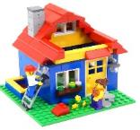  Build your dream house out of construction blocks.
Find your house on google maps-  Explore using google maps to look at your house from above and on street view. Use the arrows to move up and down the road and around your area. Can they find key places e.g. the corner shop, their school, grandparent’s houses?  Search for a house in a different part of the world and discuss how it is similar or different to your own. You could use places children have visited on holiday or search places that are significantly different. | Exploring with your senses-  Gather a collection of household objects e.g. fork, cup, toothbrush, teddy bear, and book and show your child. Use a scarf/ material as a blindfold and pass your child one of the objects. Can they figure out what it is through touch alone? Give clues if they are struggling. Swap roles and ask your child to give you an object to figure out.  Explore the textures around your house. Can children find something rough, smooth, and bumpy? They could take a wax rubbing of each texture (Lay a piece of paper over the top and rub over with the side of a crayon). You could continue this into the garden.  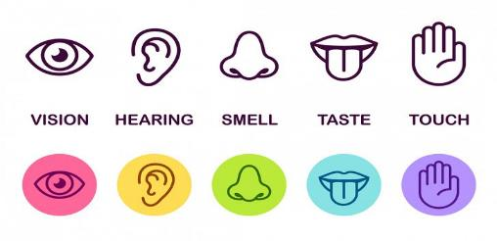
Additional learning resources you may wish to engage with
https://www.ictgames.com/mobilePage/literacy.html - a range of phonics games for all phonic phases, modelling of handwriting, spelling activities EYFS/KS1
www.phonicsplay.com – phonics activities and games EYFS/KS1
www.bbc.co.uk/cbeebies/shows/alphablocks - Letters of the alphabet tell stories and make words using phonics. EYFS/KS1
https://www.bbc.co.uk/cbeebies/shows/alphablocks - An interactive show that teachers children the different phonemes and graphemes.
https://www.oxfordowl.co.uk/for-home/find-a-book/library-page/
Over 100 free to read eBooks, developed for children aged 3–11 years old. Just login you’re your class login and password.
https://www.bbc.co.uk/cbeebies/shows/bedtime-stories - A range of famous bedtime stories read by famous celebrities. Fantastic to listen to before bed.
https://www.bbc.co.uk/programmes/b007t9wg - Jackanory Junior. A range of online interactive stories.
https://www.bbc.co.uk/cbbc/shows/blue-peter – Author chats, story challenge with Matt Haig, Cressida Cowell & many more.
http://www.wordsforlife.org.uk/ - Fun stuff for different ages, downloadable activities, recommended reads, tips from authors and supportive tools for parents to support their children with reading.
https://m.facebook.com/story.php?story_fbid=10157244494779370&id=76302436/ - World book online have made their 3000 ebooks available for free! Over 3000 ebooks you can enjoy at home on your tablet or PC.
https://authorfy.com/ - Authorfy brings readers and writers closer together through interactive video masterclasses, fun downloadable activities and exciting after school resources.
https://www.bbc.co.uk/cbeebies/shows/alphablocks - An interactive show that teachers children the different phonemes and graphemes.
https://literacytrust.org.uk/freeresources/?gclid=EAIaIQobChMIvKfVtLSL6AIVibTtCh01fQAgEAAYASABEgLS-_D_BwE Early years activities - CBeebies magazine resource
Writing Friday: Cressida Cowell's top writing tips for primary pupils Children's author and illustrator Cressida Cowell has created some fantastic resources for primary school pupils, packed full of writing tips and inspiring...
A River of Stories - Tales and Poems from Across the Commonwealth Explore intercultural understanding with your class using four beautifully illustrated anthologies of poems and stories from around the world, with comprehensive supporting... Authors inspiring reading classroom posters.
https://www.weareteachers.com/virtual-author-activities/ - These authors are offering read-alouds of their books and books by their favourite authors.
https://www.oliverjeffers.com/books#/abookaday/ - Famous Author, Oliver Jeffers reads his favourite story every day.
https://www.ictgames.com/mobilePage/literacy.html - A range of literacy and mathematic games.
https://www.oxfordowl.co.uk/for-home/find-a-book/library-page/ - Free Oxford Owl eBooks For children
https://www.storylineonline.net/ Online reading/videos - Hundreds of free ebooks.
https://www.topmarks.co.uk/maths-games/3-5-years/counting
Teachers love this site for fun maths games that you can plan on the laptop, tablet or interactive whiteboard. Just choose the area of maths you want to practise.
https://www.ictgames.com/mobilePage/literacy.html- A range of literacy and mathematic games.
https://www.familydaystriedandtested.com/free-virtual-tours-of-world-museums-educational-sites-galleries-for-children/
Free Virtual Tours of World Museums, Educational Sites & Galleries For Children
https://www.nationalgeographic.com/ - This website offers your child a range of texts and video clips all about our natural world.
https://www.researchify.co.uk/ - A safe search website that enables you to ask questions and find information.
http://www.primaryhomeworkhelp.co.uk/ - A range of wider curriculum subjects with interactive activities
https://www.nationaltrust.org.uk/50-things-to-do - Created by the national Trust, here are 50 things to do before you turn 11.

