Home Learning Project Week 2 - The Area You Live in
Key Stage 1: Penguins, Puffins, Kingfishers and Hummingbirds
Maths tasks | Writing Tasks
As a school, we will be following the White Rose Home Learning sequence found at https://whiterosemaths.com/homelearning/.  Your teacher will explain which lesson to complete in a daily Marvellous Me message. The lessons are based upon videos and a linked activity.  Optional activities:  Below is extra maths links you might find useful:  - Play on The Mental Maths Train Game - practise adding and subtracting.  - https://www.topmarks.co.uk/maths-games/hit-the-button | Your teacher will send you more information about the daily tasks through marvellous me. Here is the overview of what the week will look like:  Monday: Read through the WAGOLL (What A Good One Looks Like) of a diary entry and identify the key features outlined to you.  Tuesday: Read examples and develop comprehension skills  Wednesday- Complete the grammar task.  Thursday- Apply grammar focus independently.  Friday- Have a go at writing a diary entry summarising your past week
Phonics/Spellings Tasks  Aim to do 1 per day | Reading Tasks  Aim to do 1 per day
Phonics learning will still be sent through on marvellous me, however these are other activities for children to enjoy:  Daily phonics - Ask your child to practice their sounds and blend words. Interactive games found on link below.  - Phonics play  - Top Marks  - Spelling  - Spell the days of the week  - Spell common exception words  - Spelling City | Below is a selection of reading tasks to choose from throughout the week:  - Your child could share a book everyday. This can be reading a book aloud everyday or sharing a book with an adult.  - Listen to a story read: https://www.storylineonline.net/  - Watch Newsround and find out what is happening in the world. What did you find out? Is there anything you need help understanding?  - Read the book ‘Voices in the Park’ Discuss the illustrations and why the book has been set out the way it has.  - Create a mask of one of the characters from ‘Voices in the Park’. Can your child hot seat the character?  - Children also have a class log in for the website Epic which allows them to access books to read and listen to.  https://www.getepic.com/app/explore-topics/193
Wider Curriculum Menu

Choose one of these projects to have a go at over the week. The project this week aims to provide opportunities for your child to learn more about the area in which they live. The numbered step by step guide by each can help make your chosen project extra special by working on a bit each day, if you want:
Rainbow trail - go along your road and create a map showing which houses have rainbows in their windows. You’ll need some help with this:

- What shape is your road? It is a line or does it curve round? Where on your road is your house? Once you know, get a piece of paper and pencil and draw a line right across the middle of your page to be your road. If your road bends, your line will need to bend too. This will be your map.
- Find something to lean on, like a clipboard or book, and take your map and pencil outside to add on all the houses on your side of the road. If you live on a long road you might want to just do one bit of it. Start at one end of your road and draw a tiny square, along your line for each house as you walk past. If the house has a rainbow in the window put the letter R inside the square, or above it if it won’t fit inside.
- Make a Key by writing on your map saying R = rainbows in the window and that = house
- Colour all the houses with an R in your favourite colour
- Add a title by neatly writing your road name at the top of your map in big letters and underlining it. You could find this on an addressed letter at home or on the road sign on your road.
or
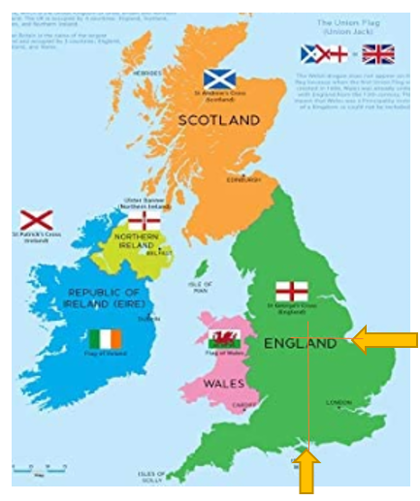
Use different maps to firstly find Nottingham, then your own home within it. Next, look at where in the world the UK is.

- Where is Nottingham on a map of the UK? Look carefully at where the UK’s shape goes in at the bottom and east side, as shown on the orange arrows here. Now follow straight lines through the map to where they meet to find Nottingham.
- Use Google maps to look up Nottingham Old Market Square (Slab Square) then click the directions arrow and put your own address in. As the map zooms out to show you directions from Old Market Square to your address, explore the area and route. Look for places you recognise and zoom in on your own house to see the roads around. Find the 3 roads that are closest to your own and make a list of them.
- If you can go out for a walk with an adult, take your list and explore to see if you can find those roads. Make sure you can find your way back home again!
- Explore Europe on a world map. You can use the interactive map from Owl and Mouse to guess where the UK is, then hover the mouse over to see if you are right. Can you guess any other countries?
http://www.yourchildlearns.com/europe_map.htm
- Where in the world are we? Can you find Europe on a world map? Where is the UK?

or

Create a poster of your address:

- Find out your address by searching for the road sign and your house number. You could also find it from an addressed letter at home. Can you write the number in digits and words? Write the address in different colours and styles.

- Have a go at bubble writing to get ready for making your poster. Write the letters ABC. Use a pencil to draw out the letters then do an oval around them. Finally use a felt pen to go over the oval lines in bold, as shown on this Very Easy! How to Draw Graffiti Bubble Letters ABC video. Watch it up to 1 minute 30 seconds if you can.

https://www.youtube.com/watch?v=ZNHg714uHJQ

- To create a window poster the house or flat number and road name will be the most important information. Have a go at writing them using bubble writing in the way you did for ABC to practice for your poster.
- Now on a large piece of paper plan how big you can write your address number and road name to fit it on. Use a pencil, then felt ti, to carefully write it using bubble writing.
- Now colour in your poster and add any pictures in the background too. Can you add a rainbow or colour the letters in rainbow colours and put it up in the window? This might make people walking by smile.

or

Play the BBC’s Pirate Bunny’s World Adventure Game. You can work through the 6 stages on your own to complete the game:

https://www.bbc.co.uk/bitesize/topics/zvsd8xs/articles/z6vyf4j
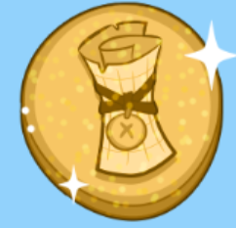
- Put the continents in the right space on the map
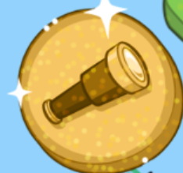
- Place the landmarks in the right UK countries
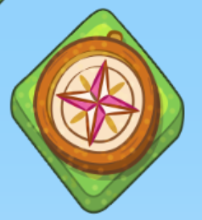
- Find each ocean around the UK
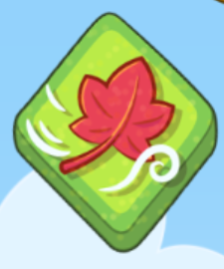
- Drag a weather into each box then press play to watch them happen

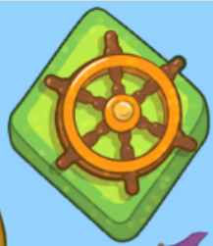
- Drag the objects into the season they go with

- Find the treasure by moving your ship north, south, west and west

Additional learning resources you may wish to engage with
- Enjoy a Harry Potter story while keeping active with this Cosmic Kids yoga video.
- Create a card game that is based around making number pairs to twenty that can then be played as a family. (E.G 18 and 2).
- Identify shapes and finish the patterns in this online game. Can any of these shapes be found around the house? How many of each shape can be found?
- Recognise the place value for numbers up to 99 in this place value basketball game.
- Recognise odd and even numbers https://www.topmarks.co.uk/learning-to-count/coconut-odd-or-even
- Get artistic and create a picture with Tate Paint. Can you make an image of your home or the view from your window?

#TheLearningProjects

