Home Learning Project Week 2 - The Area You Live in
Key Stage 1: Penguins, Puffins, Kingfishers and Hummingbirds
Maths tasks | Writing Tasks
As a school, we will be following the White Rose Home Learning sequence found at https://whiterosemaths.com/homelearning/.  Your teacher will explain which lesson to complete in a daily Marvellous Me message. The lessons are based upon videos and a linked activity.  Optional activities:  Below is extra maths links you might find useful:  - Play on The Mental Maths Train Game - practise adding and subtracting.  - https://www.topmarks.co.uk/maths-games/hit-the-button | Your teacher will send you more information about the daily tasks through marvellous me. Here is the overview of what the week will look like:  Monday: Read through the WAGOLL (What A Good One Looks Like) of a diary entry and identify the key features outlined to you.  Tuesday: Read examples and develop comprehension skills  Wednesday- Complete the grammar task.  Thursday- Apply grammar focus independently.  Friday- Have a go at writing a diary entry summarising your past week
Phonics/Spellings Tasks  Aim to do 1 per day | Reading Tasks  Aim to do 1 per day
Phonics learning will still be sent through on marvellous me, however these are other activities for children to enjoy:  Daily phonics - Ask your child to practice their sounds and blend words. Interactive games found on link below.  - Phonics play  - Top Marks  - Spelling  - Spell the days of the week  - Spell common exception words  - Spelling City | Below is a selection of reading tasks to choose from throughout the week:  - Your child could share a book everyday. This can be reading a book aloud everyday or sharing a book with an adult.  - Listen to a story read: https://www.storylineonline.net/  - Watch Newsround and find out what is happening in the world. What did you find out? Is there anything you need help understanding?  - Read the book ‘Voices in the Park’ Discuss the illustrations and why the book has been set out the way it has.  - Create a mask of one of the characters from ‘Voices in the Park’. Can your child hot seat the character?  - Children also have a class log in for the website Epic which allows them to access books to read and listen to.  https://www.getepic.com/app/explore-topics/193
Wider Curriculum Menu

Choose one of these projects to have a go at over the week. The project this week aims to provide opportunities for your child to learn more about the area in which they live. The numbered step by step guide by each can help make your chosen project extra special by working on a bit each day, if you want:
Rainbow trail - go along your road and create a map showing which houses have rainbows in their windows. You’ll need some help with this:

- What shape is your road? It is a line or does it curve round? Where on your road is your house? Once you know, get a piece of paper and pencil and draw a line right across the middle of your page to be your road. If your road bends, your line will need to bend too. This will be your map.
- Find something to lean on, like a clipboard or book, and take your map and pencil outside to add on all the houses on your side of the road. If you live on a long road you might want to just do one bit of it. Start at one end of your road and draw a tiny square, along your line for each house as you walk past. If the house has a rainbow in the window put the letter R inside the square, or above it if it won’t fit inside.
- Make a Key by writing on your map saying R = rainbows in the window and that = house
- Colour all the houses with an R in your favourite colour
- Add a title by neatly writing your road name at the top of your map in big letters and underlining it. You could find this on an addressed letter at home or on the road sign on your road.
or
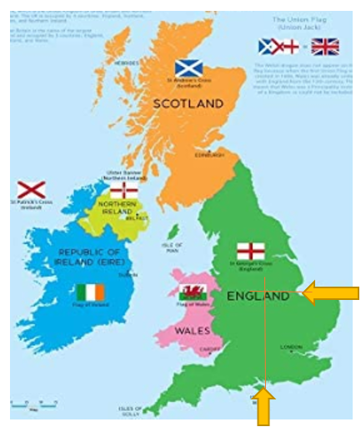
Use different maps to firstly find Nottingham, then your own home within it. Next, look at where in the world the UK is.

- Where is Nottingham on a map of the UK? Look carefully at where the UK’s shape goes in at the bottom and east side, as shown on the orange arrows here. Now follow straight lines through the map to where they meet to find Nottingham.
- Use Google maps to look up Nottingham Old Market Square (Slab Square) then click the directions arrow and put your own address in. As the map zooms out to show you directions from Old Market Square to your address, explore the area and route. Look for places you recognise and zoom in on your own house to see the roads around. Find the 3 roads that are closest to your own and make a list of them.
- If you can go out for a walk with an adult, take your list and explore to see if you can find those roads. Make sure you can find your way back home again!
- Explore Europe on a world map. You can use the interactive map from Owl and Mouse to guess where the UK is, then hover the mouse over to see if you are right. Can you guess any other countries?
http://www.yourchildlearns.com/europe_map.htm
- Where in the world are we? Can you find Europe on a world map? Where is the UK?

or

Create a poster of your address:

- Find out your address by searching for the road sign and your house number. You could also find it from an addressed letter at home. Can you write the number in digits and words? Write the address in different colours and styles.

- Have a go at bubble writing to get ready for making your poster. Write the letters ABC. Use a pencil to draw out the letters then do an oval around them. Finally use a felt pen to go over the oval lines in bold, as shown on this Very Easy! How to Draw Graffiti Bubble Letters ABC video. Watch it up to 1 minute 30 seconds if you can.

https://www.youtube.com/watch?v=ZNHg714uHJQ

- To create a window poster the house or flat number and road name will be the most important information. Have a go at writing them using bubble writing in the way you did for ABC to practice for your poster.
- Now on a large piece of paper plan how big you can write your address number and road name to fit it on. Use a pencil, then felt ti, to carefully write it using bubble writing.
- Now colour in your poster and add any pictures in the background too. Can you add a rainbow or colour the letters in rainbow colours and put it up in the window? This might make people walking by smile.

or

Play the BBC’s Pirate Bunny’s World Adventure Game. You can work through the 6 stages on your own to complete the game:

https://www.bbc.co.uk/bitesize/topics/zvsd8xs/articles/z6vyf4j
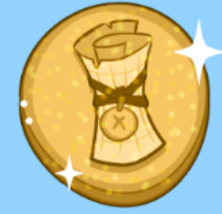
- Put the continents in the right space on the map
- Place the landmarks in the right UK countries
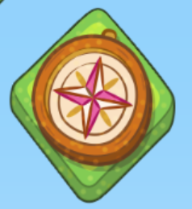
- Find each ocean around the UK
- Drag a weather into each box then press play to watch them happen

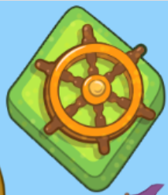
- Drag the objects into the season they go with

- Find the treasure by moving your ship north, south, west and west

Additional learning resources you may wish to engage with
- Create a card game that is based around making number pairs to twenty that can then be played as a family. (E.G 18 and 2).
- Identify shapes and finish the patterns in this online game. Can any of these shapes be found around the house? How many of each shape can be found?
- Recognise the place value for numbers up to 99 in this place value basketball game.
- Recognise odd and even numbers https://www.topmarks.co.uk/learning-to-count/coconut-odd-or-even
- Get artistic and create a picture with Tate Paint. Can you make an image of your home or the view from your window?
There are plenty of events happening online to take advantage of while at home:
· Maths with Carol Vorderman www.themathsfactor.com
· Cooking with Jamie Oliver https://www.jamieoliver.com/features/category/get-kids-cooking/
· Music with Myleene Klass https://www.youtube.com/channel/UCQh2wgJ5tOrixYBn6jFXsXQ
· Science with Professor Brian Cox, Robin Ince & Guests https://cosmicshambles.com/stayathome/upcoming-schedule
· Daily drawing lessons with Author Mo Willems https://www.youtube/Mjacom/watch?v=RmzjCPQv3y8
· Virtual museum tours https://www.familydaystriedandtested.com/free-virtual-tours-of-world-museums-educational-sites-galleries-for-children/
· San Diego Zoo live cam https://zoo.sandiegozoo.org/live-cams

#TheLearningProjects

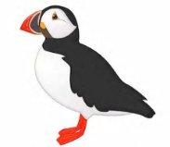
Year 1 Work
Week 2 – Monday

Hello to our fabulous team of Puffins and Penguins!
Well done for getting back into routine and while it isn’t ‘normal’ we are glad to be ‘back’ with you!
And just remember parents, try not to worry too much about school work. The home learning we send is to support you at home, but please don’t feel that every part HAS to be completed every day. Every little bit will help and when we return, we will get your child back on track. We are teachers and that’s our superpower. What we can’t fix is social-emotional trauma that prevents the brain from learning. So right now, we need you to share your laughter with your children. No children are ahead. No children are behind. Your children are exactly where they need to be right now.

The theme of the week this week is ‘The Area You Live In’. You will all be great at this because we did a huge topic on Nottingham earlier this year and we have looked closely at the different landmarks in Nottingham. We think you will really enjoy the topic this week.
Miss Horridge and Miss Keith.

Grammar Dash
Point to, write, or circle the nouns (a noun is a person, place or thing)
the big Tom bus door
cat stick win ate this
on child apple Mum pen
rug is go one how
dog bike sun desk room

English:
Read through the WAGOLL (What A Good One Looks Like) of a diary entry.

Read my diary entry and highlight or write down the key features outlined:
- Personal pronoun (refers to the person speaking): I
- Conjunctions (part of speech that connects two sentences together e.g. two and two make four)- and, but
- Places in the local area
- Opinions- what someone thinks about something

Dear Diary,
Me and my family are staying at home at the moment because of Covid19 but I am enjoying it so far. I cannot believe how different my home town looks now. When I used to look out of the window, the streets would be filled with people walking by and cars on the roads. Now it is so quiet and everybody is safe at home. A few days ago I enjoyed a bike ride around my local park with my mum and sister but we had to make sure we kept a distance from people passing by. Normally if I went to the park, my favourite thing to do would be to play on the swings but this time the swings were not in use. Today we had the best morning because we baked a delicious lemon cake. My mum even let me measure out the ingredients and mix it together. I cannot wait to eat it later on. I miss speaking to my friends at school but I am going to write a letter to my best friend Lilly to see how she is doing. I hope she writes back.
Love
Molly xx

Maths Dash:
Have a go at your number bonds to 10. We think you will be getting really good at knowing these by now.
10 + 0 = | 4 + = 10 | 2 + 8 = | 0 + = 10 | 1 + 9 =
7 + 3 = | 3 + = 10 | 4 + = 10 | 0 + 10 = | 4 + 6 =
9 + = 10 | 9 + 1 = | 5 + = 10 | 10 = 6 + | 3 + 7 =
2 + 8 = | 10 = 4 + | 7 + = 10 | 4 + 6 = | 1 + = 10
2 + = 10 | 5 + 5 = | 10 + = 10 | 5 + = 10 | 8 + = 10

Maths:
Today you will be looking at doubling numbers. Here is the video link to your lesson.
https://whiterosemaths.com/homelearning/year-1/
(Please note we are a week behind on these lessons so go to Summer Term – Week 1 – 20th April)

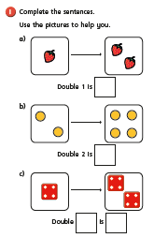
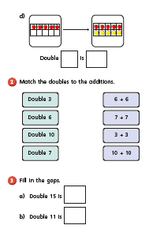

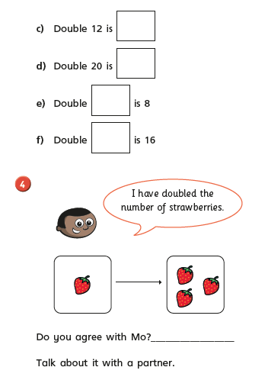
Digging Deeper
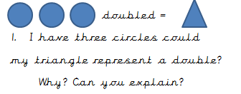
Hint: think about the sides on the shapes.

Here is a great game to play – you can use this for doubles and number bonds to 10.
https://www.topmarks.co.uk/maths-games/hit-the-button

Story time:
Here is a link to a great story – it is Kitchen Disco read by George Ezra.
https://www.bbc.co.uk/iplayer/episode/b0bfdkd2/cbeebies-bedtime-stories-641-george-ezra-kitchen-disco

Enjoy!

Year 1 Work
Week 2 – Tuesday

Hello to our wonderful children!
Today is Tuesday and it’s set to be another super day for learning. We want to remind you all how brilliant you are:

Miss Horridge and Miss Keith.

Maths Dash:
Last week you had a go at counting in 10s. Have a look at these number lines and see if you can work out the missing numbers.
10 |  | 30 |  | 50 |  | 70 |  |  | 100

100 |  | 80 |  | 60 |  | 40 |  | 20
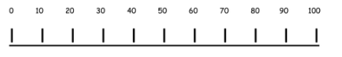

Maths:
Here is the video link for today’s maths lesson. Today you will be making equal groups.
https://whiterosemaths.com/homelearning/year-1/ (Summer 1 – Week 1 – Lesson 2)

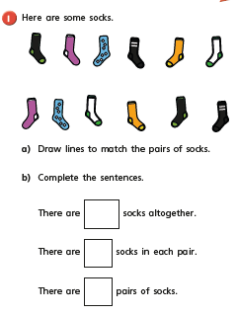

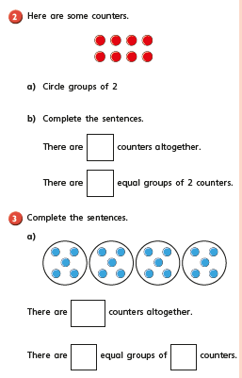

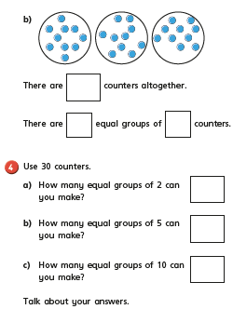

Grammar Dash
First write the proper nouns and then write the nouns. Think carefully, what might need fixing with these proper nouns?
manchester book sam wednesday
table dog school bottle
pencil aspley Nottingham
tree harvey road katie car

English
Re-read the diary from yesterday and answer the following questions:

Dear Diary,
Me and my family are staying at home at the moment because of Covid19 but I am enjoying it so far. I cannot believe how different my home town looks now. When I used to look out of the window, the streets would be filled with people walking by and cars on the roads. Now it is so quiet and everybody is safe at home. A few days ago I enjoyed a bike ride around my local park with my mum and sister but we had to make sure we kept a distance from people passing by. Normally if I went to the park, my favourite thing to do would be to play on the swings but this time the swings were not in use. Today we had the best morning because we baked a delicious lemon cake. My mum even let me measure out the ingredients and mix it together. I cannot wait to eat it later on. I miss speaking to my friends at school but I am going to write a letter to my best friend Lilly to see how she is doing. I hope she writes back.
Love
Molly xx

- Where was Molly when she wrote the diary? _____________________________________
- What has she been enjoying doing so far? ____________________________________________________________________________________________________________________________________________
- What does Molly miss about school?
______________________________________________________________________
- What was her local area like before Covid19?
__________________________________________________________________________________________________________________________________________________
- What is her local area like now?
__________________________________________________________________________________________________________________________________________________
Where do you think Tommy lives? What is it like there? List the clues:

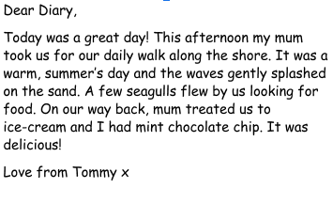
_________________________________________
_________________________________________
_________________________________________
_________________________________________
_________________________________________
_________________________________________

An extra challenge:
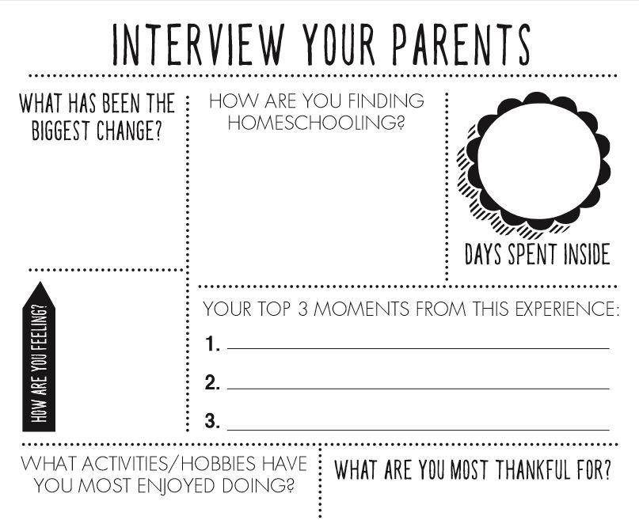

You could write the answers of even film your family.
Don’t forget to email us to share any ideas/work with the Year 1 team.
Just email the primary email address.

Story time:
Here is a link to watch Tom Hardy reading ‘There’s a Bear on My Chair’.
https://www.bbc.co.uk/iplayer/episode/b08l1ys6/cbeebies-bedtime-stories-583-tom-hardy-theres-a-bear-on-my-chair

Year 1 Work
Week 2 – Wednesday

Hello to our wonderful children!
It’s already the middle of the week! Doesn’t time fly when you’re having fun. Today we would love you to send us your best joke! We will send them out or even add them to the archway Instagram. If there’s anything else that you’d like to share with us. Just send it to primary@bluecoat.uk.com
Keep Smiling!
Miss Horridge and Miss Keith.
Maths Dash:
We know that you will be amazing at your bonds to 10 by now. So we would like if you could get to know your bonds to 20. Use your knowledge of bonds to 10 to help you with your bonds to 20.
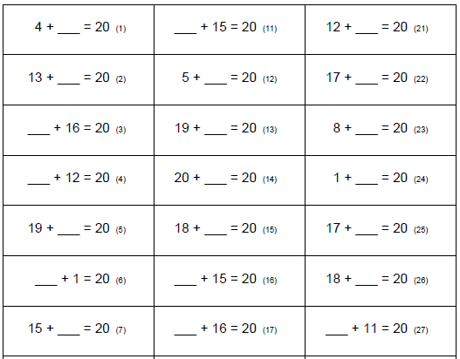

Maths:
Today you will be continuing with making equal groups. Your lesson today is under
Summer Term – Week 1 – Lesson 3
https://whiterosemaths.com/homelearning/year-1/

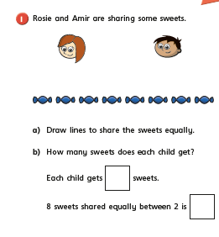

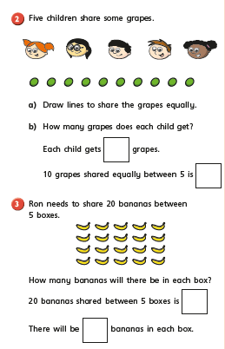

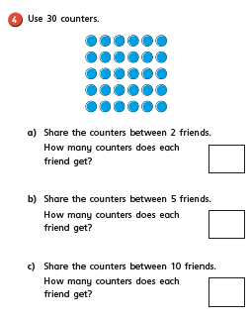

Grammar Dash
Is it a question or a sentence?
Remember that a sentence tells you some information where as a question is trying to find something out. It will usually start with a question word (who, what, where, why, when, how, which) and it should have a question mark at the end. A sentence will usually have a full stop. When you have looked at these statements below, you need to decide whether each one needs a full stop or a question mark.

What day is it today
When will you be going on holiday
We are working in our classroom
When I go on holiday I always take my sun hat with me.
Did you remember your homework
Who is teaching us today

English
Joining words using and
Write and in the gaps to make a pair together.
salt_________ pepper
king__________queen
knife____________fork
bucket___________spade
cats_____________dogs
brother______________sister
fish___________chips

2. Point to or write the word ‘and’ in the correct gap in these sentences.
E.g. The _____bee is black _____ yellow.
The and bee is black yellow.
The bee is black and yellow.
Answer……..The bee is black and yellow.
My grey _________ dog is soft _________ furry.
Tom _____________ Katie are playing ________ outside
Fred wants___________ a pear _______ an apple.
Mum _________Dad are taking _________ to school.
I wear my hat ________ scarf______ in the winter.

Challenge can you write an independent sentence using the word and?

Story time:
Here is a link to a Joe Wicks reading ‘Love Monster and the Perfect Present’.
https://www.bbc.co.uk/iplayer/episode/m000fbs4/cbeebies-bedtime-stories-740-joe-wicks-love-monster-and-the-perfect-present

Year 1 Work
Week 2 – Thursday

Hello to our wonderful children!
Thursday’s are normally singing assemblies –
Why not listen to some of our Believe Time Bangers and sing a song from our playlist!
https://www.youtube.com/watch?v=stdPSPOejbw&list=PL9I7aCiPOXFrNCmChrXIf4fq6Mc7PogaJ
A sing song and boogie is always the best way to start a Thursday. Who knows your family might even want to join in!
Miss Horridge and Miss Keith.
Maths Dash:
Have a go at some retrieval of shape. If you cannot print this off, match the shapes by pointing and by saying the answers out loud.
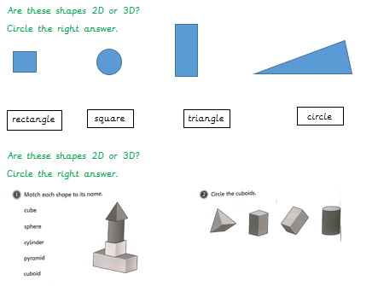
Maths:
Today you will be starting to look at fractions. Fraction means part of a whole and you will be looking at the fraction known as half.
Here is the video link for your lesson:
https://whiterosemaths.com/homelearning/year-1/
Please look at Summer 1 – Week 1 – Lesson 4

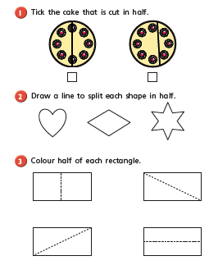

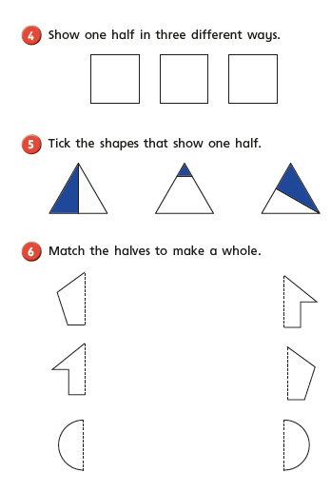

Grammar Dash
Underline the nouns (if you cannot print this off, just point to the nouns).
The dog ran down the road.
The girl went to the shop with her mum.
A man fell down the step.
The cat ran fast.
Fat Cat got up.

English
- Start by drawing a map of places in your local area and label this.
2) Then write about what your local area used to look like and what it looks like now.

For example
There used to be busy roads and open libraries, now it is very quiet. Normally your family would be at work and you would be at school but now you are all home and the house is busy.
Use conjunctions and/but.
Then:_________________________________________________________________________________________________________________________________________________________________________________________________________________________________________________________________________________________________________________________________________________________________________________________________________________________
Now:______________________________________________________________________________________________________________________________________________________________________________________________________________________________________________________________________________________________________________________________________________________________
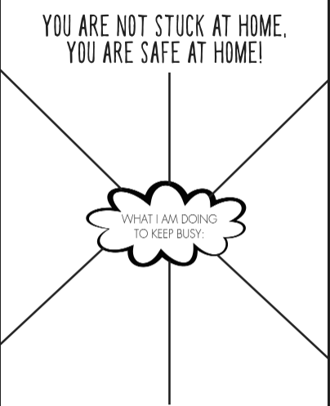

Extra Challenge

Story time:
Here is a link to Jodie Whittaker reading ‘Inspector Hector’.
https://www.bbc.co.uk/iplayer/episode/m0006vsk/cbeebies-bedtime-stories-715-jodie-whittaker-inspector-hector

Year 1 Work
Week 2 – Friday

Hello to our wonderful children!

Another week. Another 5 days full of fantastic experiences and things to learn. You are all amazing and have achieved so much this week.
Enjoy your weekend and remember to keep smiling and having lots of fun!
Miss Horridge and Miss Keith.
Maths Dash:
These questions will make you think about which numbers you add together to make the teen numbers.

10 + = 14 10 + = 13 10 + = 15

9 + = 19 7 + = 17 10 + = 11

7 + = 17 8 + = 18 10 + = 16

Maths:
Today you will be continuing to look at fractions. Fraction means part of a whole and you will be looking at the fraction known as half. To start with, re-watch the video from yesterday’s lesson.
Here is the video link for your lesson:
https://whiterosemaths.com/homelearning/year-1/
Please look at Summer 1 – Week 1 – Lesson 4

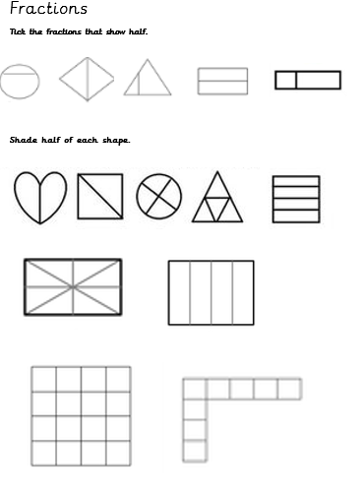

The have a go at the Summer 1 – Week 1 – Friday Challenge on the Whiterose website.
Here is the link:
https://whiterosemaths.com/homelearning/year-1/

Grammar Dash
In the box below (or in your books) write down as many nouns and you can see in your house.

Task:

Write a diary entry about the area you live in. Include the following:
● What you have been up to.
● Children write any changes in daily life, activity on your street, traffic.
● Who is still off to work and why?
● What are you doing now compared to what you normally do? How does it feel?
● Explain what it used to be like compared to now.
● Changes in routine.

You can write your diary in your book.
Dear Diary,

Extra Challenge
Can you write a poem for Bluecoat
Here is ours
Brilliant Building
Lovely Staff
Uniform for everyone
Excellent Engagement
Children who are all fantastic
Our favourite place to be
All together
Team Bluecoat

Story time:
Here is a link to Dr Ranj reading ‘Sometimes’.
https://www.bbc.co.uk/iplayer/episode/b084fhhd/cbeebies-bedtime-stories-566-dr-ranj-sometimes

