Home Learning Project Week 1 - My Family
Key Stage 1: Penguins, Puffins, Kingfishers and Hummingbirds
Maths tasks | Writing Tasks
As a school, we will be following the White Rose Home Learning sequence found at https://whiterosemaths.com/homelearning/.  Your teacher will explain which lesson to complete in a daily Marvellous Me message. The lessons are based upon videos and a linked activity sheet. .  Optional maths games:  - Practise counting in 2s, 5s and 10s use the following links to practice this:  https://mathsframe.co.uk/en/resources/resource/504/Super-Maths-Bowling-Multiplication  https://www.topmarks.co.uk/times-tables/coconut-multiples | Your teacher will send you more information about the daily tasks through marvellous me. Here is the overview of what the week will look like:  Monday: Read through the WAGOLL (What A Good One Looks Like) of a character description and identify the key features outlined to you.  Tuesday: Read examples of texts about families- compare similarities and differences between the stories and to your own experiences.  Wednesday- Complete the grammar task.  Thursday- Apply grammar focus independently.  Friday- Have a go at writing your own character description based on a member of your family.
Phonics/Spellings Tasks  Aim to do 1 per day | Reading Tasks  Aim to do 1 per day
Phonics learning will still be sent through on marvellous me, however these are other activities for children to enjoy:  - Daily phonics - your child to practice their sounds and blend words. Interactive games found on link below.  - Phonics play  - Top Marks  - Spelling  - Spell the days of the week: Keep a diary of things you do in the week.  - Spell common exception words  - Spelling City | Below is a selection of reading tasks to choose from throughout the week:  - Reading a variety of books at home. Your child could share a book everyday. This can be reading a book aloud everyday or sharing a book with an adult.  - Listen to a story read, Storytime.  - Watch Newsround and find out what is happening in the world. What did you find out? Is there anything you need help understanding?  - Create a bookmark, perhaps you could choose characters from your favourite stories.  - Complete a book review on one of the books you have read - what did you like about it? Would you recommend it to anyone? You can write this on purple mash if you like: https://www.purplemash.com/#app/pup/blank_book_reviews  - Take a look at a variety of poems with your child. Ask them to pick their favourite poem and write a poem https://www.poetry4kids.com/topic/family/
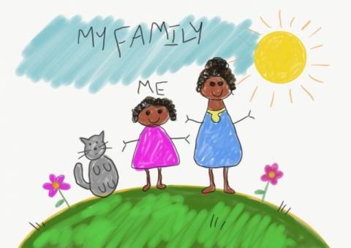
Wider Curriculum Menu

Choose one of these projects on the theme of family to have a go at over the week. The numbered step by step guide by each can help make your chosen project extra special by working on a bit each day, if you want to:

Draw a portrait of a family member
1, Have a go at drawing your own face by looking at it in the mirror. If you can, watch this BBC video on self-portraits. You could use pencil crayons and chalk if you have it.
https://www.bbc.co.uk/teach/class-clips-video/art-and-design-draw-self-portrait/z6ytscw
2, Look at what you have drawn. Decide what you like and what you could make better. Choose a part to practice again, maybe just the nose or the outline of the head. Practice just that bit on another piece of paper.
3. Now watch the video again, if you can. Have a go at drawing your face using something different. If you used pencil crayons before, have a go using felt tip pens now.
4. Either find a photo of someone in your family (it could be on a phone if you don’t have a paper photo) or find yourself a live model in your family to sit while you draw them. Have a go at drawing their face using pens, chalk or pencil crayons depending on what you liked best.
5. Find some coloured paper or even old magazines with pictures on. Cut this into long strips (2 long ways and 2 across) to stick around the outside of your picture as a frame.
or

Create a card:

1. Choose someone to make a card for by asking parents or carers if they can think of someone who would really like to hear from you. It could be wider family who don’t live with you, friends or neighbours.
2. If you have 2 bits of paper and glue you can try a pop up card. Watch this How to Make a Simple Pop Up Card video by JB and have a go, or simply fold a piece of card or paper in half and write your message inside.
https://www.youtube.com/watch?v=hBGLyjraKbs
3. Decide what you would like to draw and practice it on scrap paper. Now draw your picture onto the front of your card using a pencil and rubber.
4. Next add colour using pencil crayons or felt pens.
5. Now to deliver the card. If it is not possible to give or send the card now you can speak to the person on the phone and describe the card and all the effort you put in for them. Explain it is waiting for them and keep it safe for when you see them next. Perhaps you can take a photograph and send that to them using a mobile phone.
or

Be a news reporter by interviewing family members about their favourite things:

1. Make a list of things you could ask family members about, for example their favourite food, colour, book, place, sport, food or anything else you can think of. Pick a top 5 to use for your interviews.

2. Make flash cards by cutting paper up into squares that are about the size of your hand and use a felt tip to write a word from your list onto each card ready for your interviews

3. Now get in touch with as many people as possible to ask your questions to. If you have a phone you can film your interviews, with a little introduction explaining what you are doing first. If not try to remember, or write down, what each person said. Is there anyone in your wider family that you could phone to add to what you’ve learnt?

4. What did you learn? Either film or just explain to someone anything you found out that you didn’t know before. Does anyone like the same thing as someone else? Did anything surprise you?

5. Finally, are there any extra questions that you would want to add in now? Maybe you can find someone to ask them to.

or

Be a data detective and create a tally chart to show something about your family:

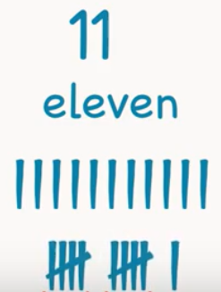
1. Look at the people in your house and choose something you want to investigate about your family. It could be hair colour or eye colour or something else. Think about the answers people could give and list these. For example, eye colour might have blue, green, brown and other and write these down ready for a tally chart.
2. Time to practice how to tally. Watch this clip on Youtube about tally marks from Kids Academy if you can. Write down the numbers 6, 10 and 12 using tally marks, like the bottom marks on the picture here.
https://www.youtube.com/watch?v=-pEA3w8SQws
3, Investigation time. Get your list of answers from 1. and then look at or ask everyone in your home about what you’re investigating (like eye colour). Put a tally mark by the answer they give.
4. Who else could you ask? Think about wider family, neighbours and friends. Can you get more answers from anyone else and add them into your tally chart?
5. Finally, look at your tally chart and explain what you have found out. Tell someone about which answer had the most tally marks by it and what that means.
Additional learning resources you may wish to engage with
- Have a family workout alongside Joe Wicks, live at 9am.

- Work on a shopping list for the weekly shop and get children to add up how many items and add up the cost of some items. This game could support work on making amounts of money.

- Practise telling the time. This could be done through this game (scroll down to access the game). Read to the hour and half hour.

- Take a nosey inside Buckingham Palace through a virtual tour

Monday
English: Reading the WAGOLL of a character description of someone in my family:

My mum is called Shelly and she is 56 years old. She has long, black hair and small round eyes. My mum has a beautiful smile and rosy cheeks. My favourite thing about my mum is that she tells me funny jokes and she always makes me laugh. Her chocolate cakes is the best and she even lets me lick the bowl after she is finished making it. In her free time she enjoys cooking delicious food and reading lots of story books. The activity she loves the most is to watch movies with our family.

Read and underline the key features outlined to you- adjectives, appearance, personality, favourite thing to do. You can also write them in your book.

Monday
Maths: Find three quarters
The White Rose website has a video, activity and answer sheet for every day’s lesson. We will be using these each day. We are starting Summer Term - Week 1 Home Learning Lessons this week. Watch the Lesson One: Find three quarters video, then have a go at the activity and mark it. This will always be how the main part of your maths lesson works. Video:https://whiterosemaths.com/homelearning/year-2/
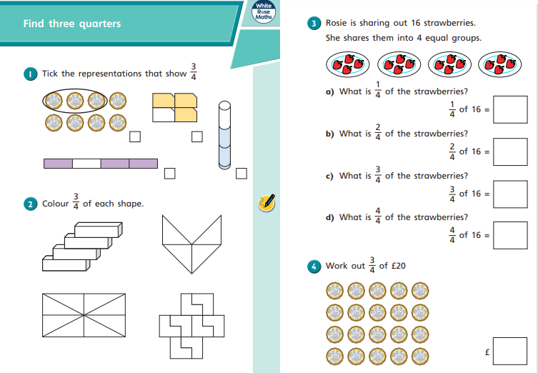
Worksheet:https://wrm-13b48.kxcdn.com/wp-content/uploads/2020/homelearning/year-2/Lesson-1-Y2-Spring-Block-4-WO11-Find-three-quarters-2019.pdf
Just so you know...
If you can print the worksheets out for the activity that is great, but don’t worry if you can’t. Just look at the activity worksheet online for the question and write your answers into your book.

Write the short date or lesson title at the top of the page, and the question number by each answer so you can then go through and check your answers using the answer sheet more easily.
There will be questions, like the first two on today’s worksheet, where it is hard to write an answer without the printed out activity sheet. For these questions just discuss what the answer is and don’t worry about what is written down. You can always put the question number, then tick it knowing you discussed the right answer.
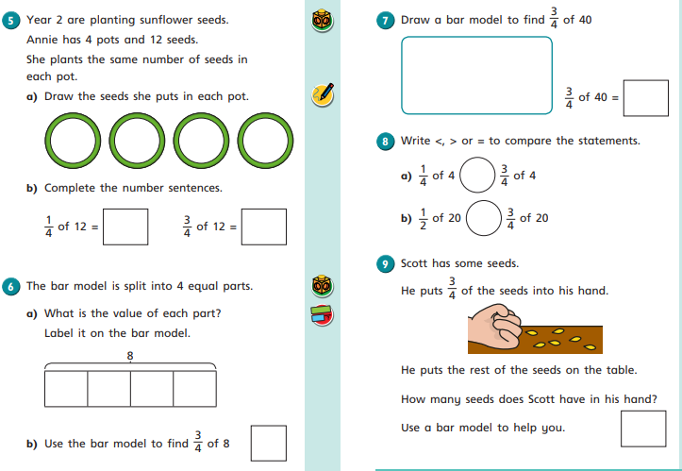
Digging Deeper
Can you challenge yourself to go a bit further? Here is the Digging Deeper task. 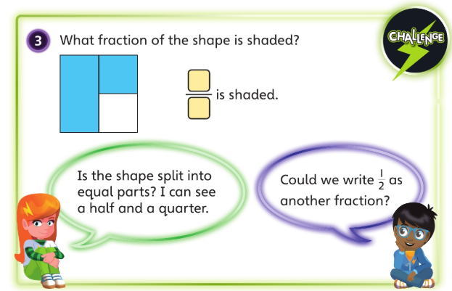
Just so you know…
This Digging Deeper activity is to be used as an extra, extension task. If you found the lesson easy or made very few mistakes then it’s important for you to have a go at it. However, if you have worked very hard already on the main lesson, getting some bits wrong the first time and learning from your mistakes, then you don’t need to do this extra Digging Deeper task.
The aim of the Digging Deeper task is to get you thinking in new, deeper ways about the topic. You can write DD in your book then answer it, but what you actually write down for the task is not as important as the thinking and discussion that goes with it.

Tuesday
English: Read examples of texts about families- compare similarities and differences between the stories and to your own experiences.

- Who is important to you? Draw a picture of the people that are most important to you? (Family members, friends, neighbours etc). Why are they important to you? (You can do this in your book).

Read some stories on Epic: Sonya’s family, Miguel’s family and My Family. https://www.getepic.com/app/search

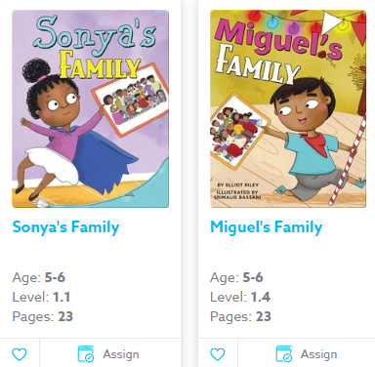

- Write a list of things that are similar or different about these families:

- Are there any similarities between your family and Sonya’s?

- Are there any similarities between your family and Miguel’s?

Tuesday
Maths: Count in fractions
We are on Lesson 2 of Summer Term - Week 1 of the Year 2 Home Learning Lessons this week. Watch the Lesson 2 Count in Fractions video, then have a go at the worksheet and check your answers. This is the main part of your maths lesson.
Video: https://whiterosemaths.com/homelearning/year-2/
Worksheet: https://wrm-13b48.kxcdn.com/wp-content/uploads/2020/homelearning/year-2/Lesson-2-Y2-Spring-Block-4-WO12-Count-in-fractions-2019.pdf

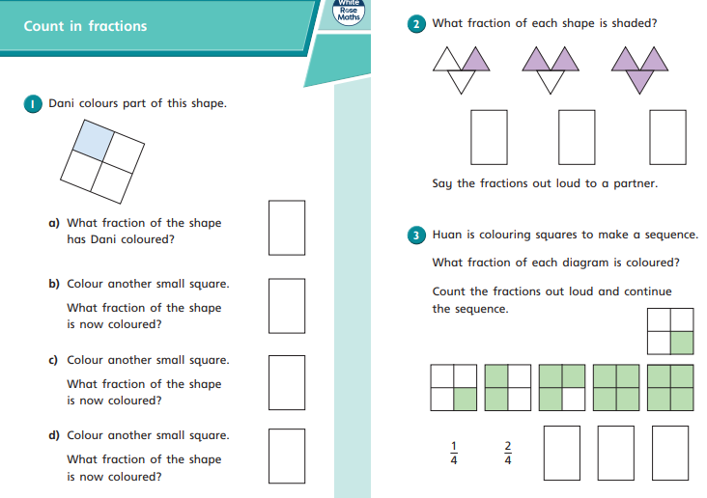

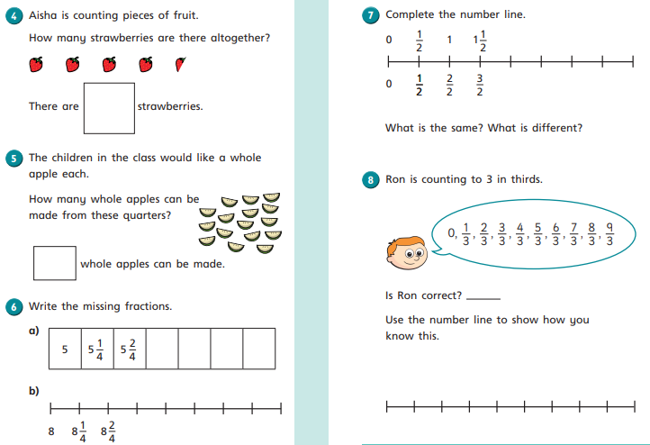
Digging Deeper
How did today’s main lesson go? Are you up for the challenge of digging even deeper? If you sailed through the lesson then keep going with today’s Digging Deeper task here:
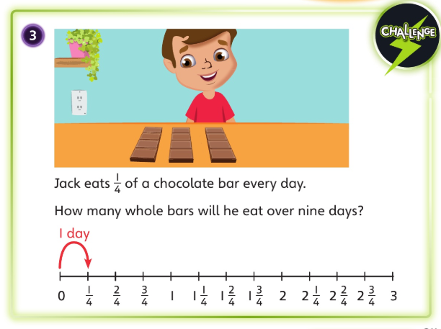

A note on yesterday’s Digging Deeper:
The fraction of the shape that is shaded is ¾.
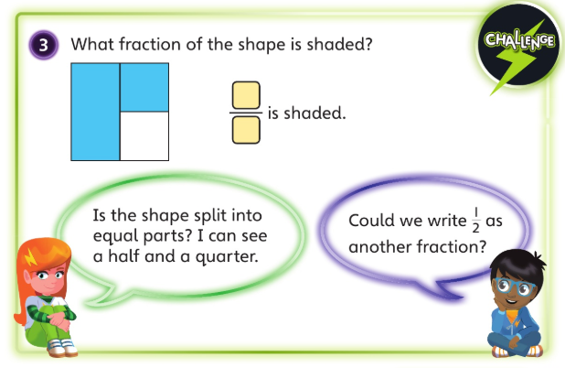
You may have discussed that the shape is not split into equal parts, it is split into one half. A quarter and another quarter. The half is the same (or equivalent to) two of the quarters.

Wednesday
English: Complete grammar task about adjectives.

An adjective is a word that describes a noun.
- Spot the adjectives:
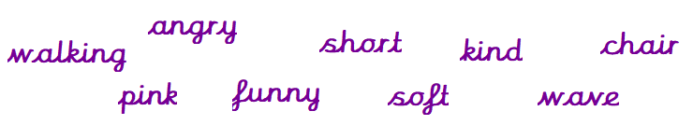
- Circle the adjectives from the list of words to describe the picture:
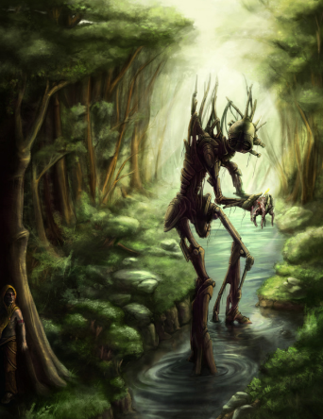

- Why do we use adjectives?
______________________________________________________________________________________________________________________________________________________________________
- Read the sentences and write down the adjectives that you can spot:
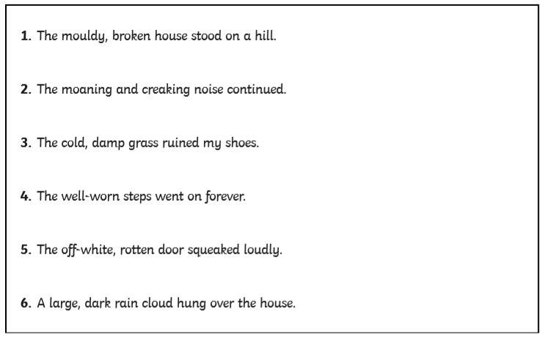

Wednesday
Maths: Measure length (cm)
We are on Lesson 3 of Summer Term - Week 1 of the Year 2 Home Learning Lessons this week. Watch the Lesson 3 Measure Length (cm) video, then have a go at the worksheet and check your answers. This is the main part of your maths lesson.
Video: https://whiterosemaths.com/homelearning/year-2/
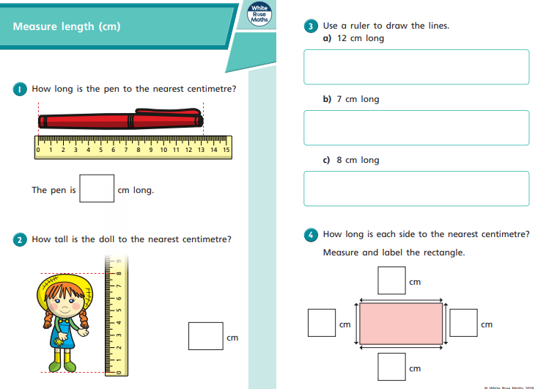
Worksheet: https://wrm-13b48.kxcdn.com/wp-content/uploads/2020/homelearning/year-2/Lesson-3-Y2-Spring-Block-5-WO1-Measure-length-cm-2019.pdf

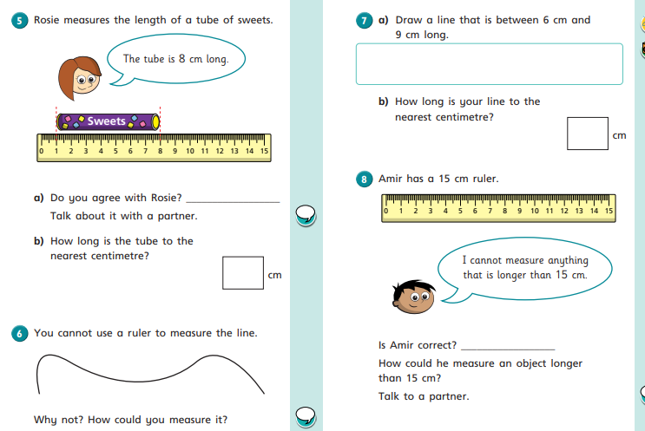
Digging Deeper
How did today’s main lesson go? Are you up for the challenge of digging even deeper? If you sailed through the lesson then keep going with today’s Digging Deeper task here:

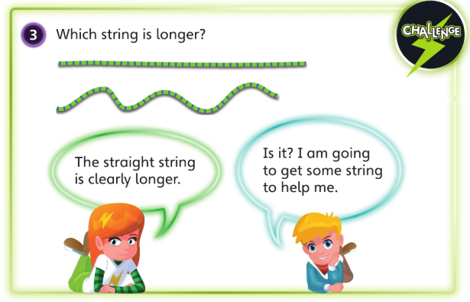

A note on yesterday’s Digging Deeper:

He eats 2 whole chocolate bars over 9 days.
You may have discussed that he ate another quarter as well. The remainder was a quarter. This would be written as 2 ¼

Thursday
English: Apply grammar focus (adjectives) independently.

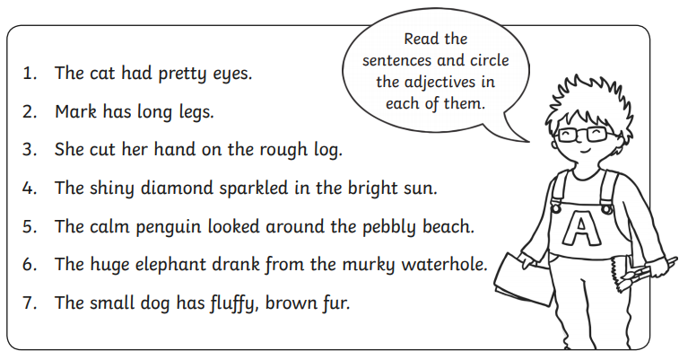
Start by spotting the adjectives in the sentences:

Write some sentences about what members of your family or people do day to day and what they are like. Remember to use adjectives and write this in your book:
You can draw a picture of the family member.
Thursday
Maths: Measure Length (m)
We are on Lesson 4 of Summer Term - Week 1 from the Year 2 Home Learning Lessons. Watch the Lesson 4 Measure Length (m) video, then have a go at the worksheet and check your answers. This is the main part of your maths lesson.
Video: https://whiterosemaths.com/homelearning/year-2/
Worksheet: https://wrm-13b48.kxcdn.com/wp-content/uploads/2020/homelearning/year-2/Lesson-4-Y2-Spring-Block-5-WO2-Measure-length-m-2019.pdf

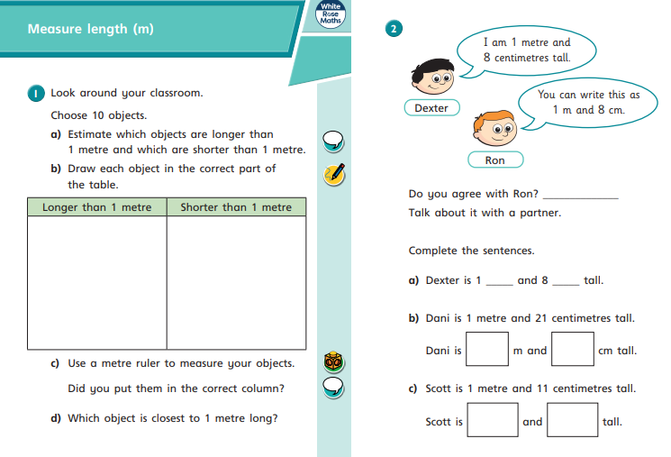

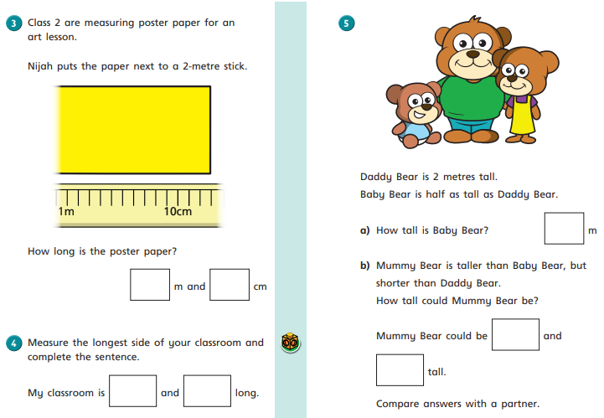

Digging Deeper
How did today’s main lesson go? Are you up for the challenge of digging even deeper? If you sailed through the lesson then keep going with today’s Digging Deeper task here:
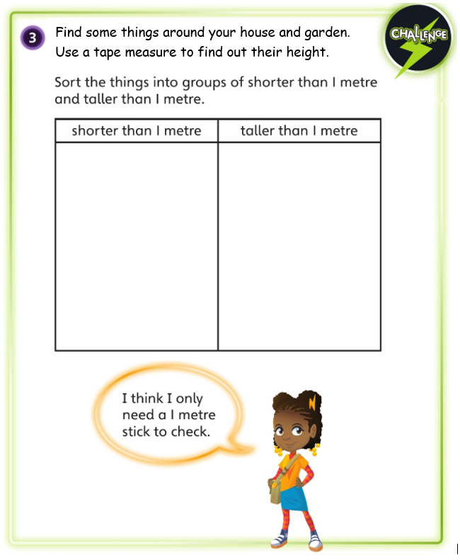
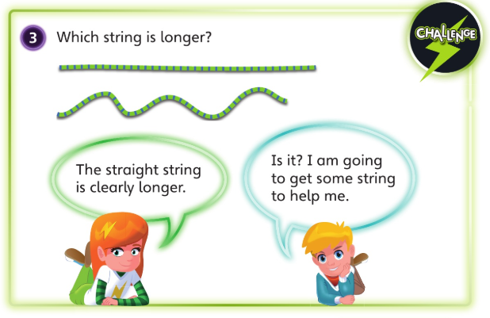
A note on yesterday’s Digging Deeper:
The bottom, wiggly string is the longest.
You may have got some string to show that bends create a greater length. You could also show it by walking in a straight line or a zigzag line between two points, because you walk further for the zigzag line.

Friday 24th April
English: Character description
Have a go at writing your own character description based on a member of your family. You can do this in your book.
You must use: adjectives, capitals and full stops.
Remember to write about:
- Appearance
- Personality
- What they do
- Favourite thing about them
Finish by drawing a picture of this person.
Appearance | Favourite thing about them
Personality | What they do
 | Draw a picture of the family member

Friday
Maths: Maths Challenge

We are on Lesson 5 of Summer Term Week 1 of the Year 2 Home Learning Lessons. Have a go at the Maths Challenge. Enjoy! https://whiterosemaths.com/homelearning/year-2/

