Home Learning Project Week 2 - The Area You Live in
Key Stage 1: Penguins, Puffins, Kingfishers and Hummingbirds
Maths tasks | Writing Tasks
As a school, we will be following the White Rose Home Learning sequence found at https://whiterosemaths.com/homelearning/.  Your teacher will explain which lesson to complete in a daily Marvellous Me message. The lessons are based upon videos and a linked activity.  Optional activities:  Below is extra maths links you might find useful:  - Play on The Mental Maths Train Game - practise adding and subtracting.  - https://www.topmarks.co.uk/maths-games/hit-the-button | Your teacher will send you more information about the daily tasks through marvellous me. Here is the overview of what the week will look like:  Monday: Read through the WAGOLL (What A Good One Looks Like) of a diary entry and identify the key features outlined to you.  Tuesday: Read examples and develop comprehension skills  Wednesday- Complete the grammar task.  Thursday- Apply grammar focus independently.  Friday- Have a go at writing a diary entry summarising your past week
Phonics/Spellings Tasks  Aim to do 1 per day | Reading Tasks  Aim to do 1 per day
Phonics learning will still be sent through on marvellous me, however these are other activities for children to enjoy:  Daily phonics - Ask your child to practice their sounds and blend words. Interactive games found on link below.  - Phonics play  - Top Marks  - Spelling  - Spell the days of the week  - Spell common exception words  - Spelling City | Below is a selection of reading tasks to choose from throughout the week:  - Your child could share a book everyday. This can be reading a book aloud everyday or sharing a book with an adult.  - Listen to a story read: https://www.storylineonline.net/  - Watch Newsround and find out what is happening in the world. What did you find out? Is there anything you need help understanding?  - Read the book ‘Voices in the Park’ Discuss the illustrations and why the book has been set out the way it has.  - Create a mask of one of the characters from ‘Voices in the Park’. Can your child hot seat the character?  - Children also have a class log in for the website Epic which allows them to access books to read and listen to.  https://www.getepic.com/app/explore-topics/193
Wider Curriculum Menu

Choose one of these projects to have a go at over the week. The project this week aims to provide opportunities for your child to learn more about the area in which they live. The numbered step by step guide by each can help make your chosen project extra special by working on a bit each day, if you want:
Rainbow trail - go along your road and create a map showing which houses have rainbows in their windows. You’ll need some help with this:

- What shape is your road? It is a line or does it curve round? Where on your road is your house? Once you know, get a piece of paper and pencil and draw a line right across the middle of your page to be your road. If your road bends, your line will need to bend too. This will be your map.
- Find something to lean on, like a clipboard or book, and take your map and pencil outside to add on all the houses on your side of the road. If you live on a long road you might want to just do one bit of it. Start at one end of your road and draw a tiny square, along your line for each house as you walk past. If the house has a rainbow in the window put the letter R inside the square, or above it if it won’t fit inside.
- Make a Key by writing on your map saying R = rainbows in the window and that = house
- Colour all the houses with an R in your favourite colour
- Add a title by neatly writing your road name at the top of your map in big letters and underlining it. You could find this on an addressed letter at home or on the road sign on your road.
or
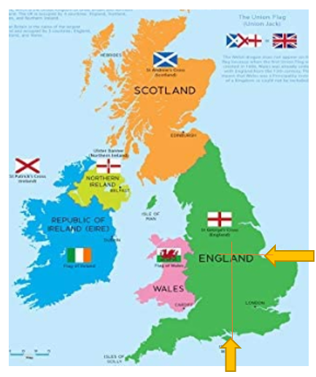
Use different maps to firstly find Nottingham, then your own home within it. Next, look at where in the world the UK is.

- Where is Nottingham on a map of the UK? Look carefully at where the UK’s shape goes in at the bottom and east side, as shown on the orange arrows here. Now follow straight lines through the map to where they meet to find Nottingham.
- Use Google maps to look up Nottingham Old Market Square (Slab Square) then click the directions arrow and put your own address in. As the map zooms out to show you directions from Old Market Square to your address, explore the area and route. Look for places you recognise and zoom in on your own house to see the roads around. Find the 3 roads that are closest to your own and make a list of them.
- If you can go out for a walk with an adult, take your list and explore to see if you can find those roads. Make sure you can find your way back home again!
- Explore Europe on a world map. You can use the interactive map from Owl and Mouse to guess where the UK is, then hover the mouse over to see if you are right. Can you guess any other countries?
http://www.yourchildlearns.com/europe_map.htm
- Where in the world are we? Can you find Europe on a world map? Where is the UK?

or

Create a poster of your address:

- Find out your address by searching for the road sign and your house number. You could also find it from an addressed letter at home. Can you write the number in digits and words? Write the address in different colours and styles.

- Have a go at bubble writing to get ready for making your poster. Write the letters ABC. Use a pencil to draw out the letters then do an oval around them. Finally use a felt pen to go over the oval lines in bold, as shown on this Very Easy! How to Draw Graffiti Bubble Letters ABC video. Watch it up to 1 minute 30 seconds if you can.

https://www.youtube.com/watch?v=ZNHg714uHJQ

- To create a window poster the house or flat number and road name will be the most important information. Have a go at writing them using bubble writing in the way you did for ABC to practice for your poster.
- Now on a large piece of paper plan how big you can write your address number and road name to fit it on. Use a pencil, then felt ti, to carefully write it using bubble writing.
- Now colour in your poster and add any pictures in the background too. Can you add a rainbow or colour the letters in rainbow colours and put it up in the window? This might make people walking by smile.

or

Play the BBC’s Pirate Bunny’s World Adventure Game. You can work through the 6 stages on your own to complete the game:

https://www.bbc.co.uk/bitesize/topics/zvsd8xs/articles/z6vyf4j
- Put the continents in the right space on the map
- Place the landmarks in the right UK countries
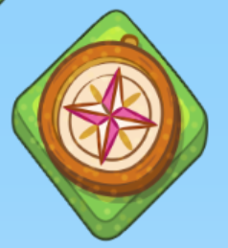
- Find each ocean around the UK
- Drag a weather into each box then press play to watch them happen

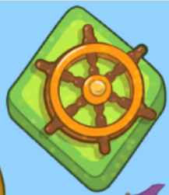
- Drag the objects into the season they go with

- Find the treasure by moving your ship north, south, west and west

Additional learning resources you may wish to engage with
- Enjoy a Harry Potter story while keeping active with this Cosmic Kids yoga video.
- Create a card game that is based around making number pairs to twenty that can then be played as a family. (E.G 18 and 2).
- Identify shapes and finish the patterns in this online game. Can any of these shapes be found around the house? How many of each shape can be found?
- Recognise the place value for numbers up to 99 in this place value basketball game.
- Recognise odd and even numbers https://www.topmarks.co.uk/learning-to-count/coconut-odd-or-even
- Get artistic and create a picture with Tate Paint. Can you make an image of your home or the view from your window?

#TheLearningProjects

Monday 27th April
English: Read through the WAGOLL (What A Good One Looks Like) of a diary entry.

Read my diary entry and highlight or write down the key features outlined:
- First person pronoun: I, we, my
- Past tense- was, were, ate, played.
- Places in the local area
- Opinions- what someone thinks about something

Dear Diary,
Me and my family are staying at home at the moment because of Covid19 but I am enjoying it so far. I cannot believe how different my home town looks now. When I used to look out of the window, the streets would be filled with people walking by and cars on the roads. Now it is so quiet and everybody is safe at home. A few days ago I enjoyed a bike ride around my local park with my mum and sister but we had to make sure we kept a distance from people passing by. Normally if I went to the park, my favourite thing to do would be to play on the swings but this time the swings were not in use. Today we had the best morning because we baked a delicious lemon cake. My mum even let me measure out the ingredients and mix it together. I cannot wait to eat it later on. I miss speaking to my friends at school but I am going to write a letter to my best friend Lilly to see how she is doing. I hope she writes back.
Love
Molly xx
Monday
Maths: Compare lengths
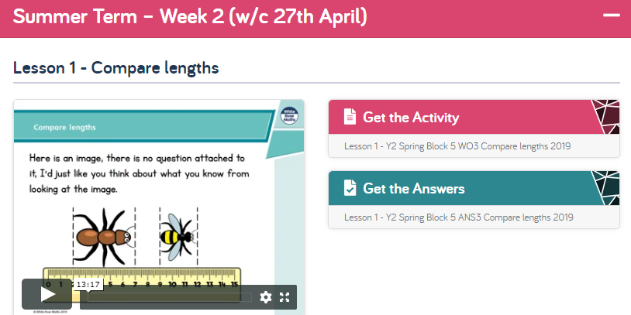

The White Rose website has a video, activity and answer sheet for everyday’s lesson. We will continue to use these each day.
We are starting Summer Term - Week 2 this week. Watch the Lesson One: Compare Lengths video, then have a go at the activity and mark it.
Video: https://whiterosemaths.com/homelearning/year-2/
Worsheet:https://wrm-13b48.kxcdn.com/wp-content/uploads/2020/homelearning/year-2/Lesson-5-Y2-Spring-Block-5-WO3-Compare-lengths-2019.pdf
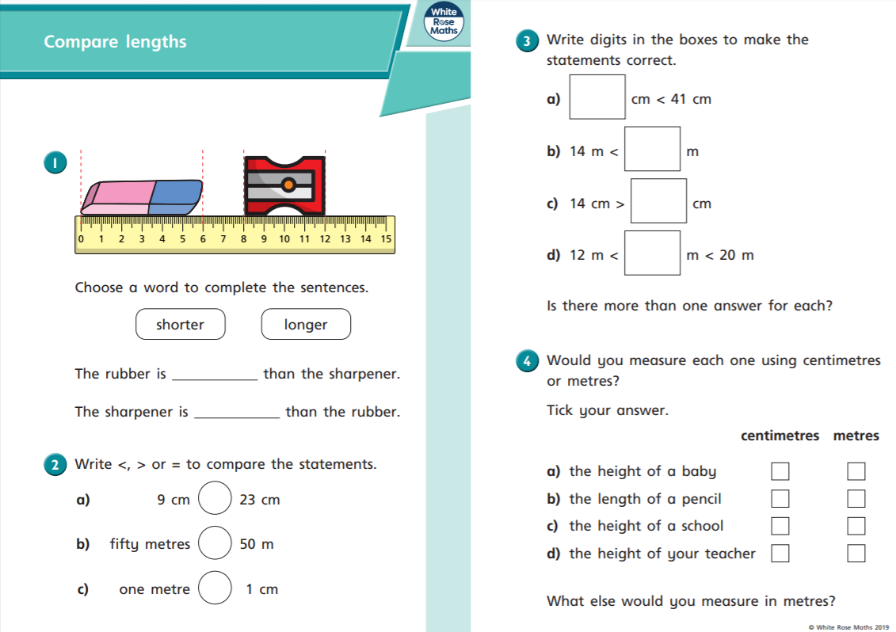
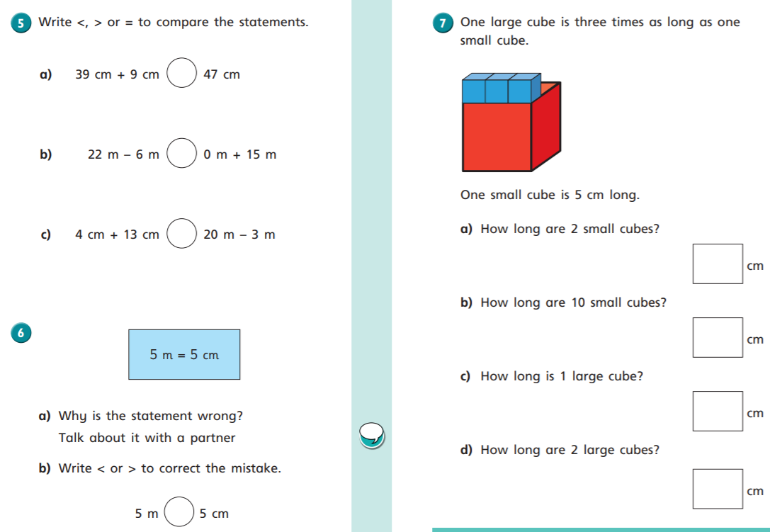

Digging Deeper
Can you challenge yourself to go a bit further? Here is the Digging Deeper task.
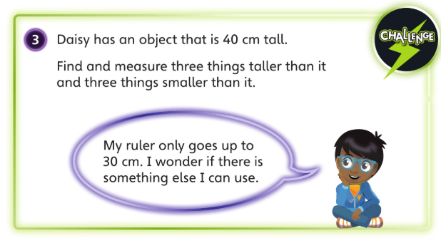

Tuesday 28th April
English: Develop comprehension skills.

Re-read the diary from yesterday and answer the following questions:

Dear Diary,
Me and my family are staying at home at the moment because of Covid19 but I am enjoying it so far. I cannot believe how different my home town looks now. When I used to look out of the window, the streets would be filled with people walking by and cars on the roads. Now it is so quiet and everybody is safe at home. A few days ago I enjoyed a bike ride around my local park with my mum and sister but we had to make sure we kept a distance from people passing by. Normally if I went to the park, my favourite thing to do would be to play on the swings but this time the swings were not in use. Today we had the best morning because we baked a delicious lemon cake. My mum even let me measure out the ingredients and mix it together. I cannot wait to eat it later on. I miss speaking to my friends at school but I am going to write a letter to my best friend Lilly to see how she is doing. I hope she writes back.
Love
Molly xx

- Where was Molly when she wrote the diary? _____________________________________
- What has she been enjoying doing so far? ____________________________________________________________________________________________________________________________________________
- What does Molly miss about school?
______________________________________________________________________
- What was her local area like before Covid19?
__________________________________________________________________________________________________________________________________________________
- What is her local area like now?
__________________________________________________________________________________________________________________________________________________
Where do you think Tommy lives? What is it like there? List the clues:
Dear Diary,
Today was a great day! This afternoon my mum took us for our daily walk along the shore. It was a warm, summer’s day and the waves gently splashed on the sand. A few seagulls flew by us looking for food. On our way back, mum treated us to ice-cream and I had mint chocolate chip. It was delicious!
Love from Tommy x
_________________________________________
_________________________________________
_________________________________________
_________________________________________
_________________________________________
_________________________________________

Tuesday
Maths: Order Lengths
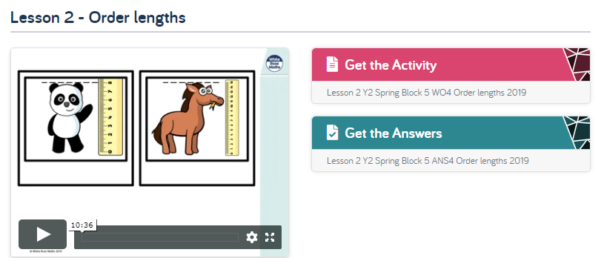

We are on Lesson 2 of Summer Term - Week 2 of the Year 2 Home Learning Lessons this week. Watch the Lesson 2 Order Lengths video, then have a go at the worksheet and check your answers. This is the main part of your maths lesson.
Video: https://whiterosemaths.com/homelearning/year-2/
Worsheet: https://wrm-13b48.kxcdn.com/wp-content/uploads/2020/homelearning/year-2/Lesson-2-Y2-Spring-Block-5-WO4-Order-lengths-2019.pdf
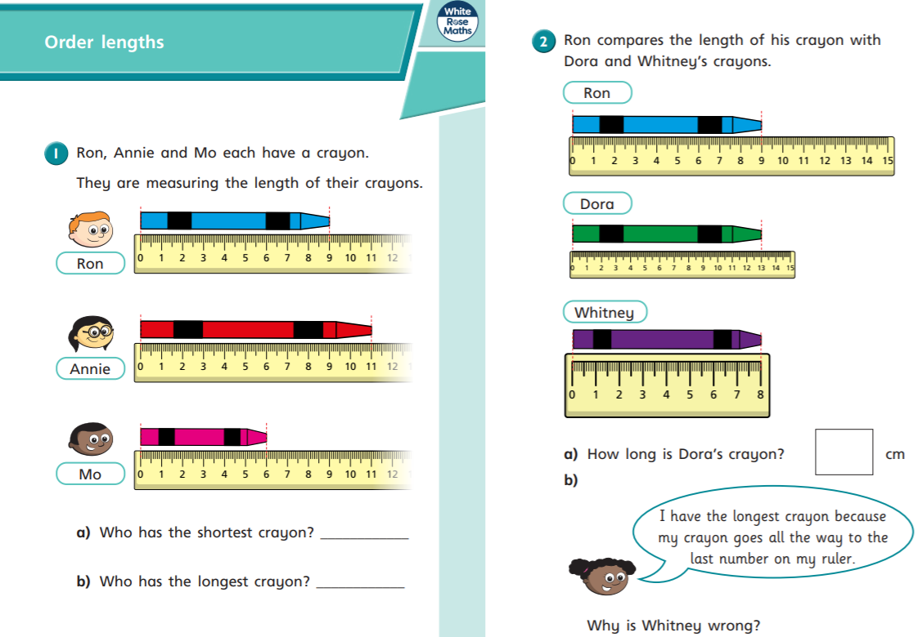
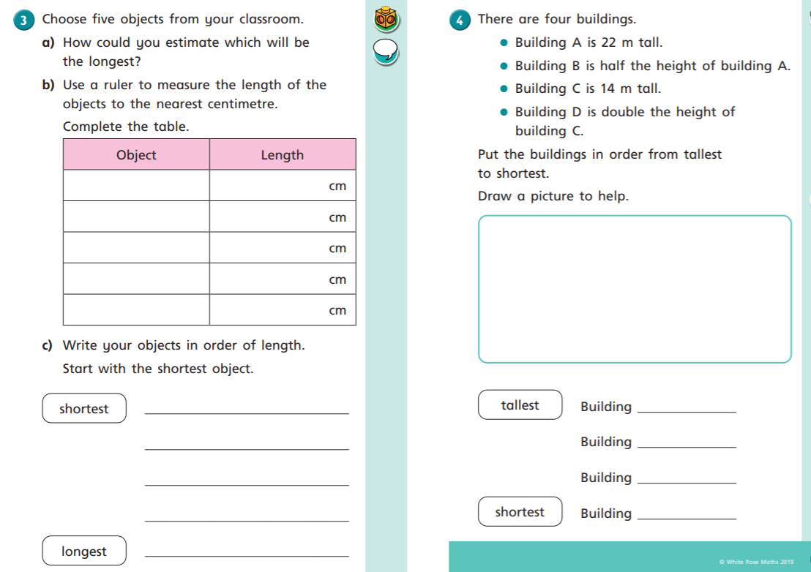
Digging Deeper
How did today’s main lesson go? Are you up for the challenge of digging even deeper? If you sailed through the lesson then keep going with today’s Digging Deeper task here:
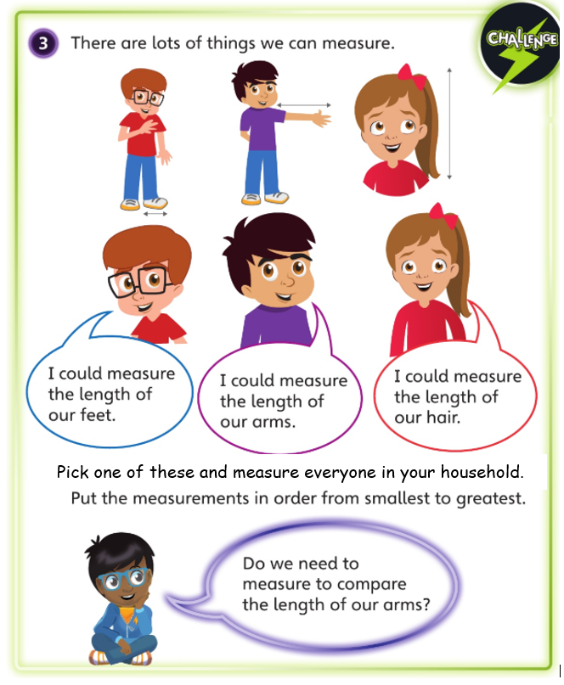

Wednesday 29th April
English: Complete the grammar task.

Verbs: Verbs are words that describe an action.
- Spot the verbs below and write them in your book:
Past tense verbs: actions or events in the past.
- Now spot the past tense verbs and write them in your book:
Regular verbs: verbs that end in ‘d’ or ‘ed’
Irregular verbs: A verb in which the past tense is not formed by adding the usual -ed ending (felt, found, saw).
- Read the sentences and spot the verbs. Write the regular verbs past tense verbs in one list and the irregular past tense verbs in another list:
Write the letters on the line.
Yesterday I washed my shoes.
The birds flew in the sky.
This morning I found my favourite bear and I played with it for an hour.
When I looked out of my window, I saw bright lights.

- Fill the gaps using past tense verbs:
Last week, I ___________ a cake.
In art I ______________ a picture.
I ____________ my bike to school.
I was going to go on holiday so I _______________ my bag.
I wanted to grow a plant so I ______________ a seed.
Wednesday
Maths: Four operations with length
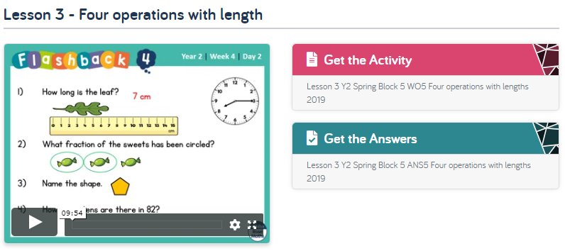

We are on Lesson 3 of Summer Term - Week 2 of the Year 2 Home Learning Lessons this week. Watch the Lesson 3 Four operations with length video, then have a go at the worksheet and check your answers. This is the main part of your maths lesson.
Video: https://whiterosemaths.com/homelearning/year-2/
Worksheet: https://wrm-13b48.kxcdn.com/wp-content/uploads/2020/homelearning/year-2/Lesson-3-Y2-Spring-Block-5-WO5-Four-operations-with-lengths-2019.pdf
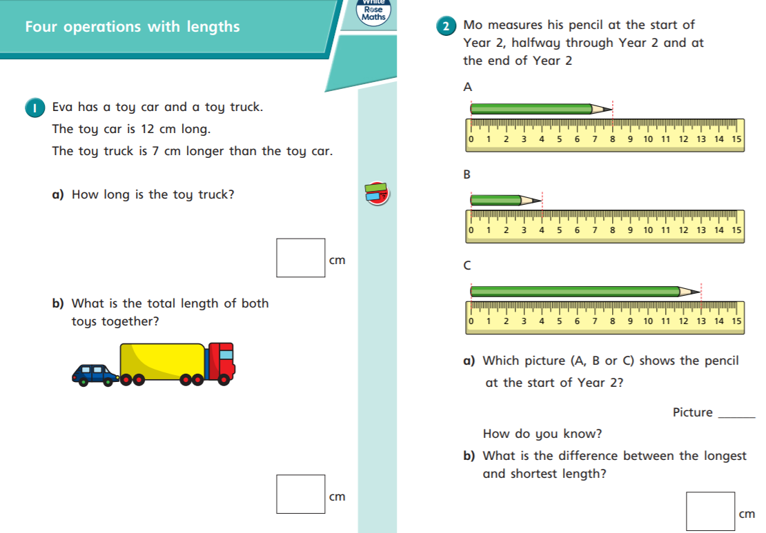
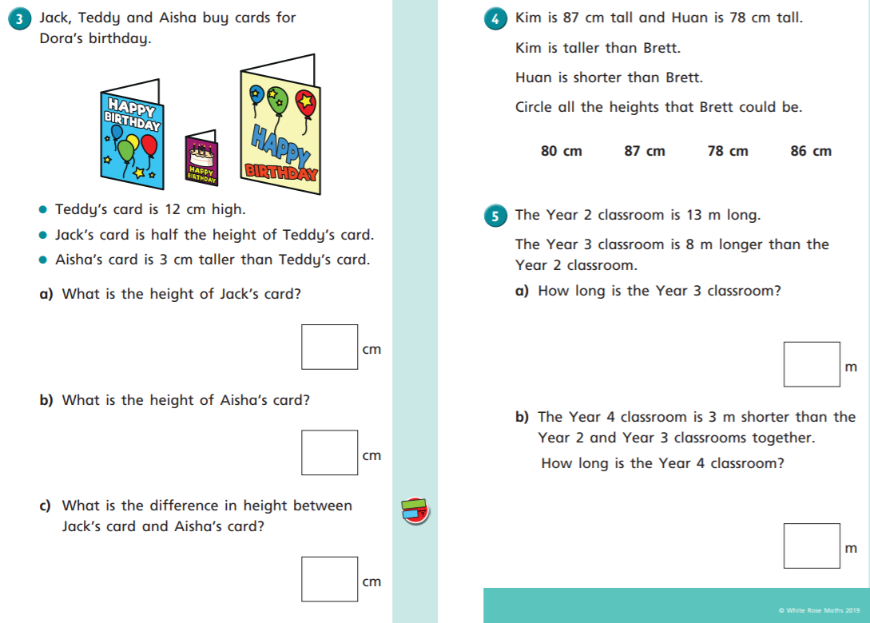

Digging Deeper
How did today’s main lesson go? Are you up for the challenge of digging even deeper? If you sailed through the lesson then keep going with today’s Digging Deeper task here:

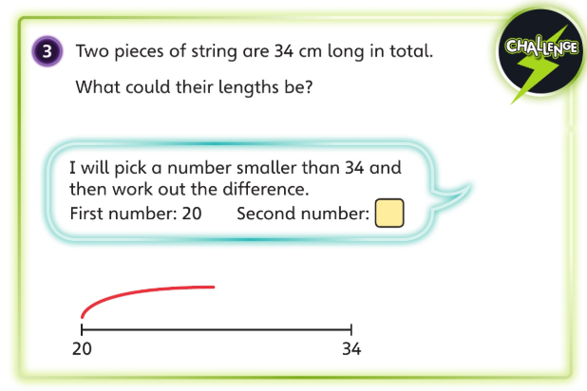

Thursday 30th April
English: Apply grammar focus independently.

- Start by drawing a map of places in your local area and label this.

2) Then write about what your local area used to look like and what it looks like now.
For example there used to be busy roads and open libraries, now it is very quiet. Normally your family would be at work and you would be at school but now you are all home and the house is busy.
Use past tense verbs.
Then:_________________________________________________________________________________________________________________________________________________________________________________________________________________________________________________________________________________________________________________________________________________________________________________________________________________________Now:______________________________________________________________________________________________________________________________________________________________________________________________________________________________________________________________________________________________________________________________________________________________

Thursday
Maths: Problem solving
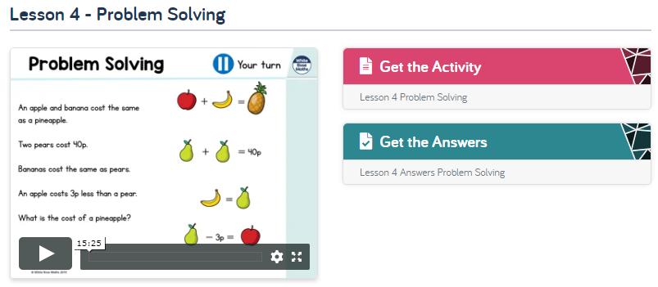

We are on Lesson 4 of Summer Term - Week 2 of the Year 2 Home Learning Lessons. Watch the Lesson 4 Problem Solving video, then have a go at the worksheet and check your answers.
Video: https://whiterosemaths.com/homelearning/year-2/
Worksheet: https://wrm-13b48.kxcdn.com/wp-content/uploads/2020/homelearning/year-2/Lesson-4-Problem-Solving.pdf
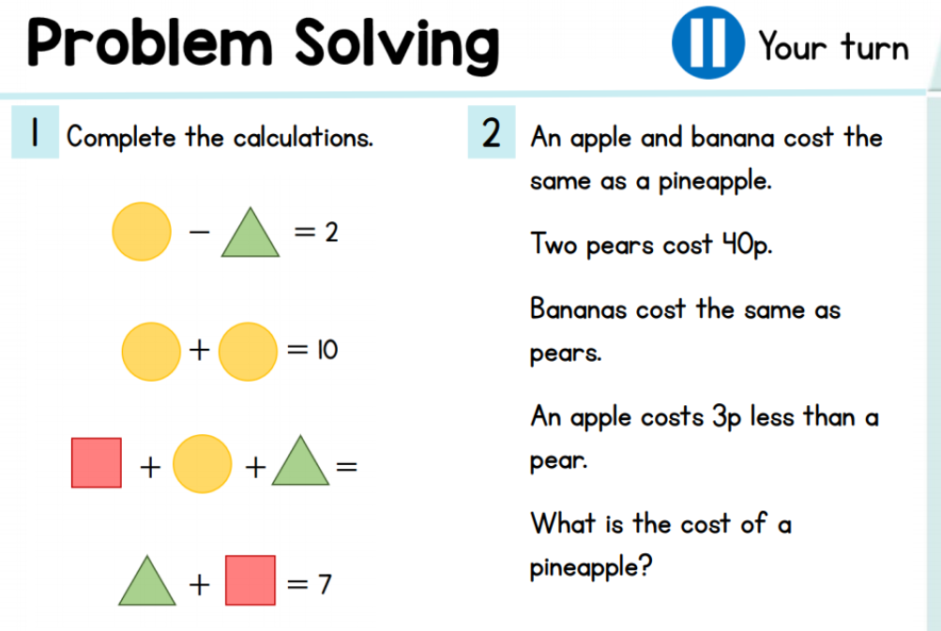
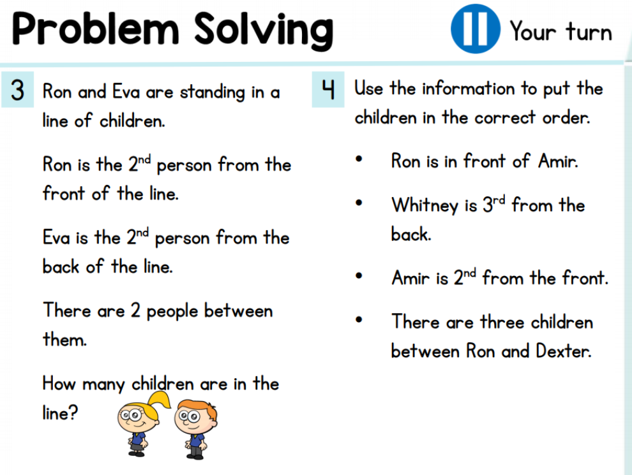

Digging Deeper
If you want an extra challenge today have a go at this. Try and make your explanation as clear and detailed as you can. You could use a number sentence in your answer to show it in another way.
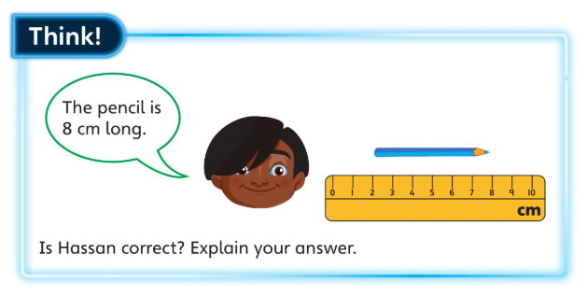

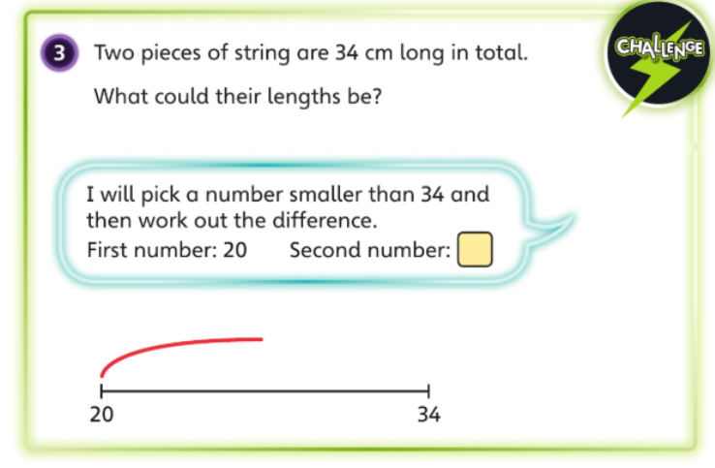
A note on yesterday’s Digging Deeper
First number: 20 Second number: 14
We know this is correct because 20 + 14 = 34
You could have worked it out by doing 34 - 20 =14

Then you could add 1 to the first number and take 1 away (subtract) from the second, 21 and 13, 22 and 12, 23 and 11 and so on.

Friday 1st May
English: Have a go at writing a diary entry summarising the events in the past week.

Write a diary entry about the area you live in. Include the following:
- What you have been up to.
- Children write any changes in daily life, activity on your street, traffic.
- Who is still off to work and why?
- What are you doing now compared to what you normally do? How does it feel?
- Explain what it used to be like compared to now.
- Changes in routine.

You can write your diary in your book.
Dear Diary,
___________________________________________________________________________________________________________________________________________________________________________________________________________________________________________________________________________________________________________________________________________________________________________________________________________________________________________________________________________________________________________________________________________________________________________________________________________________________________________________________________________________________________________________________________________________________________________
Love from _______________

Friday
Maths: Maths challenge

It’s Friday again and that means just one thing for maths…Maths Challenge! Follow the Lesson 5 Maths Challenge in Summer Term - Week 2. Enjoy!

Yesterday’s Digging Deeper
Hassan was not correct yesterday because he started measuring at 2cm and not at 0cm as he should.
Maybe you talked about the need to start counting from 0 to get the correct number. You could show this counting 6 objects but saying “3, 4, 5, 6, 7, 8” and asking if there are 8.
Perhaps you worked out the right measurement. 8cm - 2cm = 6cm, so the pencil is 6cm

