Home Learning Project WEEK 1 - My Family
Lower Key Stage 2 - Classes: Eagles, Owls, Parrots and Toucans
Maths Tasks |  | Writing Tasks
As a school, we will be following the White Rose Home Learning sequence.  Your teacher will explain which lesson to complete in a daily Marvellous Me message. Here is the overview of what the week will look like:  Monday: Unit and non-unit fractions  Tuesday: Making the whole  Wednesday: Tenths  Thursday: Counting in tenths  Friday: Tenths as decimals  To access this work you need to follow the link on your daily work sheet and look at Week 1.  Below is extra maths links you might find useful:  - Play on Hit the Button - focus on halves, doubles and times tables.  - Complete Multiplication 2Dos on Purple Mash. |  | Your teacher will send specific writing tasks to be completed on a daily Marvellous Me message. Here is the overview of what the week will look like:  Monday: Read through the WAGOLL (What A Good One Looks Like) of a character description and identify the key features outlined to you.  Tuesday: Answer comprehension questions based on the WAGOLL text.  Wednesday: Complete grammar task.  Thursday: Apply grammar focus independently.  Friday: Have a go at writing your own character description based on a member of your family.
Spelling Tasks |  | Reading Tasks
Below is a selection of spelling tasks to choose from throughout the week:  - Practise the Year 3/4 for Common Exception words.  - Complete weekly spelling 2Dos on Purple Mash. Make sure you use your personal logins.  - Practise your spelling on Spelling Frame  - Practise your spellings by playing a game on Topmarks.  - Practise 5 common exception words by making up mnemonics for them e.g. because = big elephants can always understand small elephants.  - Create and add to topic word bank which includes any new words you come across this week. |  | Below is a selection of reading tasks to choose from throughout the week:  - You could share a story together. This could be a chapter book where you read and discuss a chapter a day.  - Listen to your child read and let them discuss what they have read.  - Watch Newsround and discuss what is happening in the wider world.  - Sign in to epic! using your class login and get reading!  Owls: kbl8055  Eagles: vvg8816  Parrots: xiq1440  Toucans: xjx3740  - Bake a new recipe and let your child read the instructions to you.  - Read the First News newspaper and The Week Jr magazine together.
Wider Curriculum Menu
As well as completing a daily maths, English, spelling and reading task, we have put together a selection of different wider curriculum activities for you to complete at your leisure. We realise this is a busy time and so most of these do not require written work but instead are discussion and interaction based. You can complete as many as you like in any order you want!
Spend time looking through old photos and talking about the people in your family. | Play a board game with members of your family. |  | Help the adults in your home to make lunch/ dinner.
Create a poster which displays why differences between families should be celebrated. | With the help of adults in your family, create a family tree which shows the growth of your family. |  | Listen to different pieces of music together with your family from the different generations.
Create a portrait of your family. It could be drawn, painted, sculpted or collaged. | FaceTime or Skype a member of your family you have not seen this week for a catch up. |  | Locate on a map where different people in your family originate from.
Enjoy a family picnic in the garden or even in the living room if the weather isn’t very warm. | Have a family workout alongside Joe Wicks at 9am. |  | Let your adult tell you a story from their childhood. It might be about their grandparents or something that they remember from their childhood.
Additional learning resources you may wish to engage with
There are plenty of events happening online to take advantage of while at home:
- Maths with Carol Vorderman www.themathsfactor.com
- Cooking with Jamie Oliver https://www.jamieoliver.com/features/category/get-kids-cooking/
- Music with Myleene Klass https://www.youtube.com/channel/UCQh2wgJ5tOrixYBn6jFXsXQ
- Science with Professor Brian Cox, Robin Ince & Guests https://cosmicshambles.com/stayathome/upcoming-schedule
- Daily drawing lessons with Author Mo Willems https://www.youtube/Mjacom/watch?v=RmzjCPQv3y8
- Virtual museum tours https://www.familydaystriedandtested.com/free-virtual-tours-of-world-museums-educational-sites-galleries-for-children/
- San Diego Zoo live cam https://zoo.sandiegozoo.org/live-cams

Monday 20th April 2020

Good morning Year 3 and welcome back from your Easter break. We hope you had a wonderful time and were able to get out and play in the sunshine. Now we’re back to school work, you will be receiving daily Maths and English work to be completing as well as tasks focussed on a weekly project. This week’s project is your family – so have fun exploring your heritage and backgrounds.
We miss you lots!
Mrs Cutteridge and Mrs Smith

Maths 20.4.20
Today we would like you to focus on Lesson 1 of the home learning which can be found here: https://whiterosemaths.com/homelearning/year-3/
Today’s lesson is recognising unit and non-unit fractions

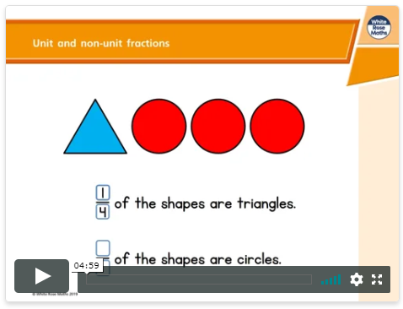
Watch the lesson video (which looks like the screen above) and then answer the attached worksheet. If you find this lesson comfortable and would like to stretch yourselves, have a go at the go deeper questions which are also attached at the end of this document.
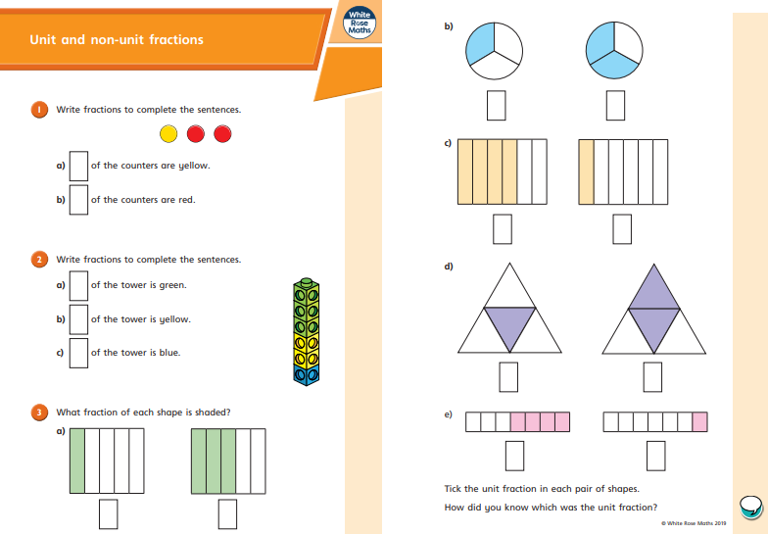

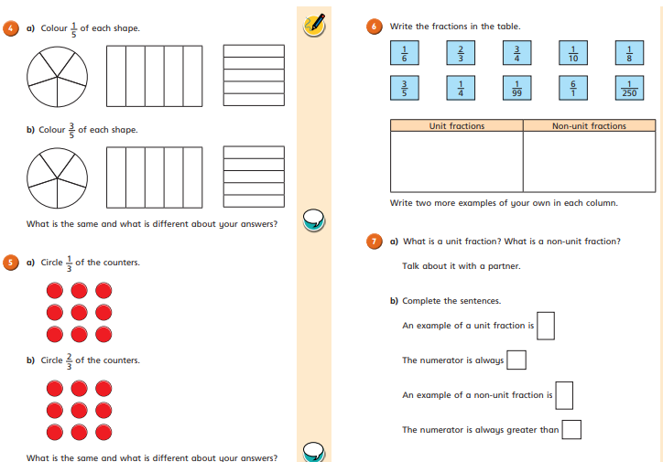

Go deep:
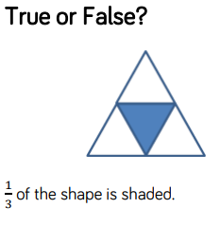

Go deeper:
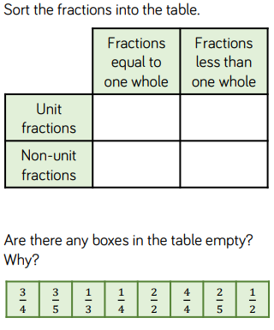

English 20.4.20
This week we are going to be building up to writing our own character descriptions of a family member. Today we would like you to read through this WAGOLL (What A Good One Looks Like) and identify the key features. You could underline, highlight or circle the features within the texts in different colours.

Key features to find | Key
Fronted adverbials of manner, time or place
Expanded noun phrases (determiner adjective, adjective noun)
Alliteration (e.g. towering tall tree)

Scorch is a huge, explosive lava monster that terrifies anyone who sees him. All over his body, there are huge, bumpy boulders. When he is angry, the boulders on his skin begin to glow a dark, burning orange. Sometimes, chunks of his rocky flesh fall like lava bombs which instantly ignite into furious flames. On top of his muscular shoulders, there are two horrendous heads with burning and smouldering eyes. Unfortunately, he has a horrid personality. During the night, he has a calm and relaxed manner. When the sun rises, the loud noises of the town irritate him. This makes him heat up with anger and raise his temperature so that he creates thick, threatening clouds from his ears and spits out liquid lava.

Tuesday 21st April 2020

Hello Year 3!
We hope you are having a productive start to the half term and enjoyed your learning yesterday. Here is the work for you to do today – enjoy!
Mrs Cutteridge and Mrs Smith

Maths 21.4.20
Today we would like you to focus on Lesson 2 of the home learning which can be found here: https://whiterosemaths.com/homelearning/year-3/
Today’s lesson is making a whole out of fractions.
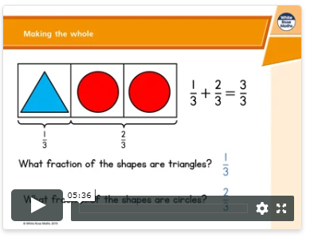
Watch the lesson video (which looks like the screen above) and then answer the attached worksheet. If you find this lesson comfortable and would like to stretch yourselves, have a go at the go deeper questions which are also attached at the end of this document.

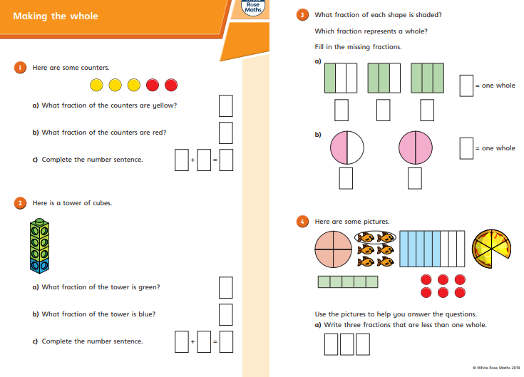

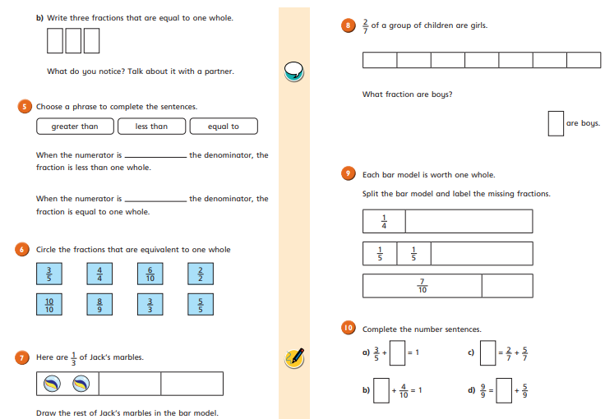

Go Deep:
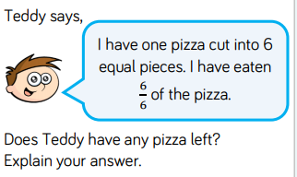

Go Deeper:
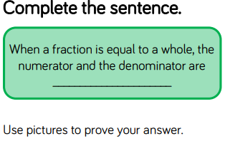

English 21.4.20
This week we are going to be building up to writing our own character descriptions of a family member. Today I would like you to read through the WAGOLL (What A Good One Looks Like) and answer the following comprehension questions. Most questions will be simple retrieving from the text but some may need you to use your inference skills to come up with plausible answers.

Scorch is a huge, explosive lava monster that terrifies anyone who sees him. All over his body, there are huge, bumpy boulders. When he is angry, the boulders on his skin begin to glow a dark, burning orange. Sometimes, chunks of his rocky flesh fall like lava bombs which instantly ignite into furious flames. On top of his muscular shoulders, there are two horrendous heads with burning and smouldering eyes. Unfortunately, he has a horrid personality and unpredictable behaviour. During the night, he has a calm and relaxed manner. When the sun rises, the loud noises of the town irritate him. This makes him heat up with anger and raise his temperature so that he creates thick, threatening clouds from his ears and spits out liquid lava.

1. What is the name of the creature being described?
2. What is all over his body?
3. Use your decoding skills. What could the word ignite mean?
4. Do you think the creature’s behaviour is predictable?
5. What time of day is he more relaxed?
6. Do you think the creature is a fan of people?
7. What happens when the creature is irritated?

Extension: If you would like to, you can visualise and draw what you think the creature looks like.

20.4.20 ANSWERS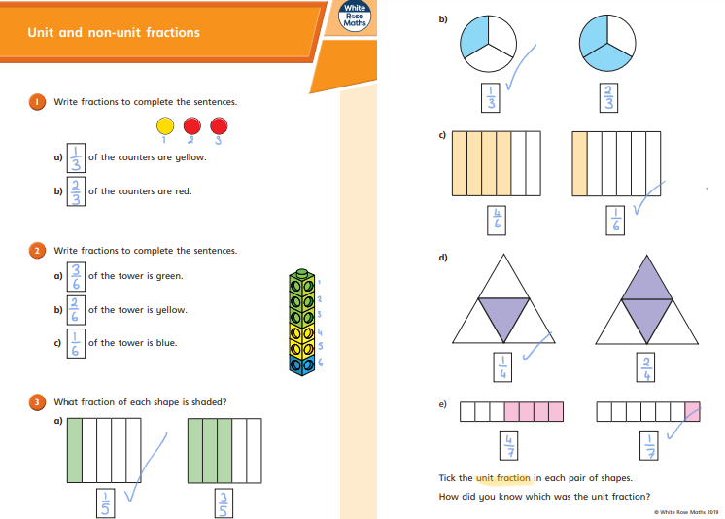

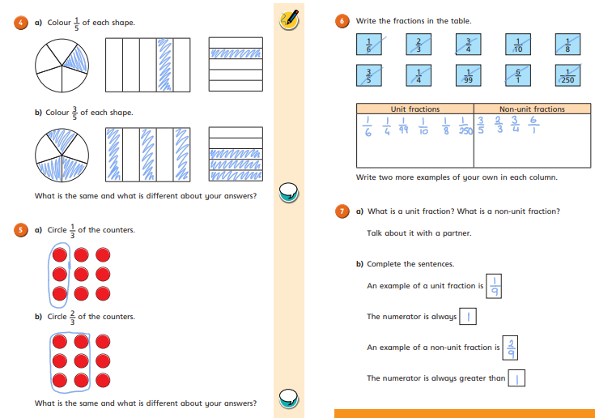

Go deep:
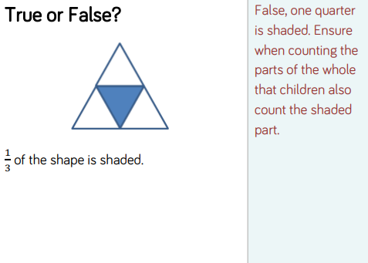
Go deeper:
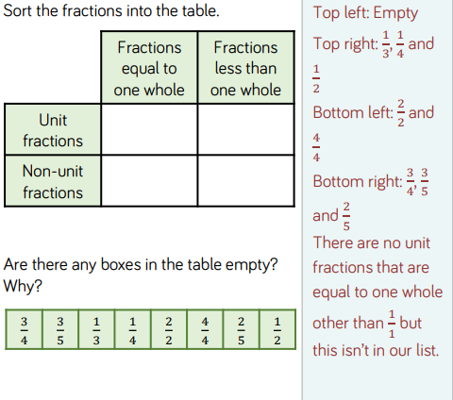

Key features to find | Key
Fronted adverbials of manner, time or place
Expanded noun phrases (determiner adjective, adjective noun)
Alliteration (e.g. towering tall tree)

Scorch is a huge, explosive lava monster that terrifies anyone who sees him. All over his body, there are huge, rough boulders. When he is angry, the boulders on his skin begin to glow a dark, burning orange. Sometimes, chunks of his rocky flesh fall like lava bombs which instantly ignite into furious flames. On top of his muscular shoulders, there are two ugly heads with burning, smouldering eyes. Unfortunately, he has a horrid personality. During the night, he has a calm and relaxed manner. When the sun rises, the loud noises of the town irritate him. This makes him heat up with anger and raise his temperature so that he creates thick, threatening clouds from his ears and spits out liquid lava.

Wednesday 22nd April 2020

Good morning Year 3!
We hope you are having a productive start to the half term. You will be receiving daily Maths and English work to be completing as well as tasks focussed on a weekly project. This week’s project is your family – so have fun exploring your heritage and backgrounds. You are awesome!
Mrs Cutteridge and Mrs Smith

Maths 22.4.20
Today we would like you to focus on Lesson 3 of the home learning which can be found here: https://whiterosemaths.com/homelearning/year-3/
Today’s lesson is tenths as a fraction.
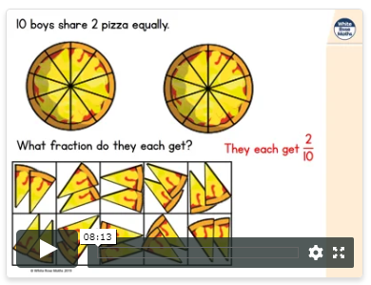
Watch the lesson video (which looks like the screen above) and then answer the attached worksheet. If you find this lesson comfortable and would like to stretch yourselves, have a go at the go deeper questions which are also attached at the end of this document.

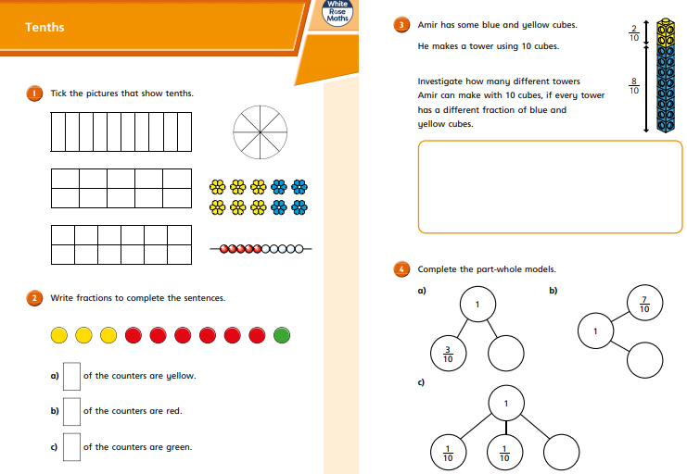

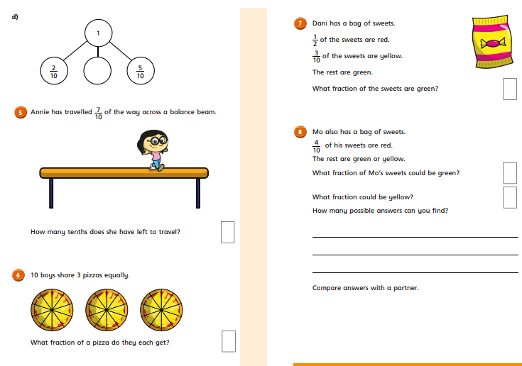

Go Deep:

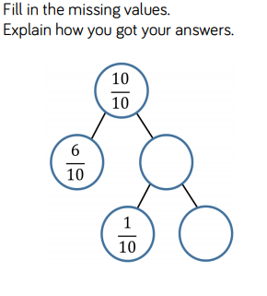
Go Deeper:
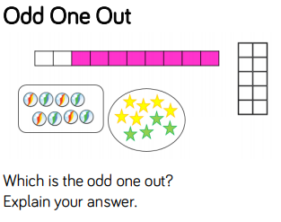

English 22.4.20
This week we are going to be building up to writing our own character descriptions of a family member. Today, I would like you to focus on expanded noun phrases and fronted adverbials. We are going to use our skills to up level the following boring sentences into more detailed and interesting ones. Here is an example:
The road ran past a field.
1. Add adjectives to expand the noun phrase.

The long, straight road ran past a luscious, green field.
2. Start your sentence with a fronted adverbial.

Early one morning, the long, straight road ran past a luscious, green field.

Some girls jumped in a field.
1. Add adjectives to expand the noun phrase.

2. Start your sentence with a fronted adverbial.

The house was in the woods.
1. Add adjectives to expand the noun phrase.

2. Start your sentence with a fronted adverbial.

The garden had lots of plants.
1. Add adjectives to expand the noun phrase.

2. Start your sentence with a fronted adverbial.

A cat chased the mouse.
1. Add adjectives to expand the noun phrase.

2. Start your sentence with a fronted adverbial.

Her mum baked a cake.
1. Add adjectives to expand the noun phrase.

2. Start your sentence with a fronted adverbial.

21.4.20 ANSWERS
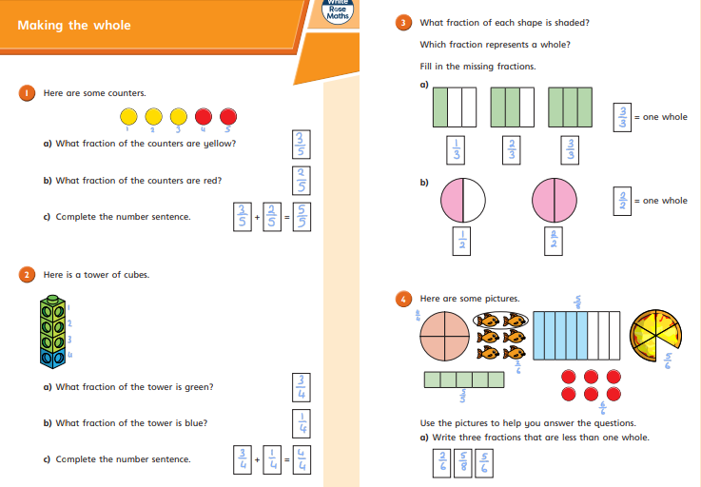

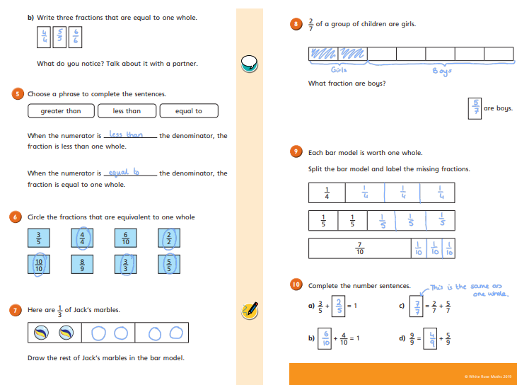

Go deep:
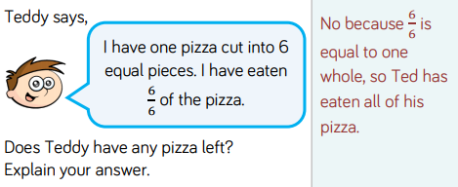

Go deeper:
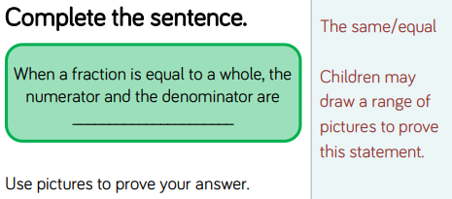
English – reading lesson
1. What is the name of the creature being described?
The name of the creature being described is Scorch.
2. What is all over his body?
All over his body, there are huge, bumpy boulders
3. Use your decoding skills. What could the word ignite mean?
The text says that ‘chunks of his rocky flesh fall like lava bombs which instantly ignite into furious flames’. If they ignite into flames, ignite could mean to become on fire.
4. Do you think the creature’s behaviour is predictable?
I do not think the creature is predictable as he is described as having a horrid personality and unpredictable behaviour which means not predictable.
5. What time of day is he more relaxed?
He is more relaxed during the night.
6. Do you think the creature is a fan of people?
Any answer, which uses what they can infer from the text, is acceptable. For example, I do not think the creature is a fan of people as he is happier at night when it is quiet and there are not many people around at night.
7. What happens when the creature is irritated?
When he is irritated, he heats up with anger and raises his temperature so that he creates thick, threatening clouds from his ears and spits out liquid lava.

Thursday 23rd April 2020

Good morning Year 3!
Well done on your hard work this week so far. Remember to complete your new English and maths learning and continue to do your project on your family. We miss you and we think you are fantastic!
Mrs Cutteridge and Mrs Smith

Maths 23.4.20
Today we would like you to focus on Lesson 4 of the home learning which can be found here: https://whiterosemaths.com/homelearning/year-3/
Today’s lesson is counting in tenths.
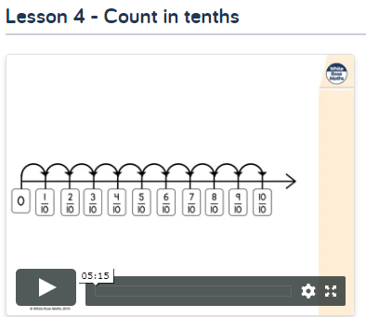

Watch the lesson video (which looks like the screen above) and then answer the attached worksheet. If you find this lesson comfortable and would like to stretch yourselves, have a go at the go deeper questions which are also attached at the end of this document.

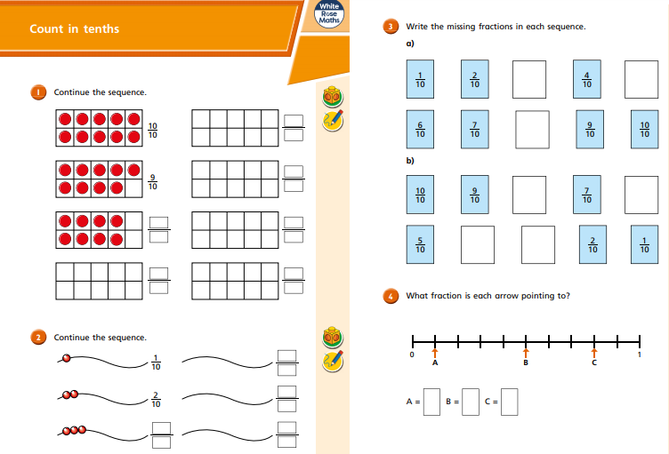
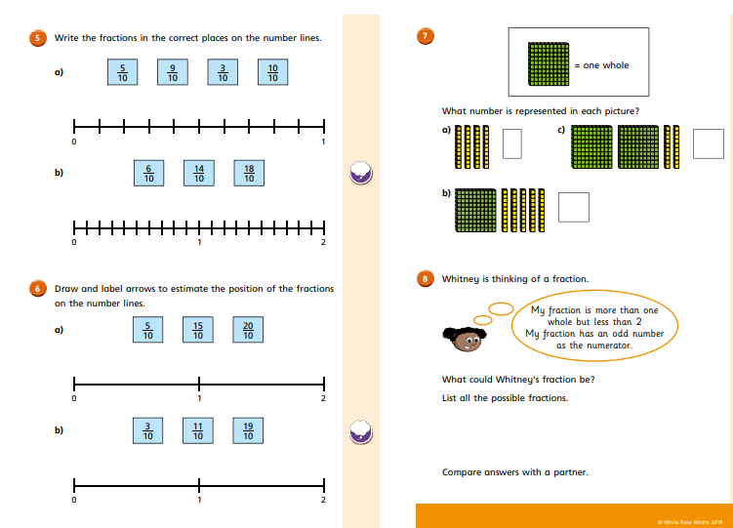

Go Deep:
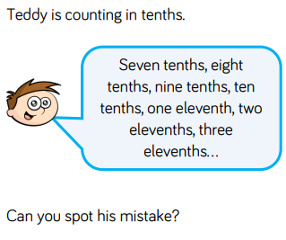

Go Deeper:
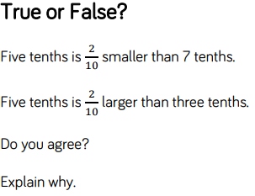

English 23.4.20
This week we are going to be building up to writing our own character descriptions of a family member. Today, you are going to construct your own interesting sentences. Use the table below to help you but if you come up with your own interesting sentences…even better! Example: Near the town, there was a colourful, gigantic bus driving through the bustling streets!

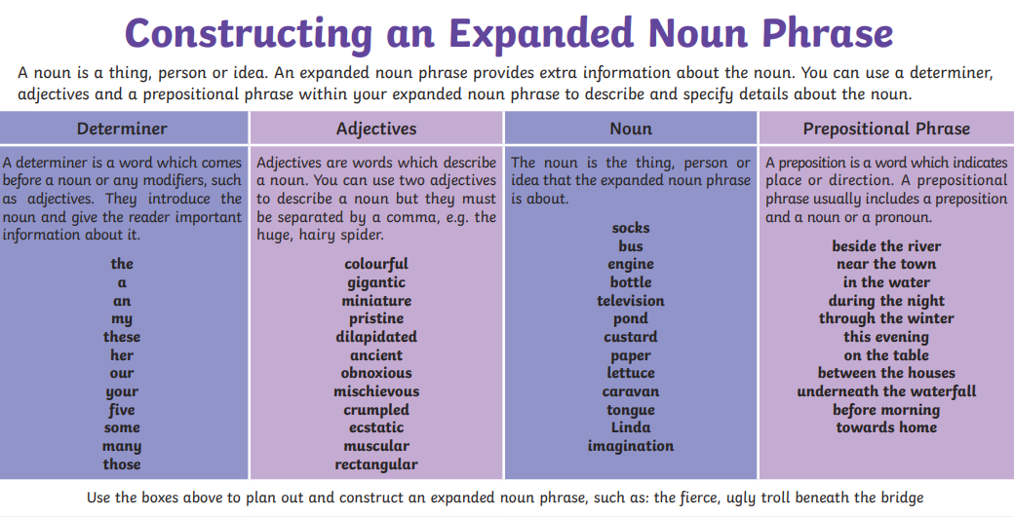

22.4.20 ANSWERS
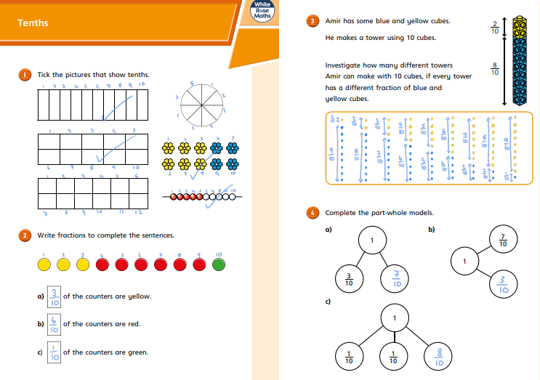
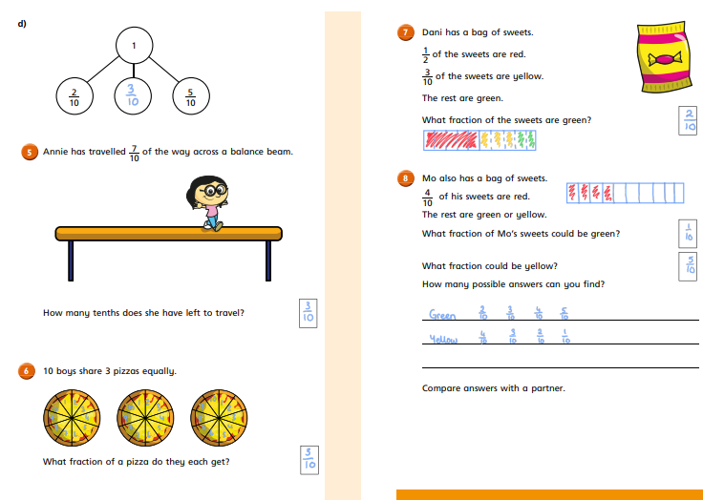

Go deep:
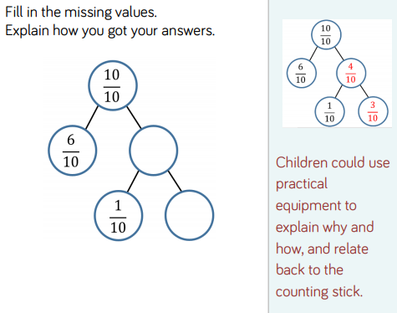
Go deeper:
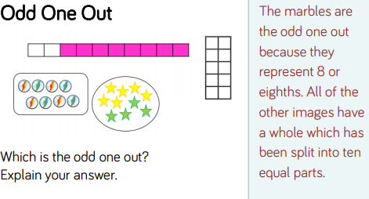

Some girls jumped in a field.
1. Add adjectives to expand the noun phrase.

Some energetic and spirited young girls jumped in a beautiful, grassy field.
2. Start your sentence with a fronted adverbial.

With great joy, some energetic and spirited young girls jumped in a beautiful, grassy field.

The house was in the woods.
1. Add adjectives to expand the noun phrase.

The ancient, moss covered house was stood in the dark, echoing woods.
2. Start your sentence with a fronted adverbial.

Eerily, the ancient, moss covered house was stood in the dark, echoing woods.

The garden had lots of plants.
1. Add adjectives to expand the noun phrase.

The bright, stunning garden had lots of blooming, colourful plants.
2. Start your sentence with a fronted adverbial.

Full of life, the bright, stunning garden had lots of blooming, colourful plants.

A cat chased the mouse.
1. Add adjectives to expand the noun phrase.

A ginger, grumpy cat chased the tiny, exhausted mouse.
2. Start your sentence with a fronted adverbial.

Mischievously, a ginger, grumpy cat chased the tiny, exhausted mouse.

Friday 24th April 2020

Hello you wonderful bunch!
Well done for working so hard on your first week back! We know it can be hard to be motivated at home but we are so proud of you and all your hard work and resilience. Have a well earnt break this week. When you start again on Monday, we will be working on a new project – wait and see what it is!
Keep smiling
Mrs Cutteridge and Mrs Smith

Maths 24.4.20
Today we would like you to focus on Lesson 5 of the home learning which can be found here: https://whiterosemaths.com/homelearning/year-3/
Today’s lesson is tenths as decimals.
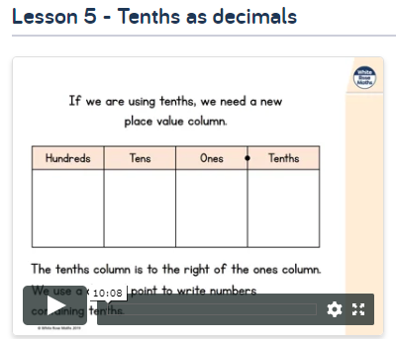

Watch the lesson video (which looks like the screen above) and then answer the attached worksheet. If you find this lesson comfortable and would like to stretch yourselves, have a go at the go deeper questions which are also attached at the end of this document.

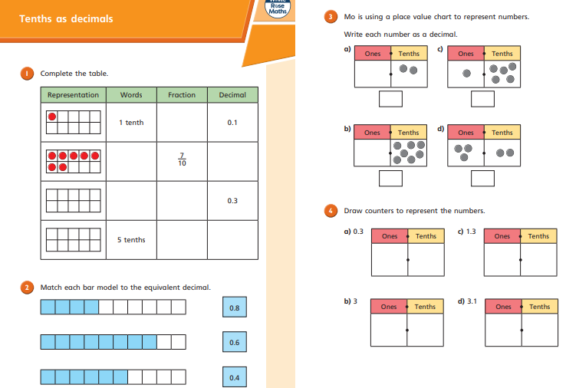
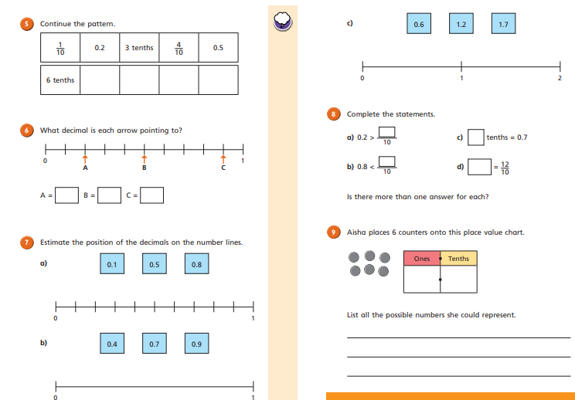

Go Deep:
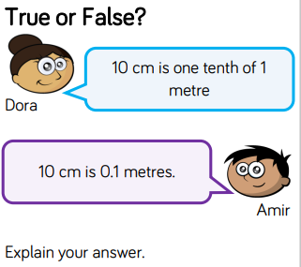

Go Deeper:
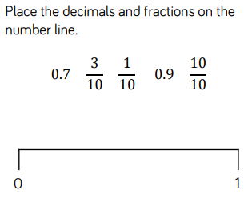

English 24.4.20
This week we are going to be building up to writing our own character descriptions of a family member. Today, you are going to have a go at writing your own character description about a member of your family. It could be about anyone – mum, dad, grandma, grandad, brother, sister etc!
Remember to include your fronted adverbials, expanded noun phrases and even alliteration if you can. Describe both their physical appearance and personality. Use the WAGOLL to guide you but make sure it is your own work.

23.4.20 ANSWERS
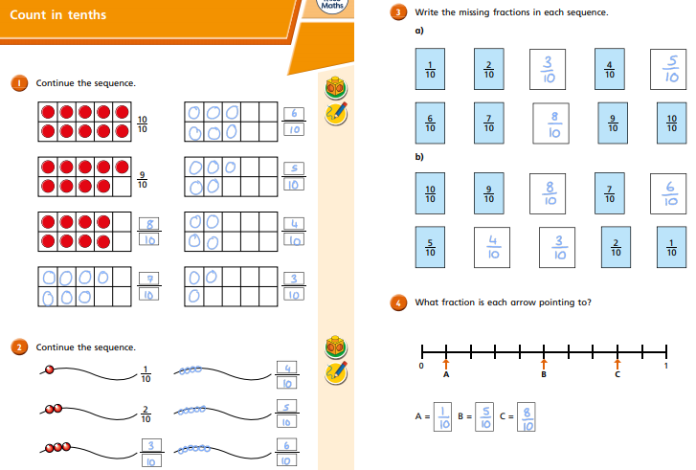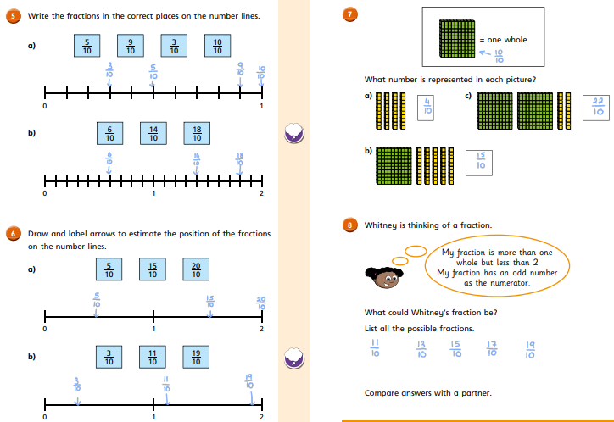

Go deep:
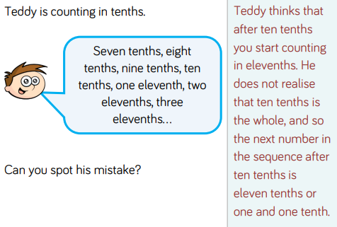
Go deeper:
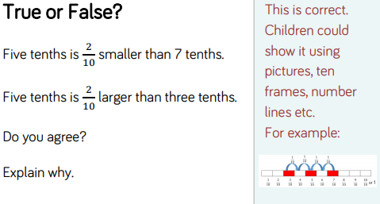

The children could have produced a number of acceptable sentences as long as they had included the 4 different aspects and their sentences made sense.
Examples:
In the water, there were many miniature, colourful fish.
This evening, my ancient, broken engine stopped working.
On the table, was a pristine, brand new television.

