Learning Project WEEK 2 – The Area You Live In
Lower Key Stage 2 - Classes: Eagles, Owls, Parrots and Toucans
Maths Tasks |  | Writing Tasks
As a school, we will be following the White Rose Home Learning sequence.  Your teacher will explain which lesson to complete in a daily Marvellous Me message. Here is the overview of what the week will look like:  Monday: Fractions on a number line  Tuesday: Fractions of a set of objects (1)  Wednesday: Fractions of a set of objects (2)  Thursday: Fractions of a set of objects (3)  Friday: Equivalent fractions (1)  Below is extra maths links you might find useful:  - Play on Hit the Button - focus on halves, doubles and times tables.  - Complete Multiplication 2Dos on Purple Mash. |  | Your teacher will send specific writing tasks to be completed on a daily Marvellous Me message. Here is the overview of what the week will look like:  Monday: Read through the WAGOLL (What A Good One Looks Like) of a diary entry and identify the key features outlined to you.  Tuesday: Answer comprehension questions based on the WAGOLL text.  Wednesday: Complete grammar task.  Thursday: Apply grammar focus independently.  Friday: Have a go at writing your own diary entry, summarising the events of the past week in your house.
Spelling Tasks |  | Reading Tasks
Below is a selection of spelling tasks to choose from throughout the week:  - Practise the Year 3/4 for Common Exception words.  - Complete weekly spelling 2Dos on Purple Mash. Make sure you use your personal logins.  - Practise your spelling on Spelling Frame  - Practise your spellings by playing a game on Topmarks.  - Practise 5 common exception words by making up mnemonics for them e.g. because = big elephants can always understand small elephants.  - Create and add to topic word bank which includes any new words you come across this week. |  | Below is a selection of reading tasks to choose from throughout the week:  - You could share a story together. This could be a chapter book where you read and discuss a chapter a day.  - Listen to your child read and let them discuss what they have read.  - Watch Newsround and discuss what is happening in the wider world.  - Sign in to epic! using your class login and get reading!  Owls: kbl8055  Eagles: vvg8816  Parrots: xiq1440  Toucans: xjx3740  - Bake a new recipe and let your child read the instructions to you.  - Read the First News newspaper and The Week Jr magazine together.
Wider Curriculum Menu
As well as completing a daily maths, English, spelling and reading task, we have put together a selection of different wider curriculum activities for you to complete at your leisure. We realise this is a busy time and so most of these do not require written work but instead are discussion and interaction based. You can complete as many as you like in any order you want!
Look through old photos of Nottingham (try here) and make a presentation of the differences between modern-day and historic Nottingham. | Create an urban landscape drawing or sketch of the view from your window – watch this video for tips. |  | Draw a map from memory of your street, your suburb or your city. Which landmarks, natural and/or physical features will you include?
Create a poster advertising Nottingham to tourists – Why should people visit? What’s Nottingham famous for? What can be done? | Create a list or table of different businesses in your local area which you may want visit after Covid-19 passes. Explain why. |  | Research what our city is famous for (it might be a person or an invention -start here) and present your findings.
Make a model of your street using household recycling, Lego or anything your parents allow. | Write a nice letter to a local nursing home to be read out to residents who may be alone during this time. |  | Locate on a map where you house is compared to school. Plan three different routes (on foot, public transport and by car).
Reflect: Think about what would improve the local area. What is the area missing? What spoils your local area? What could be done to improve it? | Conduct a survey of the local wildlife you can see from your window or in your garden. Present your findings in a pictograph, bar chart and line graph. |  | Phone a local, elderly relative or neighbour (if possible) interview them (you need to plan questions) about how the local area’s changed.
Additional learning resources you may wish to engage with
There are plenty of events happening online to take advantage of while at home:
- Maths with Carol Vorderman www.themathsfactor.com
- Cooking with Jamie Oliver https://www.jamieoliver.com/features/category/get-kids-cooking/
- Music with Myleene Klass https://www.youtube.com/channel/UCQh2wgJ5tOrixYBn6jFXsXQ
- Daily drawing lessons with Author Mo Willems https://www.youtube/Mjacom/watch?v=RmzjCPQv3y8
- Virtual museum tours https://www.familydaystriedandtested.com/free-virtual-tours-of-world-museums-educational-sites-galleries-for-children/
- San Diego Zoo live cam https://zoo.sandiegozoo.org/live-cams

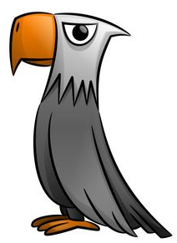
Monday 27th April 2020

Good morning Year 3!
Just like last week, you will be receiving daily Maths and English work to be completing as well as tasks focussed on a weekly project. This week’s project is The Area You Live In. We hope you enjoy exploring the geography, history and beauty of your locality from the comfort of your home!
Mrs Cutteridge and Mrs Smith

Maths 27.04.20
Today we would like you to focus on Lesson 1 of the home learning which can be found here: https://whiterosemaths.com/homelearning/year-3/
Today’s lesson is fractions on a number line
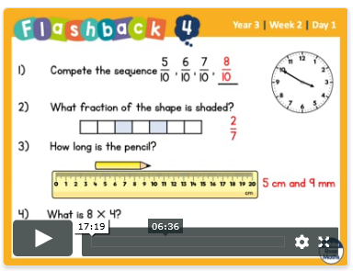
Watch the lesson video (Week 2 lesson 1), which looks like the screen above, and then answer the attached worksheet. If you find this lesson comfortable and would like to stretch yourselves, have a go and the go deeper questions which are also attached at the end of this document.

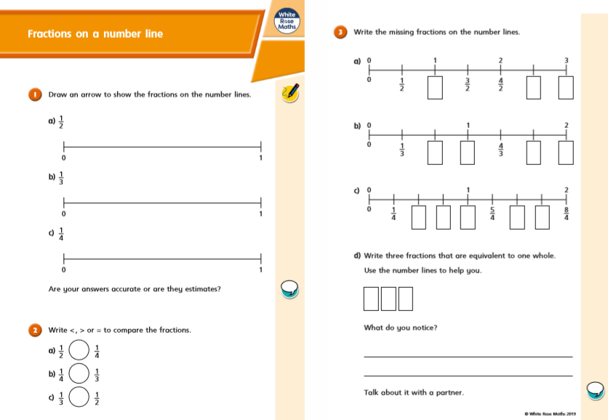

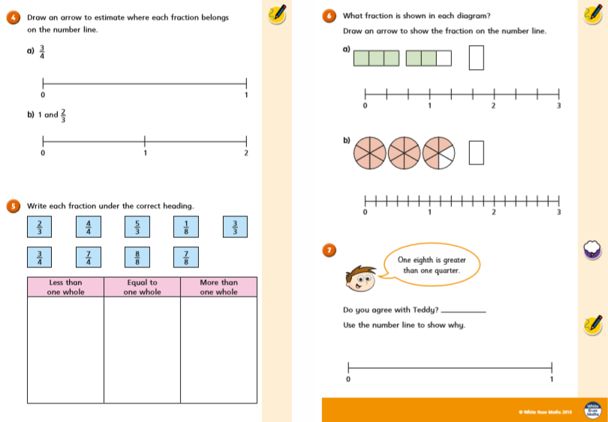
Deep: Go Deeper:
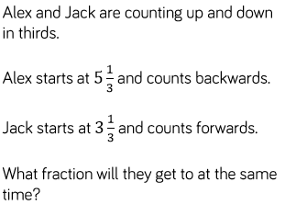
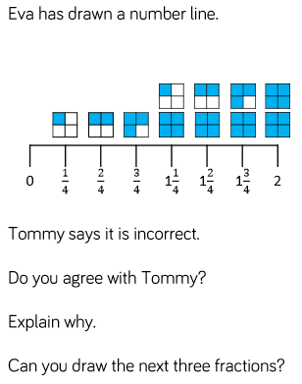

Friday’s Answers
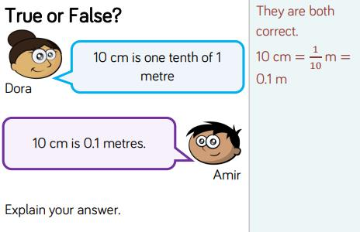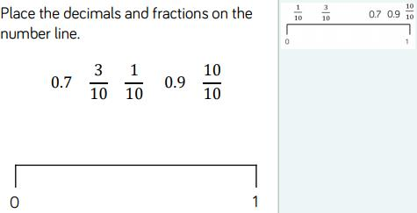
The answers to the main tasks can be downloaded from the link next to each video.

English 27.04.20
This week we are going to be building up to writing our own diary entry. Today I would like you to read through the WAGOLL (What A Good One Looks Like) and identify the key features. You can underline, highlight or circle the features within the texts.

Key Features To Find | Key (Colour)
Written in the first person
Written in the past tense
Prepositions (where something is)
Thoughts and feelings expressed

Wednesday 24th June AD43
Dear Diary,
Today was so tiring! Our generals woke us up very early so that we could start work on a new road. I crawled out of bed and rubbed the sleep from my eyes. I ate the grub they called breakfast with the seven other men from my tent – I was glad it wasn’t my turn to wash up!
I began work on the road, we spent all morning trying to build it. The stones had to be cut to exactly the right shape and size, and when I lifted them they were so heavy. My back was so sore it felt like it was on fire!
After a few hours working on the road, the general stopped us for battle training. We marched for 20 miles while we carried all our spare clothes, swords, shields, cooking equipment…even our tent! Then we practised attacking and learnt more sword fighting skills. It sounds like fun but my arms really ached by the end!
I was so happy at the end of the day when we returned to camp. All the men in our century needed to eat. Now it’s late and I’m about to climb back into my tent with the other soldiers in my group. Despite the awful weather here in England, the tent gets pretty hot with 8 of us in it! At least it keeps us warm. The campfires will soon be put out and we will all go to bed, but tomorrow we will have to do it all over again.
I thought joining the army would be fun, but it’s hard work and I’m starting to miss my family.
Maximus

Tuesday 28th April 2020

Good morning Year 3!
Here’s today’s daily Maths and English work to complete, in addition to our weekly project learning tasks. This week’s project is The Area You Live In. We hope you enjoy exploring the geography, history and beauty of your locality from the comfort of your home!
Mrs Cutteridge and Mrs Smith

Maths 28.04.20
Today we would like you to focus on Week 2 Lesson 2 of the home learning which can be found here: https://whiterosemaths.com/homelearning/year-3/
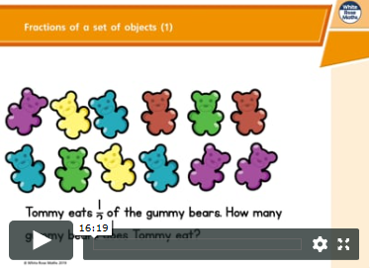
Today’s lesson is on fractions of a set of objects. It is the 1st of three lessons we will do on this subject.
Watch the lesson video (Week 2 lesson 2), which looks like the screen above, and then answer the attached worksheet. If you find this lesson comfortable and would like to stretch yourselves, have a go and the go deeper questions which are also attached at the end of this document.

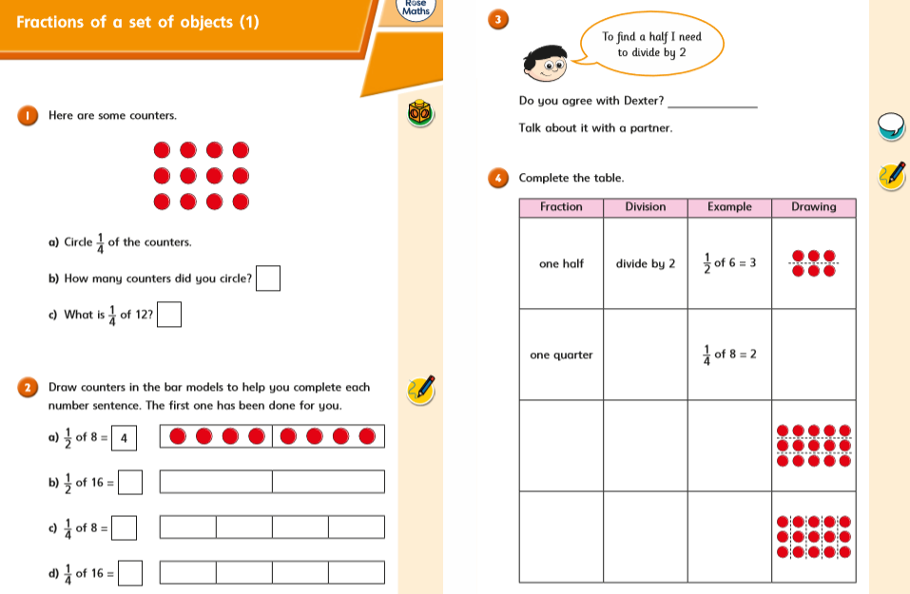
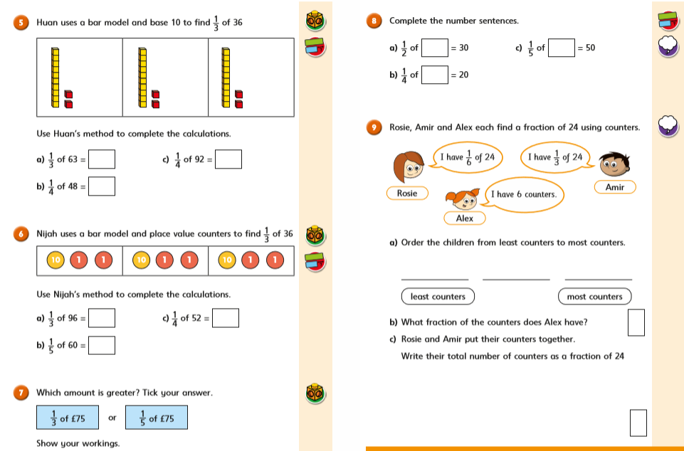
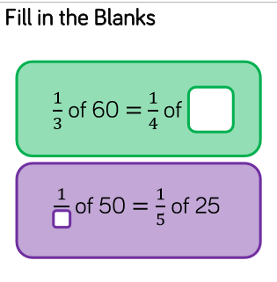
Deep: Go Deeper:
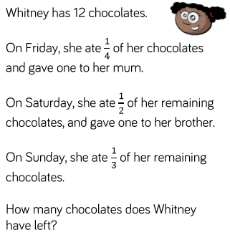

Yesterday’s Answers
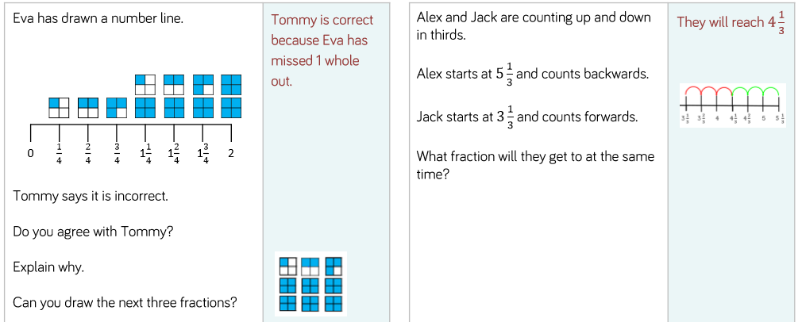

The answers to the main tasks can be downloaded from the link next to each video.

English 28.04.20
This week we are going to be building up to writing our own diary entry. Today I would like you to read through the WAGOLL (What A Good One Looks Like) and answer the following comprehension questions.
WAGOLL
Wednesday 24th June AD42
Dear Diary,
Today was so tiring! Our generals woke us up very early so that we could start work on a new road. I crawled out of bed and rubbed the sleep from my eyes. I ate the grub they called breakfast with the seven other men from my tent – I was glad it wasn’t my turn to wash up!
I began work on the road, we spent all morning trying to build it. The stones had to be cut to exactly the right shape and size, and when I lifted them they were so heavy. My back was so sore it felt like it was on fire!
After a few hours working on the road, the general stopped us for battle training. We marched for 20 miles while we carried all our spare clothes, swords, shields, cooking equipment…even our tent! Then we practised attacking and learnt more sword fighting skills. It sounds like fun but my arms really ached by the end!
I was so happy at the end of the day when we returned to camp. All the men in our century needed to eat. Now it’s late and I’m about to climb back into my tent with the other soldiers in my group. Despite the awful weather here in England, the tent gets pretty hot with 8 of us in it! At least it keeps us warm. The campfires will soon be put out and we will all go to bed, but tomorrow we will have to do it all over again.
I thought joining the army would be fun, but it’s hard work and I’m starting to miss my family.
Maximus

Questions
- What date was this diary written?
- Which adjective describes Maximus’s week? What 2 things does he do that makes him feel this way?
- How does Maximus feel after building the road? Explain using evidence from the text.
- How long did Maximus and the other soldiers march for?
- Copy a phrase that tells us every day is the same at the camp.
- Summarise this entry, keeping the key parts of Maximus’s week and his main feelings?

Monday’s Answers:
Key Features To Find | Key (Colour)
Written in the first person | I, me, my
Written in the past tense | -ed, past tense verbs
Prepositions (where something is) | on, above, between, over
Thoughts and feelings expressed | tiring, aching, missing

Wednesday 24th June 1836
Dear Diary,
Today was so tiring! Our generals woke us up very early so that we could start work on a new road. I crawled out of bed and rubbed the sleep from my eyes. I ate the grub they called breakfast with the seven other men from my tent – I was glad it wasn’t my turn to wash up!
I began work on the road, we spent all morning trying to build it. The stones had to be cut to exactly the right shape and size, and when I lifted them they were so heavy. My back was so sore it felt like it was on fire!
After a few hours working on the road, the general stopped us for battle training. We marched for 20 miles while we carried all our spare clothes, swords, shields, cooking equipment…even our tent! Then we practised attacking and learnt more sword fighting skills. It sounds like fun but my arms really ached by the end!
I was so happy at the end of the day when we returned to camp. All the men in our century needed to eat. Now it’s late and I’m about to climb back into my tent with the other soldiers in my group. Despite the awful weather here in England, the tent gets pretty hot with 8 of us in it! At least it keeps us warm. The campfires will soon be put out and we will all go to bed, but tomorrow we will have to do it all over again.
I thought joining the army would be fun, but it’s hard work and I’m starting to miss my family.
Maximus

Wednesday 29th April 2020

Good morning Year 3!
Here’s today’s daily Maths and English work to complete, in addition to our weekly project learning tasks. This week’s project is The Area You Live In. We hope you enjoy exploring the geography, history and beauty of your locality from the comfort of your home!
Mrs Cutteridge and Mrs Smith

Maths 29.04.20
Today we would like you to focus on Week 2 Lesson 3 of the home learning which can be found here: https://whiterosemaths.com/homelearning/year-3/
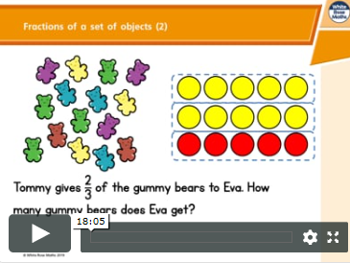
Today’s lesson is the second out of three lessons on fractions of a set of objects.
Watch the lesson video (Week 2 lesson 3), which looks like the screen above, and then answer the attached worksheet. If you find this lesson comfortable and would like to stretch yourselves, have a go and the go deeper questions which are also attached at the end of this document.

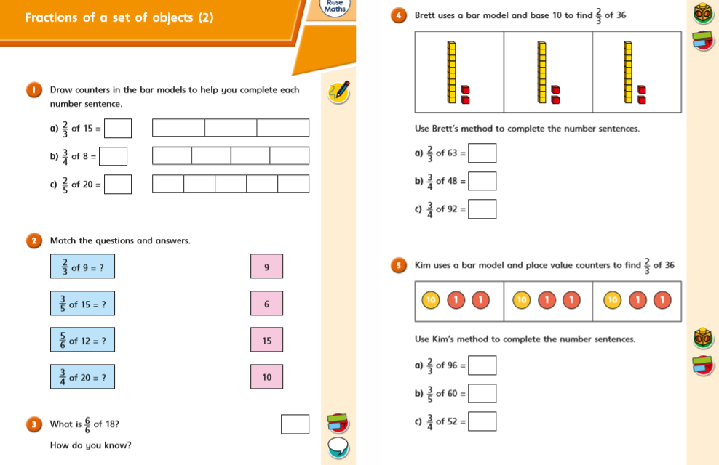
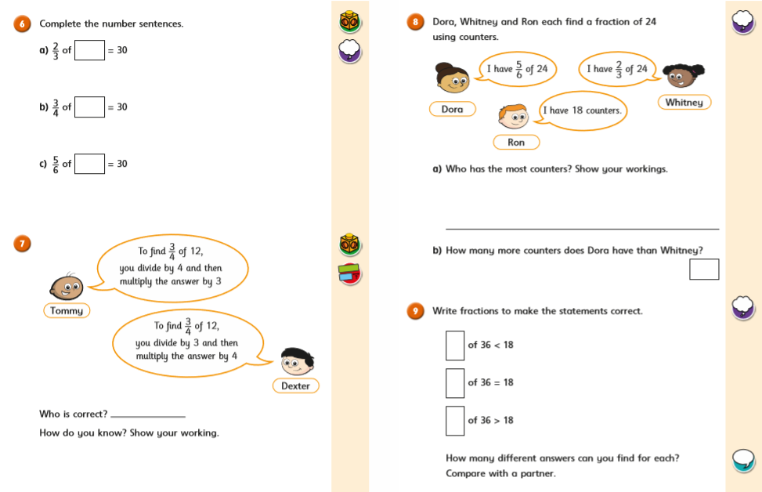
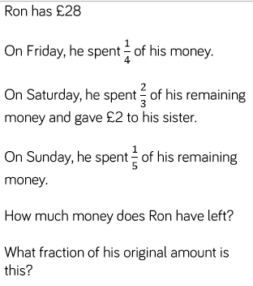
Go Deep: Go Deeper:
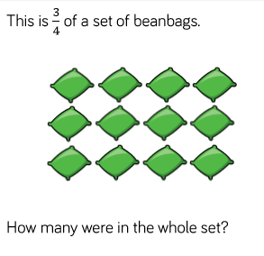

Yesterday’s Answers
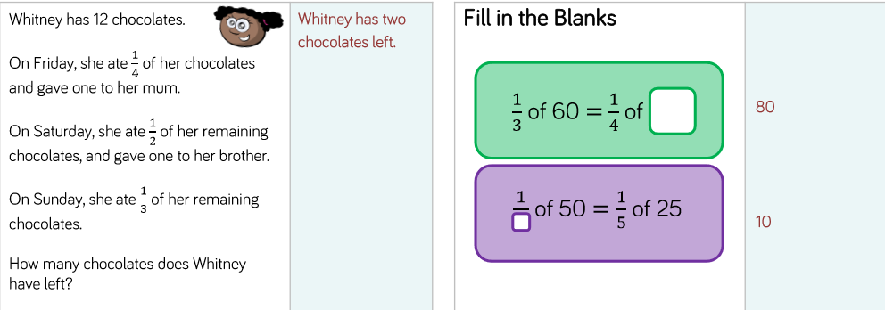

The answers to the main tasks can be downloaded from the link next to each video.

English 29.04.20
This week we are going to be building up to writing our own diary entry. Today I would like you to identify prepositional phrases. Remember a proposition tells you WHERE something is.
Task 1: Underline the prepositional phrases – the first one has been done for you.
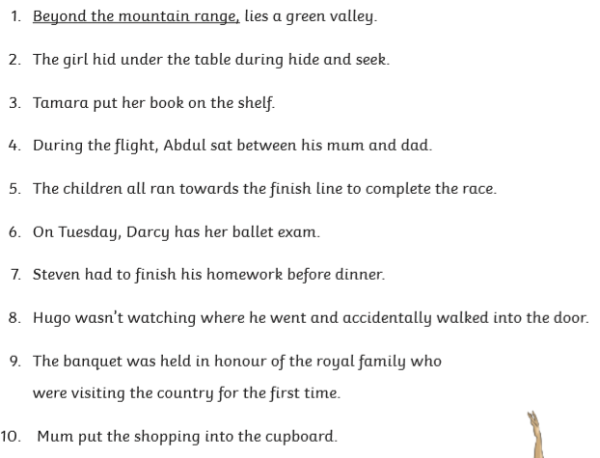

Task 2: Can you change the prepositional phrase in each sentence to make it a silly sentence?
Here’s my silly example:
Above the sapphire sky, lies a green valley.

Tuesday’s Answers:
- What date was this diary written?
Wednesday 24th June AD43
- Which adjective describes Maximus’s week? What 2 things does he do that makes him feel this way?
Tiring; 1. He has to help build a road. 2. He has to march for 20 miles with lots of equipment on his back as part of battle training.
- How does Maximus feel after building the road? Explain using evidence from the text.
Maximus feels sore after building the road – he says the stone had to be cut to the exact shape and size and that they were very heave to lift. They made his arms feel like they were on fire!
- How long did Maximus and the other soldiers march for?
Maximus and the other soldiers marched for 20 miles.
- Copy a phrase that tells us every day is the same at the camp.
But tomorrow we will do it all over again.
- Summarise this entry, keeping the key parts of Maximus’s week and his main feelings?
Maximus is woken up early to help build a new road. This was hard to do. The general stopped them for battle training and they had to march 20 miles! Maximus was happy by the end of the day because he go to eat and go to sleep. He misses his family.
(The summary doesn’t have to be exactly the same – this is just an example)

Thursday 30th April 2020

Good morning Year 3!
Here’s today’s daily Maths and English work to complete, in addition to our weekly project learning tasks. This week’s project is The Area You Live In. We hope you enjoy exploring the geography, history and beauty of your locality from the comfort of your home!
Mrs Cutteridge and Mrs Smith

Maths 30.04.20
Today we would like you to focus on Week 2 Lesson 4 of the home learning which can be found here: https://whiterosemaths.com/homelearning/year-3/
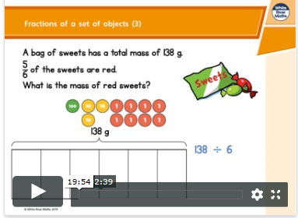
Today’s lesson is the last lesson on fractions of a set of objects.
Watch the lesson video (Week 2 lesson 4), which looks like the screen above, and then answer the attached worksheet. If you find this lesson comfortable and would like to stretch yourselves, have a go and the go deeper questions which are also attached at the end of this document.

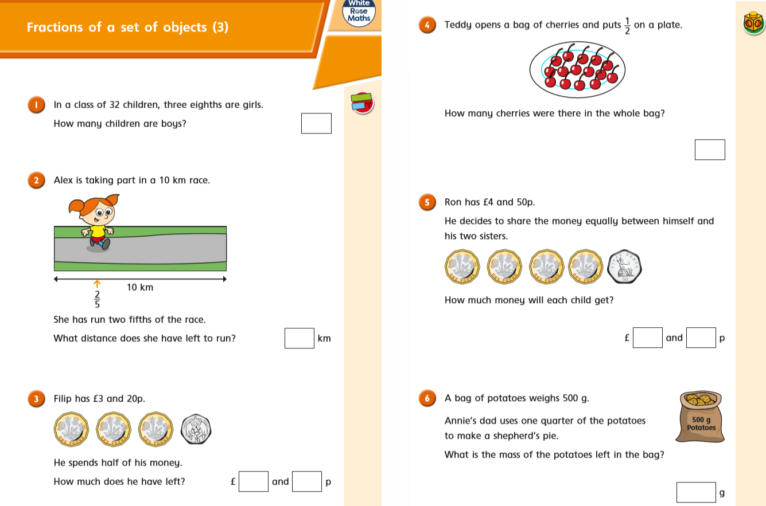

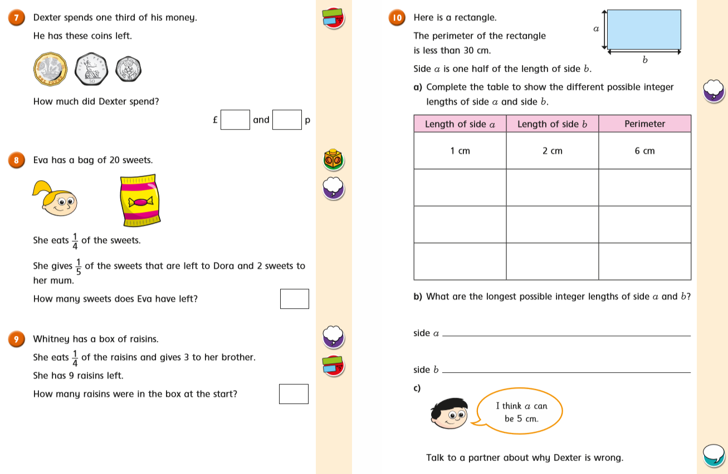
Go Deep: Go Deeper:
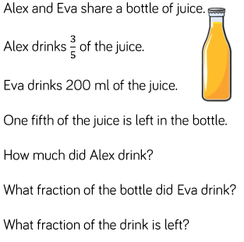

Yesterday’s Answers
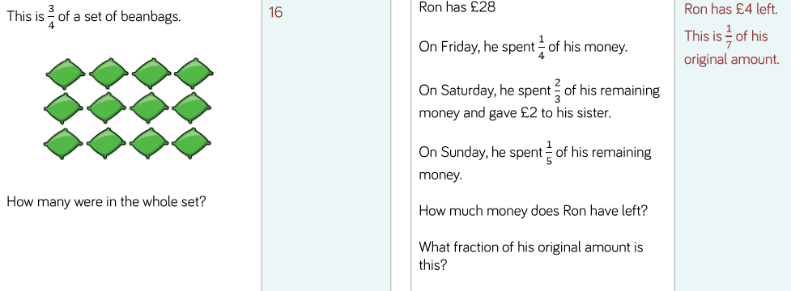
The answers to the main tasks can be downloaded from the link next to each video.

English 30.04.20
This week we are going to be building up to writing our own diary entry. Today I would like you to apply your knowledge of prepositions and create your own sentences with prepositional phrases – remember to use correct sentence punctuation, such as commas, full stops and exclamation marks.

Think of a room in your house. Draw it exactly as it is (or add in some interesting parts!)
Now you need to write about the room describing where things are using prepositional phrases (Use the words at the side to help you write your sentences).

Wednesday’s Answers:
Task 1:
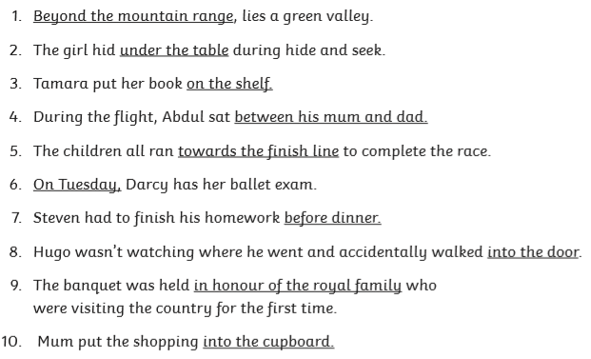

Task 2:
For task 2 the answers will vary depending on what silly sentences they decided on.

Friday 1sh April 2020

Good morning Year 3!
Here’s today’s daily Maths and English work to complete, in addition to our weekly project learning tasks. This week’s project is The Area You Live In. We hope you enjoy exploring the geography, history and beauty of your locality from the comfort of your home!
Mrs Cutteridge and Mrs Smith

Maths 01.05.20
Today we would like you to focus on Week 2 Lesson 5 of the home learning which can be found here: https://whiterosemaths.com/homelearning/year-3/
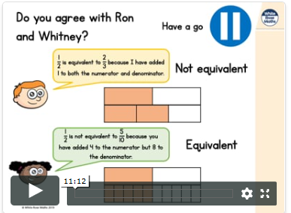
Today’s lesson is on equivalent fractions (fractions that are the same).
Watch the lesson video (Week 2 lesson 5), which looks like the screen above, and then answer the attached worksheet. If you find this lesson comfortable and would like to stretch yourselves, have a go and the go deeper questions which are also attached at the end of this document.

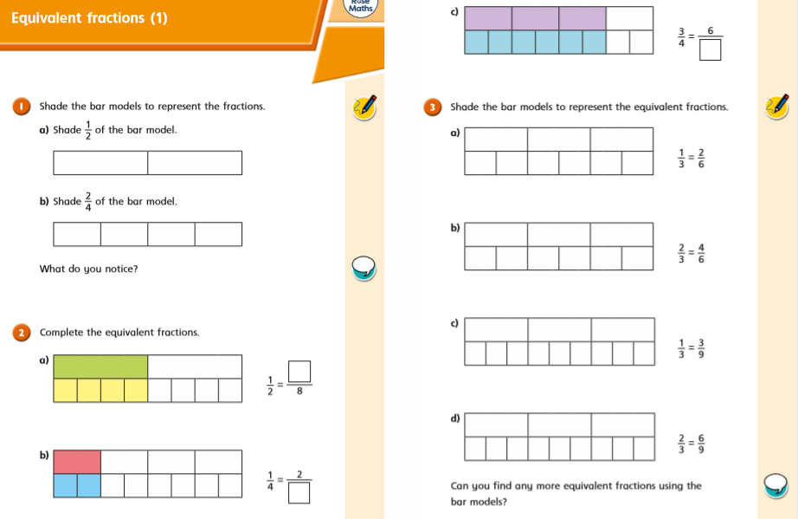
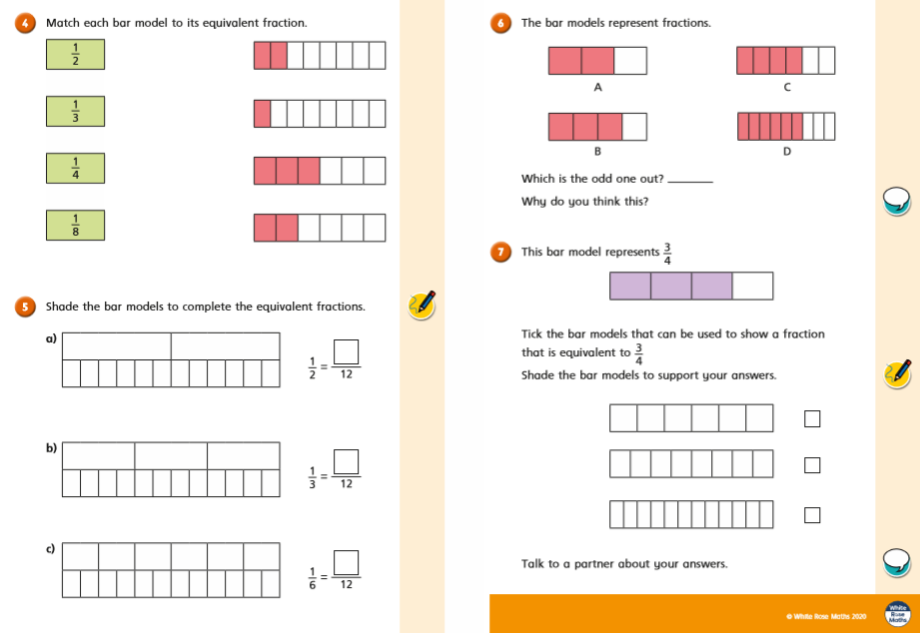
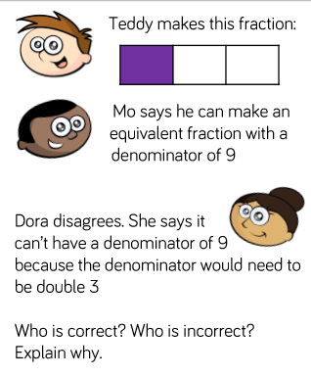
Go Deep: Go Deeper:
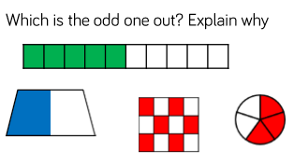

Yesterday’s Answers
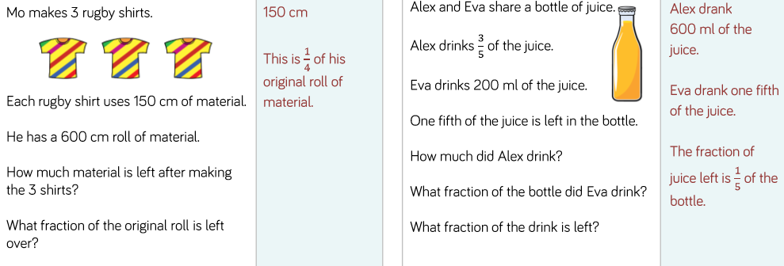

The answers to the main tasks can be downloaded from the link next to each video.

English 01.05.20
This week we are going to be building up to writing our own diary entry. Today I would like you to write a diary entry, in the style of Monday’s WAGOLL, about your week. You can include anything that you have dome, made, seen, watched or spoken about… It must include the success criteria included in the checklist table, below. Good luck!

Feature | Child √ / X | Adult Checking √ / X
Written in the first person
Written in the past tense
Prepositions / prepositional phrases
Range of punctuation used accurately (, . ? ! …)
Thoughts and feelings expressed

Thursday’s Answers:
These will depend on what the child has written.
Sentences could be written like this:
- The dirty clothes were hanging over the back of the chair.
- The TV was standing on the TV cabinet.
- My pet dog, Ruby was curled up asleep next to the fire.

