Home Learning Project WEEK 1 - My Family
Lower Key Stage 2 - Classes: Eagles, Owls, Parrots and Toucans
Maths Tasks |  | Writing Tasks
As a school, we will be following the White Rose Home Learning sequence.  Your teacher will explain which lesson to complete in a daily Marvellous Me message. Here is the overview of what the week will look like:  Monday: Recognising tenths and hundredths.  Tuesday: Tenths as a decimal  Wednesday: Tenths on a place value grid.  Thursday: Tenths on a number line.  Friday: Dividing one digit numbers by 10.  Below is extra maths links you might find useful:  - Play on Hit the Button - focus on halves, doubles and times tables.  - Complete Multiplication 2Dos on Purple Mash. |  | Your teacher will send specific writing tasks to be completed on a daily Marvellous Me message. Here is the overview of what the week will look like:  Monday: Read through the WAGOLL (What A Good One Looks Like) of a character description and identify the key features outlined to you.  Tuesday: Answer comprehension questions based on the WAGOLL text.  Wednesday: Complete grammar task.  Thursday: Apply grammar focus independently.  Friday: Have a go at writing your own character description based on a member of your family.
Spelling Tasks |  | Reading Tasks
Below is a selection of spelling tasks to choose from throughout the week:  - Practise the Year 3/4 for Common Exception words.  - Complete weekly spelling 2Dos on Purple Mash. Make sure you use your personal logins.  - Practise your spelling on Spelling Frame  - Practise your spellings by playing a game on Topmarks.  - Practise 5 common exception words by making up mnemonics for them e.g. because = big elephants can always understand small elephants.  - Create and add to topic word bank which includes any new words you come across this week. |  | Below is a selection of reading tasks to choose from throughout the week:  - You could share a story together. This could be a chapter book where you read and discuss a chapter a day.  - Listen to your child read and let them discuss what they have read.  - Watch Newsround and discuss what is happening in the wider world.  - Sign in to epic! using your class login and get reading!  Owls: kbl8055  Eagles: vvg8816  Parrots: xiq1440  Toucans: xjx3740  - Bake a new recipe and let your child read the instructions to you.  - Read the First News newspaper and The Week Jr magazine together.
Wider Curriculum Menu
As well as completing a daily maths, English, spelling and reading task, we have put together a selection of different wider curriculum activities for you to complete at your leisure. We realise this is a busy time and so most of these do not require written work but instead are discussion and interaction based. You can complete as many as you like in any order you want!
Spend time looking through old photos and talking about the people in your family. | Play a board game with members of your family. |  | Help the adults in your home to make lunch/ dinner.
Create a poster which displays why differences between families should be celebrated. | With the help of adults in your family, create a family tree which shows the growth of your family. |  | Listen to different pieces of music together with your family from the different generations.
Create a portrait of your family. It could be drawn, painted, sculpted or collaged. | FaceTime or Skype a member of your family you have not seen this week for a catch up. |  | Locate on a map where different people in your family originate from.
Enjoy a family picnic in the garden or even in the living room if the weather isn’t very warm. | Have a family workout alongside Joe Wicks at 9am. |  | Let your adult tell you a story from their childhood. It might be about their grandparents or something that they remember from their childhood.
Additional learning resources you may wish to engage with
There are plenty of events happening online to take advantage of while at home:
- Maths with Carol Vorderman www.themathsfactor.com
- Cooking with Jamie Oliver https://www.jamieoliver.com/features/category/get-kids-cooking/
- Music with Myleene Klass https://www.youtube.com/channel/UCQh2wgJ5tOrixYBn6jFXsXQ
- Science with Professor Brian Cox, Robin Ince & Guests https://cosmicshambles.com/stayathome/upcoming-schedule
- Daily drawing lessons with Author Mo Willems https://www.youtube/Mjacom/watch?v=RmzjCPQv3y8
- Virtual museum tours https://www.familydaystriedandtested.com/free-virtual-tours-of-world-museums-educational-sites-galleries-for-children/
- San Diego Zoo live cam https://zoo.sandiegozoo.org/live-cams

Monday 20th April 2020

Good morning Year 4!
Welcome back! You will be receiving daily Maths and English work to be completing as well as tasks focussed on a weekly project. This week’s project is your family – so have fun exploring your heritage and backgrounds.
Mr. Ward and Miss Hatcher

Maths 20.4.20
Today we would like you to focus on Lesson 1 of the home learning which can be found here: https://whiterosemaths.com/homelearning/year-4/
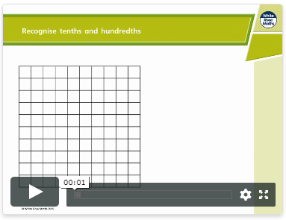
Today’s lesson is recognising tenths and hundredths.

Watch the lesson video (which looks like the screen above) and then answer the attached worksheet. If you find this lesson comfortable and would like to stretch yourselves, have a go at the go deeper questions which are also attached at the end of this document.

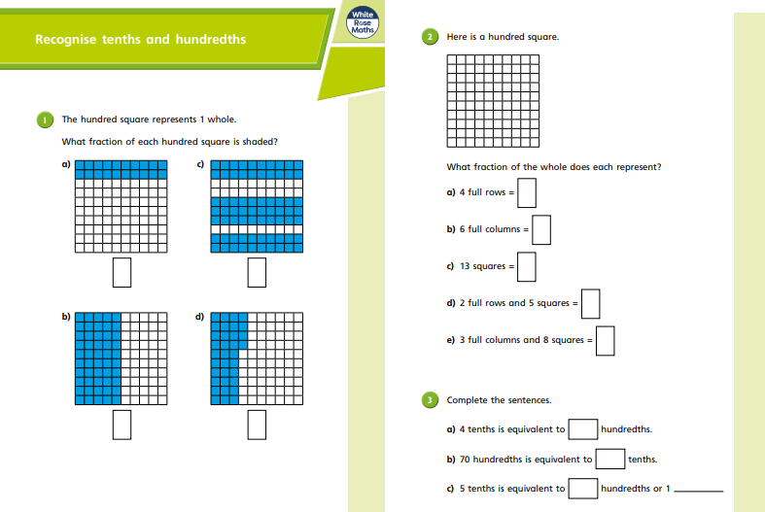

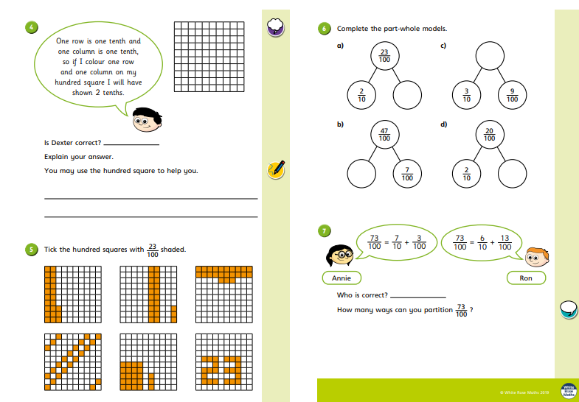

Go Deep:
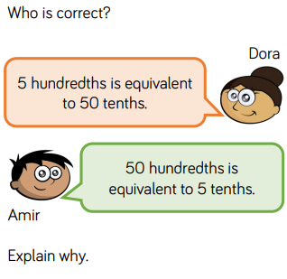
Go Deeper:
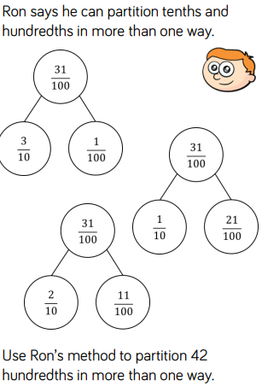

English 20.4.20
This week we are going to be building up to writing our own character descriptions of a family member. Today I would like you to read through the WAGOLL (What A Good One Looks Like) and identify the key features. You can underline, highlight or circle the features within the texts.

Key features to find | Key
Fronted adverbials
Expanded noun phrases
Specific language to produce vivid imagery

Scorch is a huge, explosive lava monster that torments volcanic cities. Over his entire body, are lots of huge, crumbling boulders which stack up to form his back. When in a rage, these rocks begin to pulsate and glow a dark orange. Occasionally, chunks of his rocky flesh fall like lava bombs which instantly ignite into a sea of furious, dancing flames. On top of his muscular shoulders, are two ominous heads with burning and smouldering eyes. Unfortunately, he has a temperamental, unpredictable personality due to his burning core. His mood can fluctuate at any moment, depending on the situation. During the night, he has a calm and relaxed manner because there is little noise in his surroundings. Once day arrives and the city awakens, the hustle and bustle irritates him. This makes him heat up with anger; raise his temperature; produce grey, threatening clouds from his ears and spew lava.

Tuesday 21st April 2020

Good morning Year 4!
We hope you are having a productive start to the half term. You will be receiving daily Maths and English work to be completing as well as tasks focussed on a weekly project. This week’s project is your family – so have fun exploring your heritage and backgrounds.
Mr. Ward and Miss Hatcher

Maths 21.4.20
Today we would like you to focus on Lesson 2 of the home learning which can be found here: https://whiterosemaths.com/homelearning/year-4/
Today’s lesson is tenths as decimals.
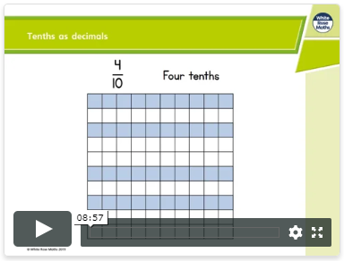

Watch the lesson video (which looks like the screen above) and then answer the attached worksheet. If you find this lesson comfortable and would like to stretch yourselves, have a go at the go deeper questions which are also attached at the end of this document.

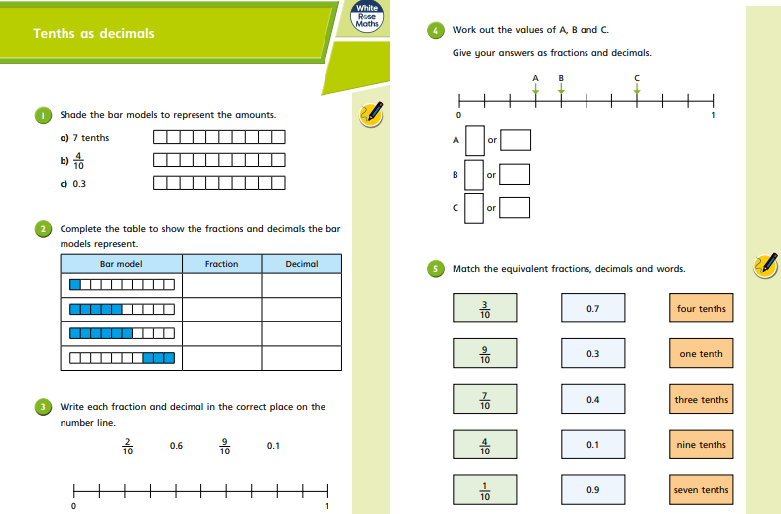

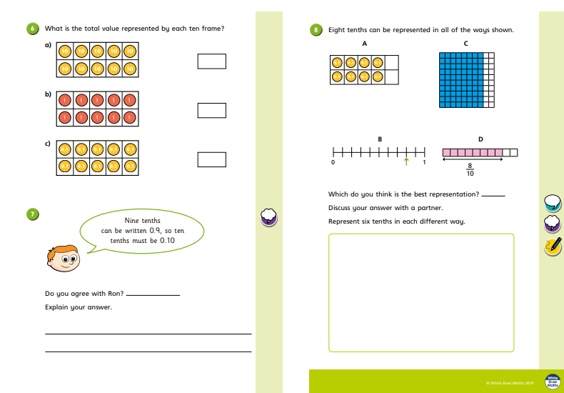

Go Deep:
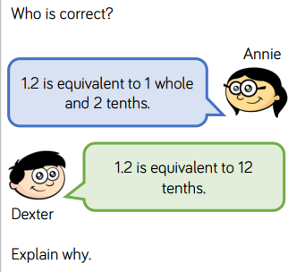

Go Deeper:
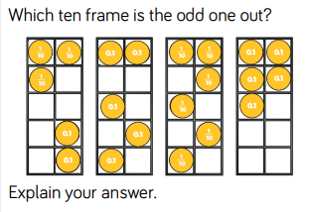

English 21.4.20
This week we are going to be building up to writing our own character descriptions of a family member. Today I would like you to read through the WAGOLL (What A Good One Looks Like) and answer the following comprehension questions. Most questions will be simple retrieving from the text but some may need you to use your inference skills to come up with plausible answers.

Scorch is a huge, explosive lava monster that torments volcanic cities. Over his entire body, are lots of huge, crumbling boulders which stack up to form his back. When in a rage, these rocks begin to pulsate and glow a dark orange. Occasionally, chunks of his rocky flesh fall like lava bombs which instantly ignite into a sea of furious, dancing flames. On top of his muscular shoulders, are two ominous heads with burning and smouldering eyes. Unfortunately, he has a temperamental, unpredictable personality due to his burning core. His mood can fluctuate at any moment, depending on the situation. During the night, he has a calm and relaxed manner because there is little noise in his surroundings. Once day arrives and the city awakens, the hustle and bustle irritates him. This makes him heat up with anger; raise his temperature; produce grey, threatening clouds from his ears and spew lava.

1. What is the name of the creature being described?
2. What is the creature’s back made out of?
3. How athletic do you think the creature is?
4. How does his burning core affect his personality?
5. Do you think the creature’s behaviour is predictable?
6. What time of day is he more relaxed?
7. Do you think the creature is a fan of people?
8. What happens when the creature is irritated?

Extension: If you would like to, you can draw what you think the creature looks like.

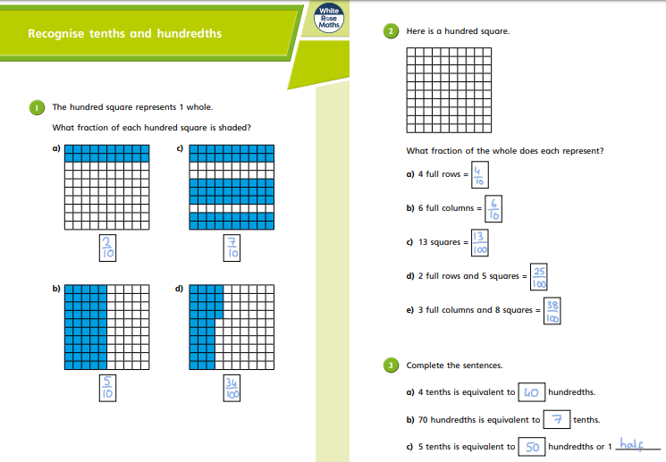
20.4.20 ANSWERS
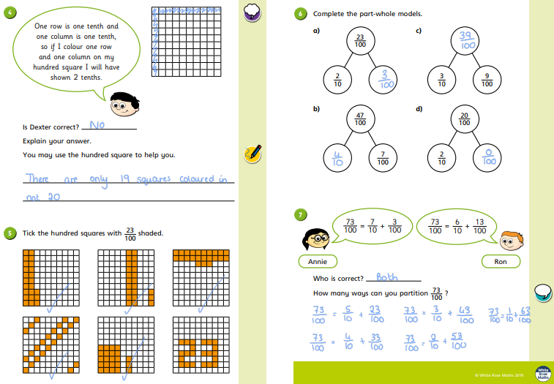

Go deep:
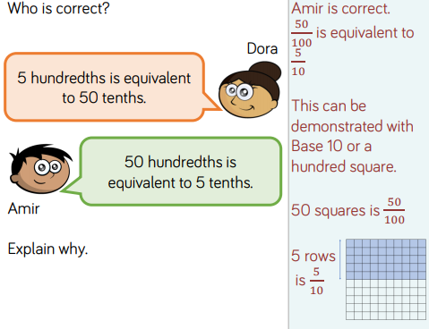
Go deeper:
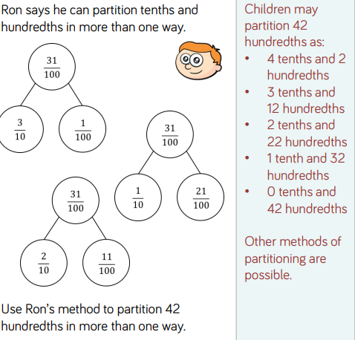

Key features to find | Key
Fronted adverbials
Expanded noun phrases
Specific language to produce vivid imagery | There are many acceptable answers – highlighted are just a few.

Scorch is a huge, explosive lava monster that torments volcanic cities. Over his entire body, are lots of huge, crumbling boulders which stack up to form his back. When in a rage, these rocks begin to pulsate and glow a dark orange. Occasionally, chunks of his rocky flesh fall like lava bombs which instantly ignite into a sea of furious, dancing flames. On top of his muscular shoulders, are two ominous heads with burning and smouldering eyes. Unfortunately, he has a temperamental, unpredictable personality due to his burning core. His mood can fluctuate at any moment, depending on the situation. During the night, he has a calm and relaxed manner because there is little noise in his surroundings. Once day arrives and the city awakens, the hustle and bustle irritates him. This makes him heat up with anger; raise his temperature; produce grey, threatening clouds from his ears and spew lava.

Wednesday 22nd April 2020

Good morning Year 4!
We hope you are having a productive start to the half term. You will be receiving daily Maths and English work to be completing as well as tasks focussed on a weekly project. This week’s project is your family – so have fun exploring your heritage and backgrounds.
Mr. Ward and Miss Hatcher

Maths 22.4.20
Today we would like you to focus on Lesson 3 of the home learning which can be found here: https://whiterosemaths.com/homelearning/year-4/
Today’s lesson is tenths on a place value grid.
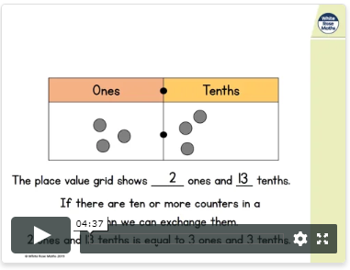

Watch the lesson video (which looks like the screen above) and then answer the attached worksheet. If you find this lesson comfortable and would like to stretch yourselves, have a go at the go deeper questions which are also attached at the end of this document.

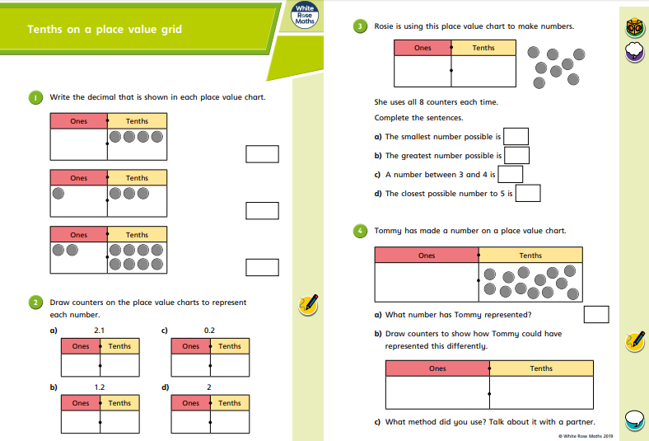

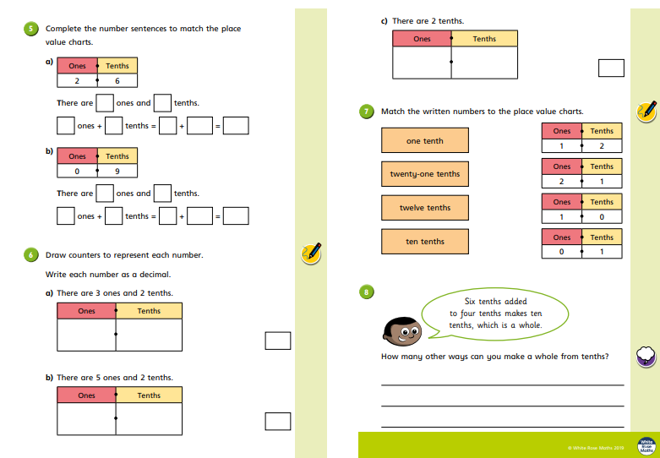

Go Deep:
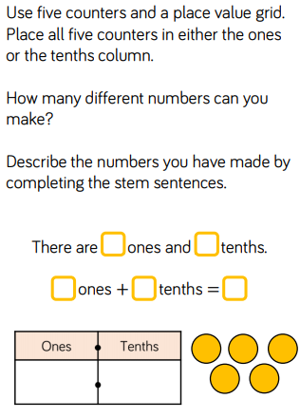

Go Deeper:
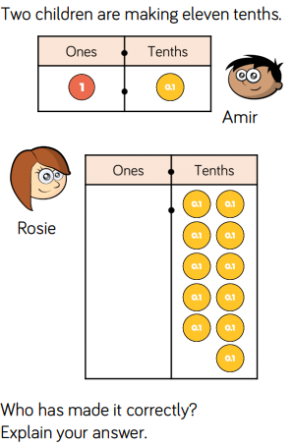

English 22.4.20
This week we are going to be building up to writing our own character descriptions of a family member. Today, I would like you to focus on expanded noun phrases. We are going to use our skills to up level the following boring sentences into more detailed and interesting ones. Here is an example:
The road ran past a field.
1. Add adjectives to expand the noun phrase.

The long, straight road ran past a luscious, green field.
2. Start your sentence with a fronted adverbial.

Early one morning, the long, straight road ran past a luscious, green field.

Some girls jumped in a field.
1. Add adjectives to expand the noun phrase.

2. Start your sentence with a fronted adverbial.

The house was in the woods.
1. Add adjectives to expand the noun phrase.

2. Start your sentence with a fronted adverbial.

The garden had lots of plants.
1. Add adjectives to expand the noun phrase.

2. Start your sentence with a fronted adverbial.

A cat chased the mouse.
1. Add adjectives to expand the noun phrase.

2. Start your sentence with a fronted adverbial.

Her mum baked a cake.
1. Add adjectives to expand the noun phrase.

2. Start your sentence with a fronted adverbial.

21.4.20 ANSWERS
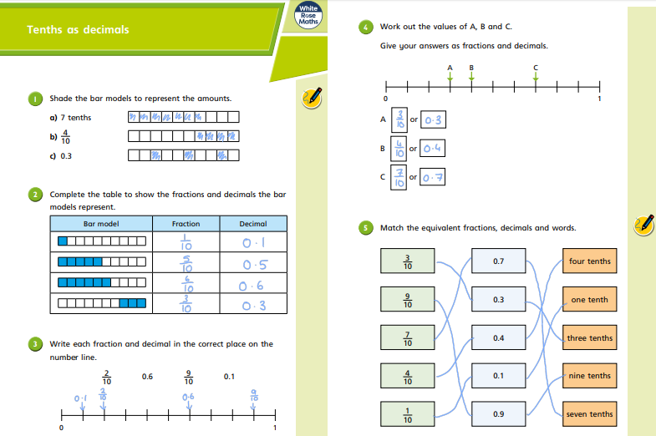

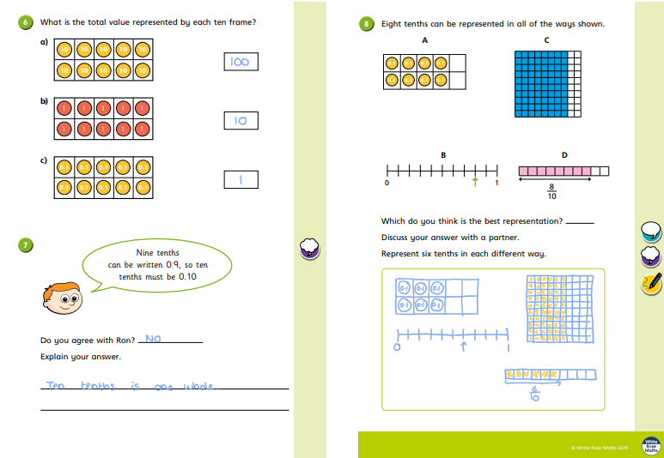

Go deep:
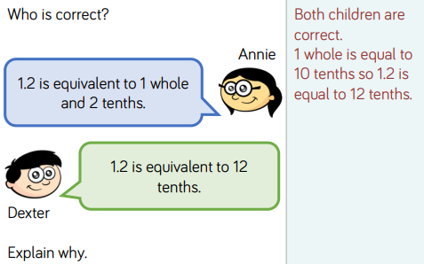

Go deeper:
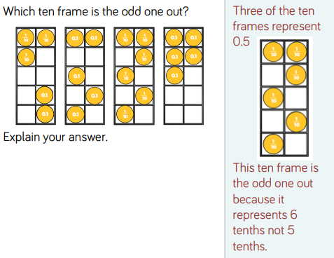

1. What is the name of the creature being described?
The name of the creature being described is Scorch.
2. What is the creature’s back made out of?
The creature’s back is made out of huge, crumbling boulders which are stacked up.
3. How athletic do you think the creature is?
Acceptable answers could include:
I do not think that the creature is very athletic because of its huge size/ it is made out of rock and stone so would be heavy.
I think the creature is athletic because the text mentions his muscular shoulders.
4. How does his burning core affect his personality?
His burning core affects his personality as it makes him temperamental and unpredictable. Also it says his mood can fluctuate at any moment, depending on the situation.
5. Do you think the creature’s behaviour is predictable?
I do not think the creature is predictable as he is described as temperamental and unpredictable which is the opposite of this.
6. What time of day is he more relaxed?
He is more relaxed during the night.
7. Do you think the creature is a fan of people?
Any answer, which uses what they can infer from the text, is acceptable. For example, I do not think the creature is a fan of people as he is happier at night when it is quiet and there are not many people around at night.
8. What happens when the creature is irritated?
When he is irritated, he heats up with anger; raises his temperature; produces grey, threatening clouds from his ears and spews lava.

Thursday 23rd April 2020

Good morning Year 4!
We hope you are having a productive start to the half term. You will be receiving daily Maths and English work to be completing as well as tasks focussed on a weekly project. This week’s project is your family – so have fun exploring your heritage and backgrounds.
Mr. Ward and Miss Hatcher

Maths 23.4.20
Today we would like you to focus on Lesson 4 of the home learning which can be found here: https://whiterosemaths.com/homelearning/year-4/
Today’s lesson is tenths on a number line.

Watch the lesson video (which looks like the screen above) and then answer the attached worksheet. If you find this lesson comfortable and would like to stretch yourselves, have a go at the go deeper questions which are also attached at the end of this document.

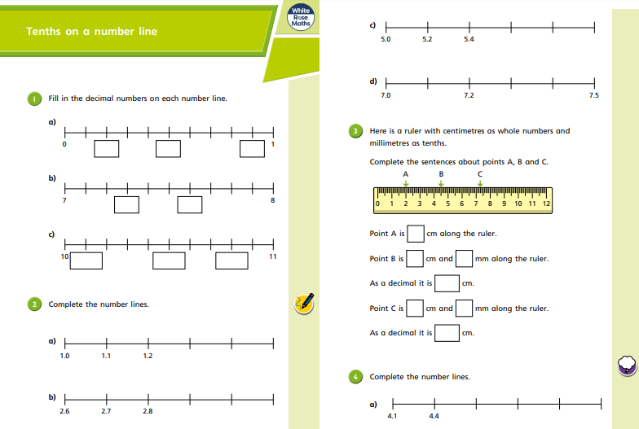

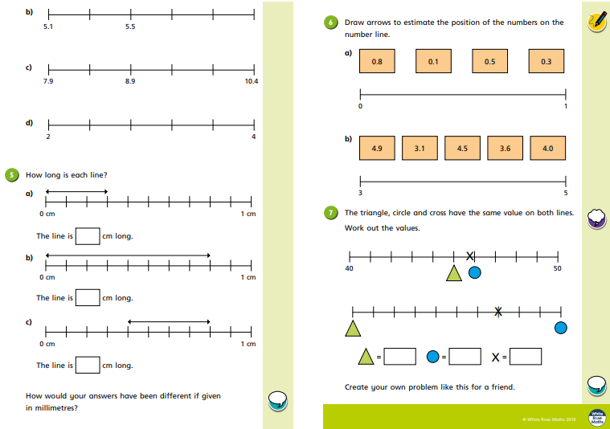

Go Deep:
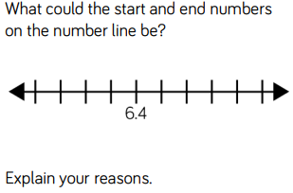

Go Deeper:
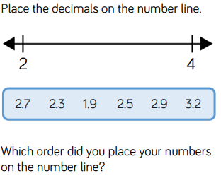

English 23.4.20
This week we are going to be building up to writing our own character descriptions of a family member. Today, you are going to construct your own interesting sentences. Use the table below to help you but if you come up with your own interesting sentences…even better! Example: Near the town, there was a colourful, gigantic bus driving through the bustling streets!

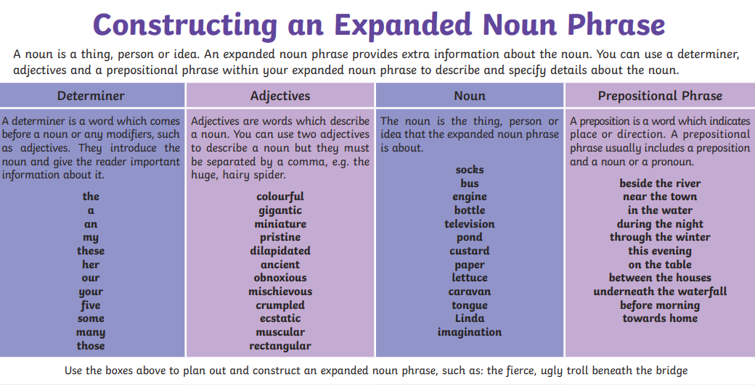

22.4.20 ANSWERS
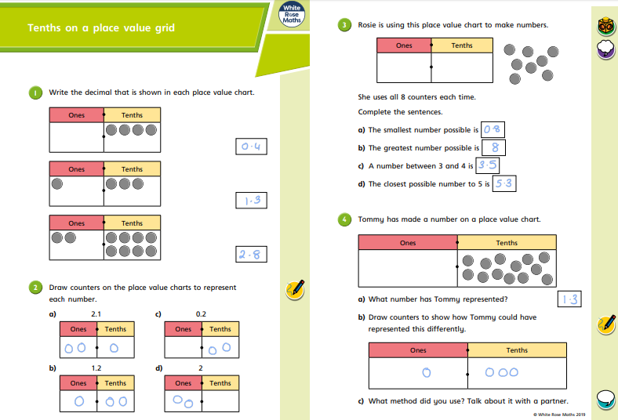

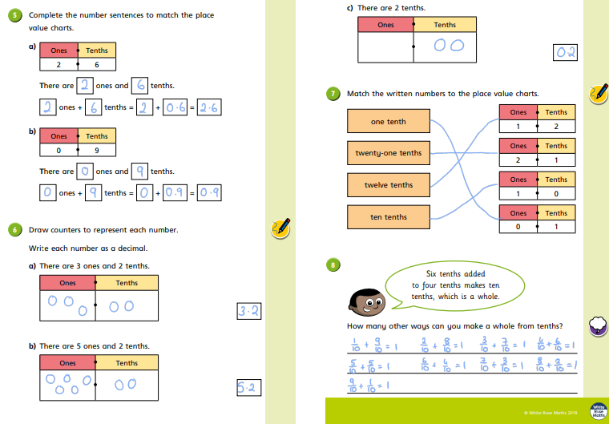

Go deep:
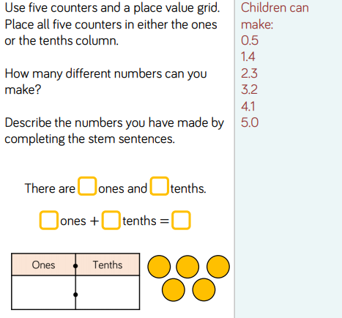
Go deeper:
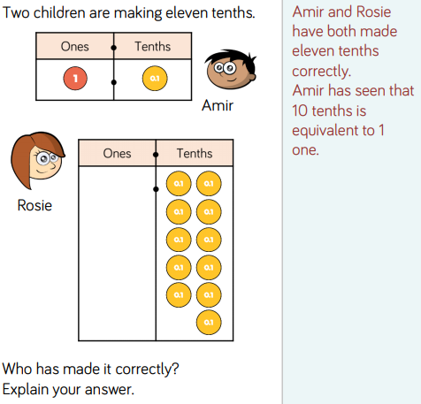

Some girls jumped in a field.
1. Add adjectives to expand the noun phrase.

Some energetic and spirited young girls jumped in a beautiful, grassy field.
2. Start your sentence with a fronted adverbial.

With great joy, some energetic and spirited young girls jumped in a beautiful, grassy field.

The house was in the woods.
1. Add adjectives to expand the noun phrase.

The ancient, moss covered house was stood in the dark, echoing woods.
2. Start your sentence with a fronted adverbial.

Eerily, the ancient, moss covered house was stood in the dark, echoing woods.

The garden had lots of plants.
1. Add adjectives to expand the noun phrase.

The bright, stunning garden had lots of blooming, colourful plants.
2. Start your sentence with a fronted adverbial.

Full of life, the bright, stunning garden had lots of blooming, colourful plants.

A cat chased the mouse.
1. Add adjectives to expand the noun phrase.

A ginger, grumpy cat chased the tiny, exhausted mouse.
2. Start your sentence with a fronted adverbial.

Mischievously, a ginger, grumpy cat chased the tiny, exhausted mouse.

Friday 24th April 2020

Good morning Year 4!
Well done for working so hard on your first week back! We know it can be hard to be motivated at home but we are so proud of you. You will be receiving daily Maths and English work to be completing as well as tasks focussed on a weekly project. This week’s project is your family – so have fun exploring your heritage and backgrounds.
Mr. Ward and Miss Hatcher

Maths 24.4.20
Today we would like you to focus on Lesson 5 of the home learning which can be found here: https://whiterosemaths.com/homelearning/year-4/
Today’s lesson is dividing one digit numbers by 10.

Watch the lesson video (which looks like the screen above) and then answer the attached worksheet. If you find this lesson comfortable and would like to stretch yourselves, have a go at the go deeper questions which are also attached at the end of this document.

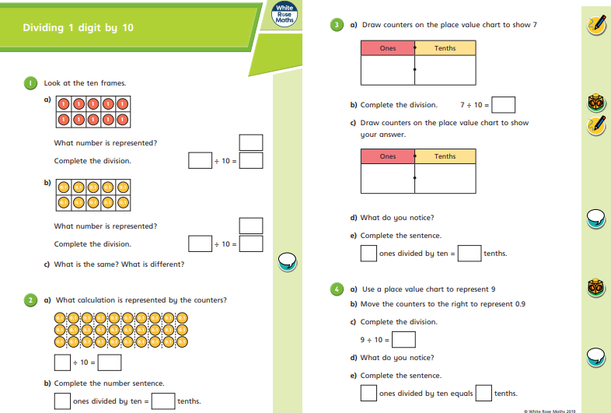

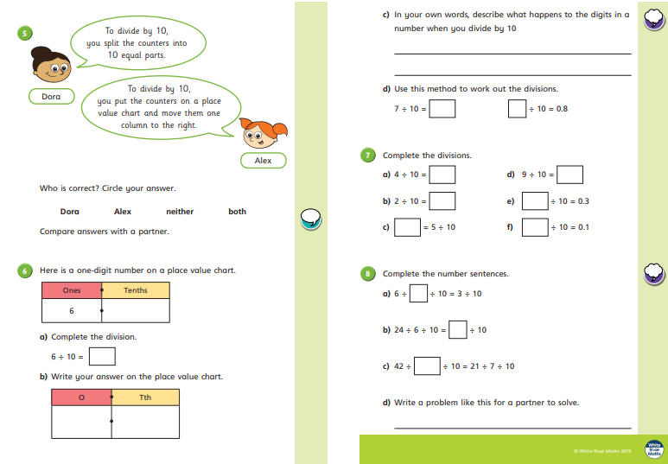

Go Deep:
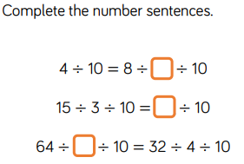

English 24.4.20
This week we are going to be building up to writing our own character descriptions of a family member. Today, you are going to have a go at writing your own character description about a member of your family. It could be about anyone – mum, dad, grandma, grandad, brother, sister etc!
Remember to include your fronted adverbials and expanded noun phrases. Describe both their physical appearance and personality. Use the WAGOLL to guide you but make sure it is your own work.

23.4.20 ANSWERS
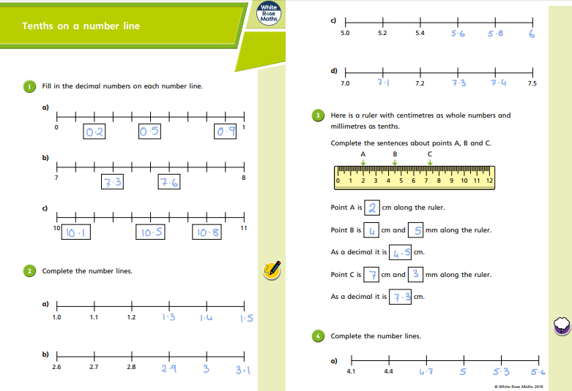

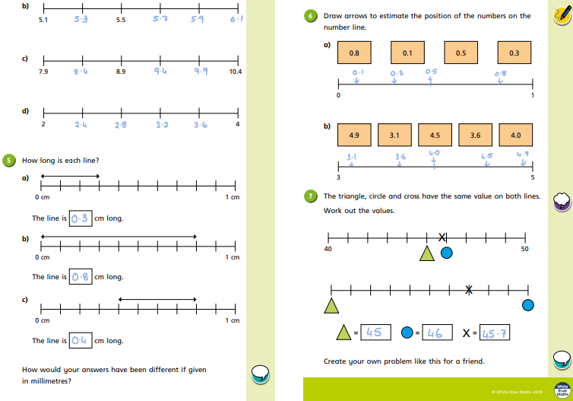

Go deep:
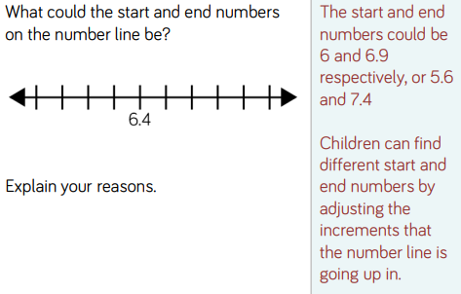
Go deeper:
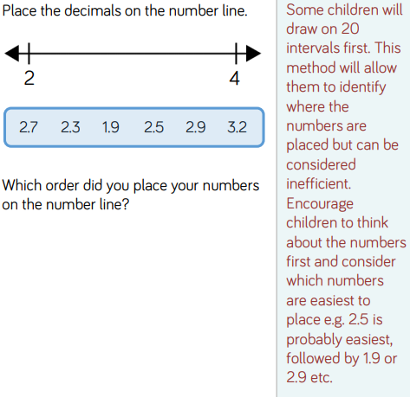

The children could have produced a number of acceptable sentences as long as they had included the 4 different aspects and their sentences made sense.
Examples:
In the water, there were many miniature, colourful fish.
This evening, my ancient, broken engine stopped working.
On the table, was a pristine, brand new television.

