Learning Project WEEK 2 – The Area You Live In
Lower Key Stage 2 - Classes: Eagles, Owls, Parrots and Toucans
Maths Tasks |  | Writing Tasks
As a school, we will be following the White Rose Home Learning sequence.  Your teacher will explain which lesson to complete in a daily Marvellous Me message. Here is the overview of what the week will look like:  Monday: Divide 2-digits by 10  Tuesday: Hundredths  Wednesday: Hundredths as decimals  Thursday: Hundredths on a place value grid  Friday: Divide 1 or 2-digits by 100  Below is extra maths links you might find useful:  - Play on Hit the Button - focus on halves, doubles and times tables.  - Complete Multiplication 2Dos on Purple Mash. |  | Your teacher will send specific writing tasks to be completed on a daily Marvellous Me message. Here is the overview of what the week will look like:  Monday: Read through the WAGOLL (What A Good One Looks Like) of a diary entry and identify the key features outlined to you.  Tuesday: Answer comprehension questions based on the WAGOLL text.  Wednesday: Complete grammar task.  Thursday: Apply grammar focus independently.  Friday: Have a go at writing your own diary entry, summarising the events of the past week in your house.
Spelling Tasks |  | Reading Tasks
Below is a selection of spelling tasks to choose from throughout the week:  - Practise the Year 3/4 for Common Exception words.  - Complete weekly spelling 2Dos on Purple Mash. Make sure you use your personal logins.  - Practise your spelling on Spelling Frame  - Practise your spellings by playing a game on Topmarks.  - Practise 5 common exception words by making up mnemonics for them e.g. because = big elephants can always understand small elephants.  - Create and add to topic word bank which includes any new words you come across this week. |  | Below is a selection of reading tasks to choose from throughout the week:  - You could share a story together. This could be a chapter book where you read and discuss a chapter a day.  - Listen to your child read and let them discuss what they have read.  - Watch Newsround and discuss what is happening in the wider world.  - Sign in to epic! using your class login and get reading!  Owls: kbl8055  Eagles: vvg8816  Parrots: xiq1440  Toucans: xjx3740  - Bake a new recipe and let your child read the instructions to you.  - Read the First News newspaper and The Week Jr magazine together.
Wider Curriculum Menu
As well as completing a daily maths, English, spelling and reading task, we have put together a selection of different wider curriculum activities for you to complete at your leisure. We realise this is a busy time and so most of these do not require written work but instead are discussion and interaction based. You can complete as many as you like in any order you want!
Look through old photos of Nottingham (try here) and make a presentation of the differences between modern-day and historic Nottingham. | Create an urban landscape drawing or sketch of the view from your window – watch this video for tips. |  | Draw a map from memory of your street, your suburb or your city. Which landmarks, natural and/or physical features will you include?
Create a poster advertising Nottingham to tourists – Why should people visit? What’s Nottingham famous for? What can be done? | Create a list or table of different businesses in your local area which you may want visit after Covid-19 passes. Explain why. |  | Research what our city is famous for (it might be a person or an invention -start here) and present your findings.
Make a model of your street using household recycling, Lego or anything your parents allow. | Write a nice letter to a local nursing home to be read out to residents who may be alone during this time. |  | Locate on a map where you house is compared to school. Plan three different routes (on foot, public transport and by car).
Reflect: Think about what would improve the local area. What is the area missing? What spoils your local area? What could be done to improve it? | Conduct a survey of the local wildlife you can see from your window or in your garden. Present your findings in a pictograph, bar chart and line graph. |  | Phone a local, elderly relative or neighbour (if possible) interview them (you need to plan questions) about how the local area’s changed.
Additional learning resources you may wish to engage with
There are plenty of events happening online to take advantage of while at home:
- Maths with Carol Vorderman www.themathsfactor.com
- Cooking with Jamie Oliver https://www.jamieoliver.com/features/category/get-kids-cooking/
- Music with Myleene Klass https://www.youtube.com/channel/UCQh2wgJ5tOrixYBn6jFXsXQ
- Daily drawing lessons with Author Mo Willems https://www.youtube/Mjacom/watch?v=RmzjCPQv3y8
- Virtual museum tours https://www.familydaystriedandtested.com/free-virtual-tours-of-world-museums-educational-sites-galleries-for-children/
- San Diego Zoo live cam https://zoo.sandiegozoo.org/live-cams

Monday 27th April 2020

Good morning Year 4!
Just like last week, you will be receiving daily Maths and English work to be completing as well as tasks focussed on a weekly project. This week’s project is The Area You Live In. We hope you enjoy exploring the geography, history and beauty of your locality from the comfort of your home!
Mr. Ward and Miss Hatcher

Maths 27.04.20
Today we would like you to focus on Lesson 1 of the home learning which can be found here: https://whiterosemaths.com/homelearning/year-4/
Today’s lesson is dividing 2-digit numbers by 10.
Watch the lesson video (Week 2 lesson 1), which looks like the screen above, and then answer the attached worksheet. If you find this lesson comfortable and would like to stretch yourselves, have a go and the go deeper questions which are also attached at the end of this document.

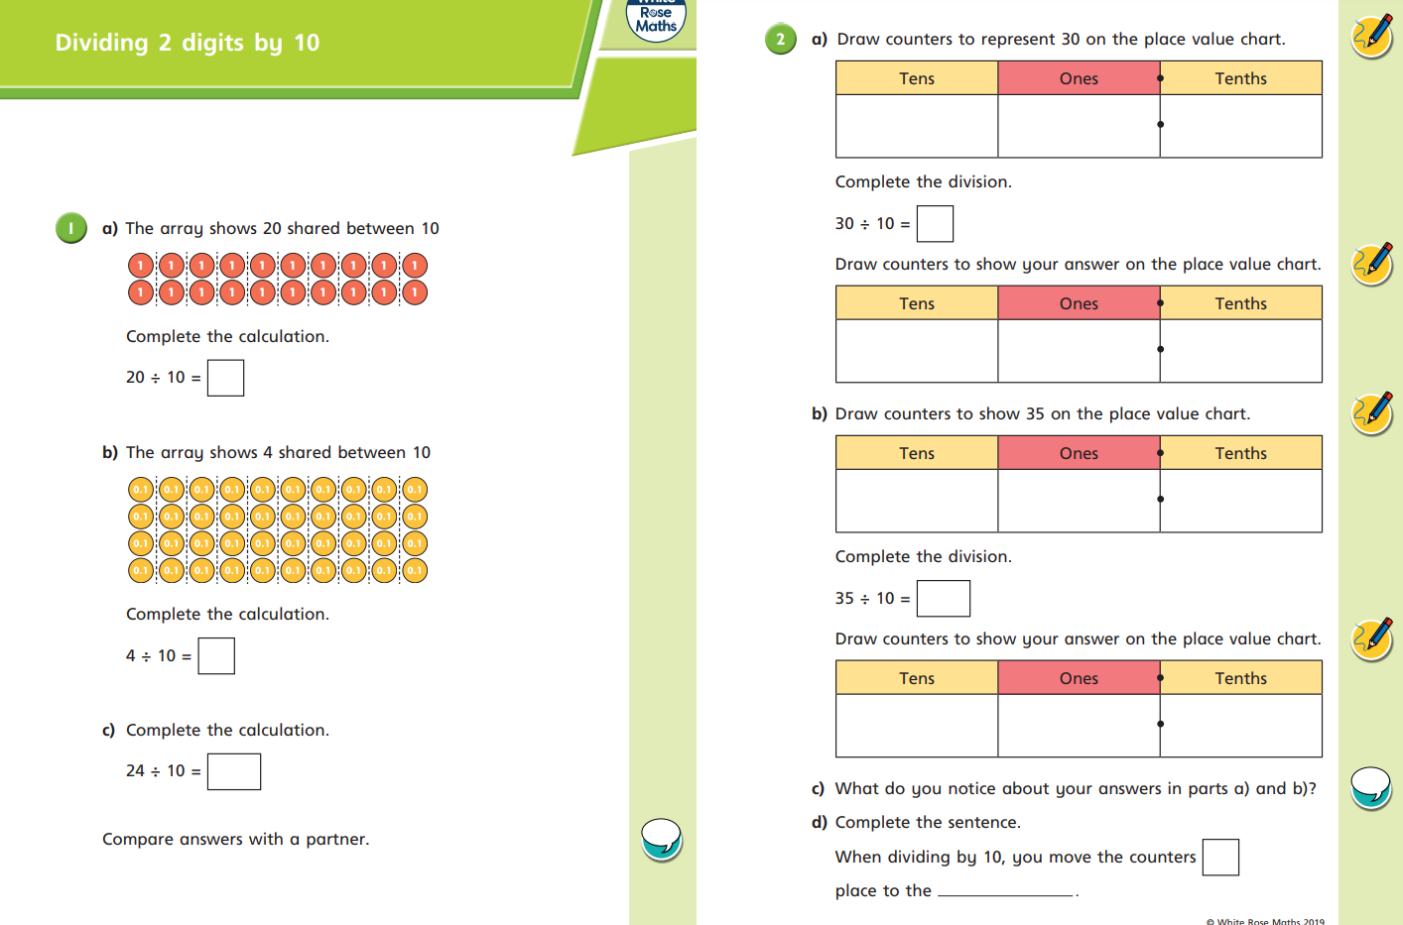

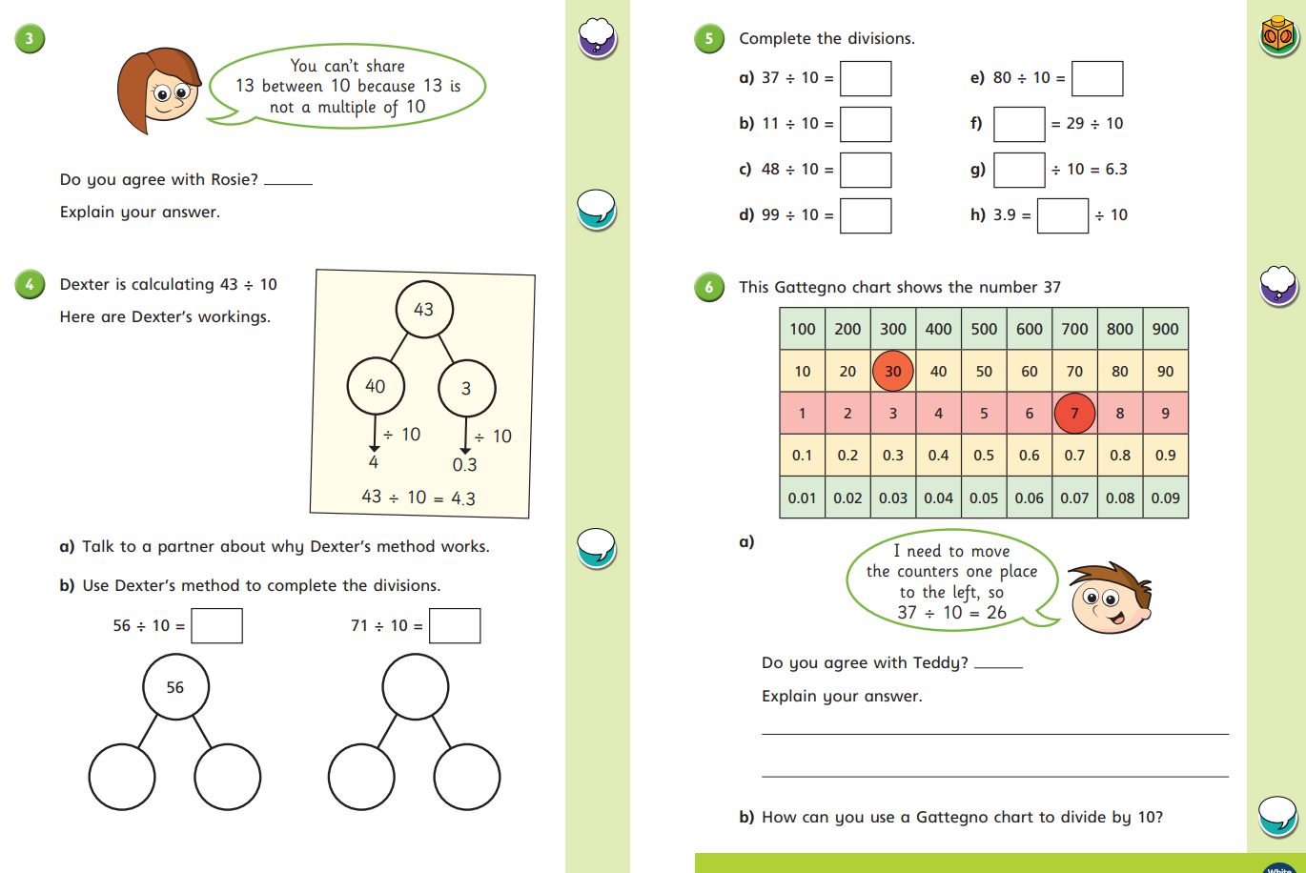

Go Deep: Go Deeper:

English 27.04.20
This week we are going to be building up to writing our own diary entry. Today I would like you to read through the WAGOLL (What A Good One Looks Like) and identify the key features. You can underline, highlight or circle the features within the texts.

Key Features To Find | Key (Colour)
Written in the first person
Written in the past tense
Relative clauses /
complex sentences used
Thoughts and feelings expressed

Wednesday 24th June 1836
Dear Diary,
What a horrific week it’s been! I have found myself in the grimmest situation and I don’t know what to do!
Firstly, I was sold from the workhouse. Me and the other boys had been so desperately hungry that we pulled straws to see who would try and ask the master for more gruel at supper. Terrifyingly, it was me! I went through with it, but it was an awful mistake. The master, who was in charge of everything including the gruel, was furious and I was immediately removed from the workhouse and sold into an even more desperate situation; I was to be Mr Sowerberry’s apprentice. He was a cruel, harsh man, whose other apprentices were horrid to me, and I hated every minute of being his lackey.
Because of this, a fight started between me and another apprentice. I knew I would be punished severely so I decided to escape before this could happen. I ran and ran, with hopes of reaching London. For four whole days and nights I trundled down country roads on blistered feet, until finally, I reached the city; they say it’s paved with gold. I was petrified. I had no one. I was cold and starving. That was until I was approached by the most peculiar boy. The boy, who was around my age, was wearing a gentleman’s scruffy top hat that balanced on the top of his head, and he wore a long jacket that swamped him. He introduced himself as the Artful Dodger. Soon after, he took me with him to his home. We wandered through dingy streets, which were more like the workhouse toilet than something paved with gold, and crowded alleyways. The smell was powerful and stung my nostrils. Eventually, we arrived.
So, I now find myself with Fagin. He is a crooked man with red-matted hair. I’m very wary of him, and I feel more like his prisoner than his guest. He has me locked up in one of his rooms with the other boys, who are allowed to leave each day, and every night they return with items for him. I don’t know where from. I’m not sure what I would prefer - to stay here, or be back in the gloomy workhouse eating gruel…
We will have to see what happens.
Oliver

Friday’s Answers

Tuesday 28th April 2020

Good morning Year 4!
Here’s today’s daily Maths and English work to complete, in addition to our weekly project learning tasks. This week’s project is The Area You Live In. We hope you enjoy exploring the geography, history and beauty of your locality from the comfort of your home!
Mr. Ward and Miss Hatcher

Maths 28.04.20
Today we would like you to focus on Week 2 Lesson 2 of the home learning which can be found here: https://whiterosemaths.com/homelearning/year-4/
Today’s lesson is on Hundredths.
Watch the lesson video (Week 2 lesson 2), which looks like the screen above, and then answer the attached worksheet. If you find this lesson comfortable and would like to stretch yourselves, have a go and the go deeper questions which are also attached at the end of this document.

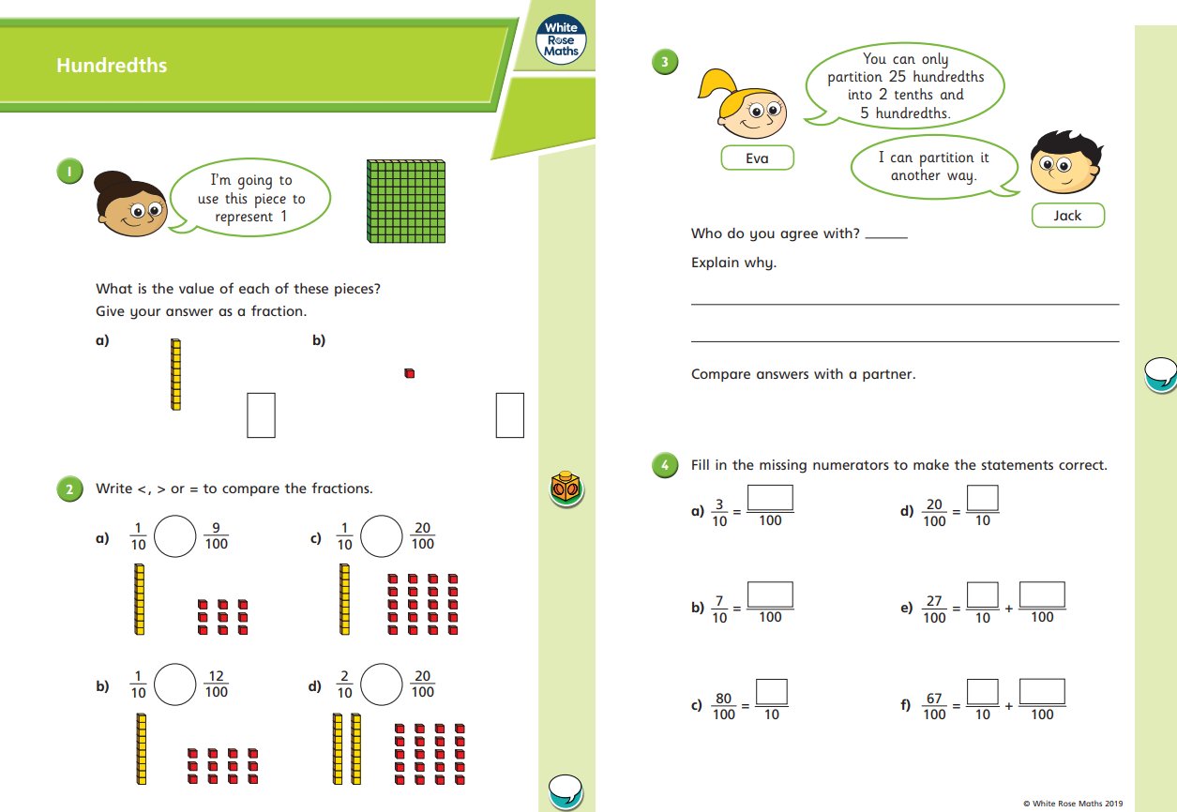

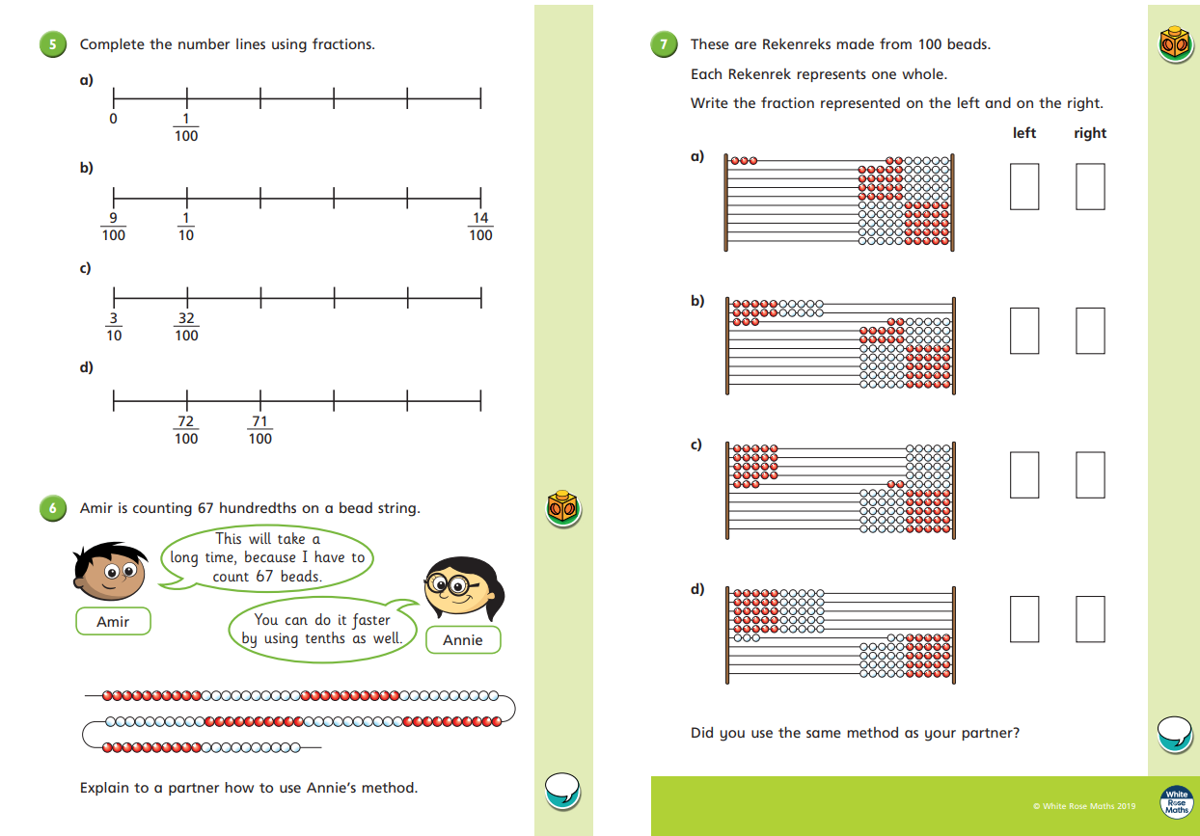

Go Deep: Go Deeper:

Yesterday’s Answers

English 28.04.20
This week we are going to be building up to writing our own diary entry. Today I would like you to read through the WAGOLL (What A Good One Looks Like) and answer the following comprehension questions.
WAGOLL
Wednesday 24th June 1836
Dear Diary,
What a horrific week it’s been! I have found myself in the grimmest situation and I don’t know what to do!
Firstly, I was sold from the workhouse. Me and the other boys had been so desperately hungry that we pulled straws to see who would try and ask the master for more gruel at supper. Terrifyingly, it was me! I went through with it, but it was an awful mistake. The master, who was in charge of everything including the gruel, was furious and I was immediately removed from the workhouse and sold into an even more desperate situation; I was to be Mr Sowerberry’s apprentice. He was a cruel, harsh man, whose other apprentices were horrid to me, and I hated every minute of being his lackey.
Because of this, a fight started between me and another apprentice. I knew I would be punished severely so I decided to escape before this could happen. I ran and ran, with hopes of reaching London. For four whole days and nights I trundled down country roads on blistered feet, until finally, I reached the city; they say it’s paved with gold. I was petrified. I had no one. I was cold and starving. That was until I was approached by the most peculiar boy. The boy, who was around my age, was wearing a gentleman’s scruffy top hat that balanced on the top of his head, and he wore a long jacket that swamped him. He introduced himself as the Artful Dodger. Soon after, he took me with him to his home. We wandered through dingy streets, which were more like the workhouse toilet than something paved with gold, and crowded alleyways. The smell was powerful and stung my nostrils. Eventually, we arrived.
So, I now find myself with Fagin. He is a crooked man with red-matted hair. I’m very wary of him, and I feel more like his prisoner than his guest. He has me locked up in one of his rooms with the other boys, who are allowed to leave each day, and every night they return with items for him. I don’t know where from. I’m not sure what I would prefer - to stay here, or be back in the gloomy workhouse eating gruel…
We will have to see what happens.
Oliver
Questions
- What date was this diary written?
- Which two adjectives describe Oliver’s week and situation he finds himself in?
- Why did Oliver fight with another apprentice?
- How long did it take Oliver to reach London?
- Copy a phrase or clause that describes the powerful smell?
- How does Oliver feel about Fagin? Explain using evidence from the text.
- Summarise this entry, keeping the key parts of Oliver’s week and his main feelings?

Yesterday’s English Answers

Key Features To Find | Key (Colour)
Written in the first person
Written in the past tense
Relative clauses /
complex sentences used
Thoughts and feelings expressed

Wednesday 24th June 1836
Dear Diary,
What a horrific week it’s been! I have found myself in the grimmest situation and I don’t know what to do!
Firstly, I was sold from the workhouse. Me and the other boys had been so desperately hungry that we pulled straws to see who would try and ask the master for more gruel at supper. Terrifyingly, it was me! I went through with it, but it was an awful mistake. The master, who was in charge of everything including the gruel, was furious and I was immediately removed from the workhouse and sold into an even more desperate situation; I was to be Mr Sowerberry’s apprentice. He was a cruel, harsh man, whose other apprentices were horrid to me, and I hated every minute of being his lackey.
Because of this, a fight started between me and another apprentice. I knew I would be punished severely so I decided to escape before this could happen. I ran and ran, with hopes of reaching London. For four whole days and nights I trundled down country roads on blistered feet, until finally, I reached the city; they say it’s paved with gold. I was petrified. I had no one. I was cold and starving. That was until I was approached by the most peculiar boy. The boy, who was around my age, was wearing a gentleman’s scruffy top hat that balanced on the top of his head, and he wore a long jacket that swamped him. He introduced himself as the Artful Dodger. Soon after, he took me with him to his home. We wandered through dingy streets, which were more like the workhouse toilet than something paved with gold, and crowded alleyways. The smell was powerful and stung my nostrils. Eventually, we arrived.
So, I now find myself with Fagin. He is a crooked man with red-matted hair. I’m very wary of him, and I feel more like his prisoner than his guest. He has me locked up in one of his rooms with the other boys, who are allowed to leave each day, and every night they return with items for him. I don’t know where from. I’m not sure what I would prefer - to stay here, or be back in the gloomy workhouse eating gruel…
We will have to see what happens.
Oliver

Wednesday 29th April 2020

Good morning Year 4!
Here’s today’s daily Maths and English work to complete, in addition to our weekly project learning tasks. This week’s project is The Area You Live In. We hope you enjoy exploring the geography, history and beauty of your locality from the comfort of your home!
Mr. Ward and Miss Hatcher

Maths 29.04.20
Today we would like you to focus on Week 2 Lesson 3 of the home learning which can be found here: https://whiterosemaths.com/homelearning/year-4/
Today’s lesson is on Hundredths as decimals (E.g. in this decimal number, the digit 3 is the hundredth digit… 1.234).
Watch the lesson video (Week 2 lesson 3), which looks like the screen above, and then answer the attached worksheet. If you find this lesson comfortable and would like to stretch yourselves, have a go and the go deeper questions which are also attached at the end of this document.

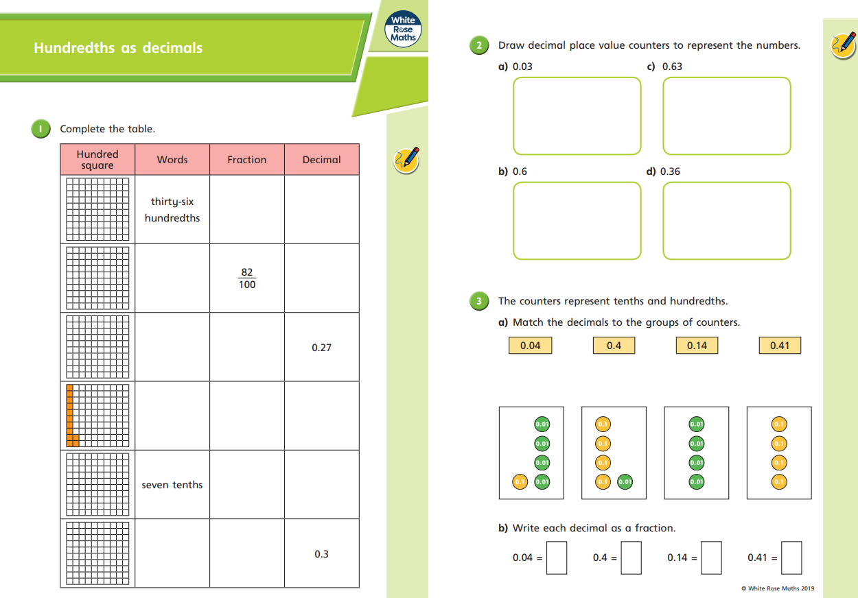

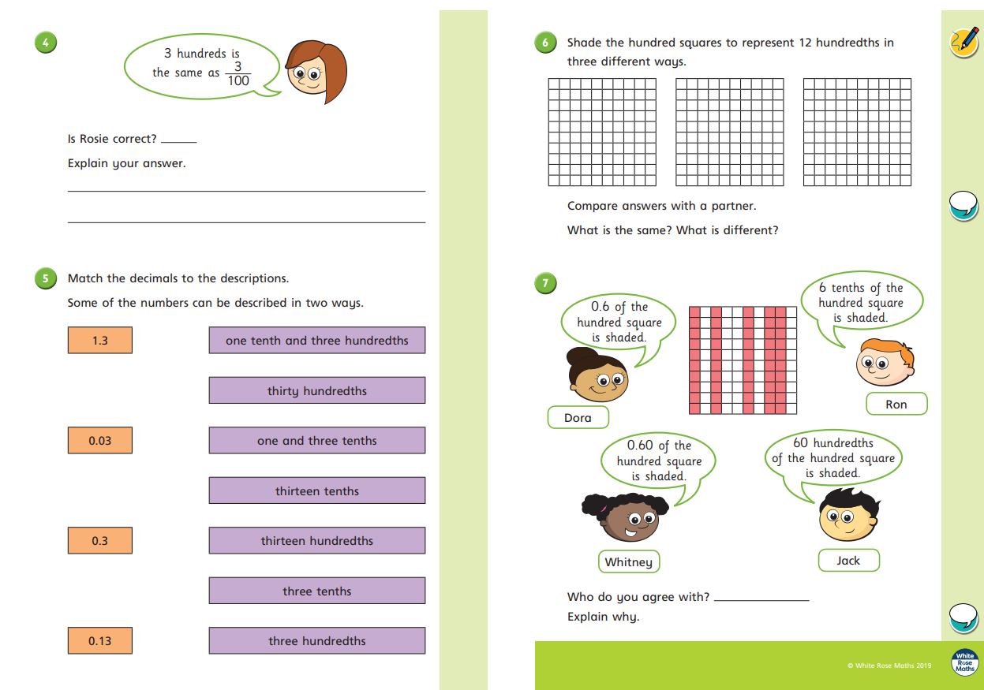

Go Deep: Go Deeper:

Yesterday’s Answers

English 29.04.20
This week we are going to be building up to writing our own diary entry. Today I would like you to identify relative clauses (clauses that being with a relative pronoun such as, who, whom, whose, that or which).

Yesterday’s English Answers
- What date was this diary written?
This diary entry was written on Wednesday 24th June 1836.

- Which two adjectives describe Oliver’s week and situation he finds himself in?
Oliver uses the adjectives ‘horrific’ and ‘grimmest’ to describe his week.

- Why did Oliver fight with another apprentice?
Oliver had a fight with another apprentice because the other boys were horrid to him and Oliver hated being there.

- How long did it take Oliver to reach London?
It took Oliver four whole days and nights to reach London.

- Copy a phrase or clause that describes the powerful smell?
The smell was powerful or stung my nostrils

- How does Oliver feel about Fagin? Explain using evidence from the text.
VARIOUS ANSWERS MAKING REFERENCE TO ILIVER BEING WARY OF FAGIN, CALLING HIM CROOKED AND THE LIVING CONDITIONS.
E.g. Oliver does not trust Fagin. I know this because he said he was wary of him and you are not wary of things or people that you trust. Fagin locks Oliver up with the other boys and makes them take things from people, therefore Oliver cannot like Fagin for treating him this way.

- Summarise this entry, keeping the key parts of Oliver’s week and his main feelings?
Various: Brief review of the main points of the text…

Thursday 30th April 2020

Good morning Year 4!
Here’s today’s daily Maths and English work to complete, in addition to our weekly project learning tasks. This week’s project is The Area You Live In. We hope you enjoy exploring the geography, history and beauty of your locality from the comfort of your home!
Mr. Ward and Miss Hatcher

Maths 30.04.20
Today we would like you to focus on Week 2 Lesson 4 of the home learning which can be found here: https://whiterosemaths.com/homelearning/year-4/
Today’s lesson is on Hundredths on a place value grid.
Watch the lesson video (Week 2 lesson 4), which looks like the screen above, and then answer the attached worksheet. If you find this lesson comfortable and would like to stretch yourselves, have a go and the go deeper questions which are also attached at the end of this document.

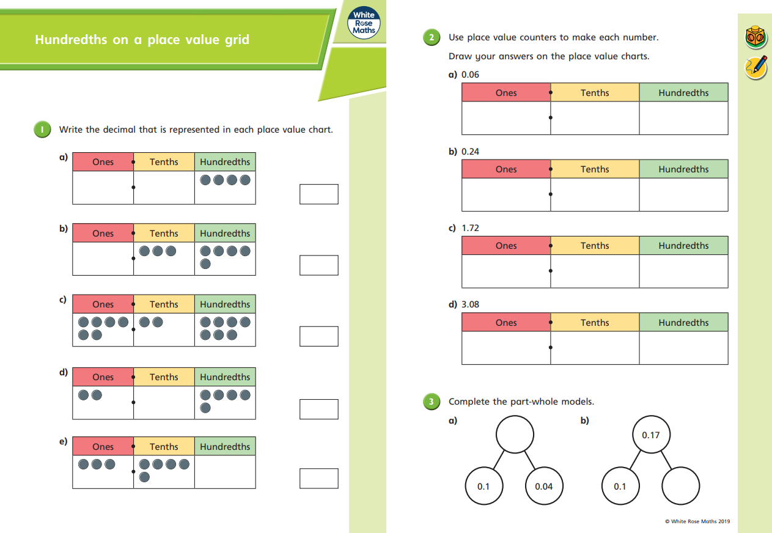

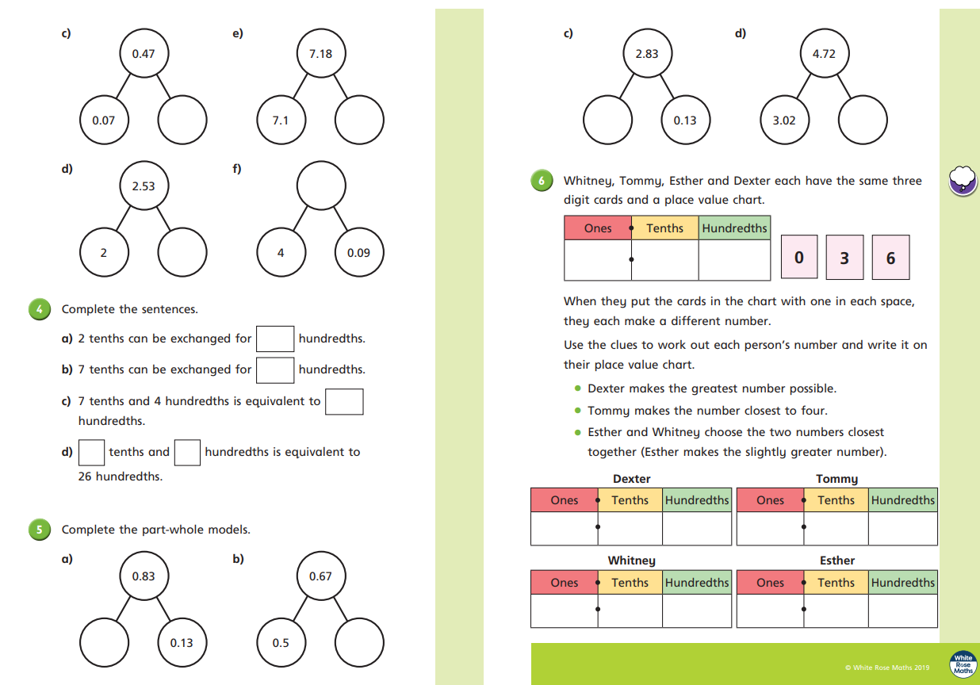

Go Deep: Go Deeper:

Yesterday’s Answers

English 30.04.20
This week we are going to be building up to writing our own diary entry. Today I would like you to apply your knowledge of relative clauses and create your own – remember to use correct sentence punctuation, such as commas, full stops and exclamation marks.

Once you have done this, write three sentences about what you have done so far this week. Remember to write in the first person (I, me, my our, ours, we) and past tense. Each sentence should include a relative pronoun.

Yesterday’s English Answers

Friday 1sh April 2020

Good morning Year 4!
Here’s today’s daily Maths and English work to complete, in addition to our weekly project learning tasks. This week’s project is The Area You Live In. We hope you enjoy exploring the geography, history and beauty of your locality from the comfort of your home!
Mr. Ward and Miss Hatcher

Maths 01.05.20
Today we would like you to focus on Week 2 Lesson 5 of the home learning which can be found here: https://whiterosemaths.com/homelearning/year-4/
Today’s lesson is on Dividing 1 or 2-digit numbers by 100.
Watch the lesson video (Week 2 lesson 5), which looks like the screen above, and then answer the attached worksheet. If you find this lesson comfortable and would like to stretch yourselves, have a go and the go deeper questions which are also attached at the end of this document.

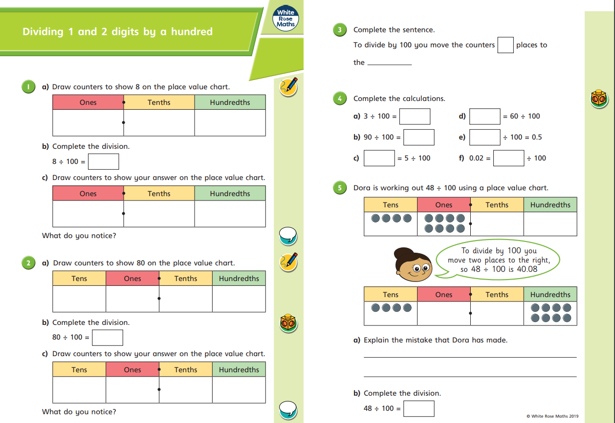

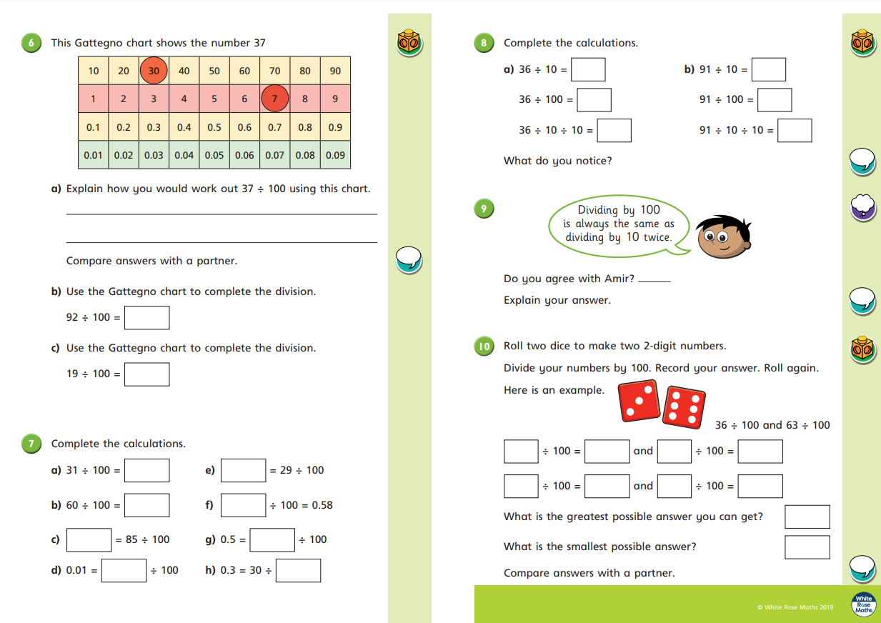

Go Deep: Go Deeper:

Yesterday’s Answers

English 01.05.20
This week we are going to be building up to writing our own diary entry. Today I would like you to write a diary entry, in the style of Monday’s WAGOLL, about your week. You can include anything that you have dome, made, seen, watched or spoken about… It must include the success criteria included in the checklist table, below. Good luck!

Feature | Child √ / X | Adult Checking √ / X
Written in the first person
Written in the past tense
Relative clauses /
complex sentences used
Range of punctuation used accurately (, . ? ! …)
Thoughts and feelings expressed

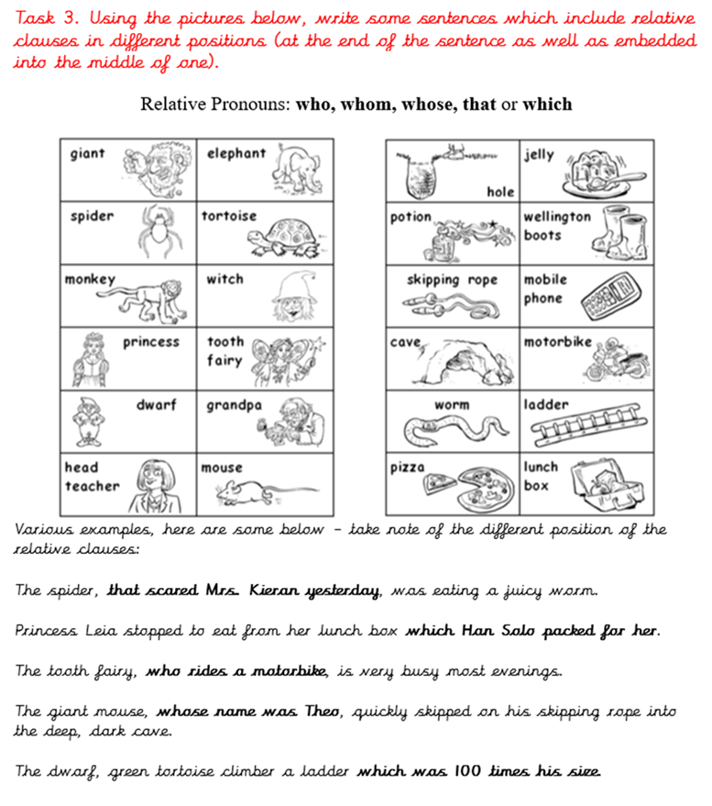
Yesterday’s English Answers

