‘

Bluecoat Primary Academy Art Progression Document 2021

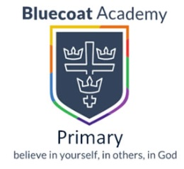
Bluecoat Primary Academy Art Intent Statement

Through believing in ourselves, in others and in God, we STRIVE for life in all its fullness.
At Bluecoat Primary Academy we share a life-long love of learning and celebrate success in all its forms. Our stimulating and challenging curriculum means that each school day is fun and purposeful. In our nurturing and welcoming environment everyone is valued and everybody has a voice. We pride ourselves on our Christian ethos whilst embracing other faiths, ultimately believing in ourselves, in others and in God.

At Bluecoat Primary we aim to provide an arts curriculum whereby children can grow to discover and develop their own individual talents. Lessons will be focused on developing children’s creativity by experimenting and engaging with the technical processes associated with the visual arts (drawing, painting, printing, form and pattern). By engaging with these, children will become proficient in the skills and will be confident when applying these to their own work. Children will follow an enquiry based approach to explore their ideas and will be encouraged to express their thoughts, feelings and emotions in a variety of ways. Our curriculum will also provide the opportunities for children to know about great artists and craft makers whilst also developing their evaluative and analysis skills. This will support our children in becoming articulate and confident to express their thoughts and feelings.

As the 21st century world becomes increasingly more uncertain it has never been more important to provide an art curriculum that supports the development of the whole child. The teaching of the visual arts will enable our children to develop their aesthetic senses and provide them with the skills required to interpret and infer meaning from visual images, which are essential to navigate in a visually orientated world. Our arts curriculum will support children in developing a visual language and the understanding that we can communicate and express our thoughts and ideas in a variety of ways. Children will be able to develop their cultural understanding and will learn about controversial issues that affect society when learning about the work of significant artists. This is important as children will develop their empathy skills and an awareness of others. Ultimately, our arts curriculum aims to develop active citizens who are able to discover and identify their own voice; who are confident to make a comment and give and opinion; whilst developing their creative thinking, resilience, resistance and problem solving skills which are needed to thrive in a modern world.

Art Progression Document Guide

Curriculum overview: an overview to show where the art process will be taught in each year group over the academic year.

National Curriculum expectations: the National Curriculum expectations will be explained.

Elements of Art: an explanation of the seven elements of art.

Big ideas: provides an overview of the key ideas and procedural knowledge children should know by the end of each year group.

Key Vocabulary: each process is linked with key vocabulary, this will be identified to support subject knowledge.

Equipment: the supporting resources which are needed in order to support children’s progression will be identified here.

Curriculum Overview 2020 - 2021

 | Drawing | Painting | Sculpture | Printing | Textile
Foundation 1
Foundation 2
Year 1
Year 2
Year 3
Year 4
Year 5
Year 6

National Curriculum Expectations

Access to an art and design education is a statutory right for children in the UK. The programme of study for art and design in the National Curriculum is a slimmed down version of practical guidance. The main aims are explored below in order to provide understanding on how the subject should be presented and delivered for children.

Tha National Curriculum for art and design aims to ensure that all pupils:

- Produce creative work, exploring their ideas and recording their experiences.
This means that children should:
- Generate their own original ideas and visually record these.
- Develop personal and creative responses through diverse opportunities and through the use of difference media and processes.
- Investigate, analyse and experiment in order to explore and record their observations, imaginations, feelings and personal responses when engaged with the creative processes.
- Work produced should be individual and original.

- Become proficient in drawing, painting, sculpture and other art, craft and design techniques
This means that children should:
- Have consistent opportunities to experiment with a wide range of materials and media.
- Develop their confidence in applying these materials and media.
- Make informed choices about which media they are going to use.
- Observe in detail the world around them.
- Controlling suitable tools with increasing proficiency.
- Work on a different range of scales (from small size to large scale works).

- Evaluate and analyse creative works using the language of art, craft and design.
This means that children should:
- Discuss their own work and the work of others with confidence whilst making reference to technical vocabulary.
- Develop their resilience when receiving feedback.
- Use their feedback to help them make decisions about their work and thus, work on improvements.
- Become visually perceptive and visually literate through looking, thinking, recognising, interpreting and understanding art, craft and design as a medium of communication and meaning which uses visual symbols and icons.

- Know about great artists, craft makers and designers, and understand the historical and cultural development of their art forms.

This means that children should:
- Research, communicate, analyse, critically evaluate and review the work of significant artists*, craftspeople*, and designers*.
- Learn about, research and explore relevant and significant artists, craftspeople and designers to inform their creative thinking and the development of their own creative practice, informing their outcomes and signposting to career and vocational paths.
- Have opportunities to explore the work of artists, crafts people, and designers that should include examples selected from both male and female practitioners, examples from diverse genres, periods and cultures, exploring a range of different intentions.
- In their study, reflection and response to the work of artists, craftspeople and designers, and to the social and historic context in which they worked. This will enable children to learn more about other world cultures. They develop awareness of the place of art, craft and design in the world and will understand the impact this can have on people’s lives.

*Artists to include: painters, portrait artists, landscape artists, abstract and conceptual artists, print makers, illustrators and graffiti artists all from different world cultures, periods or artistic movements.
*Crafts people to include: potters, ceramicists, weavers, jewellers, glass makers, furniture makers, textile artists in weave and print, stone masons, letter cutters, toy and automata makers and craftspeople working in traditional, cultural and heritage industry craft forms to include preservation and conservation.
*Designers to include: book designers, illustrators, typographers, graphic designers, fashion and textile designers, interior and exhibition designers, stylists and advertisers.

The Seven Elements of Art
The building blocks that structure every single work of art, piece of design or craft artefact are known as the ‘Seven Elements of Art’. Understanding each of these is essential subject knowledge as these make up every piece of artwork and are fundamental to the creation of artwork. These should be considered as the vital ingredients. They can be taught separately and have lessons focused specifically on each element however, these will often overlap. This is likely to happen in EYFS and Key Stage 1. As children progress into Key Stage 2, children should begin to have a secure knowledge of these elements and should use them when discussing different forms of visual art.

Element | Definition
Line | Line is a mark made using a drawing tool or brush. There are many types of lines: thick, thin, horizontal, vertical, zigzag, diagonal, curly, curved, spiral, etc. and are often very expressive. Lines are basic tools for artists—though some artists show their lines more than others. Some lines in paintings are invisible—you don't actually see the dark mark of the line. But they are there, shown in the way the artist arranges the objects in the painting.
Shape | Shape is a flat area surrounded by edges or an outline. Artists use all kinds of shapes. Geometric shapes are precise and regular, like squares, rectangles, and triangles. They are often found in human-made things, like building and machines while biomorphic shapes are found in nature.
Space | Space deals with the area around or inside the shapes. ‘Positive space’ is the area occupied by an object and ‘negative space’ is the area around the object. This element is used to give the illusion of depth in a two-dimensional image. Specific vocabulary that relates to this is ‘foreground’, ‘middle ground’ and ‘back-ground’.
Colour | Colour is what we see because of reflected light. Light contains different wavelengths of energy that our eyes and brain "see" as different colours. When light hits an object, we see the coloured light that reflects off the object. Red, blue, and yellow are the primary colours. With paints of just these three colours, artists can mix them to create all the other colours. When artists mix pigments of the primary colours, they make secondary colours. Colour has three main properties: hue, which is the name we give to different colours. Intensity related to the vividness of the colour; and tonal value, which relates to the share or tint of a colour.
Texture | This element relates to how the surface of something feels, or might feel if you could touch it. For artists, this could mean either real surface quality, such as in sculpture, or the illusion of surface quality, as represented though for example, painting or drawing.
Form | All objects that have three dimensions are examples of this element. 3D forms will have height, width, depth and volume. Forms can be viewed from all side, either by picking them up or by walking around them.
Tone | Tonal value refers to the degree of lightness or darkness, or shade, of an object or colour. Artists use this element to create the illusion of depth in two-dimensional shapes, by shading and adding shadow. ‘Tints’ make colour lighter by adding white or, in some cases, yellow can help tones seem brighter; ‘shades’ make colours appear darker, which is achieved by adding black or darker colours, such as purple or blue.

Big Ideas and Prior Learning

Foundation Stage | By the end of Foundation 1:  Expressive Arts and Design:  - Children should explore different materials in order to develop their ideas about how to use them and what to make.  - Develop ideas and begin to make informed choices about which materials to use to express themselves.  - Experiment with different materials and explore different textures.  - In drawing, children should use basic lines and shapes and begin to notice simple details and try and represent these in their drawings.  - Begin to show different emotions in their drawings and paintings.  - Explore colour and colour mixing.  Physical Development:  - Develop large muscle movements to paint and make marks.  - Use one-handed tools and equipment.  - Use a comfortable grip with good control when holding pens.  By the end of Foundation 2:  Expressive Arts and Design:  - Explore, use and refine a variety of artistic effects and techniques to express their ideas.  - Become increasingly competent when using a variety of tools (paintbrushes, scissors, rollers etc)  - Make carefully informed choices about which materials they would like to use.  - Experiment and explore with colour and make secondary colours.  - Children should have seen the work of significant artists.  - Children should begin to develop opinions around their artwork and discuss the emotions that the artwork evokes.  Physical Development:  - Begin to show accuracy and care when drawing.  - Use a variety of tools with confidence.  - Develop their small motor skills.
Key Stage 1 | - Drawing - Pupils should be able to draw basic lines and shapes with increasing confidence to create more complex forms. They should have drawn and made marks using a range of media and surfaces, drawn from observation and imagination and developed their ability to shade and colour neatly & evenly.  - Painting – there should be an increased ability to control brushes and paint to render ideas & observations. They should have used different paints and surfaces, be able to mix primary & secondary colours confidently and use different painting techniques such as stippling, dripping, spattering etc.  - Media - there should be a well-developed ability to apply formal elements in their work using drawing, painting, craft and mixed media. Pupils should have designed & invented complex forms to solve problems, experienced craft processes such as weaving, sewing, cutting, fabrics, wire, clay and collage.  - Ideas – Should understand how to develop ideas over time. Express ideas about things they want to make. Use imagination to invent and create. Select aspects of significant art to incorporate in own work.  - Knowledge – Learn how artists use formal elements in work to create effects, ideas and feelings. Study significant works of art.  - Evaluation – Identify similarities and differences in own and others work. Make choices and decisions. Give and receive constructive praise and criticism.
Lower Key Stage 2 | By the end of Lower Key Stage 2:  - Drawing - Further developed skills in drawing using 2D and 3D shapes, becoming aware of proportion, scale and order of drawn forms. Develop shading using a range of media. Learned sketching techniques, mark making and drawing in different media. Draw for different purposes and reasons.  - Painting – Increasing control using different painting techniques, painting on different surfaces exploring textures, pattern, colour, line, shape and form. Create ideas, thoughts, moods and feelings through paint.  - Media – Design & make for purpose, experience a range of craft mediums such as collage, embroidery, sewing, weaving, felt. Have learned simple printing techniques and used blocks to make repeat patterns. Created 3D sculptures and forms in a range of materials. Created digital images and edited these using appropriate apps.  - Ideas – Have used sketchbooks to record observations, thoughts, ideas, research & explore. Used art to express ideas & feelings, made art for pleasure and to develop ideas.  - Knowledge – Given opinions of art using a more complex vocabulary related to the formal elements of art. Studied how significant artists work both in the past and today.  - Evaluation – Used evaluation in the classroom to understand what they need to do to improve. Learned how to advise others and receive constructive criticism.
Upper Key Stage 2 | Upon leaving Key Stage 2:  - Pupils should be able to draw complex forms using 2D and 3D shapes to help them. They should have a grasp of basic one-point perspective and learned how to model forms using shading, light and tone. They should have drawn using a range of mark making techniques in a range of media, making their own choices and decisions when drawing. There should be an awareness of different styles of drawing for different purposes and reasons.  - Painting – Pupils should paint with greater confidence and control, understanding how to mix and blend primary & secondary colours, create tone and textures and apply paint sensitively for purpose. They understand how to use and apply the formal elements when painting.  - Media – Pupils should have designed and made art for different purposes. They should have explored craft techniques and developed their skill in cutting, joining and forming when working in a range of craft materials. They will have developed their printing ability by printing geometric patterns, made 3D sculptures, and created digital art using photography and editing apps.  - Ideas – Pupils will be familiar with using a sketchbook to record thoughts, ideas, feelings, research, investigations and explorations in media. They will be more confident at taking risks, working independently and mistake making. They will have worked from their imagination, from observation and used art to express their thoughts and feelings.  - Knowledge – Pupils will have studied significant art in some depth and be aware of a basic chronological development of art over time. They will know the content, process, form, mood technique of deconstructing art. They will be aware of the different purposes of art in society and as a creative occupation.  - Evaluation – Pupils will be sensitive to the inner difficulty of the creative process and be able to use discussion and feedback to build confidence in themselves and others.

Drawing and Mark Making

Key Vocab | Line, tone, pressure, shade, dark, light, shadow, soft, curve, straight, wavy, shape, space, texture, pattern, subtle, gradation, blend, tonal values, density, smudge, sharp, darkness, reflection, highlight, stokes, side strokes, cross hatch, stippling, scribbling, layers, background, foreground, hatching, scumbling, dimension, perspective, composition, scale and proportion, scale.
Equipment | Drawing pencils, fine liners, drawing pens, tracing paper, drawing paper, pastels, chalks, crayons, oil pastels, charcoal pencils, willow charcoal, charcoal sketch sticks, mannequins, putty rubbers, erasers, felt tips, mirrors, viewfinders, sketchbooks.
Foundation Stage |  | Year 1 | Year 2 | Year 3 | Year 4 | Year 5 | Year 6
Foundation Stage 1  -Children will experiment freely with different drawing implements.  -Children will draw on a variety of papers and surfaces.  -Include a variety of shapes and lines within their drawings. Some features will become recognisable within their drawings.  -Will develop their grip when handling a range of media.  Foundation Stage 2  - Use graphic tools, fingers, hands, chalk, pens and pencils.  - Draw on different surfaces and coloured paper.  - Produce lines of different thickness and tone using a pencil.  -Begin to show increasing accuracy and care when drawing.  - Start to produce and explore how different patterns and textures can be made from observations, imagination and illustrations.  - Look at and talk about what they have produced, describing simple techniques and media used.  -Will develop their grip when handling a range of media.  -Work collaboratively with their peers and share their ideas, resources and skills. |  | -Experiment with a variety of media; pencils, rubbers, crayons, pastels, felt tips, charcoal, pen, chalk.  - Begin to control the types of marks made with a range of media.  - Draw on different surfaces with a range of media.  - Start to record simple media explorations in a sketchbook.  - Develop a range of tone using a pencil and use a variety of drawing techniques such as: hatching, scribbling, stippling and blending to create light/dark lines.  -Begin to match and draw lines/marks from observations and invent new lines.  -Explore a range of different lines and describe their thickness.  - Investigate textures by describing, naming, rubbing, copying.  - Produce an expanding range of patterns and textures.  -Investigate tone by drawing light/dark patterns, light and dark shapes. | -Continue to experiment with a variety of media; pencils, rubbers, crayons, pastels, felt tips, charcoal, pen, chalk in sketchbooks. These experiments should start to support informed choices.  - Develop intricate patterns/marks with a variety of media.  - Demonstrate experience in different grades of pencil and other implements to draw different forms and shapes.  -Begin to understand how different grades of pencils can have different effects on work.  -Continue to develop a range of tone using a pencil and use a variety of drawing techniques such as: hatching, scribbling, stippling and blending to create light/dark lines. Children should start to use these when thinking about texture.  - Create textures and patterns with a wide range of drawing implements.  - Use a sketchbook to record media explorations and experimentations as well as planning and collecting source material for future works.  -Observe and draw shapes from observations. Begin to draw shapes in-between objects.  - Begin to show an awareness of objects having a third dimension and perspective.  -Make drawings as a starting point for work in other areas. | -Develop intricate patterns/marks with a variety of media.  -Begin to have greater control when using different media.  - Begin to show understanding of the different grades of pencil. Start to make informed choices about which pencils to choose when drawing.  -Experiment with different grades of pencils and other implements to achieve variations in tone. Apply tone in a drawing in a simple way using techniques from KS1 (scribbling, stippling etc).  -Use different pressures to create hard and soft lines.  - Use a sketchbook to record media explorations and experimentations as well as planning and collecting source material for future works.  - Continue to show an awareness of objects having a third dimension and perspective.  -Experiment with ways in which surface detail can be added to drawings.  - Create textures and patterns with a wide range of drawing implements. Use mirrors, viewfinders and magnifying glasses to aid observation.  -Make drawings as a starting point for work in other areas. | -Develop intricate patterns using different grades of pencil and other implements to create lines and marks.  - Draw for a sustained period of time at an appropriate level.  - Start to become secure with the understanding of different grades of pencil and other implements to achieve variations in tone and make marks on a range of media.  -Make informed choices about which media/grade of pencil they are going to use.  -Use different pressures to create hard and soft lines.  -Use these pencils to achieve variations in tone.  - Use sketchbooks to collect and record visual information from different sources as well as planning and collecting source material for future works.  - Have opportunities to develop further drawings featuring the third dimension and perspective.  -Use hard and soft lines to show the detail in the distance and foreground.  - Further develop drawing a range of tones, lines using a pencil, include in their drawing a range of techniques and begin to understand why they best suit. Start to explain which techniques they have included these.  - Create textures and patterns with a wide range of drawing implements. Use mirrors, viewfinders and magnifying glasses to aid observation.  -Make drawings as a starting point for work in other areas. | -Work in a sustained and independent way to create a detailed drawing.  -Have a secure understanding of the grades of pencils.  -Make informed choices about which pencils and media they are going to use, this can include charcoal, pastels and ball point pens.  - Develop a key element of their work: line, tone, pattern, texture.  - Use different techniques for different purposes i.e shading, hatching within their own work. Independently choose to include these techniques and explain why they are using them.  - Use sketchbooks to collect and record visual information from different sources as well as planning and collecting source material for future works.  - Start to develop their own style using tonal contrast and mixed media.  - Have opportunities to develop further simple perspective in their work using a single focal point and horizon.  - Begin to develop an awareness of composition, scale and proportion in their work.  - Use drawing techniques to work from a variety of sources including observation, photographs and digital images.  - Develop close observation skills using a variety of view-finders.  -Identify artists who have worked in a similar way.  -Make drawings as a starting point for work in other areas. | - Work in a sustained and independent way to develop their own style of drawing. This style may be through the development of line: tone, pattern, texture.  -Have a secure understanding of the grades of pencils.  -Make informed choices about which pencils and media they are going to use, this can include charcoal, pastels and ball point pens.  - Draw for a sustained period of time over a number of sessions working on one piece.  Use different techniques for different purposes ie. shading, hatching within their own work, understanding which works well in their work and why.  - Use sketchbooks to collect and record visual information from different sources as well as planning and collecting source material.  - Adapt their work according to their views and describe how they might develop it further.  - Develop their own style using tonal contrast and mixed media.  - Have opportunities to develop further simple perspective in their work using a single focal point and horizon.  - Develop an awareness of composition, scale and proportion in their work.  -Make drawings as a starting point for work in other areas.

Colour and Painting

Key Vocab | Primary, secondary, territory, complementary colours, glossy, matt, transparent, opaque, texture, soft, light, highlight, tone, shade, tint, hue, fine, thick, soft, flat, bristle, broad, stipple, stroke, wash, wipe, smear, blend, fluorescent, layers, splash, drip, spot, depth, intense, cool, warm, pale, greyscale, spread, stain, composition, block, muted.
Equipment | Powder paint, rags and sponges, hands and fingers, watercolours, oil paint, acrylic paint, marbelling equipment, ready mixed paint, different brush sizes.
Foundation Stage |  | Year 1 | Year 2 | Year 3 | Year 4 | Year 5 | Year 6
Foundation Stage 1  -Explore paint freely through play.  -Experiment with mixing colours.  - Experiment with mixing powder paint.  -Use a variety of tools when painting.  Foundation Stage 2  -Enjoy using a variety of tools including different size brushes and tools i.e. sponge, brushes, fingers and begin to demonstrate increasing competency when using these.  -Recognise and name the primary colours.  -Experiment with mixing colours.  -Experiment and explore with powder paint.  -Explore working with paint on different surfaces and in different ways i.e. coloured, sized and shaped paper.  -Learn the names of different tools that bring colour, glue, pastels, and paint, felt tips, crayons.  -Use a range of tools to make coloured marks on paper – glue sticks, sponges, brushes, fingers. |  | - Know the primary colours and mix secondary colours. Moving towards predicting resulting colours.  -Find collections of colour – different sorts of green, blue, purple etc.  -Explore wet and dry painting techniques.  -Explore lightening and darkening paint without the use of black or white.  -Experiment with a variety of media; different brush sizes and tools.  -Continue to mix powder paint and explore watercolours.  -Begin to control the types of marks made with the range of media. Paint on different surfaces with a range of media.  - Start to record simple media explorations in a sketch book. | - Begin to control the types of marks made with a range of painting techniques and media e.g. layering, mixing media, and adding texture (sawdust, sand etc).  - Use a brush to produce marks appropriate to work. E.g. small brush for small marks.  - Continue to experiment in lighten and darken without the use of black or white.  - Begin to mix colour shades and tones. Understand the vocabulary of shades and tones (Paint and Pastels).  -Have a secure understanding of primary and secondary colours.  -Understand  how artists use warm and cool colours and explore how this can create a mood in painting.  -Discuss how colour can be linked to different emotions.  -Use a sketchbook to plan and develop simple ideas and continue to store information on colour mixing, the colour wheel and colour spectrums. | - Demonstrate increasing control the types of marks made and experiment with different effects and textures inc. blocking in colour, washes, thickened paint creating textural effects.  - Use light and dark within painting and begin to explore complimentary colours.  - Mix colour, shades and tones with increasing confidence (use black and white).  -Continue to investigate how warm and cool colours are used in art to create moods. Start to discuss how they have achieved this in their own work.  - Use a sketchbook to record media explorations and experimentations as well as try out ideas, plan colours and collect source material for future works.  - Confidently create different effects and textures with paint according to what they need for the task.  - Discuss own and others work, expressing thoughts and feelings, and using knowledge and understanding of artists and techniques. | - Confidently control the types of marks made and experiment with different effects and textures Inc. blocking in colour, washes, thickened paint creating textural effects.  -Start to work with acrylic paint and understand the properties of acrylic paint. Compare this to powder, watercolour and poster paint.  -Start to develop a painting from a drawing.  -Begin to choose appropriate media to work with.  -Use light and dark within painting and show understanding of complimentary colours.  -Mix colour, shades and tones with increasing confidence.  - Use sketchbooks to collect and record visual information from different sources as well as planning, trying out ideas, plan colours and collect source material for future works.  -Start to look at working in the style of a selected artist.  -Discuss and review own and others work, expressing thoughts and feelings, and identify modifications/ changes and see how they can be developed further. | - Confidently control the types of marks made and experiment with different effects and textures inc. blocking in colour, washes, thickened paint creating textural effects.  -Continue to work with acrylic paint and understand the properties of acrylic paint. Compare this to powder, watercolour and poster paint.  - Mix and match colours to create atmosphere and light effects.  -Mix colour, shades and tones with confidence building on previous knowledge.  -Demonstrate a secure knowledge about primary and secondary, warm and cold, complementary and contrasting colours.  - Use sketchbooks to collect and record visual information from different sources as well as planning, trying out ideas, plan colours and collect source material for future works.  - Start to develop their own style using tonal contrast and mixed media.  - Discuss and review own and others work, expressing thoughts and feelings, and identify modifications/ changes and see how they can be developed further.  - Identify artists who have worked in a similar way to their own work. | - Work in a sustained and independent way to develop their own style of painting. This style may be through the development of: colour, tone and shade.  --Demonstrate a secure knowledge about primary and secondary, warm and cold, complementary and contrasting colours.  -Understand tertiary colours.  - Purposely control the types of marks made and experiment with different effects and textures inc. blocking in colour, washes, thickened paint creating textural effects.  - Mix colour, shades and tones with confidence building on previous knowledge, understanding which works well in their work and why.  -Start to work with oil paint and compare the difference between acrylic, watercolour and poster paint.  - Use sketchbooks to collect and record visual information from different sources as well as planning and colleting source material.  - Adapt their work according to their views and describe how they might develop it further.  - Annotate work in sketchbook.  - Discuss and review own and others work, expressing thoughts and feelings explaining their views.

Sculpture and Form

Key Vocab | coiling, pinching, slabbing, slip, hollow form, malleable, pull out, add on, impress, engrave, carve, layers of relief, scoring, moistening, blending, varnish, polish, mold, press, wrap, layer, smooth, roll, stretch, cut, score, sgraffito, carve, shape, form, kiln, biscuit, pummel, roll, blend, relief, curl, air-dry, harden, hollow, layer, smooth, surface, detail, design, pattern, decoupage, scrunch, rigid, attach, bind, intersection, spatial, substance, geometric, engrave, etch, whittle,
Equipment | Clay, salt dough, modelling clay, play doh, mod roc, sticky bricks, art straws, clay gun, modelling and carving tools, knives, rolling pins, wire cutter, tile cutter, any recyclable material, stone.
Foundation Stage |  | Year 1 | Year 2 | Year 3 | Year 4 | Year 5 | Year 6
Foundation Stage 1  -Handle, feel and manipulate materials.  -Make impressions on malleable materials.  -Investigate materials using pulling, twisting, rolling, squeezing and shaping.  -Begin to cut, tear and fold.  -Join different materials and explore different textures.  -Use junk modelling to create simple sculptures and then explain what they have made.  Foundation Stage 2  -Continue to Handle, feel and manipulate materials.  -Construct and build from simple objects.  -Pull apart and reconstruct.  -Cut shapes using scissors.  -Shape and model from observation and imagination.  -Impress and apply simple decoration.  -Use junk modelling to create simple sculptures and then explain what they have made.  -Use simple language created through discussion of feel, size, look, smell etc.  -Make simple joins by manipulating modelling material or gluing carefully. |  | -Use a combination of shapes.  -Manipulate clay in a variety of ways and make comparisons between malleable materials.  -Include lines and texture. Use different modelling tools to support the use of texture.  -Use materials and tools safely.  -Experiment by squeezing, pinching, pulling, pressing, rolling, modelling, flattening, poking, squashing and smoothing the malleable material.  -Discover that clay will dry out if it is over-handled, left out. Learn about the properties of clay.  -Use rolled up paper, straws, paper, card and clay as materials.  -Use techniques such as rolling, cutting, moulding and carving.  -Use sculpture as a medium to develop and share ideas.  -Create using imagination, known experiences and personal ideas.  -Cut shapes using scissors.  -Make simple joins by manipulating modelling material or gluing carefully.  -Construct from found junk materials. | -Use a combination of shapes.  - Continue to experiment by squeezing, pinching, pulling, pressing, rolling, modelling, flattening, poking, squashing, moulding and smoothing the malleable material.  -Pinch small balls of the malleable material to create hollow forms in clay.  -Cut shapes out of flattened pieces and  join clay securely by blending surfaces together using tools or their fingers.  -Apply skills to a relief tile.  -Develop and use a texture for effect and select appropriate materials to create these effects.  -Use materials and tools safely and demonstrate an understanding of how to care for clay. Observe and describe how clay changes as it air dries.  -Refine skills in sculpture and develop and share ideas by combining personal experiences and imagination.  -Use rolled up paper, straws, paper, card and clay as materials.  -Have an awareness of natural and man-made forms in the environment.  -Use a range of decorative techniques: applied, impressed, painted, etc.  -Shape and form materials from direct observation.  -Begin to make simple thoughts about own work and that of other sculptors. | -Create and combine shapes to create recognisable forms from nets or solid materials.  -Include texture that conveys feeling expression or movement.  -Flatten and roll pieces of the malleable material to make slabs. Use rollers and guides to make clay slabs of even thickness.  -Create and use coils when using clay (making coils of even thickness; and add coils and other clay forms to create images or decoration)  -Create a slip to join materials when using clay.  -Add materials to provide interesting detail.  -Use the equipment and media with increasing confidence.  -Shape, form, model and construct from observation and / or imagination with increasing confidence.  -Plan and develop ideas in sketchbook and make simple choices about media.  -Begin to have some thought towards size.  -Have simple discussion about aesthetics.  -Experiment and apply a varnish or paint to clay.  -Use a range of decorative techniques: applied, impressed, painted, etc. | -Create and combine shapes to create recognisable forms from nets or solid materials.  -Design and make for a purpose.  -Include textures that convey feeling expression or movement.  -Have an understanding of different adhesives and joining techniques (PVA, tapes, glue guns and glue sticks).  -Learn about the properties of these adhesives (such as how quick each dries, how strong the finished join is)  -Explore the nature and qualities of a range of construction materials (brick, stone, plastic, wood, polystyrene etc). Think about how light materials can be made strong.  -Work on large scale projects which enable the children to create an armature as a framework for sculpture.  -Add materials to provide interesting detail.  -Plan and develop ideas in sketchbook and make informed choices about media.  -Shape, form, model and construct from observation and / or imagination with increasing confidence.  -Discuss own work and work of other sculptors with comparisons made.  -Consider light and shadow, space and size.  -Investigate, analyse and interpret natural and manmade forms of construction. | -Show life-like qualities and real-life proportions or, if more abstract, provoke different interpretations.  -Use tools to carve and add shapes, texture and pattern.  -Combine visual and tactile qualities.  -Use frameworks (such as wire or moulds) to provide stability and form.  -Use sketchbook to inform, plan and develop ideas.  -Shape, form, model and join with confidence.  -Produce more intricate patterns and textures.  -Work directly from observation or imagination with confidence.  -Take into account the properties of media being used.  -Discuss and evaluate own work and that of other sculptors in detail.  -Explore papier mache and create a paste using knowledge of adhesives.  -Explore carving as a form of 3D art.  - Confidently carve a simple form.  -Use language appropriate to skill and technique. | -Show life-like qualities and real-life proportions or, if more abstract, provoke different interpretations.  -Use tools to carve and add shapes, texture and pattern.  -Combine visual and tactile qualities.  -Use frameworks (such as wire or moulds) to provide stability and form.  -Make imaginative use of the knowledge they have acquired of tools, techniques and materials to express own ideas and feelings.  -Create and evaluate a sculpture. Incorporate form, pattern, and texture.  -Use a wide variety of tools and refine skills. --Use imagination and experience to influence work.  -Evaluate and edit using artistic language.  -Discuss and evaluate own work and that of other sculptors in detail.  -Use language appropriate to skill and technique.

Printing and Pattern

Key Vocab | block, brayer, roller, collagraphy, engraving, etching, monoprint, printing press, proofs, relief, relief print, screen print, stencil, repeated pattern.
Equipment | Rollers, roller trays, printing ink, neoprene foam, corks, hinged screens, squeegees, stencil cards.
Foundation Stage |  | Year 1 | Year 2 | Year 3 | Year 4 | Year 5 | Year 6
Foundation Stage 1  -Explore printing from hands, fingers, vegetables etc.  -Experiment with finger-paints and dabbers as a form of printing.  -Use a variety of found objects to explore printing  Foundation Stage 2  -Make rubbings showing a range of textures and patterns.  -Take prints from object (manmade and natural) leaf, hand, onion, feet, junk, bark, modelling clay etc.  -Produce simple pictures by printing objects.  -Work from imagination and observation.  -Imprint onto a range of textures – newspaper, coloured paper, plain paper, into clay and dough etc.  -Print with block colours.  -Experiment with finger-paints and dabbers as a form of printing. |  | -Create patterns and pictures by printing from objects using more than one colour (including the use of manmade and natural objects).  -Create their own stamps to support understanding of repeating patterns.  -Develop impressed images with some added pencil or decorative detail.  -Relief printing - string, card, etc.  -Use equipment and media correctly, to produce clean image.  -Use appropriate language to describe tools, process, etc.  -Use sketchbook for recording textures/patterns. | -Create order, symmetry, and irregularity.  -Extend repeating patterns - overlapping, using two contrasting colours etc (relief printing).  -Create still prints with a growing range of objects, including manmade and natural printing tools.  -Explore the difference between relief printing and mono printing.  -Talk simply about own work and that of other artists.  -Identify the different forms printing takes: books, pictures, wallpaper, fabrics, etc.  -Use sketchbook for recording textures/patterns. | -Use the equipment and media with increasing confidence.  -Use relief and impressed printing processes.  -Explore images through mono printing on a variety of papers (Egypt).  -Use sketchbook for recording textures/patterns.  -Use language appropriate to skill.  -Discuss own work and that of other artists.  -Explore colour mixing through overlapping colour prints deliberately.  -Expand experience in 3  colour printing. | -Use sketchbooks to  collect and record  visual information from  different sources as  well as planning, trying  out ideas, plan colours  and collect source  material for future  works.  -Explore texture through collogram printing and through deliberate selection of materials (lentils, corrugated card, string etc).  -Interpret environmental and manmade patterns and form.  -Discuss the nature of effects able to modify and adapt print as work progresses.  -Use language appropriate to skill.  -Become secure with 3  colour printing. | -Become experienced in combining prints taken from different objects to produce an end piece.  -Develop skills in string printing.  -Use sketchbooks to  collect and record  visual information from  different sources as  well as planning, trying  out ideas, plan colours  and collect source  material for future  works.  -Discuss the nature of effects able to modify and adapt print as work progresses.  -Use language appropriate to skill.  -Designs prints for fabrics, book covers and wallpaper.  -Makes connections between own work and patterns in their local environment (e.g. curtains, wallpaper). | -Build up drawings and images of whole or parts of items using various techniques, e.g. card, relief.  -Explore fabric printing through resist printing  including marbling,  silkscreen, glue and batik wax.  -Develop skills in screen printing.  -Start to overlay prints with other media.  -Explore printing techniques using by various artists.

Textile and Collage

Key Vocab | Batik, decoupage, applique, knitting, weaving, fabric, felt, yarn, overlapping, under laying, needles, stiches, cross stitch, back0stitch, tie-dying, running stiches, fraying, fringing, pulling, twisting, plaiting, chain stitch, binka.
Equipment | Weaving cards, yarn, cotton, needles, lace, buttons, binka.
Foundation Stage |  | Year 1 | Year 2 | Year 3 | Year 4 | Year 5 | Year 6
Foundation Stage 1  -Explore a range of fabrics and stick them together.  -Hold simple discussions about what the different fabrics feel like.  -Create simple collages by overlaying fabrics and papers.  -Experiences of cutting, tearing, gluing, folding and scrunching.  Foundation Stage 2  -Handling, manipulating and enjoying using materials.  -Match and sort fabrics for colour, texture, length, size and shape.  -Simple collages, using paper, pasta, beans and larger tactile things.  -Selects, sorts, tears and glues items down. |  | -Uses simple paper and/or material weaving using a card loom.  -Mix colours and paint strips of paper to weave with.  -Add objects to the weaving - buttons, twigs, dried flowers.  -Explore colour in weaving.  -Build on skills of using various materials to make collages –using some smaller items.  -Use texture to provide information – e.g. manmade/natural materials, a ‘journey’ of where they have been etc.  -Sort according to specific qualities, e.g. warm, cold, shiny, smooth etc.  -Discuss how textiles create things – curtains, clothing, decoration | -Build on experiences in Year 1  -Develop skills of overlapping and overlaying to create effects.  -Use large eyed needles, different thicknesses of thread and different sized running stitches to draw with.  -Simple appliqué work attaching material shapes to fabric with running stitches.  -Start to explore other simple stitches - backstitch, cross-stitch.  -Use various collage materials to make a specific picture. | -Use smaller eyed needles and finer threads.  -Continue to develop understanding of simple stitches - backstitch, cross-stitch  -Use colour to express an idea in weaving - seasons, moods, or create a picture - swamp, seascape.  -Develops awareness of the nature of materials and surfaces – fragile, tough and durable.  -Use tie dying, batik – ways of colouring or patterning material.  -Continue to develop appliqué work, attaching material shapes to fabric with running stiches.  -Change and modify threads and fabrics, knotting, fraying, fringing, pulling threads, twisting and plaiting. | -Continue to build on all previous experiences.  -Use a wider variety of stitches to 'draw' with and develop pattern and texture – e.g. zig zag stitch, chain stitch, seeding.  -Start to place more emphasis on observation and design of textural art.  -Use initial sketches to aid work.  -Continue experimenting with creating mood, feeling, movement and areas of interest.  -Look at fabrics from other countries and discuss. Compare with own. Discuss different types of fabric.  -Continue to change and modify threads and fabrics, knotting, fraying, fringing, pulling threads, twisting and plaiting. | -Select and use materials to achieve a specific outcome.  - Develop understanding of binka.  -Embellish work, using a variety of techniques, including drawing,  painting and printing on top of textural work.  -Consider methods of making fabric.  -Look at work of other artists using textiles (freedom blankets). | -Develop experience in embellishing, pooling together experiences in texture to complete a piece – applique, drawing, sticking, cutting, paint, weaving, layering etc.  -Apply knowledge of different techniques to express feelings.  -Use found and constructed materials.  -Work collaboratively on a larger scale.
Evaluation

Foundation Stage | Year 1 | Year 2 | Year 3 | Year 4 | Year 5 | Year 6
Foundation Stage 1  -Comment on what they have created and explain what they have made to an adult.  -Commentate on what they are doing and simply explain what they are trying to achieve.  -Be exposed to different artworks and comment simply on what they like and dislike.  Foundation Stage 2  -Has opportunities to make creative decisions about the content of their work, select appropriate media to work with and making choices about outcomes.  -Develop skills in orally describing their thoughts, ideas and intentions about their work.  -Compare their art to significant works of art recognising what is the same and what is different.  -Work alongside their peers and share their ideas in the creative process. | -Has opportunities to make creative decisions about the content of their work, select appropriate media to work with and making choices about outcomes.  -Develop skills in orally describing their thoughts, ideas and intentions about their work. They form opinions about the process of their work saying what went well & how they might improve it.  -Compare their art to appropriate works of art recognising what is the same and what is different. | -Pupils develop skills in verbally describing their thoughts, ideas and intentions about their work.  -Talk about how they could improve their work.  -Children should be taught how to offer critical advice to others understanding that all artists do this and give confidence and praise.  -Pupils should describe their work and the work of others, describing the formal elements of colour, line, shapes, textures and patterns.  -They should develop skills in orally describing their thoughts, ideas and intentions | -Pupils should verbally describe their work and the work of others, describing the formal elements of colour, line, shapes, textures and patterns.  -They should develop skills in orally describing their thoughts, ideas and intentions.  -Uses spoken and written evaluation to understand what they need to do to improve and that all artists do this.  -They offer advice, confidence and praise to others. | -Orally describe their work and the work of others, describing the formal elements of colour, line,  -Uses spoken and written evaluation to understand what they need to do to improve and that all artists do this.  -Pupils talk about how they could improve their work.  -They offer advice, confidence and praise to others. | -Pupils should try to fairly appraise their own work and understand how to improve it, accepting criticism of other pupils.  -Make careful and considerate judgments about own & others work without comparing their own work to that of others.  -Uses spoken and written evaluation to understand what they need to do to improve & that all artists do this. | -They should try to fairly appraise their own work and others work and understand how to improve it, accepting criticism of other pupils. They should know that most artists struggle with this and that it is a vital part of the art process.  -Uses spoken and written evaluation to understand what they need to do to improve & that all artists do this.

Sketchbooks

Sketchbooks enable children to meet the national curriculum objectives and they are key to each child developing as an artists and a designer. Sketchbooks will be introduced to children as they enter KS1 and it is an expectation that they will be maintained throughout their years at Bluecoat Primary. Sketchbooks will be respected as a private space for children, over which the child has complete ownership. There should be no limits on what can be included. Experimentation and risk-taking are all to be encouraged. The contents of a sketchbook are never right or wrong, but children should be encouraged to self-appraise and reflect on their sketches and ideas. Note taking should be encouraged. They should be viewed as a space whereby children can plan their ‘finished’ work. This will include doodles, sketching and note making whilst children work out what their painting, sculpture or design will look like. It should be a journal of the creative process not a presentation of the final product.

As children progress through the primary art curriculum children should develop an understanding that a sketchbook is a place to:

- Practice drawing to gain confidence and to improve control in mark making skills
- Develop techniques through practice and experimentation
- Develop creatively by making connections, exploring ideas and learning from experience
- Children should gain an awareness of different processes through trying them out and through failure as much as failures
- Record review and revisit ideas
- Investigate, research and record findings about ‘great’ artists and designers.
- Develop concentration skills

Photographs taken from: https://www.tts-group.co.uk/blog/2017/08/08/use-sketchbooks-gomersal-primary-school.html

Foundation Stage | Year 1 | Year 2 | Year 3 | Year 4 | Year 5 | Year 6
-Children will not use sketchbooks within the foundation stage as much of their art experience will be through experimentation within the creative area that is offered in their environment. | -Children will be introduced to children and learning tasks will be set that will enable children to develop their understanding of what a sketch book is.  -Sketchbooks are used to practice and try out ideas & techniques.  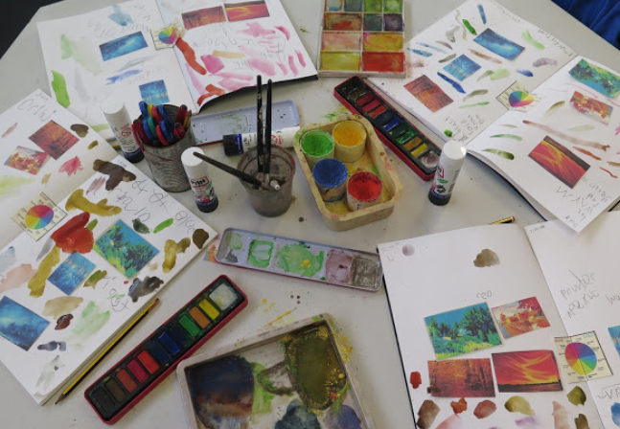 | -Sketchbooks are used to practice and try out ideas & techniques.  -Note taking may be used through scaffolded prompts and key questions provided by the teacher.  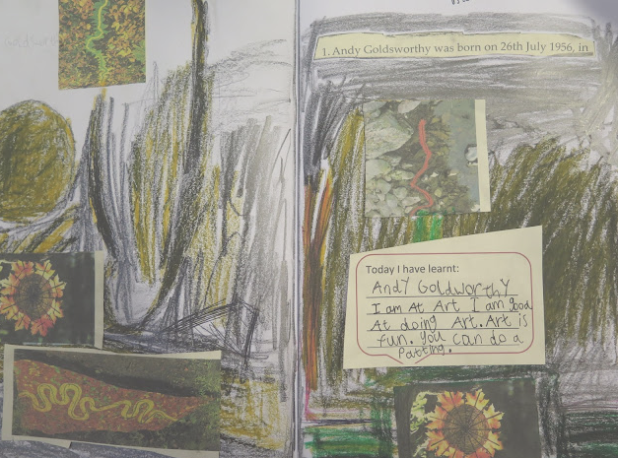 | -Sketchbooks are used to practice and try out ideas & techniques.  -They make records of the world around them, their ideas, thoughts, feelings and discoveries.  -Children should gain an awareness of different processes through trying them out and through failure as much as success.  -Note taking may be used through scaffolded prompts and key questions provided by the teacher.  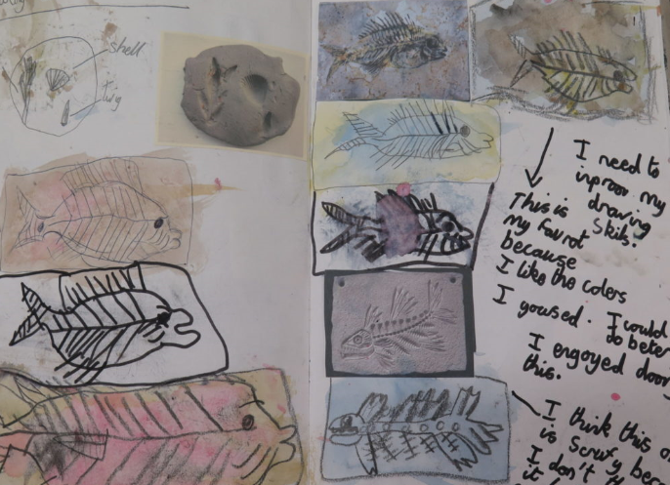 | -Sketchbooks are used to practice and try out ideas & techniques.  -They make records of the world around them, their ideas, thoughts, feelings and discoveries so their sketchbook becomes a very personal space.  -Children should start to make connections between previous learning through the development of their sketchbook.  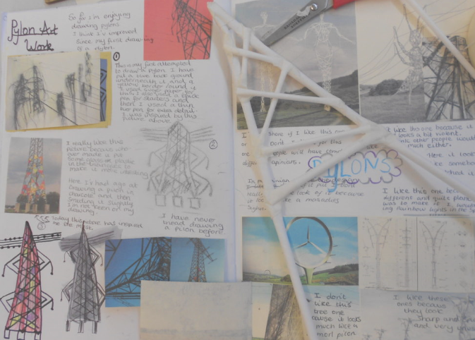 | -Pupils experiment with techniques in sketchbooks to see what works and what doesn’t.  -They label these experiments for their own learning and record keeping.  -Sketchbooks are used to practice and try out ideas & techniques.  -Record observations & research of artists and themes.  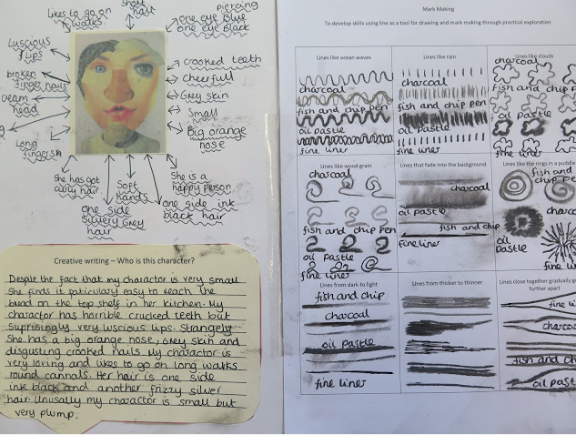  -Use a sketchbook for pleasure, recording, ideas & expression so their sketchbook becomes a very personal space. | -Experiment with techniques in sketchbooks to see what works and what doesn’t.  -They label these experiments for their own learning and record keeping. Sketchbooks are used to practice and try out ideas & techniques.  -Record observations and research of artists and themes.  -Use a sketchbook for a range of purposes, pleasure, thoughts, ideas & expression so their sketchbook becomes a very personal space.  