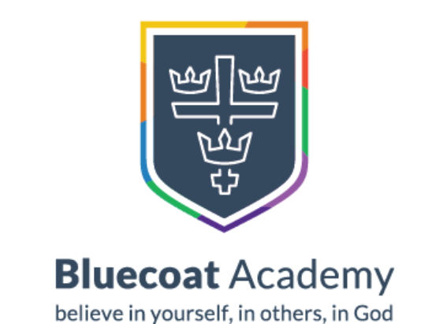

Bluecoat Primary Academy History Progression Document for EYFS 2021-2022

Year Group: Early Years Foundation Stage
Big Ideas for the Phase: The Early Years Foundation Stage Framework states that through ‘Understanding the World’, ‘children begin to make sense of their community and the world around them. They do this through exploration, observation and finding out about people, places, technology and the environment’.

‘People and Communities’ and ‘the World’ are particularly important for the foundation of historical thinking.

Nursery
Understanding of the World
Children talk about past and present events in their own life story and in their family history. They know that other children don’t always enjoy the same things, and are sensitive to this. They know about similarities and differences between themselves and others, and among families, communities and traditions.

Relevant EYFS Development Matters 2020 Statement(s):
- Begin to make sense of their own life-story and family’s history.
Vocabulary
Family, home, love, parents, mother, father, mum, dad, brother, sister, auntie, uncle, grandma, granddad, cousin, friend, stranger, past, long time ago

FS2
Understanding of the World Past and Present

Children know about similarities and differences in relation to places, objects, materials and living things and comment on images of familiar places in the past. They compare and contrast characters from stories, including figures from the past. Children talk about the features of their own immediate environment and how environments might vary from one another over time. They make observations of animals and plants and explain why some things occur, and talk about changes.

Relevant EYFS Development Matters 2020 Statement(s):
- Comments on familiar situations in the past.
- Compare and contrast characters from stories, including figures from the past.
- Talk about the lives of people around them and their roles in society.
- Know some similarities and differences between things in the past and now, drawing on their experiences and what has been read in class.
- Understand the past through settings, characters and events encountered in books read in class and storytelling.

Key Questions/Themes
AT1: What makes us unique?
- Our families and life stories. How do they differ from others?
- My home and how houses developed through the ages.
AT2: Who is our neighbour and how do they celebrate?
- People who help us – compare transport and equipment with past and present day. Children could create a biography of Mary Seacole as a stimulus.
SP1: How do we travel and where do we go?
- Transport over the ages from muscle/animal power to engine powered.
- The Wright brothers undertook the first successful plane flight on 17th December 1903. It took them a number of attempts and redesigns and they showed perseverance and hard work. Children could have a go at creating their own planes.
SP2: What’s this mysterious object and where did it go?
- Dinosaur egg – what is the progression of this egg? What was the stage before it arrived here? What do you think will happen next? How long has it been here? When do you think it will hatch?

