

Lunch Menu Week 1 next week

NEWSLETTER

Friday 18th  March 2022

=

2021

**Ofsted Report**

We are so pleased to share the Ofsted report with you today – please take time to read the report and letter attached. We are so pleased with the outcome, overall the school was graded as follows:

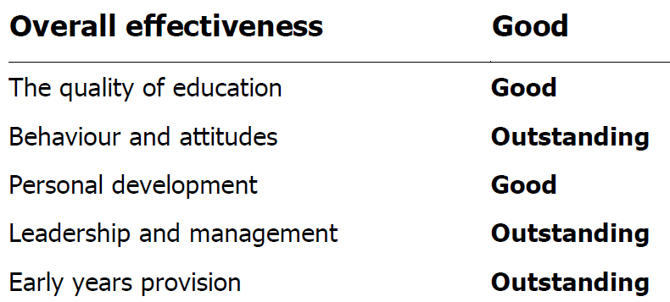

**Easter Events**

We are really excited about Easter and are looking forward to making this time fun for all the children at school whilst also exploring why Christians celebrate. We will have the following events happening during week commencing 28th March:

*Egg decorating competition.* Try to win an Easter egg. All children are invited to decorate a hard boiled egg at home and bring into school by Wednesday 30th March. School Council will be judging the entries and results will be announced in the Head Teacher’s Award Assembly on the final day of term. A poster with some ideas will follow next week.

Year 4 are preparing an **Easter performance.** They will perform this to the rest of school earlier in the week but we would like to invite their parents to come and watch them on Wednesday 30th March at 2:30pm.

Key Stage 1 will be welcoming the return of our **‘Bring and Share Easter Breakfast’**. This is an opportunity for you to bring in some food to share and to start the day with your child, other families and God. The session will include eating, craft activities, song and prayer. A letter will be sent to these classes next week with further details but dates and times are:

**Wednesday 30th March Year 2 – 8:50am to 9:30am**

**Thursday 31st March Year 1 – 8:50am to 9:30am**

The team from Woven Church will be joining the school to lead an Easter service on **Thursday 31st March**

**Parents Evening**

Your child will now have brought home a letter regarding Parents’ Evening on 30th & 31st March. Parents’ evening is a wonderful opportunity to meet your child’s class teacher, see the work they have been completing in class and find out more about how you can support their learning at home. We would love all of our parents to attend.

Lily & Co will be cancelled on both of these days therefore children must be collected at the end of the normal school day.

**INSET Days**

Our Trust INSET day that was cancelled in January due to high Covid numbers has been rearranged for Thursday 30th June to go with the pre-existing INSET day on Friday 1st July**.** We can now confirm our INSET days for the next academic year and the updated term dates are attached to this e-mail and are also available on our school website.

**Thursday 1st September 2022**

**Friday 2nd September 2022**

**Monday 3rd October 2022**

**Monday 20th February 2023**

**Friday 30th June 2023**

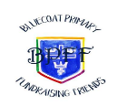

**Bluecoat Primary Fundraising Friends (BPFF) Events**

* 22nd March coffee afternoon 2.00pm.
* Mothers Day and Easter gifts being sold from the BPFF shed week commencing 28th March afterschool.

[bluecoatprimaryff@gmail.com](mailto:bluecoatprimaryff@gmail.com)

**This week in… The Nest**

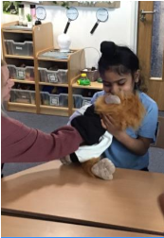The children have continued to learn about money during maths. We created our own shop where the children could ‘buy’ priced items using the correct coin. The children particularly enjoyed putting money into the piggy bank!

We continued reading ‘Monkey Puzzle’ focusing on how to describe the characters in the story. We spoke about what made each one different and what were their similarities.

We have been learning about how seasons are different, what we might wear and how the outside environment might look in Winter, Spring, Summer and Autumn. The children loved getting messy when we used our fingers to paint how a tree would look in each season!

For our PHSE lessons we have introduced a new character called ‘Monkey Boo’. He is a puppet who will help to encourage the children to make eye contact, build social skills and generally have lots of fun with. He has been a big hit so far!

**… in EYFS**

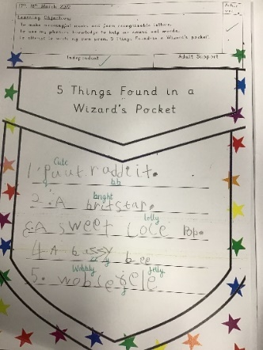Peacocks and Flamingos have been learning a new poem called “10 Things Found in a Wizards Pocket.” The children have then innovated the poem and created their own poems. They have had some fantastic ideas and used their phonics to write them. They also had another dance workshop led by Itara, who taught them an African dance. The children were fantastic and absolutely loved it! They have enjoyed the sunny days that we have had and have been busy looking for signs of Spring.

The Ducklings have been learning the story. “We’re going on a bear hunt.” They have learnt new vocabulary and drawn a story map. Some of the children have even had a go at drawing their own story maps!

**…In Key Stage 1**

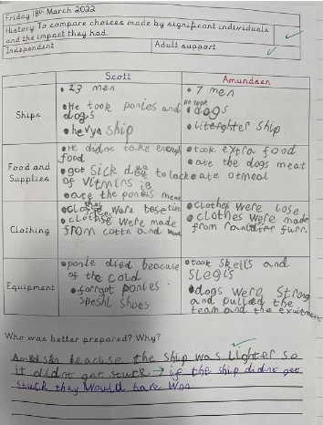This week the children have been completing their independent writing. This is a time for the children to show off all the new vocabulary and knowledge they have gained from their new key question.

In Year 1, the children have written facts all about the Great Fire of London. They have written a timeline of events starting from the fire beginning in the bakery and it ending with King Charles using gunpowder to blow up the houses to stop the flames.

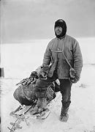In Year 2, the children have been learning all about a great explorer, Captain Scott, who raced to the South Pole against Amundson.

As part of their final outcome, the children independently wrote a diary entry about Captain Scott’s journey on the way back from the South Pole. It has been a fantastic week for writing in Key Stage One.

**…Key Stage 2**

This week, the children have had a truly awesome week of learning! In Year 3, the children have continued to explore how they apply their length knowledge to calculate perimeter. To do this, they practiced measuring lengths and using their repeated addition skills to add them. In English, the children applied all their learning so far to write a letter from a Roman soldier that included subordinating conjunctions and fronted adverbials. To complete their History learning, the children discovered how the Romans brought Christianity to Britain and the practices that we still follow today.

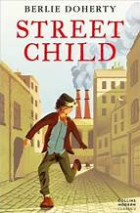In Year 4, we have been concluding our writing unit about the Workhouse, based on the book, Street Child. The children have been enthralled throughout and have applied what we have learnt well. Our focus has been using similes, metaphors and dialogue in our writing. All have produced some super work. Year 6 have had a week full of fun and challenge! In Maths, they have progressed to forming expressions and applying substitutions using algebra - a new unit of learning for them - with much success.

In Science, Year 5 have had a wonderful week, working with secret formulas to improve their writing. The children have especially enjoyed SHOW not TELL and have taken part in a drama activity to show their emotions using their body language and facial expressions. It was a very enjoyable lesson, with lots of giggles! Year 6 conducted an electricity investigation into the relationship between voltage and bulb brightness, with some 'explosive' findings!

**Dates for your diary:**

22nd March – BPFF Coffee Afternoon 2.00pm – Hall

30th March – Deadline for Egg Decorating Entries

30th March – 2.30pm Year 4 Easter Play to Year 4 Parents

30th March – 8.50am Year 1 Bring & Share Breakfast

31st March – 8.50am Year 2 Bring & Share Breakfast

30th & 31st March – Parents Evenings

**Last Day of term – Friday 1st April 2022**

**Children return to school – Tuesday 19th April 2022**